Italian strong motion database relative to the period 1972-2004: motivations and aims

Lucia Luzi(¹), Fabio Sabetta(²), Francesco Mele(¹), Barbara Castello(¹)

(¹) Istituto nazionale di Geofisica e Vulcanologia, Italy
(²) Dipartimento della Protezione Civile, Italy

Corresponding author: Fabio Sabetta
e-mail: fabio.sabetta@protezionecivile.it
tel +39 06 68204686

Abstract
The Italian Accelerometic Archive (ITACA) was created in 2007 during a joint project between the Italian Institute for Geophysics and Vulcanology (Istituto Nazionale di Geofisica e Vulcanologia, INGV) and the Italian Civil Protection (Dipartimento della Protezione Civile, DPC). The project, started in 2006, had the aim of filling the data gap of existing strong motion databases and facilitating strong motion data users in obtaining good quality waveforms, through the collection, homogenization and distribution of strong motion data acquired during the period 1972-2004 in Italy by different institutions (Ente Nazionale per l’Energia Elettrica, ENEL, Italian electricity company; Ente per le Nuove tecnologie, l’Energia e l’Ambiente, ENEA, Italian energy and environment organization DPC).
The compiled database contains 2182 three-component waveforms generated by 1008 earthquakes with a maximum moment magnitude of 6.9 (1980 Irpinia earthquake) and can be accessed on-line at the portal denominated ITACA at the site http://itaca.mi.ingv.it, where a wide range of search tools enables the user to interactively retrieve events, recording stations and waveforms with particular characteristics, whose parameters can be specified, as needed, through user friendly interfaces. A range of display options allows users to view data in different contexts, extract and download time series and spectral data. This article describes the state of the art up to 2006 and the activities which led to the completion of the project.

Keywords: strong motion, database, web portal

1 Introduction
The creation of an Italian accelerometric database was motivated by the increasing request of strong motion data from scientific and engineering communities and by the absence of an updated national database. Scientific research in seismological and engineering fields requires strong motion data for several purposes, such as evaluation of ground motion prediction equations, verification of shaking scenarios and probabilistic hazard maps or formulation of seismic codes. The correct use of accelerometric data implies a detailed knowledge of the characteristics of recording site, seismic event and instrumentation which recorded the time series.
The Italian strong motion data recorded in the time span 1972 – 1993 were previously organized as a database dated 1998, in the framework of a joint project between the Italian energy and environment organization (Ente per le Nuove tecnologie, l’Energia e l’Ambiente, hereinafter ENEA), and the Italian civil protection department (Dipartimento della Protezione Civile hereinafter DPC). Data subsequent to 1993, with the exception of the Umbria-Marche 1997-1998 and Molise 2002-2003 strong motion data sets, were assembled as an unstructured electronic archive by DPC.
In the framework of the agreement between the Italian institute for Geophysics and Vulcanology, (INGV) and the Italian Civil Protection (DPC), in the period 2004-2006, a project for the creation of the Italian strong motion database was promoted, named “Italian strong motion database in the period 1972-2004” (“Database dei dati accelerometrici italiani relativi al periodo 1972-2004”, hereinafter denominated S6, http://esse6.mi.ingv.it). The project had the aim of creating a robust database homogenizing the data acquired by different institutions in the last four decades increasing the information quality and facilitating the data accessibility to the scientific community. The compiled database has the acronym ITACA (ITalian ACcelerometric Archive) and is available at the site http://itaca.mi.ingv.it.

2. State of the art

The Italian Strong Motion Network (Rete Accelerometrica Nazionale, hereinafter RAN) was managed by the Italian Electricity Company (Ente Nazionale per l’Energia Elettrica, hereinfter ENEL) from 1972 to 1997, when, during the Umbria-Marche seismic sequence, the Italian Civil Protection Department was charged of its management and maintenance. In parallel, the institute for the development of new technologies, energy and environment (ENEA) was managing a relevant number of strong-motion stations which recorded the strongest Italian earthquakes, such as Ancona 1972, Friuli 1976, Irpinia 1980 and Umbria-Marche 1997-1998. In addition, since less than one decade other local strong-motion networks are operating in Italy, such as the Friuli Strong-motion Network (Rete Accelerometrica del Friuli, RAF), the Northern Italy Strong-Motion Network (Rete Accelerometrica in Italia Settentrionale, RAIS) and the Irpinia Seismic Network (ISNet , Weber et al., 2007).
A first attempt to unify the strong-motion data acquired by different institutions dates back to 1998, when a first version of the Italian strong-motion database was achieved by ENEA in the framework of an agreement with the former Italian Seismic Survey (DPC). That database stores information about 571 three-component waveforms recorded in the period 1972 -1993. The 458 best quality records were digitized, but only 401 of them were associable to 189 earthquakes recorded from 6/2/1972 to 26/7/1993, with maximum moment magnitude 6.9 (Irpinia earthquake). Strong-motion data were available in unprocessed and processed format, while seismic event, recording station and waveform metadata were stored in a relational database, accessible until 2005 at the site http://www.serviziosismico.it.
Strong motion data recorded subsequently to 1993 were not organized as a relational database, but as an unstructured electronic archive, containing the essential information relative to seismic events (from INGV bulletin) and recording sites (Table 1). The original analogue and digital waveforms are available in the unprocessed version. The total number of waveforms recorded by the RAN in the period 19/9/1993 - 30/06/2005 was 1668 (12% from analogue and 88% from digital instruments), relative to 852 seismic events, 80 of them having M_{l} ≥ 4.0.
Only the Umbria-Marche 1997-1998 and Molise 2002-2003 strong motion data sets were published as a CD-ROM (SSN, 2002; Dipartimento della Protezione Civile, 2004).
The first version of the European strong-motion database (European Strong Motion Database, hereinafter ESD) is dated 2000 and was achieved in the “5th Framework Programme of the European Commission” by ICSTM (The Imperial College of Science, Technology and Medicine, London), ENEA, ENEL and IPSN (Institut de Protection et de Sûreté Nucléaire, Paris). It contains 1068 waveforms relative to 432 earthquakes and 376 recording stations. As shown in Fig. 1, more than half of the time-series are Italian and the most recent among them are relative to the 1997-1998 Umbria-Marche sequence (Ambraseys et al, 2004). The data are published at the site http://www.isesd.cv.ic.ac.uk/esd/frameset.htm. Since 2000 the database has been incremented with data from Turkey, Iran and Iceland, and now contains 4370 waveforms.
The situation illustrated above, shows how, before the completion of the S6 project, strong-motion data users had to face many difficulties in accessing Italian records and retrieving information concerning seismic events and recording stations. In addition, the majority of recording stations were not enough characterized, although the recordings have been used to derive ground motion prediction equations (Ambraseys et al., 1996, Ambraseys et al., 2005; Sabetta and Pugliese, 1996), such as the case of Tolmezzo Ambiesta. Fig. 2 displays the shear and compressional wave profile and the site transfer function obtained by Castro et al. (1996), which indicate how this site cannot be defined as a “standard” rock site.
An initiative started simultaneously to the S6 project, with the same aim of promoting strong-motion data dissemination in Europe, comes from the EU NERIES project (http://www.neries-eu.org). The specific activity Improving accelerometric data dissemination, differently from the Italian database, approaches the concept of data dissemination through local databases, combined with data exchange protocols, which allow access to the unprocessed data. ITACA is a centralized database which provides the access to processed and unprocessed waveforms that can be retrieved through a search on a local database.
Efforts to make the two initiatives converge are presently spent, so that the data contained in ITACA can also be accessed through the NERIES portal.

3 Towards the Italian strong motion database

The construction of the Italian strong motion database did not mean a mere collection of the Italian strong motion data, but also the definition of the architecture for data storage and maintenance and a considerable effort to improve the metadata associated to seismic events and recording stations. In addition, the strong-motion database was published online to facilitate data accessibility to the scientific community. Five main activities were developed: i) database design, ii) waveform collection and processing; iii) verification of seismic events; iv) verification of recording stations and instruments and v) database implementation and data dissemination through the web.

3.1 Database design
The database design consisted in the definition of the structure and the selection of the software for data storage and management. It was decided to manage the strong-motion data through a relational model, which requires that the information is stored in tables linked by shared keys, in order to reduce data redundancy.
The database is handled through two different relational Data Base Management Systems: Ms Access® 2003 for data input and MySQL for the web distribution. The selection of the former product is driven by the simplicity of the software, the worldwide diffusion and the interface capability with software for the management of spatial data, such as ESRI® products, or software for scientific implementations such as Matlab®. The two databases communicate through a protocol which allows to transfer the database tables, locally stored in the MS Access format, to the web database, in order to update the information as soon as they become available.
At this stage the tables and the relative fields storing the information were designed and the technical requirements for data storage established. After the definition of the common fields, the relations existing among different tables were planned. User interfaces for data input and data query were also designed. Details about the database structure are discussed in Luzi et al. (2008, electronic supplement).

3.2 Waveform collection and processing
The same waveforms contained in the DPC-ENEA database were collected for the time span 1972 - 1993, while records after 1993 were obtained from the RAN archives, including the data of the temporary stations installed after the occurrence of the strongest earthquakes since 1993 (Umbria Marche 1997-1998; Molise 2002; Salò 2004). The time series relative to the period 1972-1993 have been almost exclusively recorded by analogue instruments and they were automatically digitized with a constant step of 400sps, while more recent data have been obtained by digital instruments. The improvement of digital instruments allows to record even low magnitude events, down to Ml 1.0, and the philosophy behind the project was to include all the recorded events in the database, although they come from low magnitude events. The term “strong – motion data” is perhaps used improperly, but we keep on using it as synonymous of accelerometric data.
It is well known that strong-motion records require processing, as they contain a variable noise level which depends on different causes. Nevertheless, there is no unique solution for data processing, as the correction procedures not only depend on the recording instrument characteristics, but also on the user which can decide subjectively the selection of the processing parameters and options (Boore and Bommer, 2005).
The correction procedures were selected in order to obtain processed signals, that could give reliable estimates of acceleration, velocity, displacement and acceleration response spectra. In order to reach this goal, the choice of individual waveform processing instead of automatically processing was made, although it required a big effort. To optimize the achievement of data quality in the short period of the project completion, simple but effective processing procedures adaptable to digital and analogue data were selected. Details about data processing are discussed in Massa et al. (this volume).

3.3 Verification of seismic events
The Italian strong-motion database covers a 30 years time-span, during which the Italian seismic and accelerometric networks undertook an unprecedented evolution. The Italian National Seismic Network managed by INGV (ING until 2001), increased from 12 instruments in 1972 to about 180 in 2004. The Italian Seismic Bulletin of 1972 included phases from 6 seismometers for the M = 5 event recorded offshore of Ancona on June 14th, 1972, while an event with the same magnitude, occurred on November 25th 2004 in the Adriatic sea, has been recorded by more than 70 instruments of the National Seismic Network. Before using the earthquake metadata contained in the database one should bear in mind the evolution of networks and instruments occurred in the time span covered by the strong-motion database, as the precision of the event locations varied enormously during those years.
A list of selected events was defined by verifying the recording quality and cross-checking the correspondence of recordings and hypocentral locations in the seismic catalogues. Fig. 3 shows the geographical distribution of seismic events included in the database. Most of them are localized in the zones affected by the main Italian seismic sequences, such as Friuli 1976, Irpinia 1980, Umbria-Marche 1997-98 and Molise 2002-2003. The magnitude versus epicentral distribution of the records is shown in Fig. 4, together with the PGA distribution with distance. Low magnitude events (2 < Ml < 4) have been mainly recorded within 40 km, while moderate to strong events have been recorded at distances up to 150-200 km. The strongest event (Irpinia 1980, Mw = 6.9) has no records at distances lower than 20 km. The most recurrent PGAs are in the range 1- 10 gal (weak events or strong events recorded at large distances) and in the range 10-100 gal. PGAs greater than 100 gal represent the records of the strongest earthquakes and are sampled up to 100 km.
In order to increase the data quality, the events recorded by the strong-motion network were revised using various catalogues to retrieve hypocentral parameters, magnitudes, focal mechanisms, fault geometries and epicentral intensities in different time periods, as listed in Table 2.
Hypocentral parameters, characteristics of the fault plane, different magnitude types and macroseismic intensity were assigned and each estimate was associated to a bibliographic reference. Multiple locations or different values attributed to the same parameter were also taken into account. The hypocentral parameters and magnitude estimates were obtained by catalogues such as ING Catalogue, Catalogo della Sismicità Italiana (Castello et al., 2006), INGV bulletin, Catalogo Parametrico dei Terremoti Italiani (working group CPTI, 2004) and catalogues by International Seismological Centre (ISC), European-Mediterranean Seismological Centre (EMSC), National Earthquake Information Center (NEIC), among others.
Each seismic event was associated to different types of magnitude. Mw, Ms and Mb values were provided for most of the strongest earthquakes (M>5.0) occurred within the Italian territory. Mw values were selected from the Centroid Moment Tensor (CMT) or Regional Centroid Moment Tensor (RCMT) solutions of the Italian CMT dataset (Pondrelli et al., 2002). If the Mw was not available in that catalogues, it was recomputed from other magnitude types in the database Earthquake Mechanisms of the Mediterranean Area (Vannucci and Gasperini, 2004). Local magnitude Ml is the reference magnitude for the M < 5.0 earthquakes. Ml was retrieved from instrumental catalogues or bulletins compiled at INGV. If a Ml value was not available, the event was associated to a Ml computed from a duration versus Ml regression function (from the CSI catalogues).
Fig. 5 describes the time and magnitude ranges covered by the used catalogues, and the priority assigned to them. Table 3 summarizes the methods used by the various sources of information.
The strong motion database also provides references to the focal mechanism solution, the computation method and the tectonic regime associated to the event. Focal mechanism solutions are derived from seismic moment tensors. The sources of information are: i) the Italian CMT dataset from 1976 up to now (Pondrelli et al., 2002) and ii) the EMMA database (Vannucci and Gasperini, 2004) where moment tensors have been evaluated by published focal mechanisms or deduced from focal mechanisms obtained using first phase arrivals.
To report the tectonic regime of the earthquakes, the classification defined by Zoback (1992) was used discriminating among 5 main types, namely: i) Normal Fault (NF): extensional stress regime; ii) Strike Slip Fault (SS): strike-slip stress regime, corresponding to faulting with dominantly horizontal slip, and eventually a minor normal or thrust component; iii) Thrust Fault (TF): a thrust faulting stress regime corresponding to reverse dip-slip faulting; iv) Normal-Strike Slip Fault (NS): a regime with a combination of both normal and strike-slip fault, predominately normal with a strike-slip component; v) Thrust-Strike Slip Fault (TS): a regime with a combination of both thrust and strike-slip fault, predominately thrust with some strike-slip component.
The database reports strike, dip and rake of faults as in the Database of Individual Seismogenic Sources (DISS working group, 2006) containing the fault geometry parameters of seismological potential sources derived from geophysical and geological integrated studies. Only 17 potential sources could be associated to events recorded by the accelerometric network.

3.4 Verification of recording stations and instruments
The geological and geotechnical characterization of recording stations is fundamental for a correct use of strong-motion data, as local site conditions can have strong influence on the frequency content and the duration of the records. Moreover, detailed site characterization is the first step towards soil classification, which is fundamental to reduce the uncertainties in ground motion prediction equations and allows to calculate shake and hazard maps including site effects.
Since 1972 about 620 recording sites (408 analogue and 212 digital) were progressively installed or removed and equipped with analogue or digital instruments. In the time span 1972 - 2004 only few recording sites were characterized with particular emphasis on the stations which recorded large magnitude events (i.e. 1976 Friuli, 1980 Irpinia), since detailed geophysical and geotechnical site investigations have relevant costs. The majority of the sites was only described by a geological sketch and an interpretative cross section, only useful to distinguish between rock and soil. At the project beginning the information available was very inhomogeneous and knowledge on geographical, geotechnical and geophysical features of the RAN sites required a relevant improvement. The choice made within the project was to make uniform the pre-existing information, characterize only five sites with detailed, high cost analysis and to perform intermediate to low cost geophysical or geomechanical surveys in about thirty selected sites. Details on recording site characterization is described in Luzi et al. (this volume).

3.5 Database implementation and data dissemination through the web
The database managed by Ms Access® 2003 was populated through I/O masks (Fig. 6) and data were transferred to a web server used for data dissemination. The acronym adopted for the web portal is ITACA (Italian ACelerometric Archive) accessible at the URL http://itaca.mi.ingv.it (Fig. 7). The database stored in the web server can be accessed through user friendly interfaces which allow the user to perform queries to select station, seismic event and waveforms and download the strong motion data. The database can be explored through 29 searchable key fields: 9 for the stations, 10 for the seismic events and 10 for the waveforms. The basic idea is that separate queries can be performed for three distinct database sub-models (stations, events and waveforms). Each query returns a list and the single outcome can be explored in detail. Both recording stations and events are mapped through the Google-Map data©, which allows to display point data alternatively on a satellite image or a basic map, as shown in Fig. 8.
The waveforms satisfying the required conditions can be displayed with the aid of a Java application (Fig. 9), which allows the user to perform simple operations like zoom in/out, modify display options (axis labels, axis limits, background and foreground colour, etc.) and plot saving or printing. The strong-motion recordings selected through a query can be downloaded by the web clients in raw and processed format, together with the velocity and displacement time-series and acceleration response spectra. Details regarding the web portal are described in Luzi et al. (2008).

4 Conclusions

The Italian strong-motion database contains 2182 three component waveforms relative to 1008 earthquakes with maximum magnitude 6.9 (1980-11-23 Irpinia earthquake) in the period range 1972 – 2004 and is devoted to engineering and scientific communities.
During this time span, the strong motion data have been acquired by different institutions, namely ENEL, ENEA and DPC with different purposes (permanent strong motion monitoring of the Italian territory and temporary monitoring during seismic sequences or before permanent installation).
Data have been collected, homogenized and processed according to a defined standard. Acceleration, velocity, displacement and acceleration response spectra have been calculated, together with the most used engineering parameters. In order to increase the data quality, the parameters relative to the seismic events have been included after a careful revision, through the use of the most updated seismic catalogues and databases. The data relative to the recording stations have also been added, not only collecting existing data, but also promoting new field investigations of various type.
The data set has been organized in a relational database that can be accessed at http://itaca.mi.ingv.it. The on-line database can be interactively searched by the user according to personal needs through user friendly data queries, which allow the identification of waveforms with particular characteristics. A range of display and download options allow users to view data in multiple contexts, extract and download metadata, time series and spectra files.
After the completion of the project many issues remain opened or not solved, at least definitively. The data collection stops at 2004 and a huge amount of data has been gathered by the Department of Civil Protection in the time span 2004-2007, as the quality of recording instruments increased, in accuracy and precision. In addition, in the last decade new strong motion networks have been installed in Italy, managed by different institutions than DPC, whose data have not been included in the database and the issue of the recording site characterization is still open, as only few sites were investigated during this project.
To fulfil the gaps after the conclusion of the S6 project a new project was started in the framework of the agreement between DPC and INGV in the period 2007-2009. The aim of the project is indeed the update of the ITACA database to 2007, but great emphasis has also been attributed to the recording site characterization. Very recently two major earthquakes occurred in Italy, the M_{w} 5.4 Parma (northern Italy) and the M_{w} 6.3 L’Aquila (central Italy) and many efforts were spent to make the waveforms soon available to the scientific community

Acknowledgments
This work was supported by grants from the understanding between Istituto Nazionale di Geofisica e Vulcanologia and Dipartimento della Protezione Civile (Italy) in the time span 2004-2006.

References

Ambraseys NN, Simpson KA, Bommer JJ (1996) The prediction of horizontal response spectra in Europe. Earthquake Engineering and Structural Dynamcs 25: 371-400.

Ambraseys N, Smit P, Douglas J, Margaris B, Sigbjornsson R, Olafsson S, Suhadolc P, Costa G (2004) Internet-Site for European Strong-Motion Data. Bollettino di Geofisica Teorica ed Applicata 45(3): 113-129.

Ambraseys NN, Douglas J, Sarma SK, Smit PM (2005) Equations for estimation of strong ground motions from shallow crustal earthquakes using data from Europe and Middle East: horizontal peak ground acceleration and spectral acceleration. Bull. Earth. Eng. 3: 1–53.

Boore DM, Bommer JJ (2005) Processing of strong motion accelerograms: needs, options and consequences. Soil Dyn. Earth. Eng. 25: 93-115.

Castello B, Selvaggi G, Chiarabba C, Amato A (2006) CSI Catalogo della sismicità italiana 1981-2002, versione 1.1. INGV-CNT, Roma. http://www.ingv.it/CSI/

Castro RR, Pacor F, Sala A, Petrungaro C (1996) S wave attenuation and site effects in the region of Friuli, Italy. J. Geophys. Res. 101: 22355–22369.

European-Mediterranean Seismological Centre http://www.emsc-csem.org

Dipartimento della Protezione Civile—Ufficio Servizio Sismico Nazionale—Servizio Sistemi di Monitoraggio (2004) The Strong Motion Records of Molise Sequence (October 2002–December 2003). CD-ROM, Rome.

DISS Working Group (2006) Database of Individual Seismogenic Sources (DISS), Version 3.0.2: A compilation of potential sources for earthquakes larger than M 5.5 in Italy and surrounding areas. http://www.ingv.it/DISS/, © INGV 2005, 2006 - Istituto Nazionale di Geofisica e Vulcanologia

ENEA – ENEL (1985) Raccolta di informazioni sulle postazioni accelerometriche del Friuli. Commissione ENEA-ENEL per lo studio di problemi sismici connessi con la realizzazione di impianti nucleari. Internal Report, Rome (in Italian).

International Seismological Centre. Bulletin of the International Seismological Centre. http://www.isc.ac.uk

Istituto Nazionale di Geofisica e Vulcanologia, CNT (2007) Bollettino della sismicità strumentale. INGV, Roma. http://bollettinosisimico.rm.ingv.it/

Luzi L, Sabetta F, Hailemikael S, Bindi D, Pacor F, Mele F (2008) ITACA (ITalian ACcelerometric Archive): a web portal for the dissemination of Italian strong motion data. Seism. Res. Lett. 79(5): 717- 723. doi: 10.1785/gssrl.79.5.

National Earthquake Information Center – NEIC. Earthquake catalogue. http:// earthquake.usgs.gov/regional/neic

Pondrelli S, Morelli A, Ekström G, Mazza S, Boschi E, Dziewonski AM (2002) European-Mediterranean regional centroid-moment tensors: 1997-2000. Phys. Earth Planet Int. 130: 71-101.

Sabetta, F, Pugliese A (1996) Estimation of response spectra and simulation of nonstationary earthquake ground motion. Bull. Seism. Soc. Am. 86: 337–352.

SSN – Monitoring System Group (2002) The strong motion Records of Umbria-Marche Sequence (September 1997–June 1998), CD-ROM, Rome.

Vannucci G, Gasperini P (2004) The new release of the database of Earthquake Mechanisms of the Mediterranean Area (EMMA version 2). Annals of Geophysics, supplement to vol. 47(1): 307-334.

Weber E, Convertito V, Iannaccone G, Zollo A, Bobbio A, Cantore L, Corciulo M, Di Crosta M, Elia L, Martino C,, Romeo A, Satriano C (2007) An advanced seismic network in the southern Apennines (Italy for seismicity investigations and experimentation with earthquake early warning. Seism. Res. Lett. 78(6): 622-634.

Working group CPTI (2004) Catalogo Parametrico dei Terremoti Italiani, versione 2004 (CPTI04), INGV, Bologna. http://emidius.mi.ingv.it/CPTI04/

Zoback ML (1992) First- and Second-Order Patterns of Stress in the Lithosphere: the World Stress Map Project. J. Geoph. Res. 97(B8):, 11703-11728.

Tables

Date | Origin time | Station name | Station  lat | Station  Lon | Event  lat | Event  lon | Depth  (km) | Ml  INGV | Md  INGV | Dist  (km) | Max PGA  (gal)
19971016 | 120031 | Colfiorito (Casermette) | 43.028 | 12.900 | 43.046 | 12.887 | 0.0 | 4.5 | 4.1 | 2.3 | 769.4
19980403 | 72636 | Nocera Umbra P.I. | 43.120 | 12.792 | 43.185 | 12.744 | 1.4 | 4.9 | 4.7 | 8.2 | 567.8
19971006 | 232453 | Nocera Umbra 2 | 43.113 | 12.785 | 43.020 | 12.844 | 6.4 | 5.4 |  | 11.4 | 531.5
19971006 | 232453 | NocUmbra (Biscontini) | 43.103 | 12.805 | 43.020 | 12.844 | 6.4 | 5.4 |  | 9.8 | 379.9
19980113 | 14916 | Sellano O. | 42.889 | 12.928 | 42.874 | 12.977 | 5.0 | 2.4 | 3.5 | 4.3 | 259.3

Table 1. Example of DPC strong-motion catalogue.

CATALOGUE | AGENCY | TIME PERIOD | REFERENCE | CODE
ING Catalogue | INGV- CNT | 1450b.C. -1990 | Internal database | ING Catalogue
Bollettino Sismico Italiano | INGV- CNT | 1984 - up to now | http://legacy.ingv.it/%7eroma/reti/rms/bollettino/ | INGV-CNT Seismic Bulletin
Catalogue of Italian Seismicity, CSI, version 1.1 and 2.0 | INGV - CNT | 1981 - 2002  2003 - 2007 | Castello et al., 2006; R. Di Stefano, p. c. | CSI1.1 e CSI2.0
Catalogo Parametrico dei Terremoti Italiani CPTI04 | INGV- MI | 217 b.C. – 2002 | Gruppo di lavoro CPTI, 2004 | CPTI04
European Mediterranean Regional Centroid-Moment Tensors | INGV-BO | 1976 – up to now | Pondrelli et al., 2006 | IT-CMT-2006
Earthquake Mechanisms of the Mediterranean Area database (version 2) | UNI Bo - INGV BO | 1905-2003 | Vannucci and Gasperini, 2004 | EMMA
International Seismological Centre  Bulletin | ISC | Up to now | htpp://www.isc.ac.uk | ISC
National Earthquake Information Centre. Earthquake catalogue | NEIC | Up to now | http://earthquake.usgs.gov/  regional/neic | NEIC
Database of Individual Seismogenic Sources, version 3.0.2 | INGV-RM1 | - | DISS Working Group, 2006 | DISS 3.0.2

Table 2. List of sources, period covered, reference and code for the seismic catalogues used to compile the event parameters metadata in Itaca.

METHOD CODE | DESCRIPTION | DETAILED DESCRIPTION
ML-Oth-ING-Catal | ML from other (non WA) instruments (ING Catalogue 1972-1983) | Local magnitude determined from various instruments (non Wood-Anderson) at the Istituto Nazionale di Geofisica (years 1972 to 1983).
ML-RM-ING-Catal | ML from the RMP WA instrument (ING Catalogue 1972-1983) | Local magnitude determined from various instruments at the Istituto Nazionale di Geofisica (years 1972 to 1983).
ML-TR-ING-Catal | ML from the TRI WA instrument (ING Catalogue 1972-1983) | Local magnitude determined from various instruments at the Istituto Nazionale di Geofisica (years 1972 to 1983).
ML-V-SP | Local Magnitude computed by vertical, short period instruments | Local magnitude computed by amplitude and period of the maximum phase recorded at a short period vertical seismometer (usually Teledyne S13).
ML-MEDN-CSTI | ML from CSTI catalogue | Local magnitude computed on real WA amplitude or simulated WA amplitude
ML-MEDN-INGV | Local-Magnitude scale from Synthetic Wood Anderson Seismograms | Since 1996 an automatic system (MUSCLES) interacts with stations of the MedNet (Mediterranean Very Broad Band Network) providing reliable and real time local magnitudes for the strongest earthquakes (ML > 3.8) in the Mediterranean region.
ML-REG | ML computed from a duration versus ML regression function | Local magnitude determined from duration values, by exploiting an ML versus duration regression function and station corrections valid for the Italian region and seismic networks.
Md-Boll-INGV | Md from INGV Bulletin | Duration magnitude in the ING-INGV Bulletin (years 1984-2004) with a distance correction function computed for the Italian region.
Md-Hypoel | Md computed in Itaca | Duration magnitude computed by Hypoellipse location program with a distance correction function computed for the Italian region.
Mw-CMT-HARVARD | Mw from Global CMT | Magnitude determined using the formula of Kanamori (1977) Mw = 2/3 *(log Mo - 16.1) where Mo is given in dyne*cm
Mw-RCMT-INGV | Mw from RCMT | Magnitude determined using the formula of Kanamori (1977) Mw = 2/3 *(log Mo - 16.1) where Mo is given in dyne*cm
Mw-EMMA | Mw recomputed from EMMA catalogue | Moment Magnitude recomputed from others types of magnitude
Mw-CPTI04 | Maw from CPTI04 catalogue | From Ma CPTI99 (average magnitude based on MS) up to 1980 or it's a combined weighted average of different magnitudes
MS-ISC | MS from ISC Bulletin | It's based on measurements of the maximum ground motion particle velocity (A/T)max of the surface wave train at period 20 s and calibration functions depending of distance Ms= log(A\T)max + 1.66 log D +3.3 from both horizontal and vertical components
MSZ-NEIS | MS from NEIS catalogue | It's based on measurements of the maximum ground motion particle velocity (A/T)max of the surface wave train at period 20 s and calibration functions depending of distance Ms= log(A\T)max + 1.66 log D +3.3 from vertical components
Ms-CPTI04 | Mas from CPTI04 catalogue | Up to 1980 corresponds to Ma (average magnitude calibrated on Ms) or it's a combined weighted of different magnitudes from 1981 up to 2002
Mb-ISC | Mb from ISC Bulletin | Magnitude relationship for teleseismic body-waves such as P, PP and S in the period range 0.5 to 12 s. It is based on theoretical amplitude calculations corrected for geometrical spreading and attenuation and then adjusted to empirical observations from shallow and deep-focus earthquakes Mb= log(A\T)max + Q(D,h)
Mb-ISC | Mb from ISC Bulletin | Magnitude relationship for teleseismic body-waves such as P, PP and S in the period range 0.5 to 12 s. It is based on theoretical amplitude calculations corrected for geometrical spreading and attenuation and then adjusted to empirical observations from shallow and deep-focus earthquakes Mb= log(A\T)max + Q(D,h)

Table 3. List of methods and their description for different types of magnitude included in the Itaca database.
Figures

Fig. 1 Relevant European and Middle east events contained in the European Strong-motion database (from the Internet Site for European Strong Motion Data)

Fig. 2 Left: shear and compressional wave profile from ENEA-ENEL (1985); right: site transfer function from Castro et al. (1996) for the station Tolmezzo Ambiesta

Fig. 3 Geographic distribution of seismic events contained in the database

Fig 4 Upper panel: local magnitude versus epicentral distance of the recorded events; lower panel: PGA versus epicentral distance distribution.

Fig. 5 Seismic catalogues and priority levels to retrieve magnitude parameters. Different box colours depend on magnitude type. Different box height defines the priority order; time and magnitude ranges correspond to the ones used in this database. NEIC Earthquake catalogue parameters are contained in ISC Bulletin

Fig. 6 Example of data input interface (seismic events)

Fig. 7 Web portal of the Italian strong-motion data (ITACA, http://itaca.mi.ingv.it)

Fig. 8 Example of data mapping through Google–Map data©

Fig. 9 Java application for waveform visualization

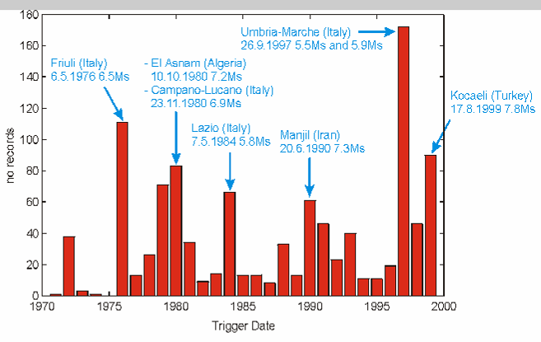
Fig. 1

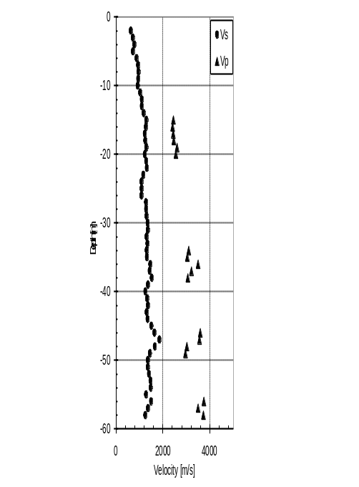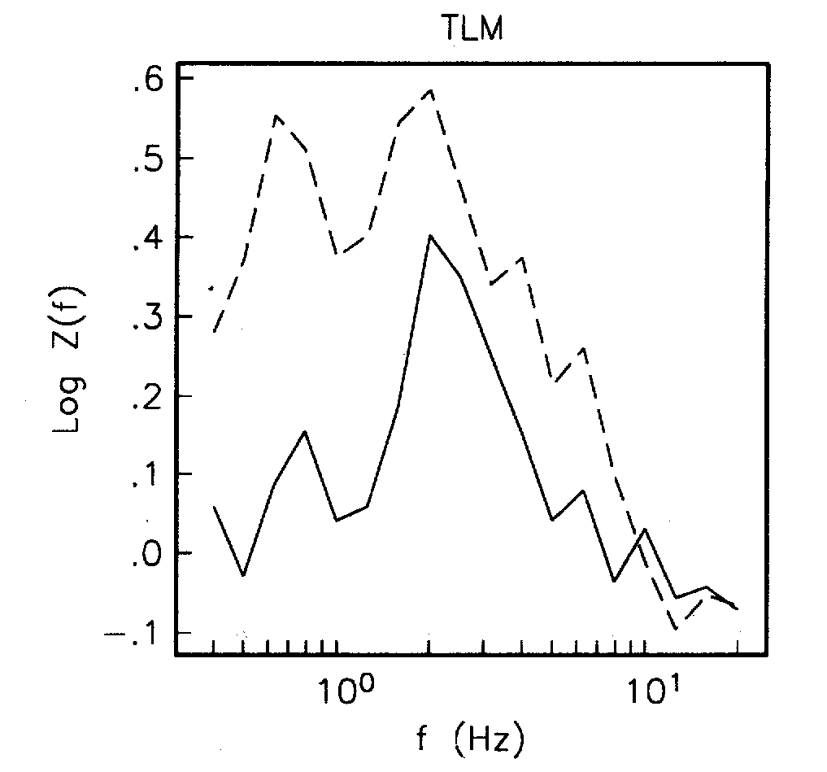

Fig. 2
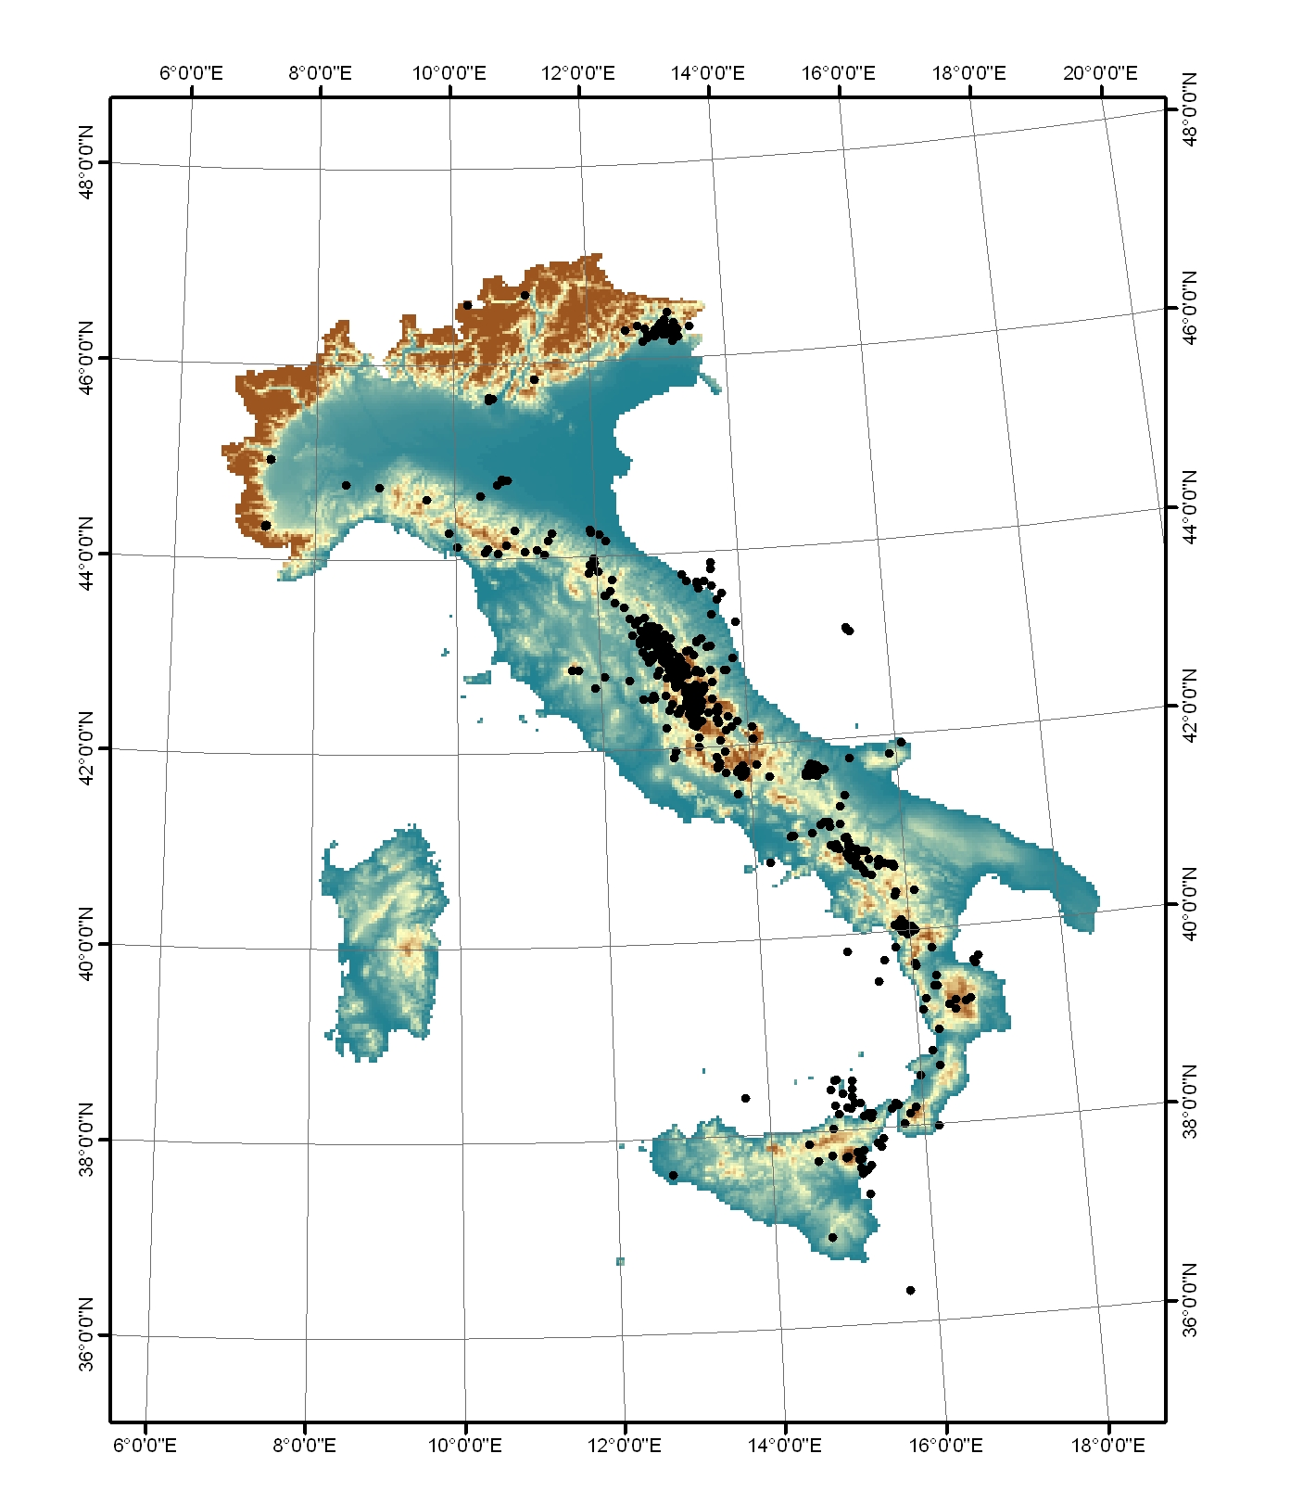
Fig. 3

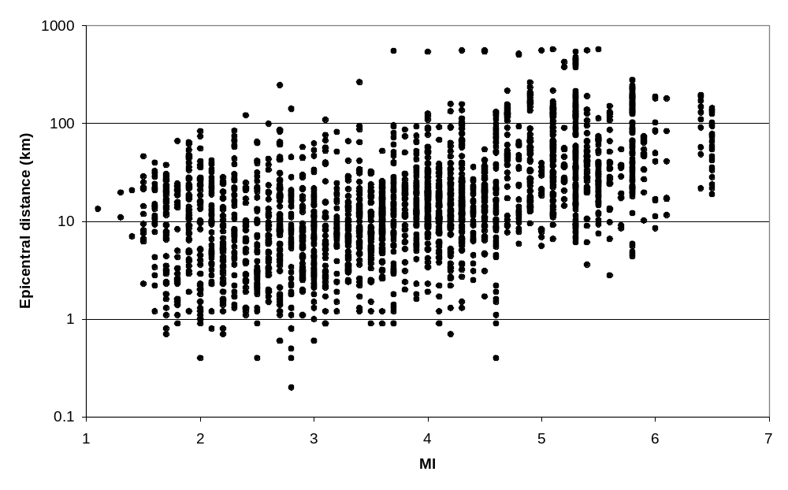

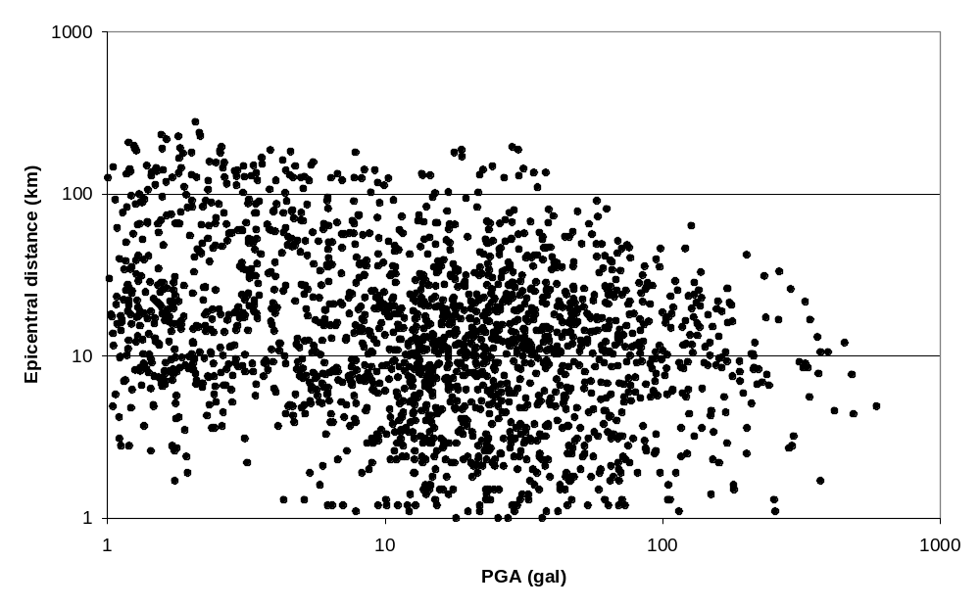

Fig 4
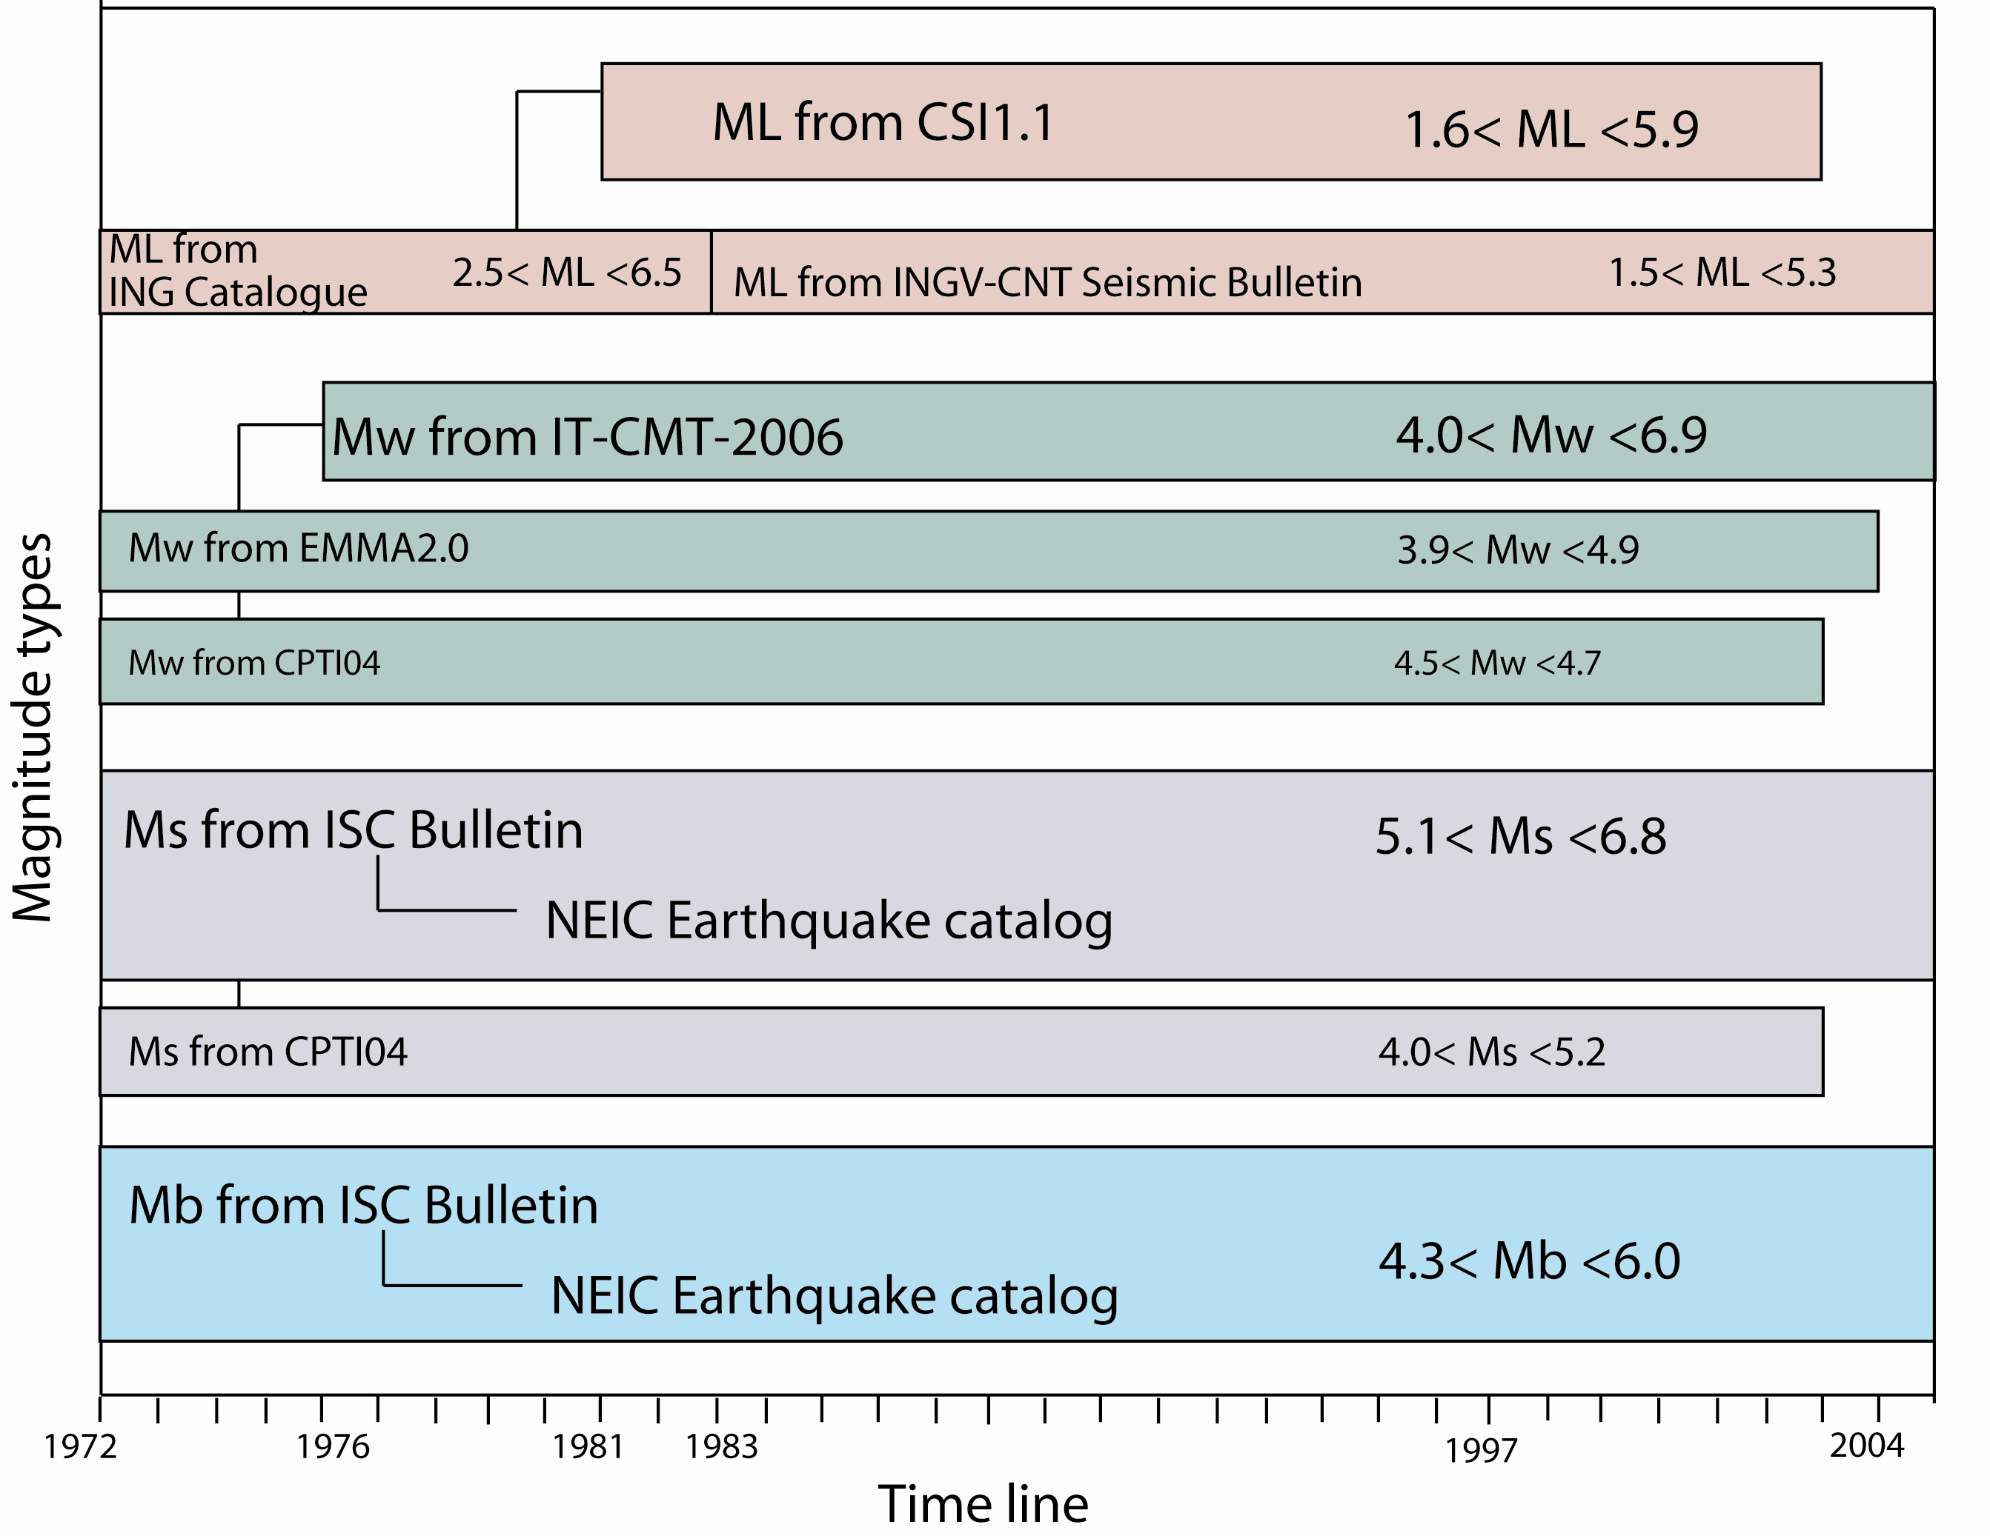
Fig. 5
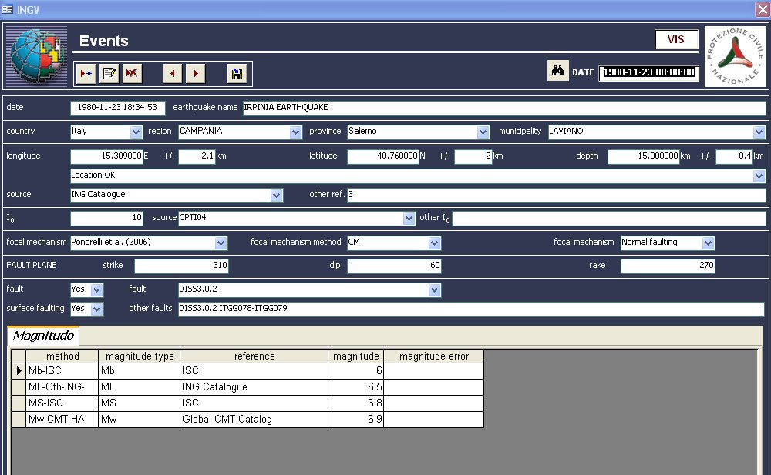
Fig. 6

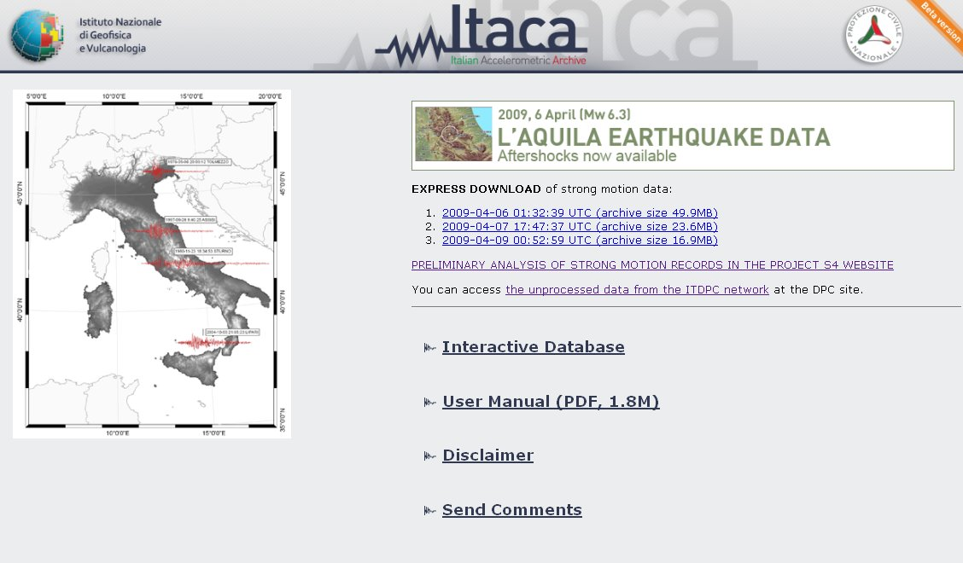
Fig. 7

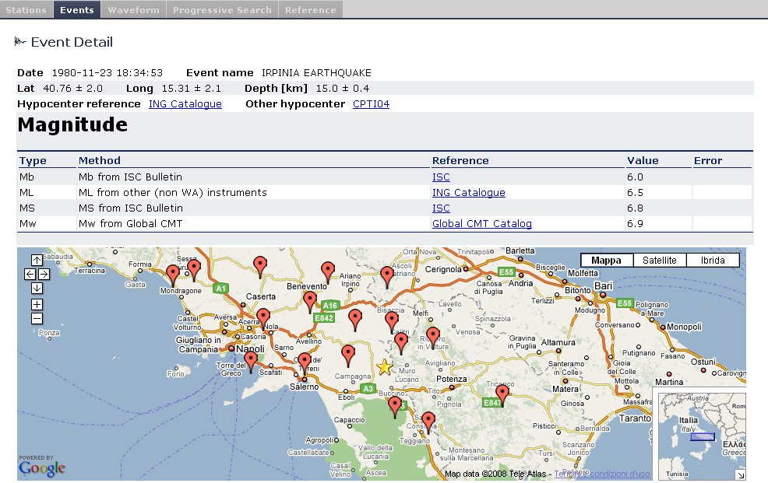
Fig. 8

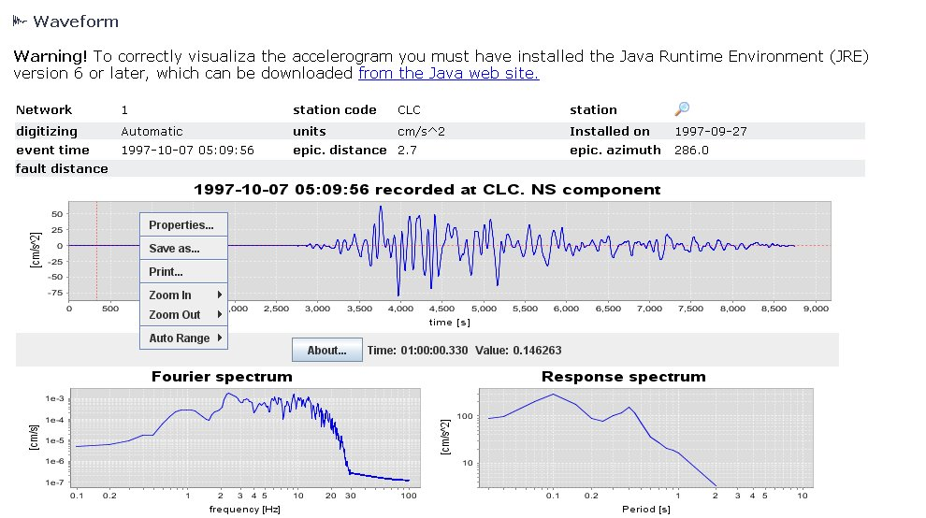
Fig. 9

