Web based macroseismic survey: fast information exchange and elaboration of seismic intensity effects in Italy.

De Rubeis Valerio¹, Sbarra Paola¹, Tosi Patrizia¹ and Diego Sorrentino¹
¹Istituto Nazionale di Geofisica e Vulcanologia, Roma, Via di Vigna Murata, 605
00143 Roma, Italy

ABSTRACT
A renewed method of macroseismic survey, based on voluntary collaboration through Internet, is running at Istituto Nazionale di Geofisica e Vulcanologia (INGV) since June 2007. The macroseismic questionnaire is addressed to a single non-specialist person; reported effects are statistically analyzed to extrapolate Mercalli-Cancani-Sieberg and European Macroseismic Scale intensity referred to that observer. Maps of macroseismic intensity are displayed on-line in almost real time and are continuously updated. The aim of the questionnaire is to evaluate seismic effects as felt by the compiler. The final result is the definition of a particular intensity degree, with the evaluation of the associated uncertainty.
Results of medium-low magnitude earthquakes are here presented showing the ability of the method in giving fast and interesting results. Effects reported in questionnaires coming from towns are analyzed in deep and assigned intensities are compared with those derived from traditional macroseismic survey, showing the reliability of web-based method.

Keywords
Earthquakes, Macroseismic Intensity, Web Survey.

INTRODUCTION
Many seismic institutions and agencies all over the world, as U.S. Geological Survey, British geological survey, European-Mediterranean Seismological Centre, Swiss Seismological Service, Le Bureau Central Sismologique Français, Minister of natural resources of Canada manage a web-based macroseismic survey (see table 1 for specific web addresses).
Institution or agency |  | Link
U.S. Geological Survey |  | http://earthquake.usgs.gov
British geological survey |  | http://www.earthquakes.bgs.ac.uk
European-Mediterranean Seismological Centre |  | http://www.emsc-csem.org
Swiss Seismological Service |  | http://www.seismo.ethz.ch
Le Bureau Central Sismologique Français |  | http://www.seisme.prd.fr
Minister of natural resources of Canada |  | http://earthquakescanada.nrcan.gc.ca
 | Table 1. Other web-based macroseismic questionnaires currently available

At the INGV a web-based questionnaire is on line since 1997. In the year 2007 the questionnaire was completely redrawn. The new questionnaire is operative since June 2007 and is reachable at the address www.haisentitoilterremoto.it (did you feel the quake?). It consists of simple questions, offering multiple-choice answers (appendix 1). Macroseismic intensity maps are produced in real time from the analysis of the questionnaires data and immediately displayed on the internet site. Both Mercalli-Cancani-Sieberg (MCS) and European Macroseismic Scale (EMS) (Grunthal, 1998) are followed. The use of web-based macroseismic surveys grew up in parallel with the wide diffusion of Internet connections. It presents several positive features: almost real time results, low cost survey, fast evaluation of earthquake severity, positive feedback between seismic institution and people, a huge amount of data, intensity values even for very small events. On the other side great care should be devoted to the design of questionnaire and to the evaluation of answers.
Here the following topics will be analyzed: the abilities of web-based surveys to produce reliable macroseismic data and the integration possibilities with the traditional survey methods.

THE DEFINITION AND ANALYSIS OF QUESTIONNAIRE
The aim of the questionnaire is to evaluate the presence of seismic effects as felt by the compiler, following the description of a specific macroseismic scale. Equally important are information on the exact location and personal elements useful to characterize the compiler.
Questions are grouped together into three principal thematic sections. First section deals with personal information, geographic location and the association with the seismic event as recorded by the INGV seismic network. Also important is the characterization of the specific location of the observer (inside a building, in open space, in roads near buildings).
Second section deals mainly with transient effects (appendix 1), usually prevalent in medium-low degrees of the macroseismic scale. The survey of these effects is traditionally considered more difficult as it can be based only on people account. Examples of such questions are: personal reaction, movement of pictures, books and vases, animal’s reaction, light furniture shake etc.. Into this frame there is a question concerning what the observer was doing during the quake (sleeping, walking, being still). This is useful to evaluate the concentration level of the observer and its sensitivity. The section ends with a box where the compiler can record any other observed effect. Although this information is not used to calculate the intensity degree, it constitutes an open gate to collect new significant descriptive elements (i.e. activation of car alarms, interruption of telephone lines): they could be subsequently associated to known effects and to their intensity degree.
The last section inquires about building damages in a very simple way. The compiler has not to be an expert of building structures.
The analysis of a compiled questionnaire for the evaluation of the local macroseismic intensity is performed by the application of a specific procedure. Dedicated statistical analyses have been applied in similar cases (De Rubeis et al., 1992) to determinate the degree and the reliability of each questionnaire. Our needs are complicated by the necessity to perform the analysis and to exclude bad-compiled questionnaires as quickly as possible. These features are necessary to put on-line the resulting macroseismic maps in almost real time. For these reasons we have designed a statistical procedure to give fast and robust results. Moreover this procedure has been applied, using the same criteria, to interpret felt effects according to respectively MCS and EMS scales.
Our procedure is based on additive scores associated to the answers, assigned following these points:
- Single person is considered belonging to the category “many” that appears on macroseismic scales.
- Each answer, concerning an observed effect, gives a score to specific intensity degrees: in fact the observation of one effect is typical of one or few degrees.
- If one effect is present in more than one degree, its weight is equally divided among all interested degrees. In this case the score assigned to each degree is smaller.
- An answer pointing to the explicit lack of a specific effect gives scores to degrees that exclude that effect. Whereas unanswered effects do not produce scores.
- If the observer reports permanent damages in the building then all scores derived from transient effects are discarded.
Every answer has a score equal to 100, this value is equally divided to all degrees characterized by the effect described by the answer. For every question there is always the answer stating that certainly such effect was not present and also the answer “unable to say”. They are quite different for the analysis: the first gives scores to degrees that certainly do not produce such effect while the latter does not assign any scores.
Scores deriving from some specific effects change depending on other variables. For example stronger buildings are supposed to be less damaged by the shaking, so a particular damage occurred on these buildings shifts his scores to higher intensity degrees. The same rule applies to the transient effect of felt vibration intensity, as its associated score may vary depending on the status of the observer: if for example the observer is still and awake then he is able to detect even a very low vibration.
Scores pertaining to each given answer are then summed thus giving a total score for each degree. The resulting distribution of scores for each questionnaire varies depending on the intrinsic coherence of the given answers and on the capability of felt effects to individuate a particular macroseismic degree. The maximum value of the distribution should point out to the most probable intensity, but usually there are several macroseismic degrees with similar high scores. The intensity degree (I) assigned to the each questionnaire is calculated using:
,
where is the total score for the degree and is the Heaviside step function.
An important evaluation, performed on the compiled questionnaire, regards its reliability: a wrong questionnaire may report effects not really observed. Basically there are two relevant possible situations in a wrong questionnaire:
- The compiler wrongly adds some effects not really felt. The resulting questionnaire will have a quite wide distribution of scores.
- The compiler wrongly or deliberately reports several self-consistent effects not really observed. The result points out to a false intensity degree, with a narrow score distribution.
To evidence the situation 1) we have calculated the variance associated to the weighted mean intensity for available questionnaire of our database. We have then defined a limit value of variance as the value separating the upper 2.5% tail of the whole distribution: questionnaires having variance bigger than this value are considered wrong.
Regarding the situation 2) we apply a filter based on the “square root” attenuation law (Gasperini 2001):
,
where is the epicentral intensity and is the epicentral distance of the town reported in the questionnaire. If the intensity associated to a questionnaire results greater then , for the Italian region we consider it dubious and temporarily discard it. The epicentral intensity has been estimated using the earthquake magnitude M and the empirical function (Marcelli and Montecchi 1962):
.
When for a seismic event more than five questionnaires are compiled, intensity maps are produced and displayed. They consist of the geographical distribution of intensities averaged for each town or village. Displayed values are located on the centroid of the municipal district area, as given by the Italian statistical agency (Istat). Since June 2007 more than 10000 questionnaires were compiled with the production of roughly one hundred intensity maps.

web application notes
The web application of the whole system (from the questionnaire through the analysis of answers to the macroseismic map publication) is based on LAMP (Linux Apache Mysql PHP) TECHNOLOGY and it is realized according the W3C (World Wide Web Consortium) specification on HTML 4.01 Transition and CSS 2.0 standards.
The architecture was split in two parts: one is represented by the Web server with the map building process and the other by SQL server (figure 1a , 1b). A Bash procedure scans at regular time intervals the official seismic events table (produced by the Italian seismic network) searching for new events located in the region and it updates its internal table. In case of a new events, a Mysql process finds registered seismic correspondent located inside the effects area (this area is sized following an empirical relationship with magnitude, slightly enlarged to comprise a portion of not felt area) and a temporary table is built. This table contains information of registered correspondent; later a PHP function sends e-mails to the interested correspondent with the request to fill the questionnaire. From the www site it is always possible to fill the questionnaire by non-correspondent, selecting the right event from a list.
Questionnaire is divided into six blocks, following a thematic scheme. No use of images assures faster page download and increased performances. During questionnaire filling up some client-side functions (realized with AJAX and Javascript technology) update the page information, according the user choice. Other functions operates enabling-disabling answers, helping the user in consistent answering.
At regular time intervals a Bash procedure, called by Cron daemon, rebuild the maps, using GMT free software, with new data. New maps are instantly available online. All generated maps, with event info and other useful data, are available on-line and sorted by the event years.
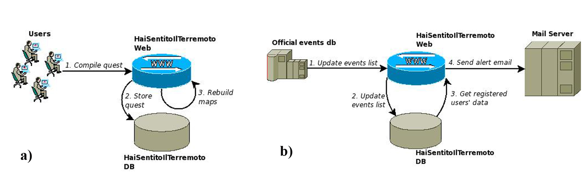
Figure 1. Web application architecture.

Data analysis
Two earthquakes and one big aftershock are here presented. They have a low-medium magnitude and interested both small villages and large towns.
First event was recorded in the town of Rome in April 12, 2008 at 5.45 UTC, with a magnitude , depth was estimated to be about 10 km. Effects were felt up to the coast to a distance of 40 km from epicenter. We received a total of 1150 compiled questionnaires, 807 of them coming from the sole town of Rome. The high number of inhabitants allowed a good sampling, opening the possibility of an in depth analysis for this area (figure 2). On average Rome experienced 3.5 EMS degree. The distribution histogram for all EMS values assigned to every single degree is shown in figure 3. Using the distribution of all effects reported by the population, we extrapolated a EMS degree following a procedure similar to a standard macroseismic survey. In figure 4, for main effects, the distribution of the observed severity is displayed. For example, considering the personal reaction of the compiler, we note that 72% reported curiosity and 28% fear. This sole distribution denotes a III-IV EMS degree, in agreement with the complete result given by the real time analysis. The same conclusion derives from all other effects.
For this event a standard macroseismic survey was independently conducted by a team of INGV (QUEST, 2008) following EMS scale. In general both methods give similar results, being the biggest differences of the order of one intensity degree (Rome east side and Ciampino), see table 2.
A different, possible comparison turns out from the estimated Modified Mercalli Intensity (MMI) map (Wood and Neumann, 1931) obtained by INGV (DPC – S4 Project, 2005), following the Shake Map procedure (Wald et al., 2006) and based on instrumental accelerograph data. Since MMI and EMS scales are very similar for low intensities (Molin 1995), we directly compare values (table 2), evidencing a general agreement.
Newspaper articles represent another source of information. Even if these data are not reliable as those of direct observation, they are frequently used to assess the macroseismic intensity especially for past earthquakes. For the event occurred in Rome, reports show that most people felt the earthquake. Many felt fear, doors were slamming, clear vibration of floors and frames in houses. Such effects denote the V degree. It represents an overestimation if compared with other available data. Probably reporters highlighted only the most striking effects, for a sort of sensationalism.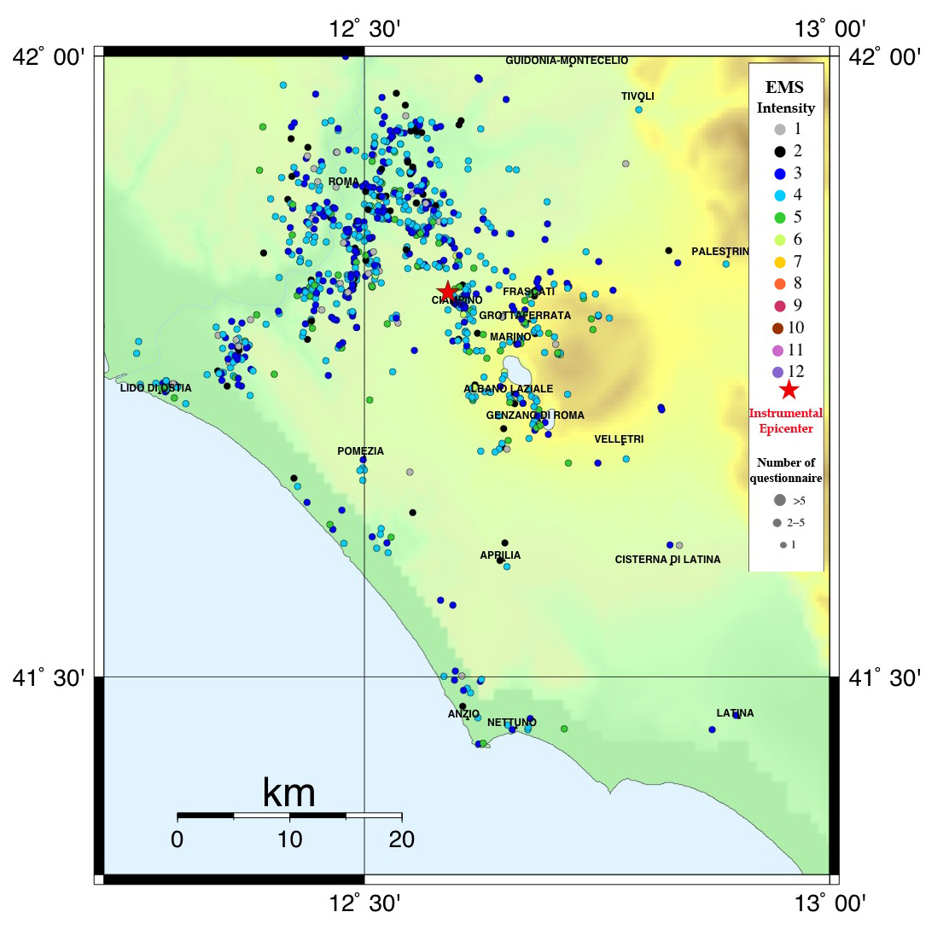
Figure 2. April 12 2008 Ml=3.8 Dept=10 km Time (UTC)= 05:45. EMS macroseismic map produced from the analysis of 1150 questionnaires.
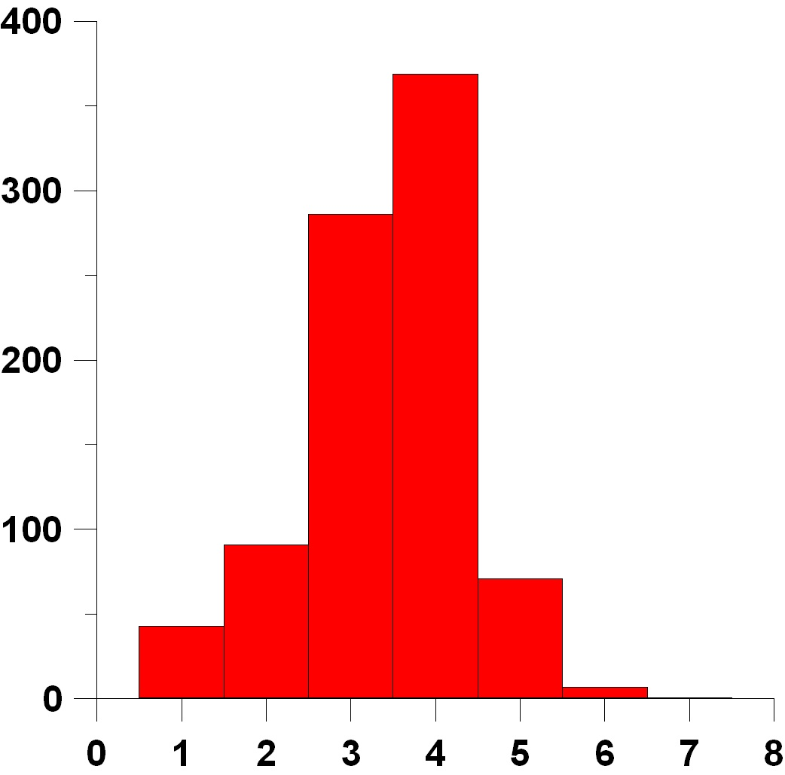
Figure 3. Distribution of EMS intensity degrees for the earthquake of April 12 2008, assigned to every single questionnaire coming from the city of Rome.

The second event was located in North Italy in the Emilia-Romagna region. It occurred at 15:24 UTC of December 23, 2008. Magnitude was estimated to be 5.1 M_{l}. The biggest aftershock followed shortly: occurrence time 21:58 UTC, same day of mainshock, magnitude 4.7. Both earthquakes received a total of around 2700 compiled questionnaires: We received 1570 questionnaires for the main shock (figure 5) and 898 for the aftershock (figure 6).

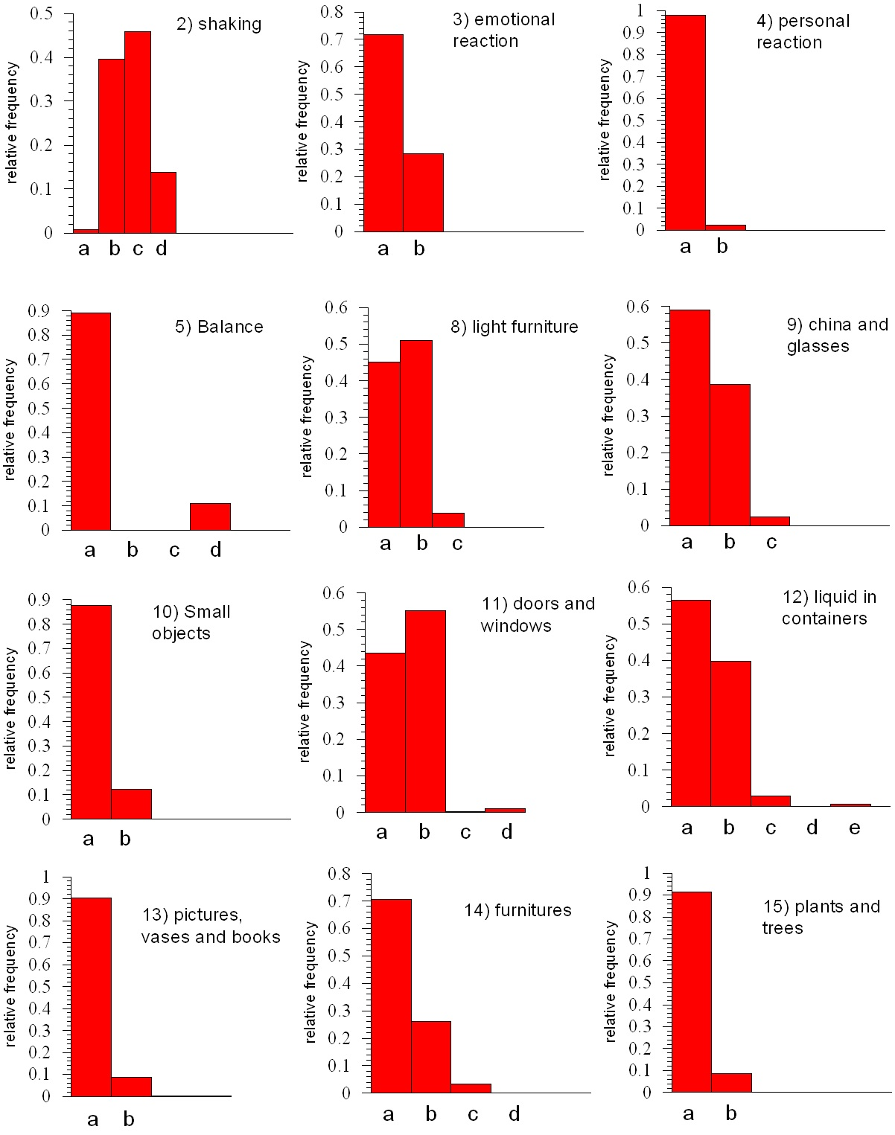
Figure 4. Distribution of the severity of main transient effects observed at Rome. For the description of effects marked with letters see Appendix 1.
Due to the relatively high depth, the main shock was felt to a vast territory, up to distances of 250 km. Highest MCS felt intensity was 5 degree in few points (6) near the epicenter. The Padana plain played an important amplification role, enhancing the 4 degree area toward the North, North-East side of the macroseismic field. This amplification is confirmed by the biggest aftershock. Although the filtering of macroseismic data produced a consistent intensity field, we note that locally a certain data variability is observed. This put in evidence the important role of local amplification-attenuation of intensity. It is interesting to show the time distribution of the compilation of questionnaires. In figure 7 is evident that the maximum people participation is immediately after each event. Very important was the role played by the media: at 8:00 pm one of the most followed national tv news gave the link to the questionnaire.

 |  | on-line Questionnaire | QUEST (survey) | shake map
Roma Est |  | 3.5 | 4.5 | 3.5
Ostia-Casal Palocco-Acilia |  | 4 | 4 | 3.5
Ciampino |  | 4 | 5 | 4
Albano |  | 4 | 4.5 | 4
Ariccia |  | 4 | 4.5 | 4
Fiumicino |  | 3.5 | 4 | 3
Frascati |  | 4 | 4 | 4
Grottaferrata |  | 4 | 4 | 4
Monte Porzio Catone |  | 4 | 4 | 4
 | Table 2. EMS intensity degrees obtained from different methodologies

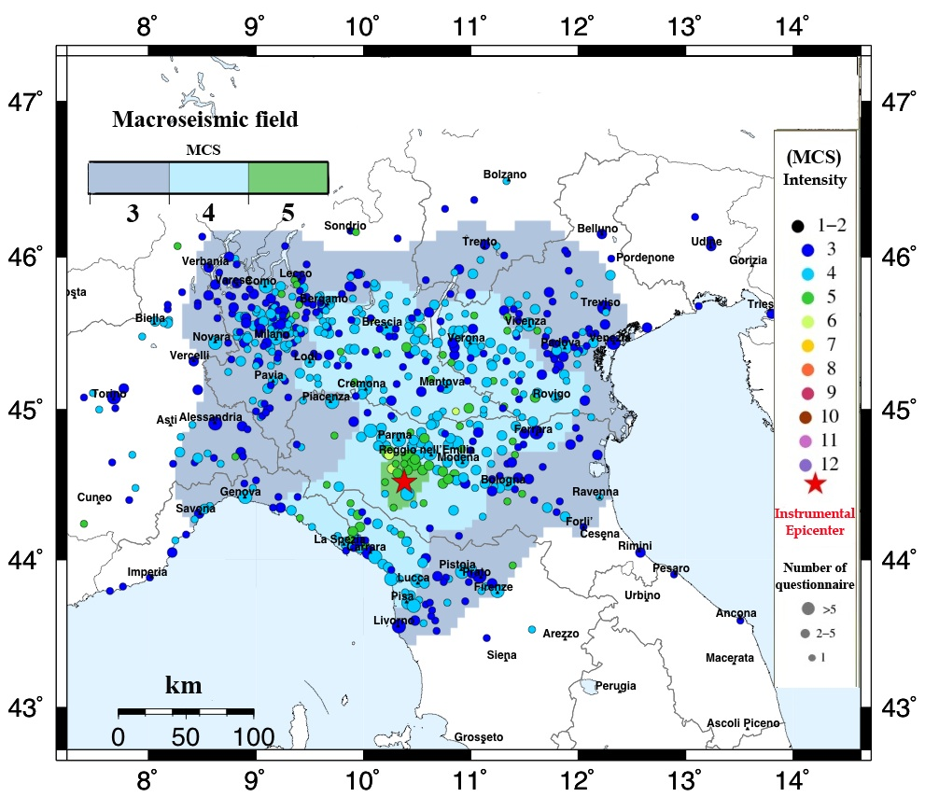
Figure 5. December 23 2008 Ml=5,1 Dept=27 km Time (UTC)= 15:24. MCS macroseismic map produced from the analysis of 1570 questionnaires.

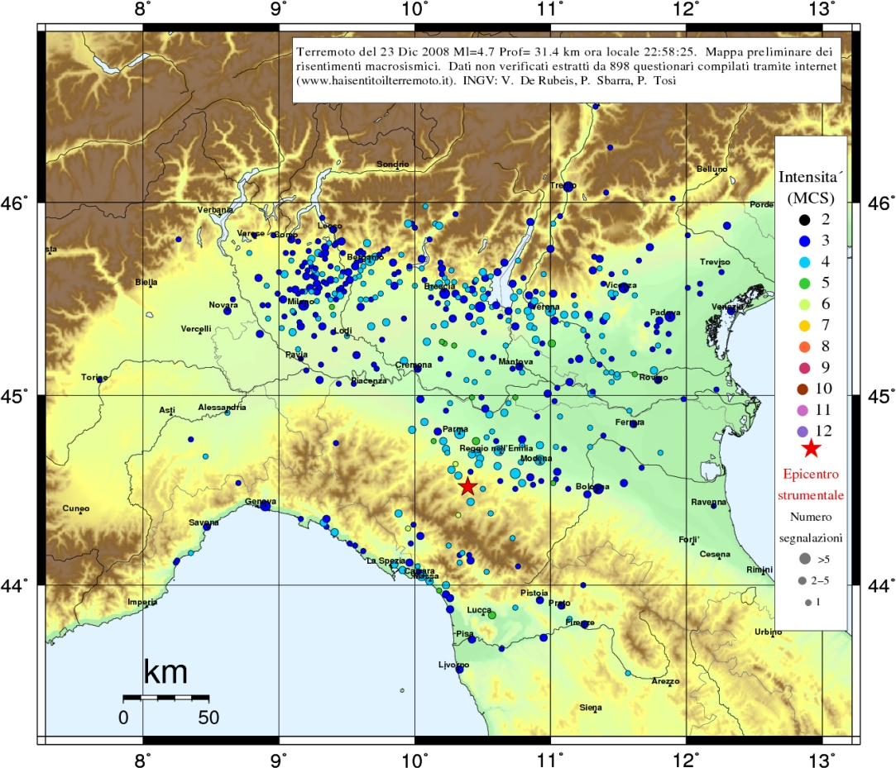
Figure 6. December 23 2008 Ml=4.7 Dept=31 km Time (UTC)= 21:58. MCS macroseismic map produced from the analysis of 898 questionnaires.

Discussion
Web based macroseismic survey is radically different from traditional data collection. It is based on collaboration of volunteers and it will experience an increasing number of adhesions, in parallel, with Internet diffusion in Italy. Results are quickly displayed: usually after half an hour, since event occurrence, intensity maps have a sufficient number of points. It is very suitable for medium-low intensities and investigated area is not previously planned, preventing biases in data acquisition. Generally we receive many answers from people that felt the event and very few from people that did not experienced any effect. For this reason at this stage we do not take into account the “not felt” questionnaires while calculating the average of data. In any case, not felt percentage evaluation looses its interest for intensities larger than 6 MCS because, for definition, everybody feels the event. Moreover macroseismic scales do not fix precise limits on the percentage of not felt, preferring the quantification through adjectives like: few, part, many etc.. Precise quantification of them was proposed (Molin et al., 2008), but a generally strict rule application is still lacking. We believe that there are two independent ways to face this aspect. One is represented by the creation of a priori group of compilers, constituted before the event and alerted immediately after. The creation of this group started since December 2008 and it is experiencing a constant growing. The group members are volunteers quite homogeneously distributed over the territory. To these correspondent we request an answer even in case of not felt effects too. The second solution will come with time, when the use of the questionnaire will be familiar to the whole population interested by the quake. During the late months we have experienced a certain amount of blogs referencing our questionnaire: in general people are very interested. They point out the double aspect of our survey system: the informative and scientific side.

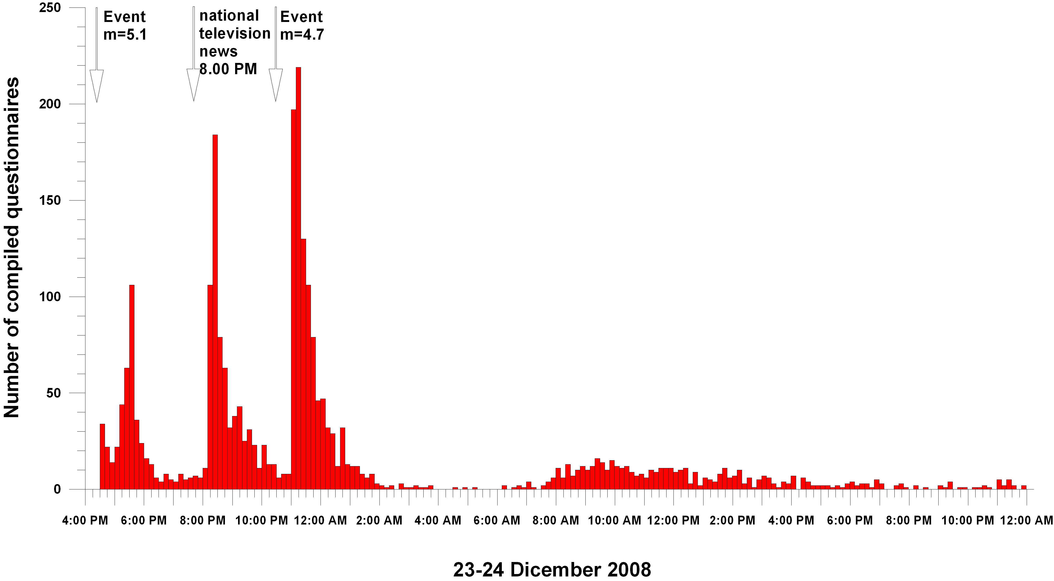
Figure 7. Number of collected questionnaires for the two earthquakes occurred at 23 December 2008 respectively at 15:24 (UTC) and 21:58 (UTC).

Conclusions
A positive aspect of our macroseismic intensity data collection lies on the possibility to analyze all available information with statistical procedures in almost real time. We moreover supply, with the calculated intensity, the number of compiled questionnaires on which it is based: normally this information is not reported on traditional survey.
The studied events show an agreement of intensities obtained averaging single questionnaires, with the overall intensity derived analyzing the distribution of the effects. An agreement was found with intensities elaborated through standard methods, i.e. following investigations made by experts. Our method has proved to give quickly good results at a very low cost in terms of funding and time.
The web-based method carries the increase of available data in respect to direct survey, given by the analysis of a greater number of events of low magnitude. Moreover, medium-high magnitude events receive a bigger surface extension analysis, by the inclusion of peripheral areas interested by low intensity effects, usually disregarded by direct inspection for evident cost reasons. Although not still yet experienced, we can expect that, for high magnitude events, with destructive effects, we can suffer a lack of data from the highest intensity epicentral area.
The attenuation or amplification anomalies receive, from web-based surveys, an enhanced possibility to be detected. This is due by the ability of lower intensities to record it, as demonstrated by our results. We have shown that transient effects too can evidence intensity anomalies. Moreover when spatial density is adequate, it is possible to evidence anomalies at a more detailed scale.

ACKNOWLEDGMENTS
The study was supported by the DPC (Dipartimento della Protezione Civile) S1 Project and DPC ((Dipartimento della Protezione Civile) S3 Project.

REFERENCES
- De Rubeis, V., Gasparini, C. and Tosi, P. (1992) Determination of the macroseismic field by means of trend and multivariate analysis of questionnaire data, Bulletin of the Seismological Society of America, 82, 1206-1222.
- DPC (Dipartimento della Protezione Civile) S4 Project. (2005) http://earthquake.rm.ingv.it
- Gasperini, P. (2001) The Attenuation of Seismic Intensity in Italy: A Bilinear Shape Indicates the Dominance of Deep Phases at Epicentral Distances Longer than 45 km, Bulletin of the Seismological Society of America, 91, 826-841.
- Grunthal, G. (1998) European Macroseismic Scale 1998 (EMS-98), Cahiers du Centre Européen de Géodynamique et de Séismologie Luxembourg, 15, 1-99.
- Marcelli, I. and Montecchi, A. (1962) Contributi per uno studio della sismicità dell'Italia, Annali di Geofisica, 15, 159.
- Molin, D. (1995). Considerations on the assessment of macroseismic intensity, Annali di Geofisica, 38, 805-810.
- Molin, D. Bernardini, F. Camassi, R. Caracciolo, C. H. Castelli, V. Ercolani, E. and Postpischl, L. (2008). Materiali per un catalogo dei terremoti italiani: revisione della sismicità minore del territorio nazionale, Quaderni di geofisica, 57, 1-75.
- QUEST (Quick earthquake survey team) (2008). www.ingv.it/real-time-monitoring/quest
- Sieberg, A. (1930). Scala MCS (Mercalli-Cancani-Sieberg), Geologie der Erdbeben, Handbuch der Geophysik, 2, 552-555.
- Wald, D. J. Worden, B. C. Quitoriano, V. and Pankow, K. L. (2006) shakemap manual version 1.0 Technical Manual, User's Guide, and Software Guide. http://pubs.usgs.gov/tm/2005/12A01/pdf/508TM12-A1.pdf
- Wood H., and Neumann, F. Modified Mercalli (1931). Intensity scale of 1931, Bulletin of the Seismological Society of America, 21, 277-283.

Appendix 1
have you felt the earthquake?
yes - no

- what were you doing?
a) unable to say b) sleeping c) still d) walking
- shaking
a) unable to say b) not felt c) weak d) moderate e) strong
- emotional reaction
a) unable to say b) curiosity c) fear
- personal reaction (inside a building)
a) unable to say b) stand motionless or leave quietly c) ran outside
- balance
a) unable to say b) no problem c) dizziness d) difficulty to keep balance e) fall
- how many people close to you have felt the earthquake and have reacted as you
a) unable to say b) I was alone c) 0 d) 1-3 e) 4-10 f) > 10
- animal upset during the earthquake or few minutes before
a) unable to say b) no problem c) animals indoors may be frightened d) animals outdoors may be frightened e) animals indoors and outdoors may be frightened
- light furniture
a) unable to say b) still c) shaking d) evident shake
- china and glasses
a) unable to say b) still c) rattling d) clattering together e) have broken
- small objects
a) unable to say b) still c) have moved or fallen
- doors and windows
a) unable to say b) still c) rattling d) opening or closing e) slamming
- liquid in containers
a) unable to say b) still c) oscillating slightly d) oscillating or spilling out e) moving strongly f) splashes from pools
- pictures, vases and books
a) unable to say b) still c) moving d) few falling e) many falling
- furniture
a) unable to say b) still c) swinging d) moving e) falling or overturning
- plants and trees
a) unable to say b) still c) plants and sprigs visibly moving d) shaking branches e) branches have broken
- acoustic effect : rumble
a) unable to say b) not felt c) felt
- when did acoustic effect became?
a) unable to say b) before the ground shaking c) during the ground shaking d) after the ground shaking
- where did acoustic effect came?
a) unable to say b) from underground c) from the building d) from outside
- other observed peculiar effect
.....................................................................

Damages or effects to the building

- structure of the building
a) unable to say b) masonry c) reinforced concrete d) wood e) steel
- walls
a) unable to say b) no damage c) cracks in plaster only d) small cracks in walls and/or big pieces of plaster fall e) large cracks in walls f) collapse of walls
- roof tiles
a) unable to say b) no damage c) few sliding d) all sliding
- chimneys
a) unable to say b) no damage c) fall of few stones d) fracture f) fall
- building
a) unable to say b) no damage c) slight damage d) moderate damage e) partial collapse f) total collapse

