Suboceanic Rayleigh Waves in the 1755 Lisbon Earthquake
Vuan A.¹, Rovelli A.², Mele G.², and E. Priolo¹

¹Istituto Nazionale di Oceanografia e Geofisica Sperimentale, Trieste, Italy
Phone: +39-0402140370, Fax: +39-0402140365, Email: avuan@inogs.it

²Istituto Nazionale di Geofisica e Vulcanologia, Roma, Italy
Phone:+39-0651860427, Fax: +39-51860507, Email: rovelli@ingv.it

Abstract
Moderate-magnitude shallow earthquakes in the Atlantic Ocean, hundreds of kilometres southwest of Lisbon, can generate efficient suboceanic Rayleigh waves (SRW) that are well recorded in Portugal. Here we compare moderate-size earthquakes recorded by seismic stations in Portugal with the Tyrrhenian Sea earthquakes recorded in peninsular Italy where SRW were recently observed. In spite of a different behaviour of high frequencies due to the different tectonic setting of the two areas, similar results are found in the intermediate-period range, suggesting that this effect, if extrapolated to a magnitude larger than 8, could be devastating at regional distance in terms of ground motion amplitude and duration. Through 1D models, we explore the hypothesis that the high level of destruction and the long duration of shaking felt during the Great 1755 Lisbon earthquake were caused by SRW. In this preliminary study, we check the role of critical model parameters. We find that duration and amplitude are largest when the average thickness of the water layer is 2 km and shear-wave velocity of the ocean floor is close to the speed of sound in the water. Both conditions are realistic for a source in the Atlantic Ocean, few hundreds of kilometres southwest of Lisbon. Moreover, the propagation of SRW at regional distances accounts for durations of more than ten minutes as the effect of a single large earthquake.

1. Introduction
SRW are large-amplitude, long-duration surface waves generated by shallow seismic sources in the ocean. These waves result from the coupling of crustal Rayleigh waves with acoustic water waves across the seafloor (Ewing et al., 1957). They propagate efficiently along oceanic paths and are well recorded at stations inland. SRW have been commonly observed for long distance paths (> 2000 km) and their effect has never been considered in earthquake engineering so far. However, recent observations in peninsular Italy during moderate earthquakes in the southern Tyrrhenian Sea (Rovelli et al., 2004) demonstrate that SRW attain large amplitude and long duration also at regional distances (300 to 2000 km).
In this study, we investigate moderate-size oceanic earthquakes recorded by the broadband station PMST in Lisbon to find the imprint of SRW. To confirm our interpretation we compare the data recorded from Tyrrhenian Sea earthquakes with PMST data by applying a frequency-time representation of the signals. Finally, we perform some simple numerical simulations to evaluate i) if wave propagation in 1-D crustal and upper mantle models, including a water layer, returns the amplitude and long coda of observed SRW, and ii) if a possible occurrence of SRW during the Great 1755 Lisbon earthquake can explain the high level of damage and duration of shaking felt in southern Portugal.

2. Analysis of Recent Earthquakes in the Atlantic Ocean
We collected digital waveforms from moderate-size earthquakes that recently occurred in the Atlantic ocean along the Azores-Gibraltar Fracture Zone (AGFZ), recorded at station PMST in Lisbon (Figure 1). Earthquake parameters are listed in Table 1. Figure 2 shows examples of vertical component broad-band seismograms recorded by PMST. The station is managed by the Instituto Superior Tecnico of Lisbon and data are freely available through ORFEUS facilities. Seismograms of events # 3 and 4 of Table 1 (see Figure 2) are characterized by a long coda composed of dispersed wave trains with a predominant long-period component. They look as double events because of the arrival of short-period (0.5 Hz – 2 Hz) T-phases about 280 s after the earthquake origin time. Seismic source (especially for event# 4 ) was beneath the seafloor, in the south western margin of the Tagus Abyssal Plain (TAP), 470 km offshore Lisbon, and large part of the propagation path was characterized by the presence of a water layer across TAP.
The other events (# 1, 2, 5, 6 and 7), mainly located in the southeastern part of AGFZ, are not characterized by long duration. This fact can be explained by considering that waves travel along different paths – continental (# 1, 2, 5, 6 and 7) versus oceanic (# 3 and 4).
The 2002, Mw 5.9 Palermo earthquake, occurred 40 km offshore the northern coast of Sicily, represents a well documented case of efficient propagation of SRW at regional distances (Rovelli et al., 2004). Seismic source was beneath the seafloor at shallow depth and large part of the propagation path was characterized by the presence of a deep water layer across the Tyrrhenian Sea. The availability of very-broadband recordings of the September 6, 2002 earthquake at AQU station, in central Italy, at an epicentral distance of 440 km, allowed Rovelli et al. (2004) to investigate the dispersion of the SRW in the Tyrrhenian Sea.
Since recordings of event # 4 in the Atlantic ocean and the 2002 Palermo earthquake have similar oceanic propagation path, source-receiver distance, and source depth, we performed a frequency-time analysis to evaluate if they present common features in the period-group velocity window interested by SRW.
Figure 3 shows a comparison between the vertical and radial component signals filtered by applying a Butterworth band pass from 15 s to 4 s. Because of the different event size (Mw=5.5 and Mw=5.9 for the Atlantic ocean and the Tyrrhenian Sea earthquakes, respectively), amplitudes are different but the vertical and radial components of the two events have a similar long-duration coda. If these signals are compared in the period-group velocity domain we can retrieve, about SRW, the same features described in Rovelli et al. (2004). Figure 4 shows a comparison of the period-group velocity diagrams for the two vertical components shown in Figure 3. Radial component diagrams are similar and do not add more detail to the analysis.
Group velocity measurements are obtained from source-to-receiver distances of 470 km and 440 km for PMST (Lisbon) and AQU (L’Aquila station), respectively. Dispersed surface waves arrive to seismic stations at a time that depends on the wave frequency. To estimate the group arrival time as a function of frequency, the original seismogram is filtered using narrow-band Gaussian filters, and the arrival time of the peak of the filtered signal envelope is used to estimate the group-delay time. Envelope amplitudes of AQU diagram (bottom panel of Figure 4) at periods shorter than 4 s - 5 s are negligible in comparison with the large amplitudes shown at longer periods.
Large envelope amplitudes are found in the period range from 5 to 15 s and within the group velocity window from 1.3 to 2.5 km/s in both PMST and AQU diagrams. Waves generated from scattering and multipathing effects are generally observed in this window. It is often difficult to interpret sonograms and detect a specific surface wave dispersion curve since different modes overlap in the same narrow band. Moreover, for mixed oceanic-continental paths, the coherency of surface waves can be destroyed at short periods by lateral inhomogeneities. However, in the sonograms of AQU, Rovelli et al., (2004) were able to distinguish and interpret the fundamental mode group velocity shape in the short-period band.
By modelling the 1-D wave propagation in the Tyrrhenian Sea Rovelli et al. (2004) observed that 1) synthetic seismograms generated for a 1D model of the Tyrrhenian basin reproduce the amplitude and duration trend of observations in the period band from 5 to 10 s and, 2) the displacement eigenfunctions of the fundamental mode at 4 and 6 sec indicate that the largest vertical and radial amplitudes are confined in the uppermost 4 km confirming that short-period crustal Rayleigh waves are coupled with acoustic water waves across the seafloor. Because of the similarity in the diagrams of Figure 4 in the period band of interest, we assume that the same is true for the Atlantic Ocean earthquakes recorded by PMST (events # 3 and 4 in Table 1).
The other events we analysed (# 1, 2, 5, 6, 7) do not show period-group velocity diagrams consistent with those presented in Figure 4. In Figure 5 is shown the vertical component period-group velocity diagram of event # 2, that we considered representative of this subset. A strong Sn phase at periods shorter than 4 s and group velocity of about 4.0 km/s is observed. No SRW are evidenced at lowest group velocities.

3. The 1755, Mw 8.7 Lisbon earthquake: inferences and preliminary modeling
A role of SRW on increasing hazard at regional distance has never been considered so far. The amplitude of horizontal (radial) ground displacement recorded at PMST during the 2006/01/09 earthquake (Figure 6) suggests that, up to magnitude 6, amplitudes are out of the range of engineering interest. Figure 6 also shows, in the inset, a prediction of the SRW amplitude at larger magnitudes. For the sake of simplicity, predictions are scaled according to a single-corner-frequency omega-squared source model; more complex, double-corner-frequency models would give slightly smaller values at intermediate periods (5-30 s). The results of Figure 6, although based on the rough approximation of a point-source model, give an important indication: during large magnitude (> 8) earthquakes, SRW might reach amplitudes of engineering interest even hundreds of kilometres away from the epicenter. Moreover, the huge number of cycles is itself a reason of concerning, especially for large structures with narrow resonance peaks. The combination of even moderate amplitude with large duration could make the global effect devastating.
According to the observations shown before the Great 1755 Lisbon earthquake could have generated this type of waves: i) its magnitude has been estimated as large as 8.7; ii) the seismogenic zone and a large part of the propagation paths are in the ocean, in a region where the average thickness of the water column is about 2 km; iii) the wide damaged region and the level of destruction, especially on low-frequency structures, are typical of efficient propagation of surface waves at regional distances. A similar selective effect was also experienced in Mexico City, more than 300 km away from the 1985 Michoacan earthquake (Singh and Ordaz 1993).
Historical chronicles report shaking durations of tens of minutes inland in southern Portugal, with two main zones of damage more than 200 km apart along the coast. The occurrence of multiple earthquakes has been invoked to justify the pattern of damage and the long duration of shaking but we believe that both of them could be also explained in terms of slowly propagating dispersed wave trains, as those shown in Figure 3. The high percentage of large buildings that were destroyed in Lisbon (Chester, 2001) plays in favour of a leading role of SRW.
In this preliminary step, we have generated synthetic seismograms from 1D models where focal mechanism, source depth, and Vs and Qs of the seafloor are varied. Synthetics were generated through a wavenumber integration method (Herrmann 2002). This method solves the 3-D full-wave equation in anelastic media with a vertically heterogeneous structure for a point source. The elastodynamic equation is written in cylindrical coordinates and then decomposed in the domain of angular frequencies and complex wavenumbers. This method is accurate and synthesizes realistic seismograms which include all wavefield phases.
For a preliminary analysis we use a simple 1D reference oceanic model. Vp/Vs and Qp/Qs ratios are fixed to 1.73 and 2, respectively. Even though a 1D structure seems too simplistic, we believe that it can be helpful in explaining and interpreting the gross features of the waves under investigation.
Without considering complex 3-D wave propagation (e.g. surface wave multipathing) wave propagation in 1-D models, including a water layer, is able to explain to some extent the observed amplitude and long coda. In Figure 7 we show the match between synthetic and observed signals for the event # 4 (470 km from Lisbon) in the period band from 50 s to 5 s. Focal mechanism parameters, depth and scalar moment are taken from Harvard CMT catalogue (http://www.seismology.harvard.edu/CMTsearch.html).
The proposed epicenters of the Great 1755 Lisbon earthquake (Figure 1) span over 600 km, a surprising uncertainty in view of a well-documented damage caused by this earthquake (Fonseca, 2005). For this study we assume a hypothetical source in the Atlantic Ocean, 300 km southwest of Lisbon, and a thrust faulting mechanism associated with the compressive structures of the Gorringe Bank (Buforn et al., 1988; see Figure 1). This choice could be questionable. However, our parametric study shows that efficiency of excitation of SRW is not sensitive to variations of the focal mechanism.
Figure 8 summarizes the role of the other model parameters on the development of SRW. Curves in these figures are obtained by dividing the Fourier spectrum of the radial component of models with a water layer (1 and 2 km thick) by the Fourier spectrum of the radial component of the corresponding model without water. These spectral ratios quantify the effect of mode coupling along the seafloor on the ground motion at regional distances. In general, we observe a significant amplification in frequency bands of engineering interest depending on the choice of the model parameters.
Source depth and Qs are also varied. Source depth has a significant role on the generation of SRW: shallowest sources are much more efficient.
The largest effects are found when the water layer is 2 km thick (Figure 8a) and source depth is very shallow (4 km, see Figure 8b). Therefore, the excitation of SRW will be stronger during large crustal earthquakes, when the fault rupture reaches the surface.
According to Butler and Lomnitz (2002), a crucial role is played by Vs: when Vs of the seafloor tends to the acoustic speed in the water (Figure 8a), the signal appears to be a composite of undispersed Rayleigh modes propagating along the ocean floor both in the sediments and in the water.
Finally, a variation of Qs from 500 to 250 decreases amplitudes by a factor of 2, approximately, in the frequency band from 1.5 to 2.5 Hz. However, it does not affect significantly the lower frequencies (Figure 8b).

4. Concluding remarks
Observations in inland Portugal and Italy for shallow moderate-size earthquakes occurring beneath the seafloor indicate that, under specific conditions, SRW propagate efficiently at regional distances (> 300 km). Both seismograms and 1D numerical modeling yield duration of shaking of a ten minutes and ampiltudes larger than those of models without column water. Timing of the SWR arrivals would explain many features of the peculiar damage pattern in south Portugal, including the wide region of destruction along the coast and the high level of damage on large-size structures in Lisbon (monumental buildings, churches, aqueducts, etc.). However, in terms of absolute amplitudes, point-source and 1D structures are oversimplifications of the reality not applicable to the 1755 Lisbon earthquake. More refined, extended-source and 3D models, based on the observations here analysed, are in progress to achieve estimates of ground motion usable for engineering evaluations.

Acknowledgements
We thank Bob Herrmann for providing his wavenumber integration code and Joao Fonseca and the Instituto Superior Tecnico of Lisbon for making available PMST seismic data. GMT package (Wessel and Smith, 1991) is used for drawing some pictures.

References
Buforn E, Udias A, Colombas MA (1988) Seismicity, source mechanisms and tectonics of the Azores-Gibraltar plate boundary. Tectonophysics 152(1-2): 89-118.
Butler R, Lomnitz C (2002) Coupled seismoacoustic modes on the seafloor. Geophys. Res. Lett. 29(10), 1418, 10.1029/2002GL014722.
Chester DK (2001) The 1755 Lisbon earthquake. Progress in Physical Geography 25(3): 363-383.
Ewing M, Jardetzky W, Press F (1957) Elastic waves in layered media. International Series in the Earth Sciences (edn), McGraw-Hill, New York, pp 156-183.
Fonseca JF (2005) The source of the Lisbon earthquake. Science 308: 50-51.
Gutscher MA (2004) What caused the Great Lisbon earthquake? Science 305: 1247-1248.
Gutscher MA, Baptista MA, Miranda JM (2006) The Gibraltar Arc seismogenic zone: Part 2. Constraints on a shallow east dipping fault plane source for the 1755 Lisbon earthquake provided by tsunami modeling and seismic intensity. Tectonophysics 426: 153–166.
Herrmann RB (2002) Computer Programs in Seismology, version 3.20, Saint Louis University, Saint Louis, Mo.
Machado F (1966). Contribuicao para o estudo do terramoto de 1 de Novembre de 1755. Rev. Fac. Ciencias Lisbon C 14: 19–31.
Moreira VS (1989). Seismicity of the Portuguese continental margin, in Earthquakes at North-Atlantic Passive Margins: Neotectonics and Postglacial Rebound, S. Gregersen and P. W. Basham (Editors), Kluwer, Hingham, Massachusetts.
Rovelli A, Vuan A, Mele G, Priolo E, Boschi E (2004) Rarely observed short-period (5-10 s) suboceanic Rayleigh waves propagating across the Tyrrhenian Sea. Geophys. Res. Lett. 31: L22605, 10.1029 /2004GL021194.
Singh KS, Ordaz M (1993) On the origin of long coda observed in the lake-bed strong-motion records of Mexico City. Bull. Seismol. Soc. Am. 83: 1298-1306.
Terrinha P, Pinheiro LM, Henriet J-P, Matia L, Ivanov AK, Monteiro JH, Akhmetzhanov A, Volkonskaya Cunha MR, Shaskin P, Rovere M (2002) Tsunamigenic–seismogenic structures, neotectonics, sedimentary processes and slope instability on the Southwest Portugese Margin. Marine Geology 195: 55–73.
Wessel P and Smith WHF (1991) Free software helps map and display data. EOS Trans. AGU 72: 441.
Zitellini N, Chierici F, Sartori R, Torelli L (1999). The tectonic source of the 1755 Lisbon earthquake and tsunami. Annals of Geophysics. 42(1): 49–55.

Fig. 1
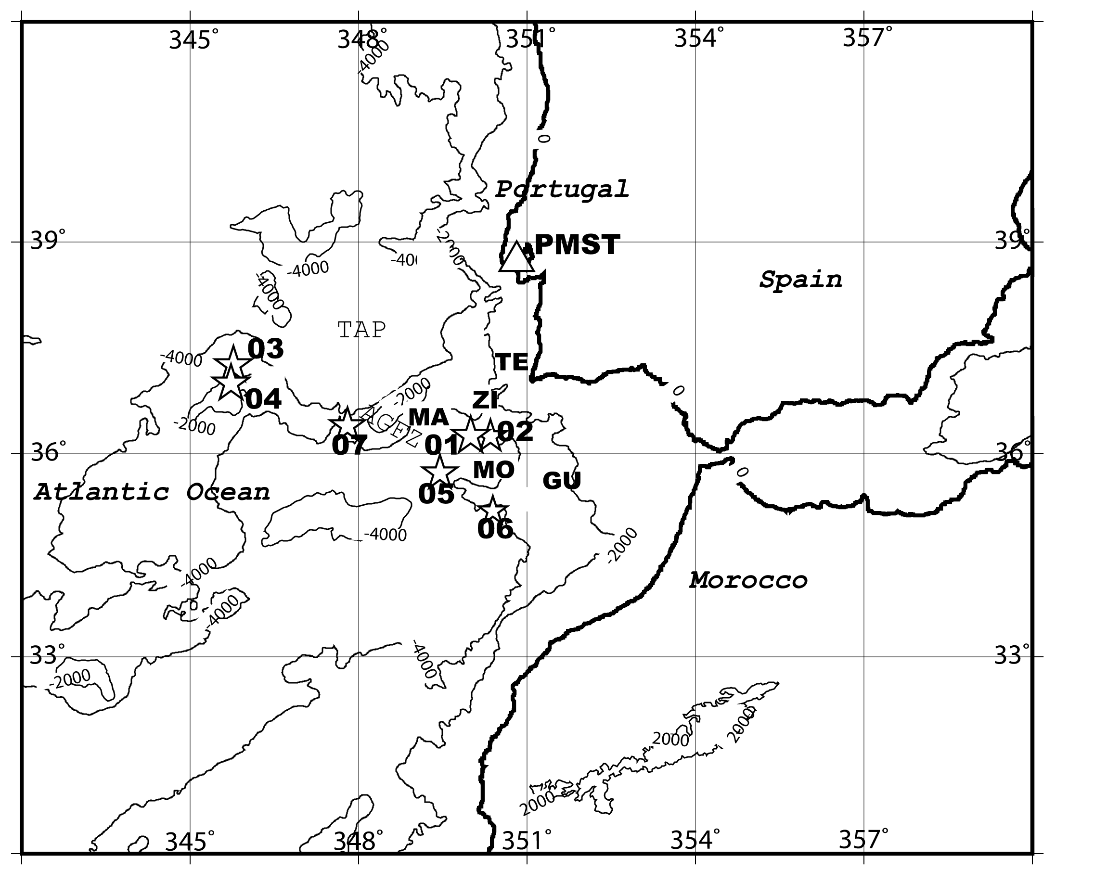
Fig. 1. Map of the Atlantic Ocean, the eastern Iberia and southwestern Africa showing the epicenters (stars) of seven earthquakes (see details on Table 1) and the PMST seismic station that recorded the events (triangle). Events 03 and 04, both occurred in the southwestern part of the Tagus Abyssal plain (TAP), generated suboceanic Rayleigh waves, whereas the other events did not. The 2000-m and 4000-m isobath is contoured in the Atlantic Ocean (TAP=Tagus Abyssal Plain, AGFZ=Azores Gibraltar Fracture Zone). Indicative epicentral locations of the 1755 earthquake proposed by different authors (GU = Gutscher et al., 2006, MA = Machado, 1966, MO = Moreira, 1989, TE = Terrinha et al., 2003, ZI = Zitellini et al., 1999).

Fig. 2
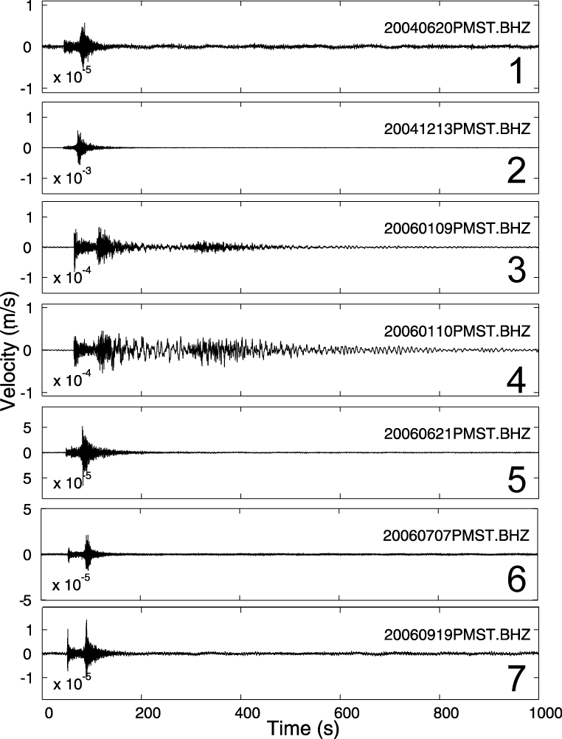

Fig. 2. Vertical components of PMST station recorded during the events listed in Table 1 and mapped in Figure 1. Numbers on the right of each panel correspond to the event number of Table 1. Events number # 3 and 4 show a long duration compared to the other events.

Fig. 3
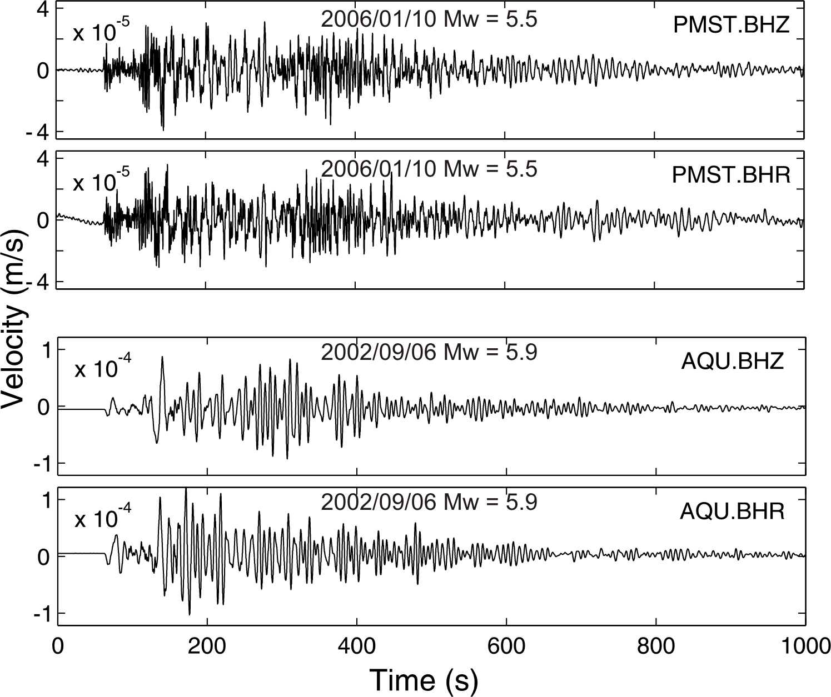
Fig. 3. (Top panels) vertical and radial component records of the PMST and (bottom panels) AQU stations, in Portugal and central Italy, respectively. Time series are filtered with a Butterworth band pass filter from 4 to 15 s. The source-to-receiver distance is 474 and 440 km, respectively.

Fig. 4
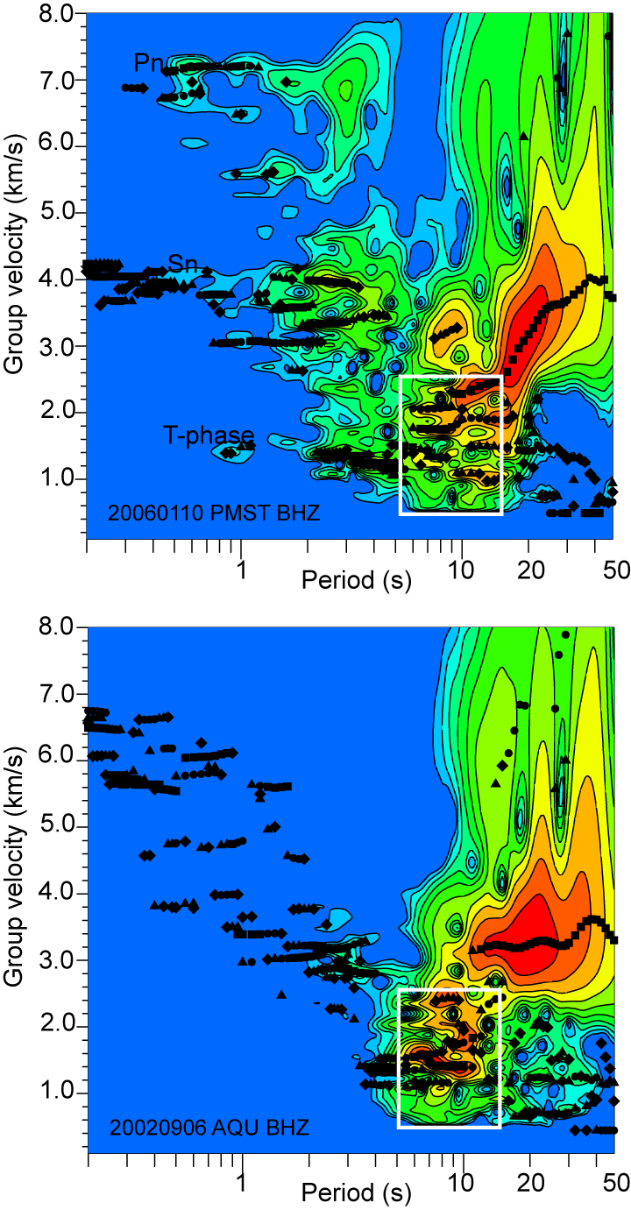
Fig. 4. Group velocity - period diagrams of two oceanic earthquakes. In the top panel the diagram of the 2006/01/10 Mw=5.5 seismic event (# 4 in Table 1) recorded by the PMST station in Lisbon. In the bottom panel the diagram of the 2002/09/06 Mw=5.9 seismic event (offshore Sicily) recorded by station AQU in central Italy. The source-to-receiver distance is 474 and 440 km, respectively. Color scale represents the spectral amplitude in dB as a function of group velocity and period (red=100 dB, yellow=60 dB). The black color symbols represent the maximum peaks.
Fig. 5
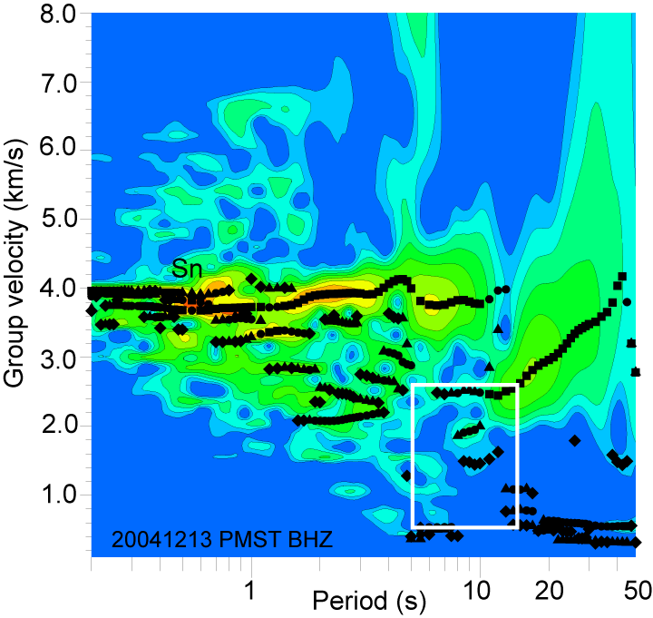
Fig. 5. Group velocity - period diagram of the 2004/12/23 Mw=5.0 seismic event (# 2 in Table 1) recorded by the PMST station in Lisbon. The source-to-receiver distance is 285 km. Color scale represents the spectral amplitude in dB as a function of group velocity and period (red=100 dB, yellow=60 dB). The black color symbols represent the maximum peaks.

Fig. 6
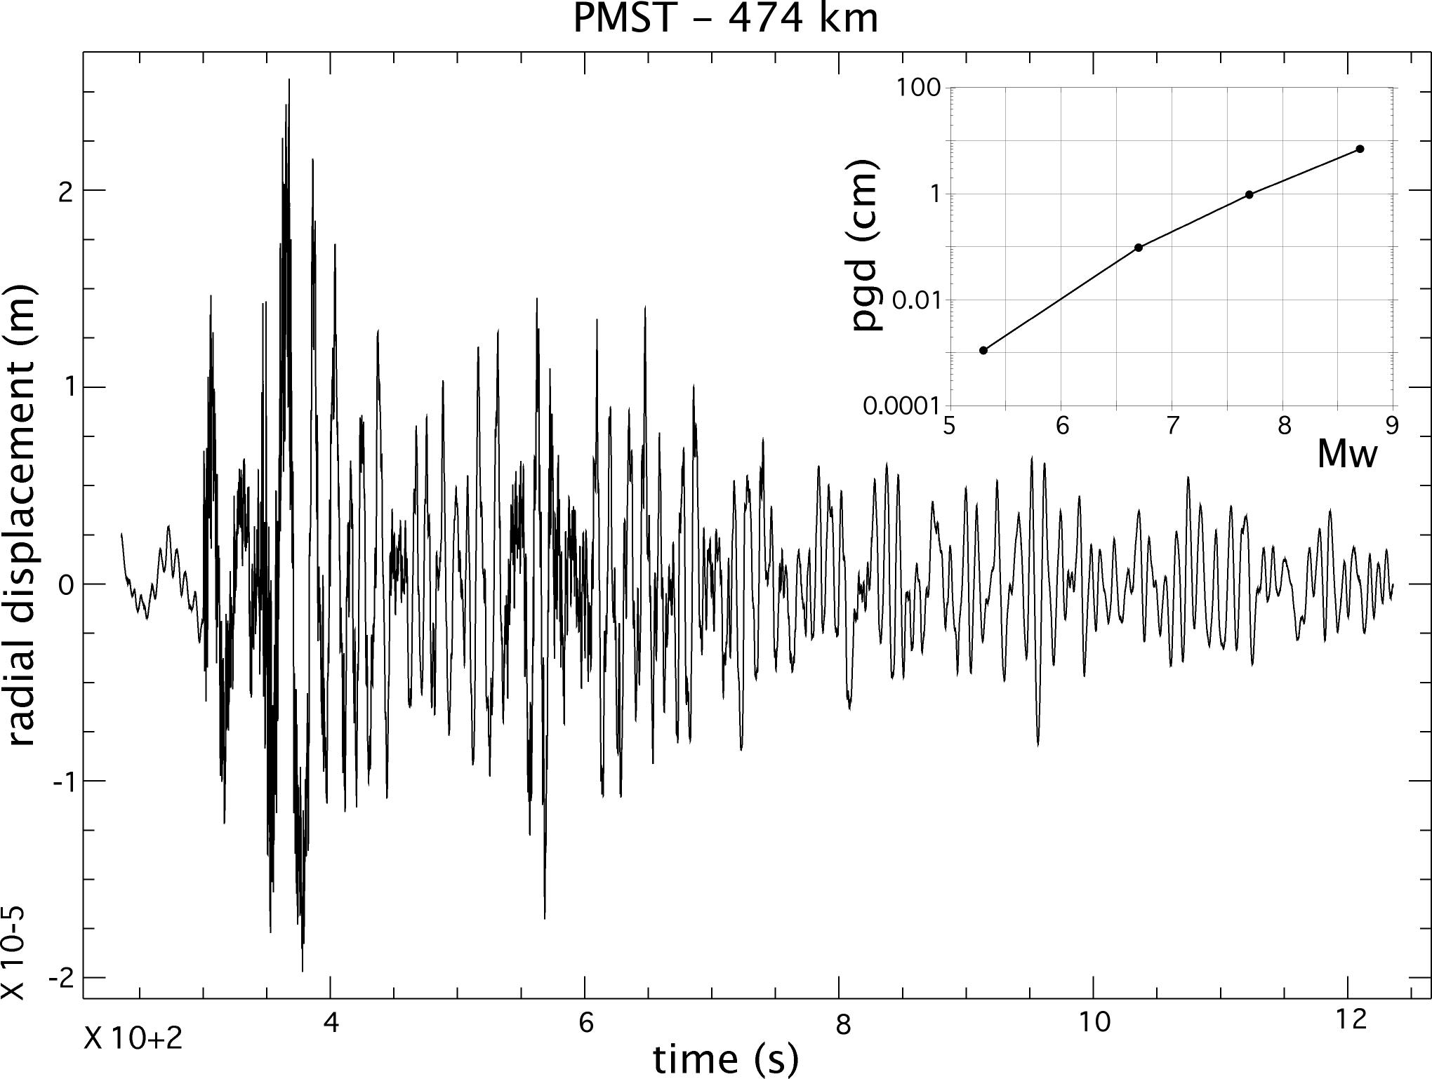
Fig. 6. Horizontal (radial) displacement recorded at station PMST during the 2006/01/09 earthquake, highpass filtered at 0.02 Hz. Note the long duration of the strongest motions. Predicted scaling of amplitude at larger magnitudes is shown in the inset. At Mw 8.7, peak-to-peak amplitude of horizontal ground motion is predicted to be as large as 7 cm.

Fig. 7
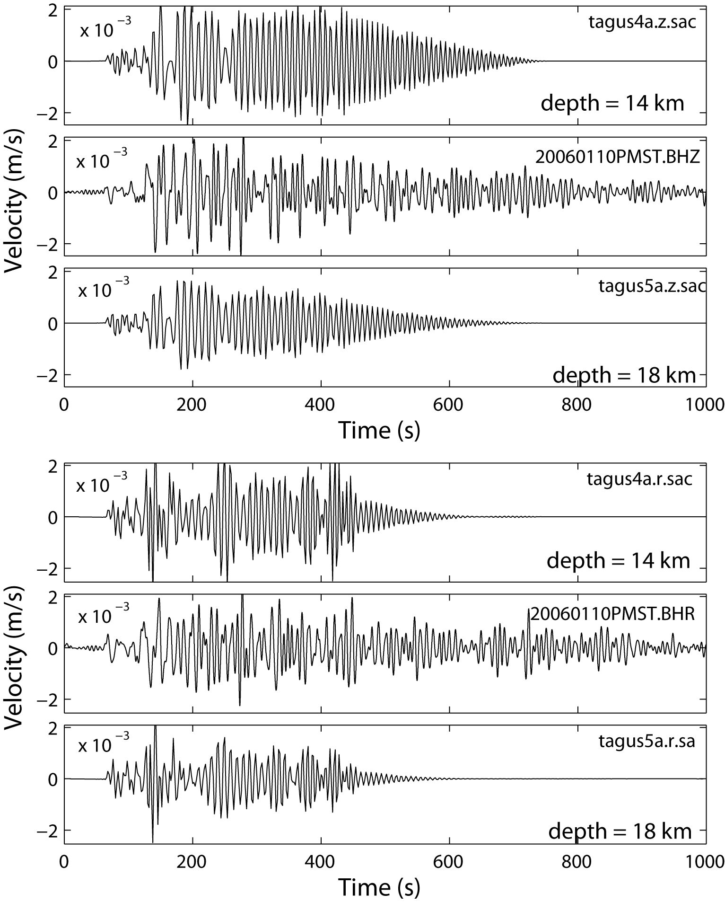
Fig. 7. (Top panels) vertical component and (bottom panels) radial component synthetic signals computed for a source depth of 14 km and 18 km (tagus4a and tagus5a, respectively) in comparison with the # 4 event (20060110PMST) of Table 1 . Waveforms are band pass filtered from 50 s to 5 s.

Fig. 8
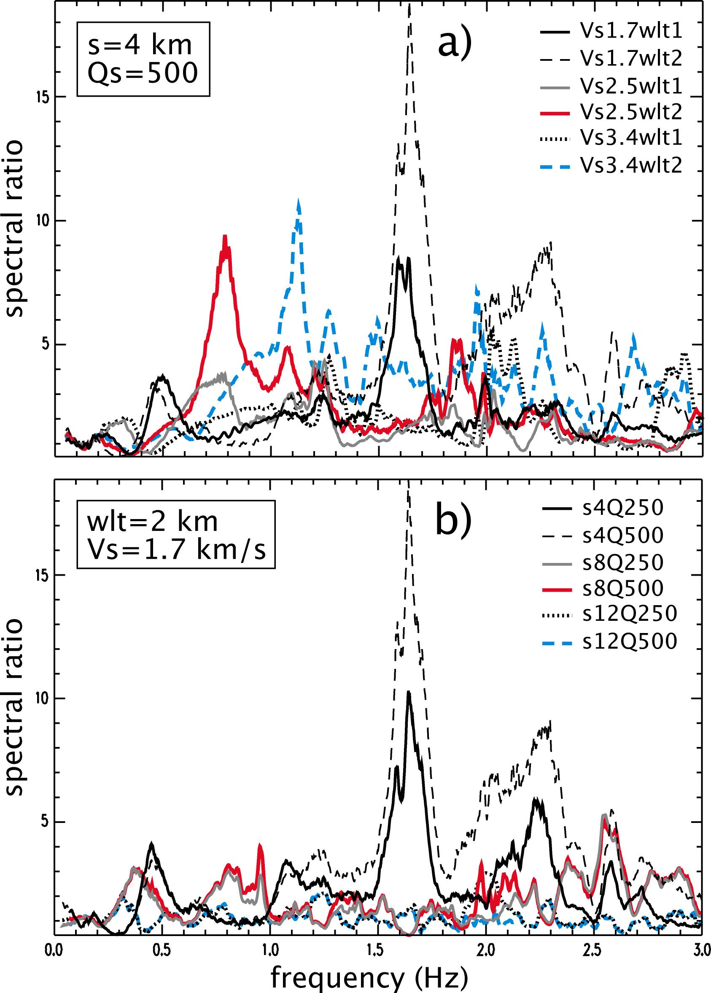
Fig. 8. Amplification of horizontal ground motion produced by the propagation of SRW in 1D models for an epicentral distance of 300 km. The reference of the spectral ratios is the Fourier spectrum of radial synthetics when no water layer is put in the model. a) Source depth (s) and Qs are fixed at 4 km and 500, respectively; shear-wave velocity Vs and water depth (wlt) are varied in the modeling. The strongest effects occur when Vs is close to the sound speed in the water and the liquid layer is 2 km thick. b) Water depth and Vs are fixed at 2 km and 1.7 km/s, respectively.

# | DATE | HOUR | LAT | LON | D | M | DIS
01 | 2004/06/20 | 03:01:16.10 | 36.2475 | -9.6545 | 10 | 4.6Ml | 279
02 | 2004/12/13 | 14:16:08.59 | 36.2550 | -10.001 | 10 | 5.0Mw | 285
03 | 2006/01/10 | 01:09:34.19 | 37.0570 | -14.133 | 10 | 5.5Mw | 473
04 | 2006/01/09 | 16:40:44.26 | 37.0500 | -14.121 | 10 | 5.3Mw | 474
05 | 2006/06/21 | 00:51:15.60 | 35.7230 | -10.545 | 33 | 4.8mb | 356
06 | 2006/07/07 | 13:12:57.90 | 35.2000 | -9.6075 | 40 | 5.1mb | 394
07 | 2006/09/19 | 23:28:16.10 | 36.4000 | -12.200 | 104 | 5.0mb | 372
Table 1 – Events located off-shore in the Atlantic ocean and recorded by the PMST broad-band seismic station. Earthquake parameters are from ISC and EMSC (D=Depth(km), M=Magnitude, DIS=Distance(km))

