BODY- WAVE ATTENUATION IN THE REGION OF GARDA, ITALY

Raúl R. Castro¹, Marco Massa², Paolo Augliera² and Francesca Pacor²

¹ Centro de Investigación Científica y de Educación Superior de Ensenada (CICESE), División Ciencias de la Tierra, Departamento de Sismología, km 107 Carretera Tijuana-Ensenada, 22860 Ensenada, Baja California, México.
E-mail: raul@cicese.mx
Fax: ++ 52- 646 - 175 0559

² Istituto Nazionale di Geofisica e Vulcanologia, Sezione di Milano-Pavia, Via Bassini 15, 20133 Milano, Italia

Abstract

We analyzed the spectral amplitude decay with hypocentral distance of P and S waves generated by 76 small magnitude earthquakes (M_{L} 0.9-3.8) located in the Garda region, Central-Eastern Alps, Italy. These events were recorded by 18 stations with velocity sensors, in a distance range between 8 and 120 km. We calculated nonparametric attenuation functions (NAF) and estimated the quality factor Q of both body waves at 17 different frequencies between 2 and 25 Hz. Assuming a homogeneous model we found that the Q frequency dependence of P and S can be approximated with the functions Q_{P}=65 f ^{0.9} and Q_{S}=160 f ^{0.6}, respectively. At 2 Hz the Q_{S} / Q_{P} ratio reaches the highest value of 2.8. At higher frequencies Q_{S}/Q_{P} varies between 0.7 and 1.7, suggesting that for that frequency band scattering may be an important attenuation mechanism in the region of Garda. To explore the variation of Q with depth, we estimated Q at short (r ≤ 30 km) and intermediate (35-90 km) distance paths. We found that in the shallow crust P waves attenuate more than S (1.3 < Q_{S} / Q_{P} < 2.5). Moreover, P waves traveling along paths in the lower crust (depths approximately greater than 30 km) attenuate more than S-waves. To quantify the observed variability of Q with depth we considered a 3-layer model and inverted the NAF to estimate Q in each layer. We found that in the crust Q increases with depth. However, in the upper mantle (~40-50 km depth) Q decreases and in particular the high frequency Q_{S} (f>9 Hz) has values similar to those estimated for the shallow layer of the crust.
Key words: Body-wave attenuation; Region of Garda, Italy;
Abbreviated title: Body-wave attenuation in Garda, Italy
Introduction

The region of Garda (Figure 1) is characterized for having low-to-moderate seismicity as result of the compressive regime that has formed folds and thrust faults, developed since the Cenozoic (Galadini et al., 2001). The active tectonics of this region, located on the margin of the southern Alpine chain, is governed by Africa-Europe convergence (Dewey et al., 1973). The main active faults affecting the area between Garda Lake and the Lessini mountains consist of mainly NNE-SSW trending thrust (Galadini et al., 2001). Evidence of Quaternary activity along faults of this region have been reported by Sauro (1978) and others. South of Garda Lake area significant seismicity has occurred in the past (Boschi et al., 2000). In this region even moderate size earthquakes generate significant intensities and damage. For instance, the Salò earthquake (M_{L} 5.2) of November 24, 2004 generated maximum intensities I_{MCC}= VII-VIII and damages estimated on 215 millions of euros (Pessina et al., 2006). To understand the observed distribution of damage generated by possible future earthquakes of the same magnitude, it is important to study how seismic waves attenuate with propagation distance. Using a limited number of earthquakes, Castro et al. (1993 and 1999) calculated nonparametric attenuation functions for the regions of Lombardia and Piemonte, a region that extends from the Southern Alps to the Po basin. Massa et al. (2007) estimated empirical attenuation relations for the north-central region of Italy. In addition, preliminary estimates of the quality factor Q have been made by Marzorati et al. (2004) in the region of Garda using local earthquakes.
In this paper we characterize the amplitude decay with distance of both P and S waves by calculating empirical attenuation functions at different frequencies. Then, we parametrize these functions to estimate the quality factor Q. Since we use direct seismic waves in our analysis, the values of Q obtained give a good estimate of total attenuation. These estimates of Q are also important because give information about attenuation mechanisms of body waves and the possible composition of Earth’s interior.

Data

The data used in this study consists of 3-component velocity records from stations installed in the past years in the North Italy regions. These stations belong to the National Institute of Geophysics and Volcanology (at Rome, INGV-CNT, URL http://www.ingv.it and at Milan-Pavia INGV-MI-PV, URL http://www.mi.ingv.it) and the Seismological Swiss network (SDS-Net, URL http://www.seismo.ethz.ch). The stations are equipped with digital three-component seismometers (Nanometrics Trillium 40, with a flat response between 0.025 and 50 Hz, Lennartz LE3D-5s, with a flat response between 0.2 and 50 Hz, Lennartz LE3D-lite and Mark L4-3D either with a flat response between 1 and 80 Hz) coupled to either a 20 bits Lennartz Mars88-MC or a 24 bits Reftek 130/01 dataloggers. The characteristics of the instruments of the stations used are resumed in table 1.
To reduce the effect of the natural noise, we computed the signal to noise ratio of each record analyzed and selected only records characterized by a ratio greater than 10 dB. For each record the signal to noise ratio was calculated considering 10 s of pre-event signal and different window length from both P and S-phase onsets.
The selected dataset is composed by earthquakes with local magnitudes (M_{L}) 0.9-3.8 recorded in the Garda area (Northern Italy) in the period 2003-2006. The map in Figure 1 shows the distribution of the stations used, the epicenters, the ray paths and their depth distribution. We analyzed 545 records from 76 events recorded in an hypocentral distance range of 7.6-119.3 km. Figure 2 shows the magnitude distribution of the data set. The smaller events (M_{L}<1.5) were mostly recorded at hypocentral distances r<70 km, but bigger earthquakes generated records at all distances up to 119 km.
To assure homogeneity of data, all selected records were re-sampled at 62.5 Hz, so that a minimum antialias cutoff of 25 Hz has been guaranteed. For each waveform the mean and the linear trend have been removed and a band-pass Butterworth 4 poles filter, between 0.2 and 25 Hz, has been applied. We calculate velocity Fourier spectra using the vertical component of ground motion for P waves and horizontal components for S waves. We selected P-phase windows starting from 0.5 s before the P-phase onset to 0.5 s before the S-phase onset. The S wave window starts from the S-phase onset and includes 95% of the total energy of the recorded signal. For all records analyzed the FFT was calculated and smoothed using the Konno and Ohmachi (1998) window with constant b=20.
In order to use reliable focal coordinates, all earthquakes were relocated using the arrival times of the events recorded by the dense INGV-MI network and arrival times from both the INGV-CNT and SDS-Net stations (see table 1). The local magnitude was calculated using an M_{L} scale calibrated for Central-Northern Italy region by Marzorati et al. (2004).
Method

Nonparametric Attenuation Functions
We characterized the spectral amplitude decay with hypocentral distance with a nonparametric model. For each frequency considered we searched for unrestricted monotonic curves, constrained to a reasonable degree of smoothness, that describe the observed trend of the spectral amplitude decay with distance. This approach has been used before by Anderson and Quaas (1988) to study the effect of magnitude on peak acceleration decay and by Castro et al. (1990, 1996) to study spectral attenuation of ground motion.
We modeled the dependence of the spectral amplitudes on hypocentral distance r for a given frequency f as:
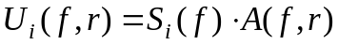 ( 1 )
Where 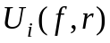 is the observed spectral amplitude from event i. A(f, r) is the empirically determined attenuation function that describes the distance decay trend and we will call them nonparametric attenuation functions (NAF hereafter). 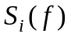is a scalar (one for each earthquake i at frequency f ) that depends on the size of the earthquake and accounts for source effects.
We constrained the attenuation functions to be one at r=0 and to decrease monotonically with distance by adding a smoothness constraint. The first constraint (A(f,0)=1.0) has a physical justification, since at r=0 the spectral amplitudes are governed by source effects, and the second constraint assumes that the amplitudes vary slowly with distance and that the undulations of the data are related to site effects. With this approach the site effects are the residual resulting from solving equation (1). We also assume that the shape of the attenuation function at a given frequency is the same for all the earthquakes regardless of the magnitude, so that we can invert equation (1) using all the events simultaneously. The advantage of this method is that spectral amplitudes from small and bigger events complement each other to define the attenuation function.
From equation (1), we formed at each frequency a set of linear equations of the form:
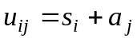 ( 2 )
where 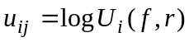is a datum from earthquake i at distance j , 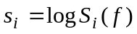and 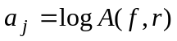 is the value of the attenuation function at distance j. Equation (2) represents a system of equations that is solved using a constrained least-squares inversion (e.g. Castro et al., 1990, 1996). Figure 3 only shows a sample of NAF for 9 frequencies, but we calculated equivalent functions for 17 frequencies between 2 Hz and 25 Hz. The lower limit of 2 Hz was chosen to minimize the effect of secondary arrivals that may be included in the time windows used to calculate the Fourier spectra. The upper limit of 25 Hz is the maximum frequency before high-frequency noise and the anti-alias filter used start contaminating the spectral amplitudes. In Figure 3 the continuous lines were calculated using P-wave spectral amplitudes and the dashed lines using S waves. Figure 4 shows the root mean squares residual (rms) calculated for each distance for a sample of 9 frequencies from the 17 analyzed. In general, the rms values calculated vary between 0.1 and 0.6 for both P (triangles) and S waves (squares).

Homogeneous Q model
The NAF can be used to estimate the quality factor Q assuming a homogeneous attenuation model of the form:
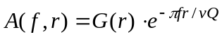 ( 3 )
Where v is the average wave velocity: 5.7 km/sec for P and 3.2 km/sec for S waves. G(r) is the geometrical spreading function that can be approximated as:
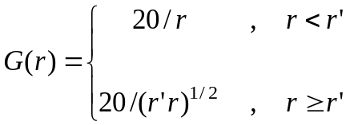 ( 4 )

Because most records are at r > 20 km (see Figure 2), we normalized G(r) at that distance. r’=80 km is the distance where the rate of decay of the attenuation functions change (see Figure 3) because the geometrical spreading has less effect on the amplitude decay due to surface-wave arrivals. The value of r’ was defined at the distance where the slope of the NAF shows a significant change.
Q was estimated at each frequency linearizing equation (3) by taking logarithms, thus we can write,
a( r ) = - m r ( 5 )

Where a( r ) = log A(f,r)-logG(r) and m=π f log e /Q v , is the slope estimated with a least-square fit of equation (5) (e.g. Castro et al., 2003, 2004). For a given frequency f, Q(f) can be estimated making
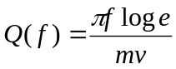 ( 6 )
Frequency dependence of geometrical spreading
We explore the frequency dependence of the geometrical spreading function making equation (4) less restrictive. We define a more general expression for the geometrical spreading as:
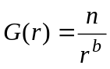 ( 7 )
Then, we can rewrite equation (3) as:

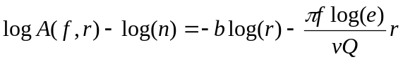 ( 8 )

For a given frequency f and a trial value of n, equation (8) represents a system of equations that can be solved to estimate b and Q.

2-Dimensional Inversion
The NAF curves can be used to formulate a 2-D inverse problem using a known velocity model. For a crustal model consisting of m laterally homogeneous layers, the attenuation functions can be expressed as:
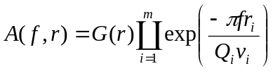 ( 9 )
We can rewrite equation (9) fixing the frequency f and taking logarithms:
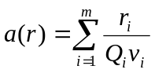 ( 10 )
Where
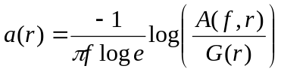 ( 11 )
Equation (10) can be expressed in matrix form as:
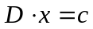 ( 12 )
Where the solution vector x contains the estimates of 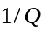in each layer i of model 1 (Table 2) and c is the data vector consisting of discrete values of a(r). Equation (12) is solved using least-squares inversion scheme.

Results and Discussion

Homogeneous Q model
It can be noticed in Figure 3 that near 80 km the slope of the NAF changes as result of secondary wave arrivals consisting of refracted and reflected waves and high-frequency surface waves. At larger distances the amplitudes do not seem to decay, particularly at low frequencies. To minimize the effect of secondary arrivals we limited our analysis in the frequency range of 2-25 Hz. Thus, by making r’=80 km and normalizing the spectral amplitudes at 20 km we can define the geometrical spreading function with equation (4). We normalized the amplitudes at 20 km because most of the records analyzed have r> 20 km (Figure 2). With this definition of G(r), we estimated the attenuation parameter for P (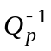) and for the S waves (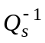).
Figure 5 shows the estimates of and and the corresponding error bars for the 17 individual frequencies (2-25 Hz), left panel for P and right panel for S waves. The frequency dependence of Q can be approximated with the relations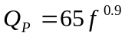and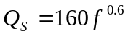. It is interesting to note that Q_{S} for S waves between 2 and 6 Hz becomes approximately constant with frequency. The weak frequency dependence of Q_{S} has been reported before in other regions. For instance, Castro et al. (2004) found that Q_{S} =438 for 10-27 Hz in Central Italy, a result confirmed by Bindi et al. (2004). Leary and Abercrombie (1994) and Abercrombie (1995) also found that in California the frequency dependence of Q weakens at high frequencies. Castro et al. (2004) suggested that the change in frequency dependence of Q, observed in the Umbria-Marche region, could be related to the presence of faults or a densely fractured zone in the crust. We interpret the complex frequency dependence of Q_{S} observed in the region of Garda as due to vertical changes in the structure of the crust. For instance, the presence of a low velocity zone may cause a decrease in the values of Q.
The ratio of observed Q_{S}/Q_{P} values can also give us some light on the possible attenuation mechanisms. Richards and Menke (1983) found that Q_{S}/Q_{P}≈ 1 for plane layer scattering. On the other hand, laboratory measurements of Q (e.g. Toksoz et al., 1978) show that Q_{S}/Q_{P} < 1 for intrinsic attenuation in water-saturated rocks and Q_{S}/Q_{P}>1 for dry rock. Figure 6 shows that for most frequencies Q_{S}/Q_{P} >1 for the values of Q shown in Figure 5.

A two-layer Q model
The NAF (Figure 3) show three main changes on rate of amplitude decay at different distance ranges. We identify one between 0 and 30 km, another between 30 km to ~80 km and the last one for r > r’=80 km. We hypothesize that the amplitude decay observed in the distance range of 0-30 km is due to the attenuation characteristics of the upper crust. To explore the depth of influence on this distance range we made ray tracing estimates using two velocity models based on deep seismic sounding results reported by Scarascia and Cassinis (1997). The first consists of a 3-layer average velocity model used by INGV for routine earthquake location (see Table 2) and the second one is a 6-layer velocity model with a total crustal thickness of 40 km (model 2 in Table 2) reported by Scarascia and Cassinis (1997).
In this paper synthetic travel times have been computed using the Um and Thurber (1987) ray tracing scheme implemented in the SIMULPS 12 code (Evans et al., 1994).
We found from ray tracing that for recording distances of 0-30 km the maximum depth of the rays-turning-point is close to 30 km. Thus, it is reasonable to relate the rate of amplitude decay for 0< r < 30 km to attenuation processes occurring in the upper crust at depths less than 30 km. To evaluate the attenuation at short distance ranges produced by the shallow crust, we calculated Q and G(r) using equations (7) and (8) for the first 30 km of the NAF (Figure 3) and average velocities of 5.7 km/sec and 3.2 km/sec for P and S waves, respectively. The circles in Figure 7 are our estimates of Q for both waves (left panel for P and right panel for S). We solved equation (8) using a least-squares criteria for different values of n between 1 and 35 km and found the best results with n=1.
Waves with longer ray paths, arriving in the distance range of 35-90 km, show a different rate of amplitude decay (Figure 3). To explain the attenuation observed at this distance range, we consider a two-layer Q model, the first layer, representing the upper crust, with a thickness of approximately 30 km and a second layer that includes the lower crust and the most upper mantle. Base on the seismic profiles reported by Scarascia and Cassinis (1997) for the Lombardian Southern Alps, near the region of Garda, the Moho discontinuity is at a depth varying between 38 and 50km. Their resulting velocity models show that for recording distances of 35-90 km the deeper ray-paths correspond to waves refracted on the Moho. So, we will assume that the second layer in our model can reach a depth up to 50 km and has average velocities of 7.1 km/sec and 3.96 km/sec for P and S waves, respectively. To estimate the attenuation parameters of the second layer, we corrected the NAF for the attenuation due to the first layer using the values of Q shown in Figure 7 with circles. Then, in a second step, we estimated Q and G( r) in the 35-90 km distance range using the corrected NAF and the same procedure as before (equations (7) and (8)).
The triangles in Figure 7 show the values of Q estimated for the lower crust using n=10 for P and n=30 for S waves. On the average b=0.35 for P and 0.7 for S waves. Figure 7 also shows the functional dependence of Q with frequency, found by least-squares fitting the values of Q displayed. These results are summarized in Table 3. The value of Q₀ =444 obtained for S waves in the lower crust agree with those found in tectonically stable regions. For instance, Cong and Mitchell (1998) found that in the Arabian Peninsula Q₀ varies between 350 and 450. Because most of the seismic activity in the region of Garda occurs at depths above 30 km, higher values of Q are expected in the lower crust, since this zone is more stable. In general, Figure 7 shows that Q in the crust increases with increasing frequency and depth for both waves and P waves attenuate more than S.
Figure 8 shows the Q_{S} / Q_{P} ratios calculated for the upper and lower crust, based on the 2-layer model described above. Although in both layers Q_{S} / Q_{P} > 1, this ratio tends to have greater values in the lower crust.

2-Dimensional Inversion
We estimated Q solving equation (12) with the 3-layer velocity model listed in Table 2. For the S waves we divided the velocity of P by 1.78. We estimated the effect of geometrical spreading with equation (4) and for each frequency the amplitudes of the respective NAF were corrected following equation (11). Thus, the data vector c was formed and equation (12) solved using a least-squares criteria. Figure 9 shows the estimates of Q obtained as a function of frequency. The circles correspond to the first layer (upper crust), the triangles and squares correspond to lower crust and upper mantle, respectively. In the crust Q increases with depth for both P and S, but in the upper mantle, between approximately 40 and 50 km depth, Q decreases. Q_{S} in the upper mantle reaches values similar to those estimated for the upper crust and in particular at high frequencies (f>9 Hz) the upper mantle Q_{S} has values even smaller. For comparison we also plotted in Figure 9 (solid and dashed lines) the estimates of Q obtained with the 2-layer model (also shown in Figure 7). For the upper layer both model give similar results (compare circles and solid line in Figure 9), and for the second layer the values of Q estimated with the 2-layer model tend to follow the estimates obtained with the inversion for the lower crust (compare dashed line with triangles in Figure 9).

Conclusions

The nonparametric attenuation functions (NAF) obtained for the region of Garda show changes on the rate of amplitude decay at different distance ranges as result of the complex crustal structure and the likely vertical variations of the attenuation parameters. We used the NAF to estimate the quality factor Q and the geometrical spreading of both P and S waves (Table 3 summarizes our estimates of Q). Assuming a homogeneous Q model, we found that Q increases with frequency for both waves following the power law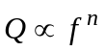, where n=0.9 for P waves and n=0.6 for S waves. The value of Q at 1 Hz (Q₀) is a factor of 2.46 greater for S (Q₀=160) relative to P (Q₀=65) waves, indicating greater P wave attenuation. In order to infer possible attenuation mechanisms to explain the observed values of Q, we calculated the ratio Q_{S} / Q_{P} and found that for most of the frequencies analyzed (2-25 Hz) Q_{S} / Q_{P}>1, suggesting that scattering (e.g. Hough and Anderson, 1988) must be an important attenuation mechanism controlling the amplitude decay with distance of the body waves that propagate in the region of Garda.
We also characterize the attenuation of the region with a 2-layer model and found that P waves suffer greater attenuation than S waves in both upper and lower crust (Figure 7).
Moreover, attenuation in the upper crust is greater than in the lower crust for the whole frequency band considered (2-25 Hz). Under the assumption that scattering is the main attenuation mechanism operating in the upper crust, and using an average velocity Vp=5.7 km/sec, we would expect sources of scatter with dimensions of at least the same order than the P wave-lengths that attenuate in the upper crust, that is of the order of 2-6 km. These dimensions may correspond to faults located in the brittle part of the crust.
The results of the inversion of the NAF curves with a 3-layer velocity model indicate that in the crust Q increases with depth. However, in the upper mantle Q decreases compared with the values of Q estimated for the crust and in particular the high frequency (f>9 Hz) Q_{S} has values similar to those estimated for the shallow layer of the crust (Figure 9). The expected higher temperature of the upper mantle may explain the observed increase of body wave attenuation in the Central-Eastern Alpine region of Italy.

Aknowledgments

This work has been supported by “Convenzione INGV-DPC 2004-2006” in the framework of the DPC-S3 project and the CICESE internal project 641161. We benefit from the careful revision, comments and suggestions provided by Edoardo Del Pezzo.
REFERENCES

Abercrombie, R.E.(1995), Earthquake source scaling relationships from -1 to 5 M_{L} using seismograms recorded at 2.5-km depth, J. Geophys. Res., 100, 24,015-24,036.
Anderson, J.G., and Quaas R. (1988), The Mexico earthquake of September 19, 1985: effect of magnitude on the character of strong ground motion: an example from the Guerrero, Mexico strong motion network, Earthquake Spectra, 4, 635-646.
Bindi, D., Castro, R.R., Franceschina, G., Luzi, L., and Pacor, F. (2004), The 1997-1998 Umbria-Marche sequence (central Italy): Source, path, and site effects estimated from strong motion data recorded in the epicentral area, Jour. Geophys. Res., 109, B04312.
Boschi, E., Guidoboni, E., Ferrari, G., Mariotti, D., Valensise, G., and Gasparini, P. (2000), Catalogue of strong Italian earthquakes, 461 b.C. to 1997, Annali di Geofisica, 43, 609-868.
Castro, R.R., Anderson, J.G., and Singh, S.K. (1990), Site response, attenuation and source spectra of S waves along the Guerrero, México, subduction zone, Bull. Seism. Soc. Am., 80, 1481-1503.
Castro, R. R., Pacor, F., and Petrungaro, C. (1993), Confronto fra diversi metodi per la stima dell’attenuazione delle onde sismiche applicati nelle regioni Lombardia e Sicilia, Atti del 12° convegno, Consiglio Nazionale delle Ricerche, Gruppo Nazionale di Geofisica della Terra Solida, 179-192.
Castro, R.R., Pacor, F., Sala, A. and Petrungaro, C. (1996), S wave attenuation and site effects in the region of Friuli, Italy. J. Geophys. Res., 101, 22,355-22,369.
Castro, R.R., Mucciarelli, M., Monachesi, G., Pacor, F., and Berardi, R. (1999), A review of nonparametric attenuation functions computed for different regions of Italy, Ann. Di Geofisica, 42, 735-748.
Castro, R.R., Fabriol, H., Bour, M. and Le Brun, B. (2003), Attenuation and site effects in the region of Guadeloupe, Lesser Antilles, Bull. Seism. Soc. Am., 93, 612-626.
Castro, R.R., Gallipoli, M.R. and Mucciarelli, M. (2004), An attenuation study in southern Italy using local and regional earthquakes recorded by the seismic network of Basilicata, Ann. Geofisica, 47, 1597-1608.
Cong, L., and Mitchell, B.J. (1998), Lg coda Q and its relation to the geology and tectonics of the Middle East, Pure and Appl. Geophys., 153, 563-585.
Dewey. J.E., Pitman, W.C., Ryan, W.B.F., and Bonnin, J. (1973), Plate tectonics and the evolution of the Alpine system, Bull. Geol. Soc. Am., 84, 3137-3180.
Evans, J.R., Eberhart-Phillips, D., and Thurber, C.H. (1994), Users’s manual for SIMULPS12 for imaging Vp and Vp/Vs:a derivative of the Thurber tomographic inversion SIMUL3 for local earthquakes and explosions, US Geol. Survey, Open File Report, 94-431
Galadini, F., Galli, P., Cittadini, A., and Giaccio, B. (2001), Late quaternary fault movements in the Mt. Baldo-Lessini Mts. sector of the southalpine area (northern Italy), Netherlands Jour. of Geosc. 80, 187-208.
Hough, S.E., and Anderson, J.G. (1988), High-frequeny spectra observed at Anza, California: Implications for Q structure, Bull. Seism. Soc. Am., 78, 692-707.
Konno, K., and Ohmachi, T. (1998), Ground-motion characteristics estimated from spectral ratio between horizontal and vertical components of microtremors, Bull. Seism. Soc. Am. 88, 228-241.
Leary, P.C. and Abercrombie, R.E. (1994), Frequency-dependent crustal scattering and absorption at 5-160 Hz from coda decay observed at 2.5 km depth, Geophys. Res. Lett. 21, 971-974.
Marzorati, S., Augliera, P., D’Alema, E., Bindi, D., Maistrello, M., and Gassi, A. (2004), The 2003 data set of seismic waveforms recorded in Lombardia and Veneto regions (Northern Italy): site selection and M_{L} scale calibration, ESC, XXIX General Assembly, Sep. 12-17, 2004, Potsdam, Germany, p 60.
Massa, M., Marzorati, S., D’Alema, E., Di Giacomo, D., and Augliera, P. (2007), Site classification assesment for estimating empirical attenuation relationships for North-Central Italy earthquakes, Jour., of Earthq. Eng., 11, 943-967.
Pessina, V., Franceschina, G., Vannoli, P., Luzi, L., and Pacor, F. (2006), Damage distribution and seismological model of the November 2004, Salò (northern Italy) earthquake, First European conference on Earthquake Eng. And Seism., paper 1371, 1-10.
Richards, P.G. and Menke, W. (1983), The apparent attenuation of a scattering medium, Bull. Seism. Soc. Am., 73, 1005-1021.
Sauro, U. (1978). Forme strutturali e neotettoniche nei Monti Lessini, Gruppo di Studio del Quaternario Padano, 4, 31-60.
Scarascia, S., and Cassinis, R. (1997), Crustal structures in the central-eastern Alpine sector: a revision of the available DSS data, Tectonophysics, 271, 157-188.
Toksoz, M.N., Johnston, A.H., and Timur, A. (1978), Attenuation of seismic waves in dry and saturated rocks. I. Laboratory measurements, Geophysics 44, 681-690.
Um, J. and Thurber, C.H. (1987), A fast algorithm for two-point seismic ray tracing, Bull. Seism. Soc. Am., 77, 972-986.

TABLE 1. Location of the seismic stations used in this study and the instrumental features.

Code | Name | Lat [°] | Long [°] | Elevation [m] | Sensor | Owner
BAG3 | Bagolino | 45.8228 | 10.4664 | 807 | LE-3D 5s | INGV-MI
MAL3 | Malenco | 46.2918 | 9.8636 | 2030 | LE-3D 5s | INGV-MI
MER2 | Merate | 45.6725 | 9.4182 | 350 | Trillium 40s | INGV-MI
MAR2 | Marone | 45.7397 | 10.1175 | 600 | Trillium 40s | INGV-MI
ASO2 | Asolo | 45.8049 | 11.9180 | 221 | LE-3D 1s | INGV-MI
NEGR | Negrar | 45.4976 | 10.9482 | 167 | LE-3D 5s | INGV-MI
CTL2 | Castelleone | 45.2763 | 9.7622 | 66 | Trillium 40s | INGV-MI
VER2 | Verona | 45.3970 | 10.9609 | 174 | Mark L4-3D 1s | INGV-MI
VERO | Verona | 45.4546 | 10.9941 | 174 | Mark L4-3D 1s | INGV-MI
MI55 | Concesio | 45.6062 | 10.2155 | 210 | Mark L4-3D 1s | INGV-MI
MI61 | Capriolo | 45.6375 | 9.9338 | 253 | Mark L4-3D 1s | INGV-MI
MI50 | Perledo | 46.0107 | 9.2910 | 219 | Mark L4-3D 1s | INGV-MI
MABI | Malga Bissina | 46.0549 | 10.5140 | 1853 | Trillium 40s | INGV-CNT
SALO | Salò | 45.6078 | 10.5254 | 90 | Trillium 40s | INGV-CNT
MDI | Monte di Nese | 45.7700 | 9.7160 | 954 | Trillium 40s | INGV-CNT
BERNI | Berninapass | 46.4134 | 10.0231 | 2310 | STS-2 120s | SDS-Net
FUORN | Ofenpass | 45.6202 | 10.2635 | 2335 | STS-2 120s | SDS-Net
MUGIO | Muggio | 45.9219 | 9.0417 | 830 | STS-2 120s | SDS-Net

TABLE 2. Velocity models used for ray tracing

Model | Velocity  (km/sec) | Thickness  (km)
1 | 5.0 | 10.0
 | 6.0 | 30.0
 | 8.1 | -
2 | 5.183 | 5.0
 | 5.796 | 15.0
 | 6.330 | 5.0
 | 6.337 | 13.0
 | 6.747 | 2.0
 | 7.983 | -

TABLE 3. Q-functions obtained within the frequency band of 2-25 Hz

Model | P wave | S wave
Homogeneous
2-Layer
Upper crust | 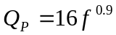 | 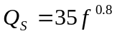
Lower crust | 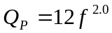 | 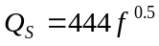

FIGURE CAPTIONS

Figure 1. Tope panel is a map of the region of Garda that shows the distribution of the epicenters (crosses) and stations (triangles) used. Bottom panel is a vertical section crossing the area in the middle of the epicenter distribution.
Figure 2. Distance-Magnitude distribution of the data set.
Figure 3. A sample of nonpaprametric attenuation functions (NAF) obtained. Continuous lines correspond to P waves and dashed lines to S. Each frame corresponds at a particular frequency between 2 and 25 Hz.
Figure 4. Root mean squares of residuals calculated from when solving equation (1) to find the NAF.
Figure 5. Estimates of Q as function of frequency obtained for P waves (left panel) and S waves (right panel) using attenuation functions in the distance range of 0-120 km. Upper frames are 1/Q ± 1 standard deviation, lower frames are the values of Q and the linear fit obtained.
Figure 6. Qs / Qp ratio obtained using the estimate of Q shown in figure 5.
Figure 7. Estimates of Q as a function of frequency obtained using nonparametric functions (left panel for P, right panel for S). The circles are values of Q obtained in the distance range of 0-30 km. The triangles are the values of Q estimated for the lower crust using the NAF in the 35-90 km distance range. The straight lines resulted from a least-squares fit obtained with the estimates of Q shown.
Figure 8. Qs / Qp ratio as a function of frequency obtained using the estimates of Q displayed in figure 7. Left panel shows values for upper crust, right panel for lower crust.
Figure 9. Estimates of Q obtained using the 3-layered model for P waves (left panel) and for S waves (right panel). The circles are Q values in the upper crust, triangles in the lower crust and squares in the most upper mantle. The lines are Q from the 2-layer model, continuous lines for the upper crust and dashed lines for lower crust.

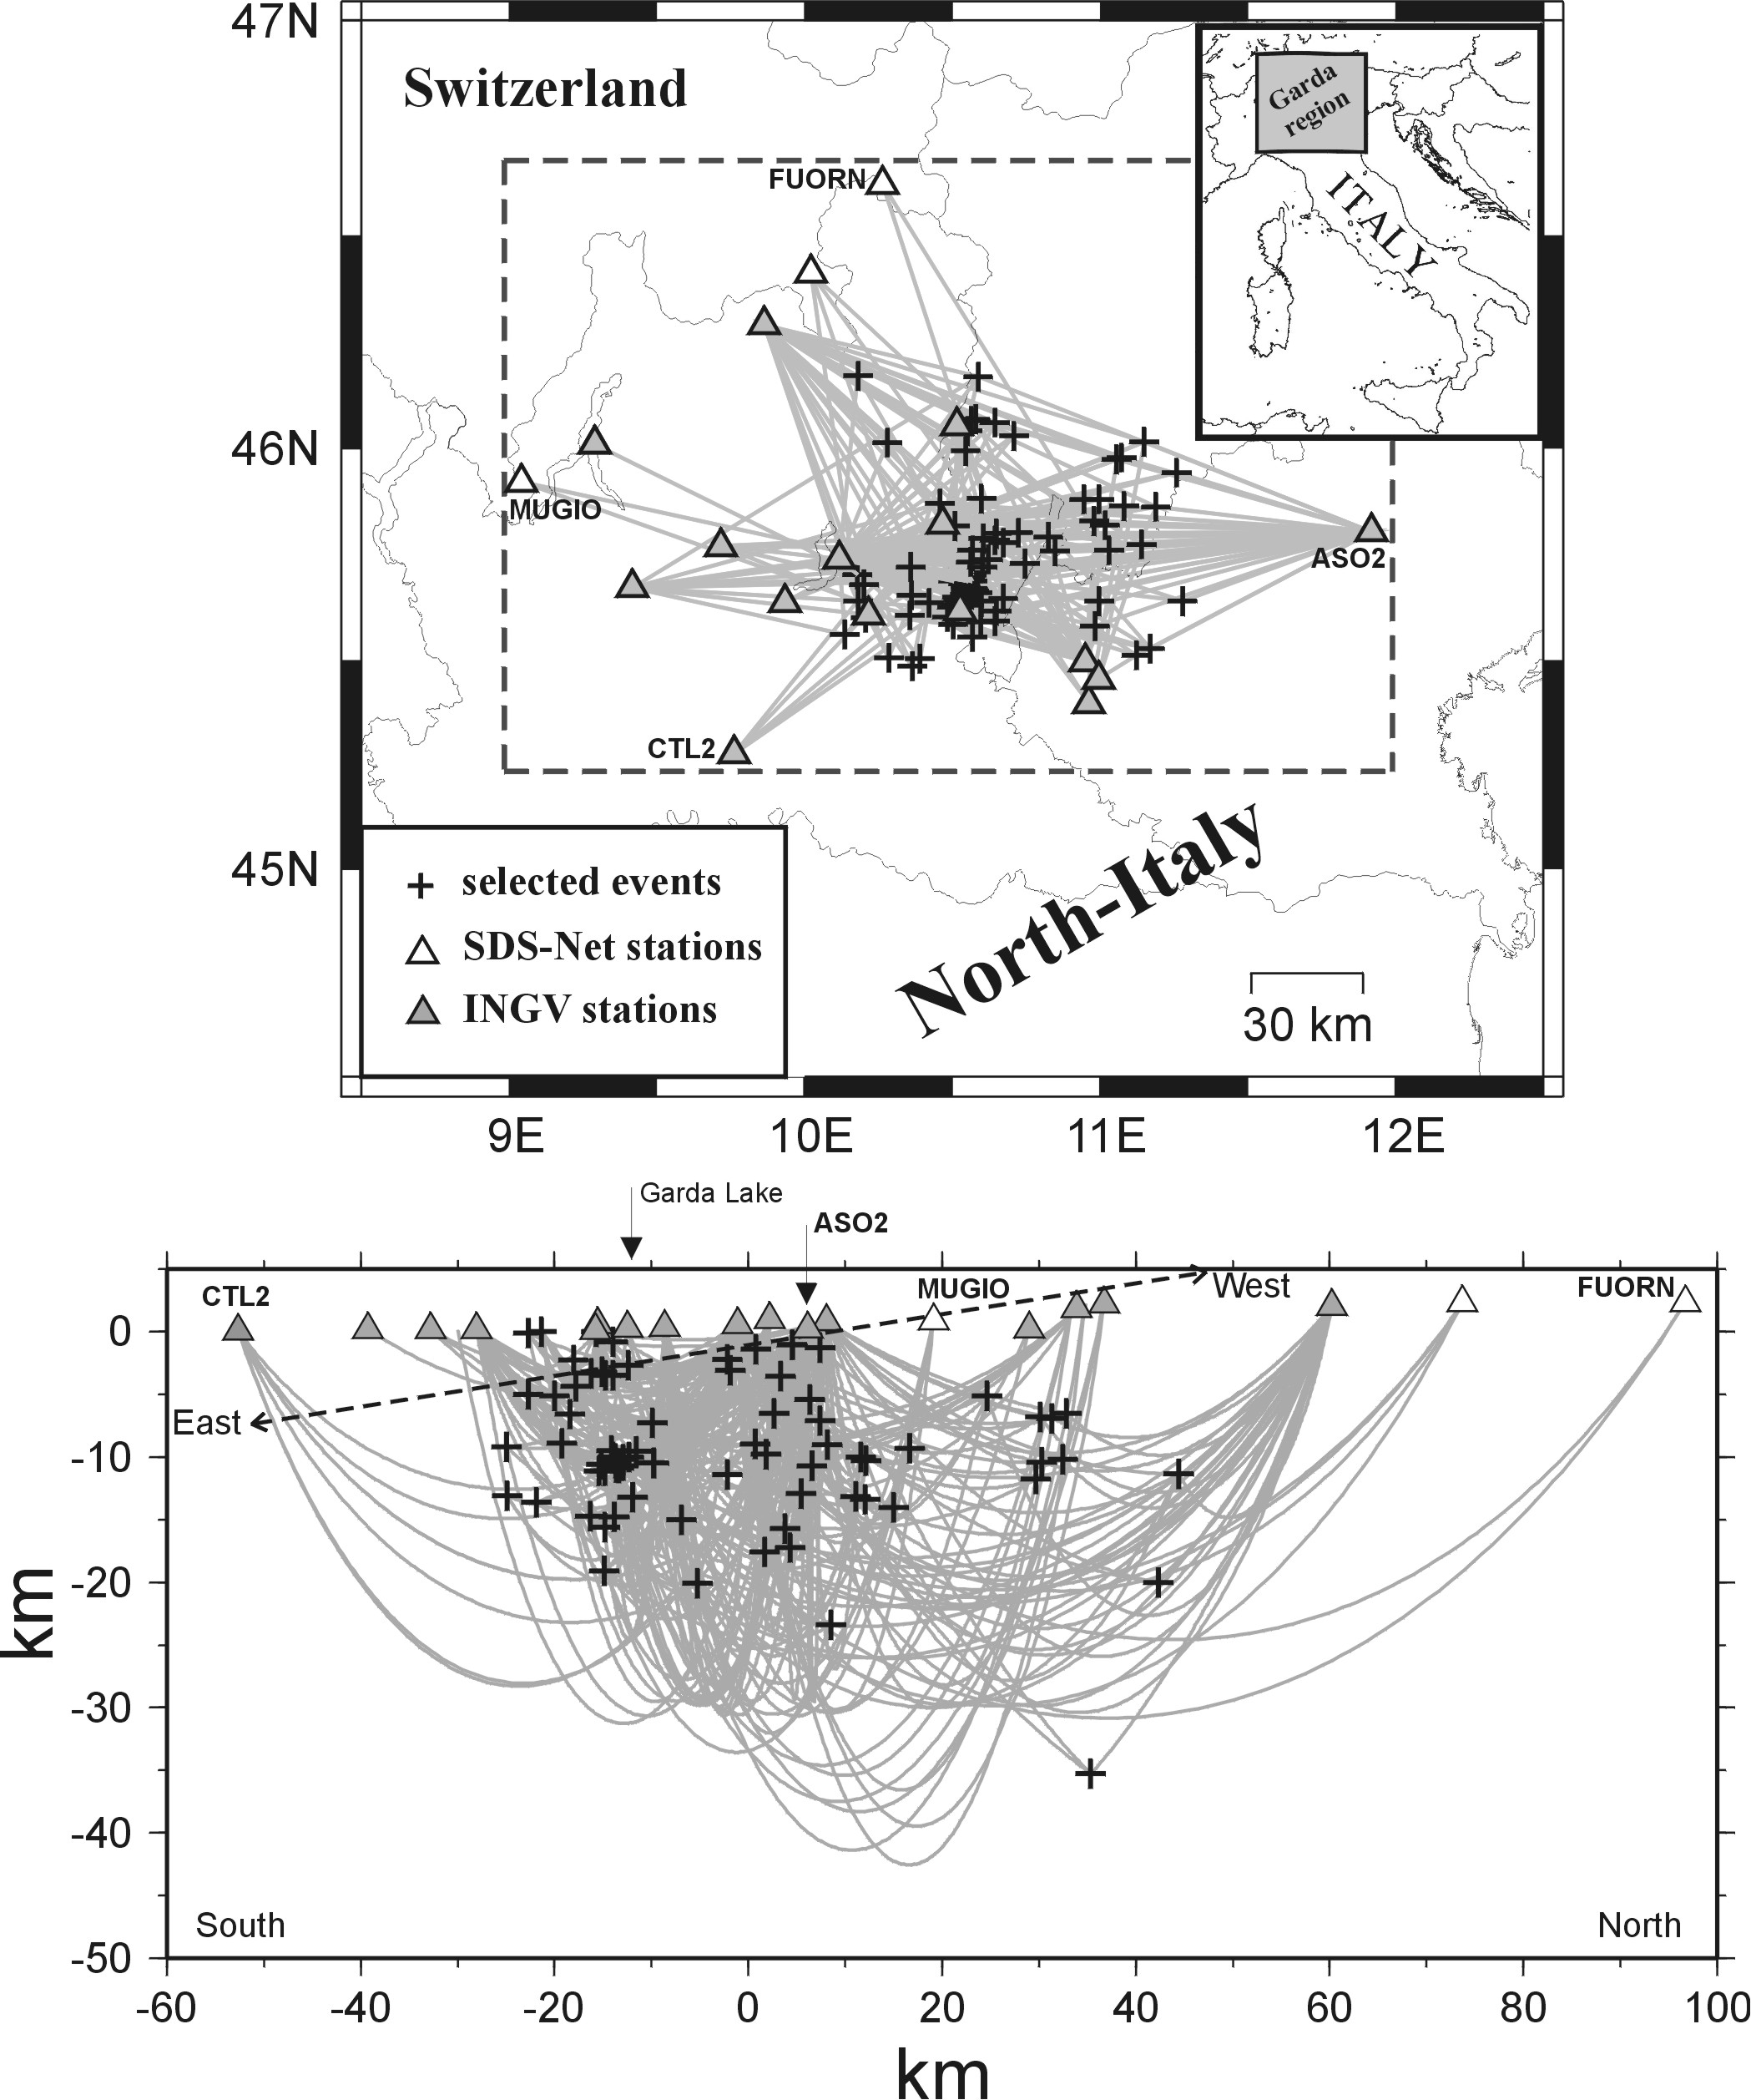

FIGURE 1

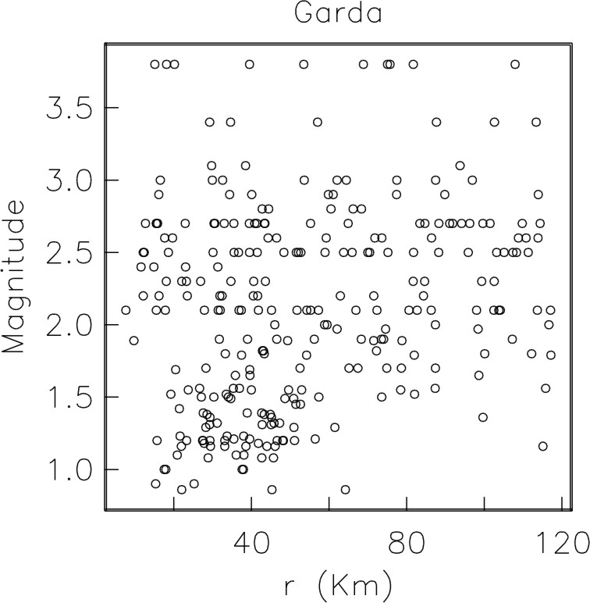
FIGURE 2

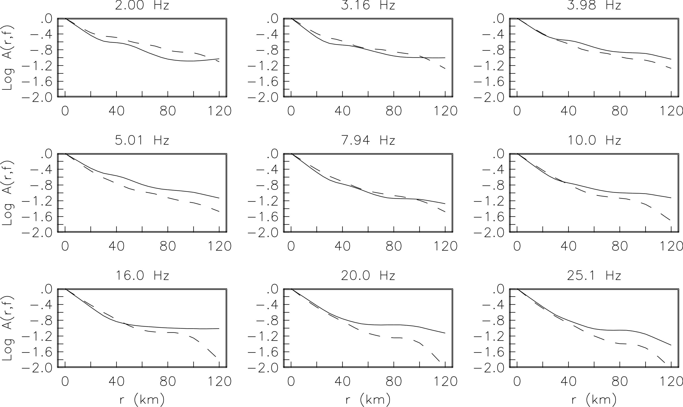

FIGURE 3

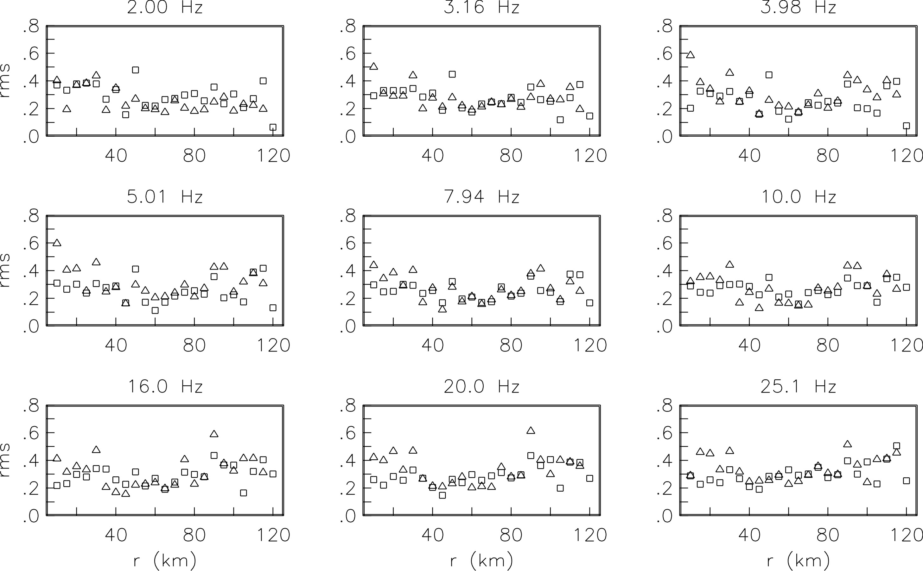

FIGURE 4

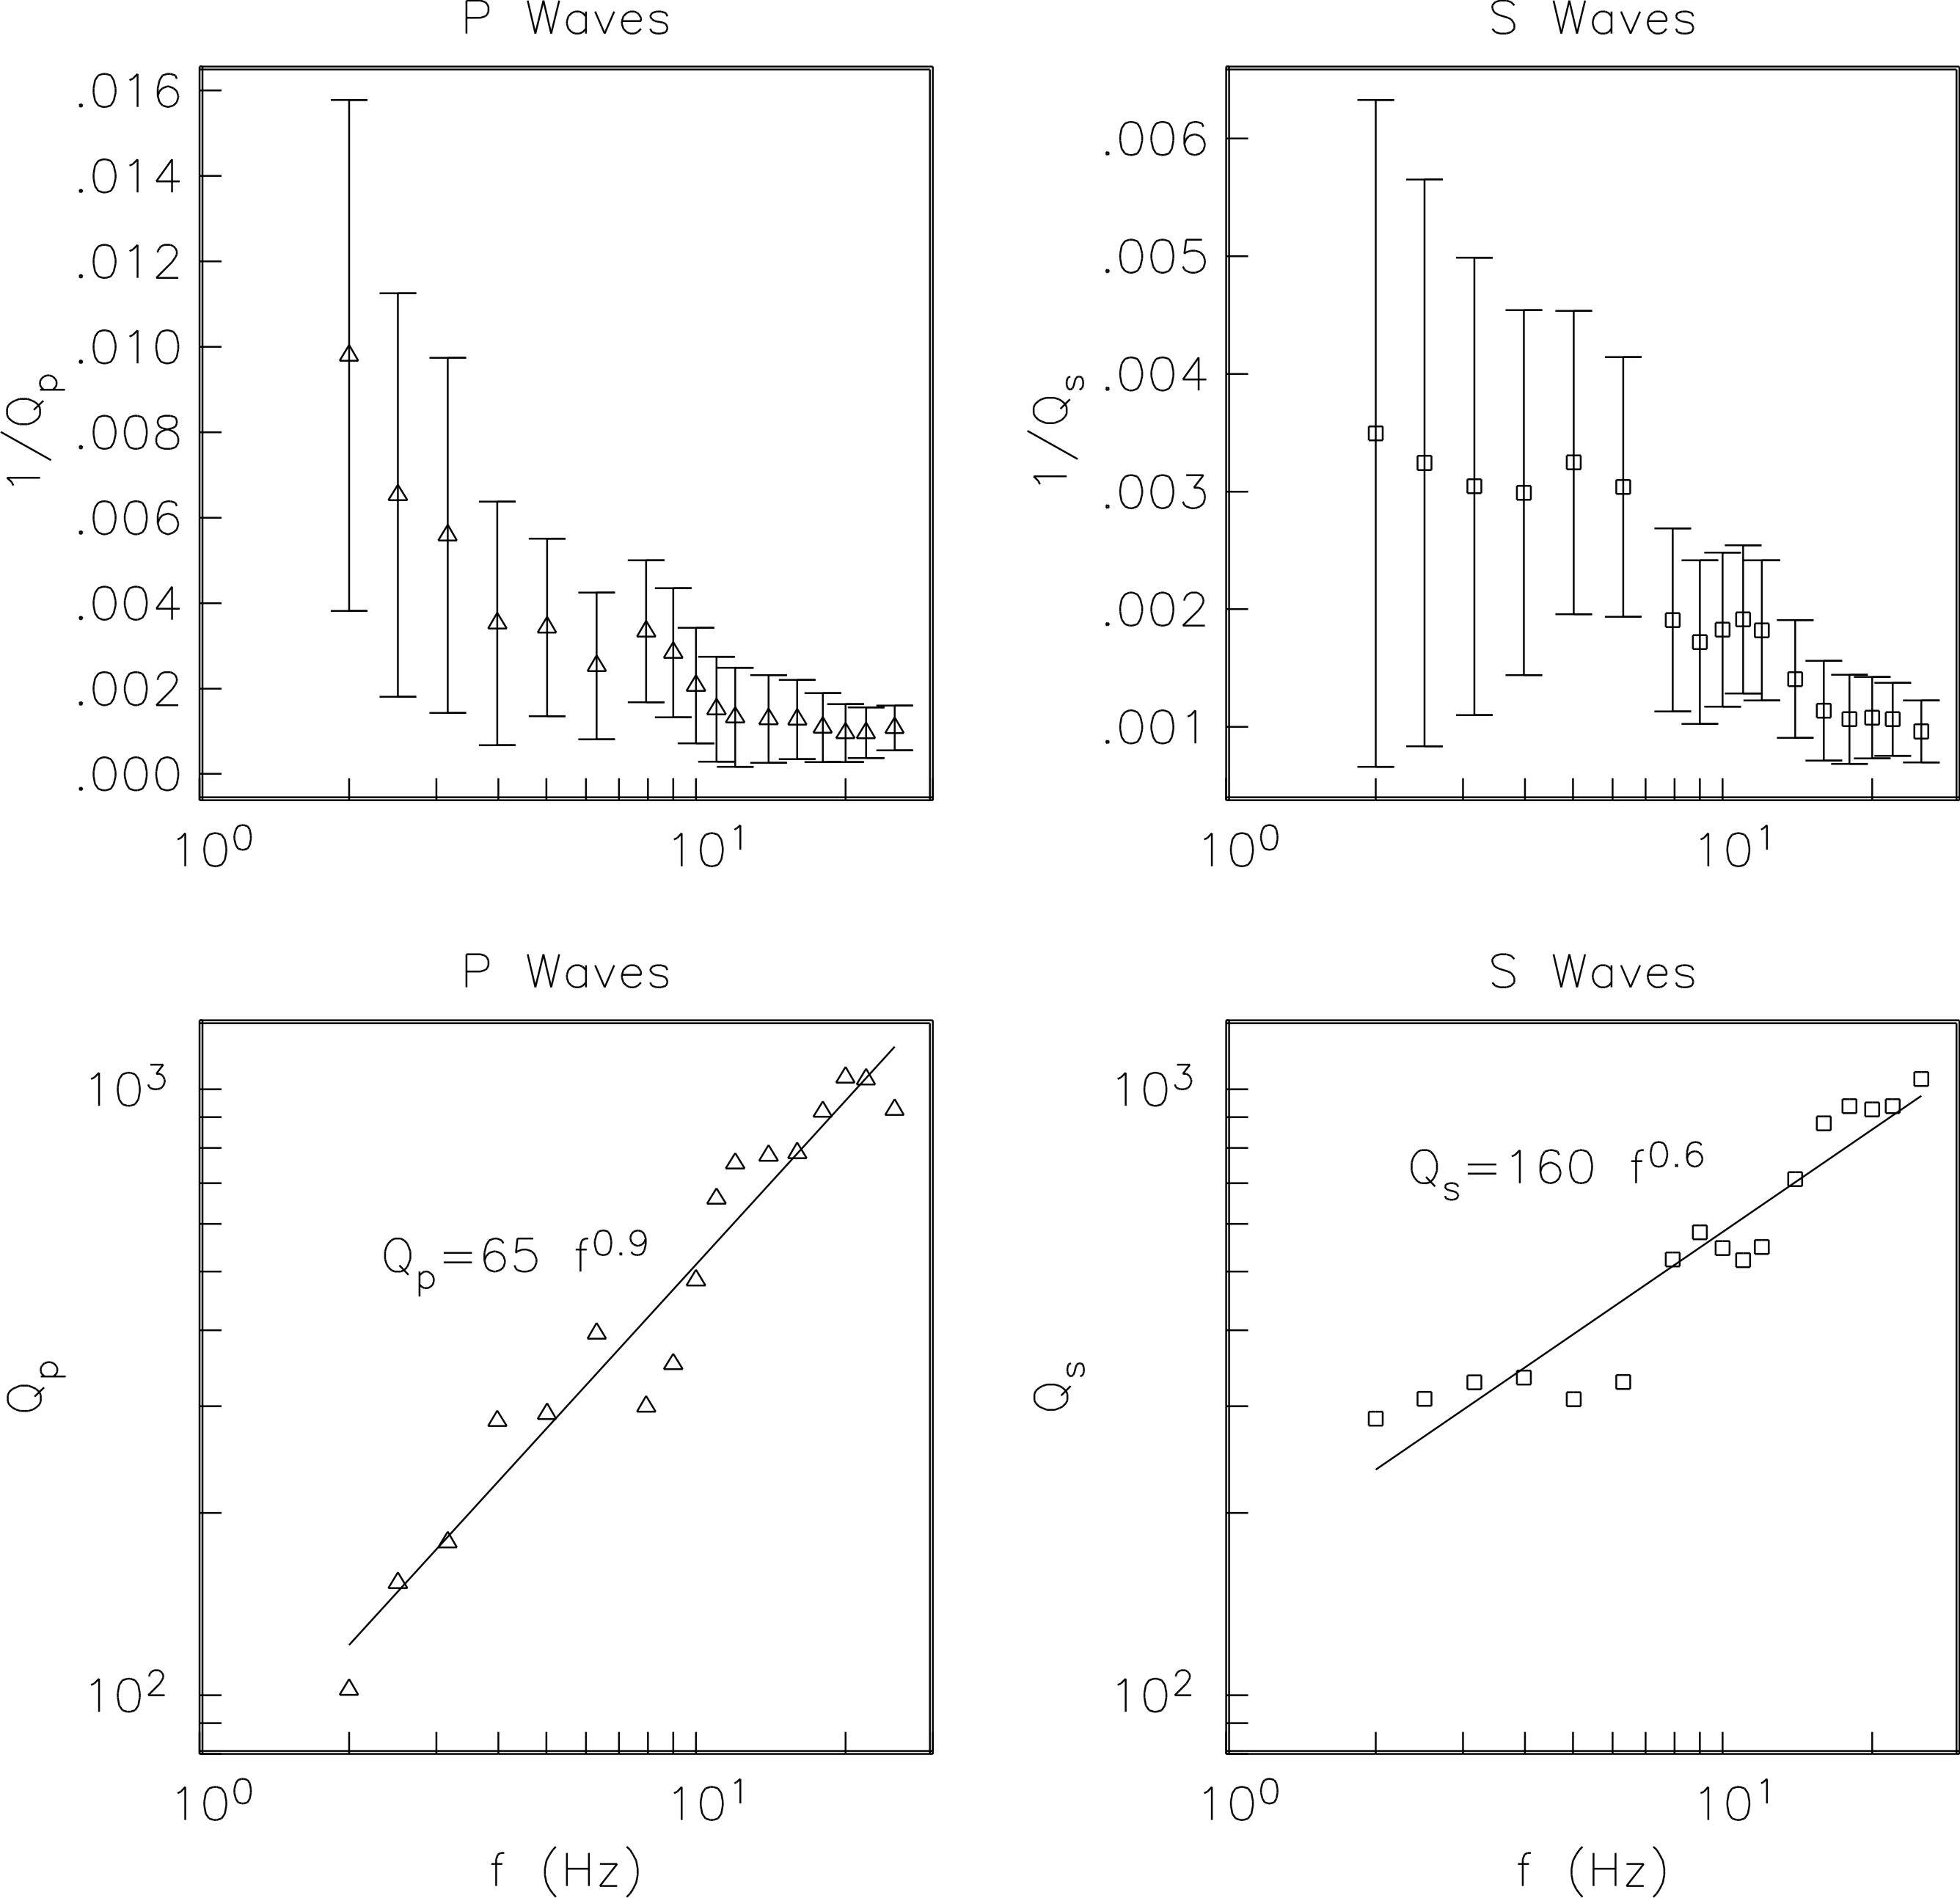

FIGURE 5

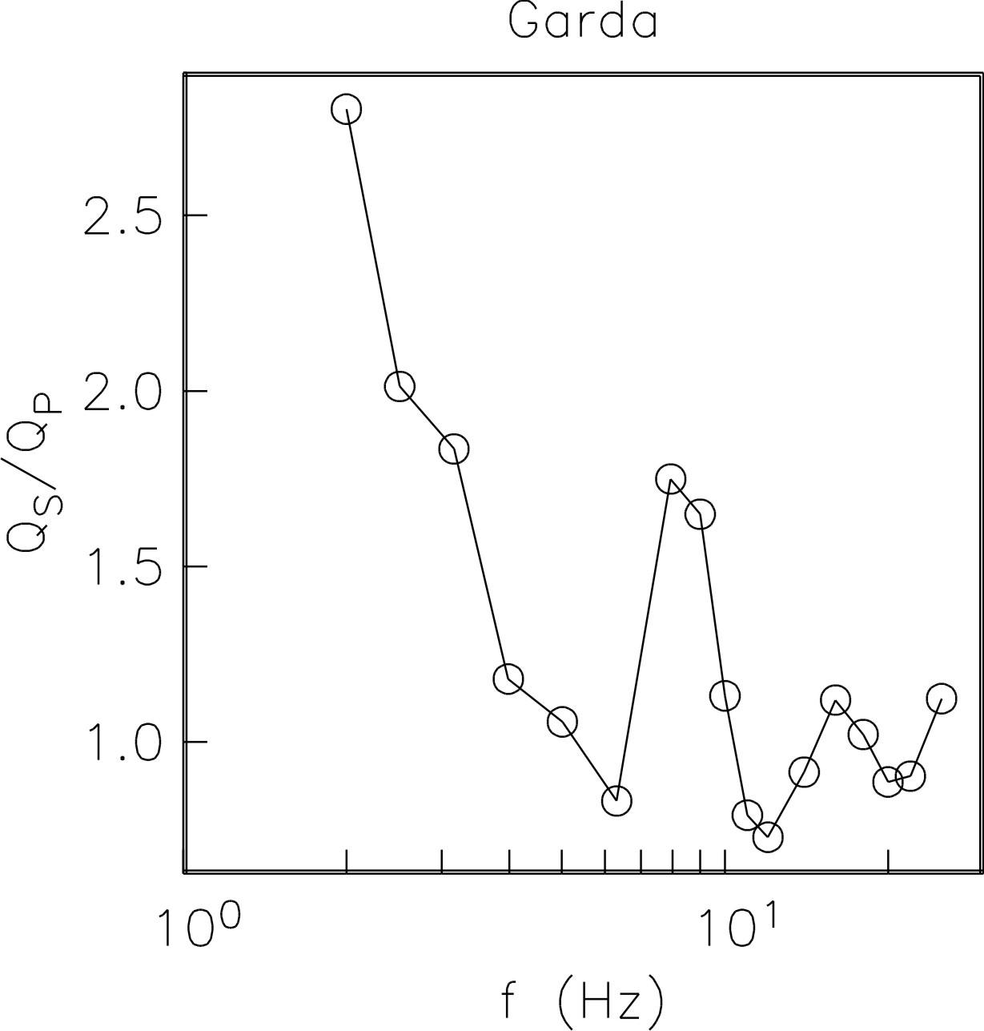

FIGURE 6

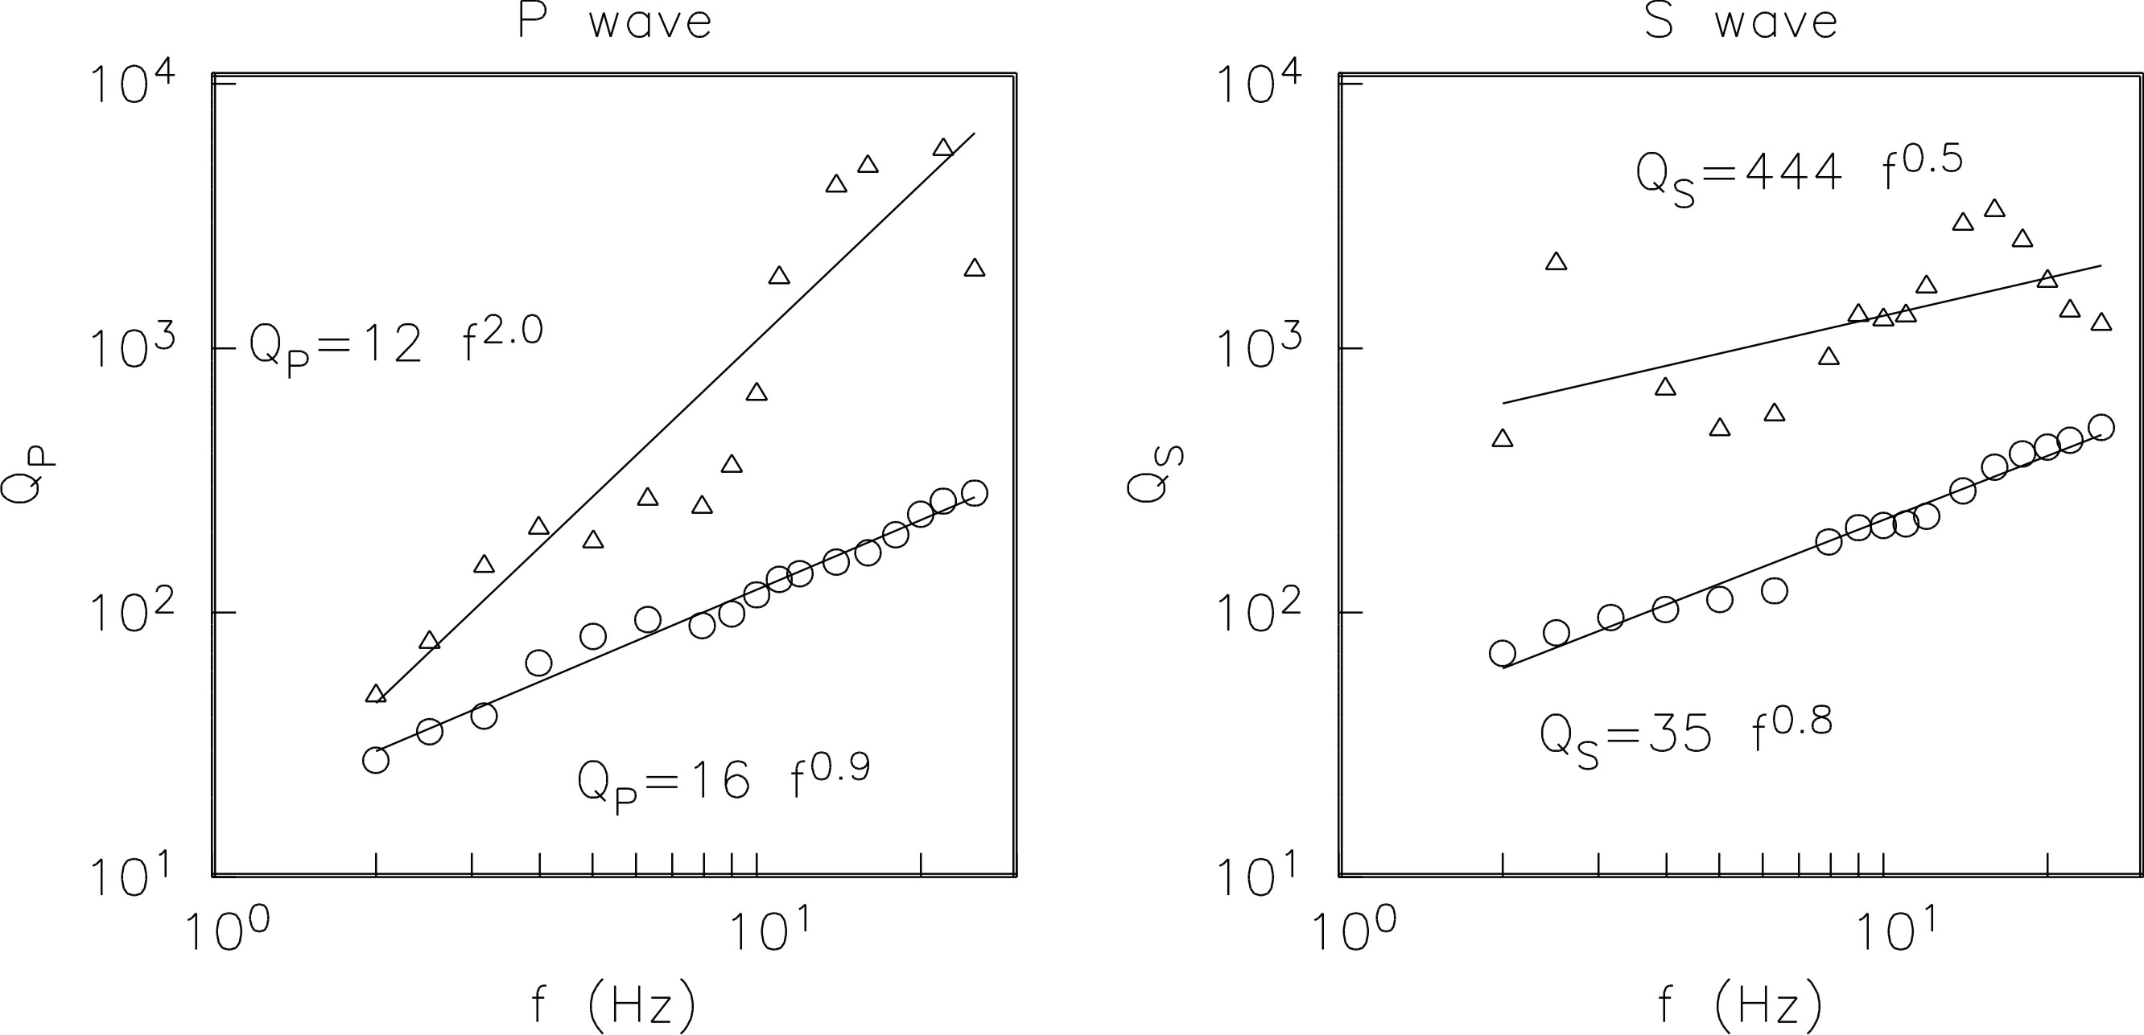

FIGURE 7

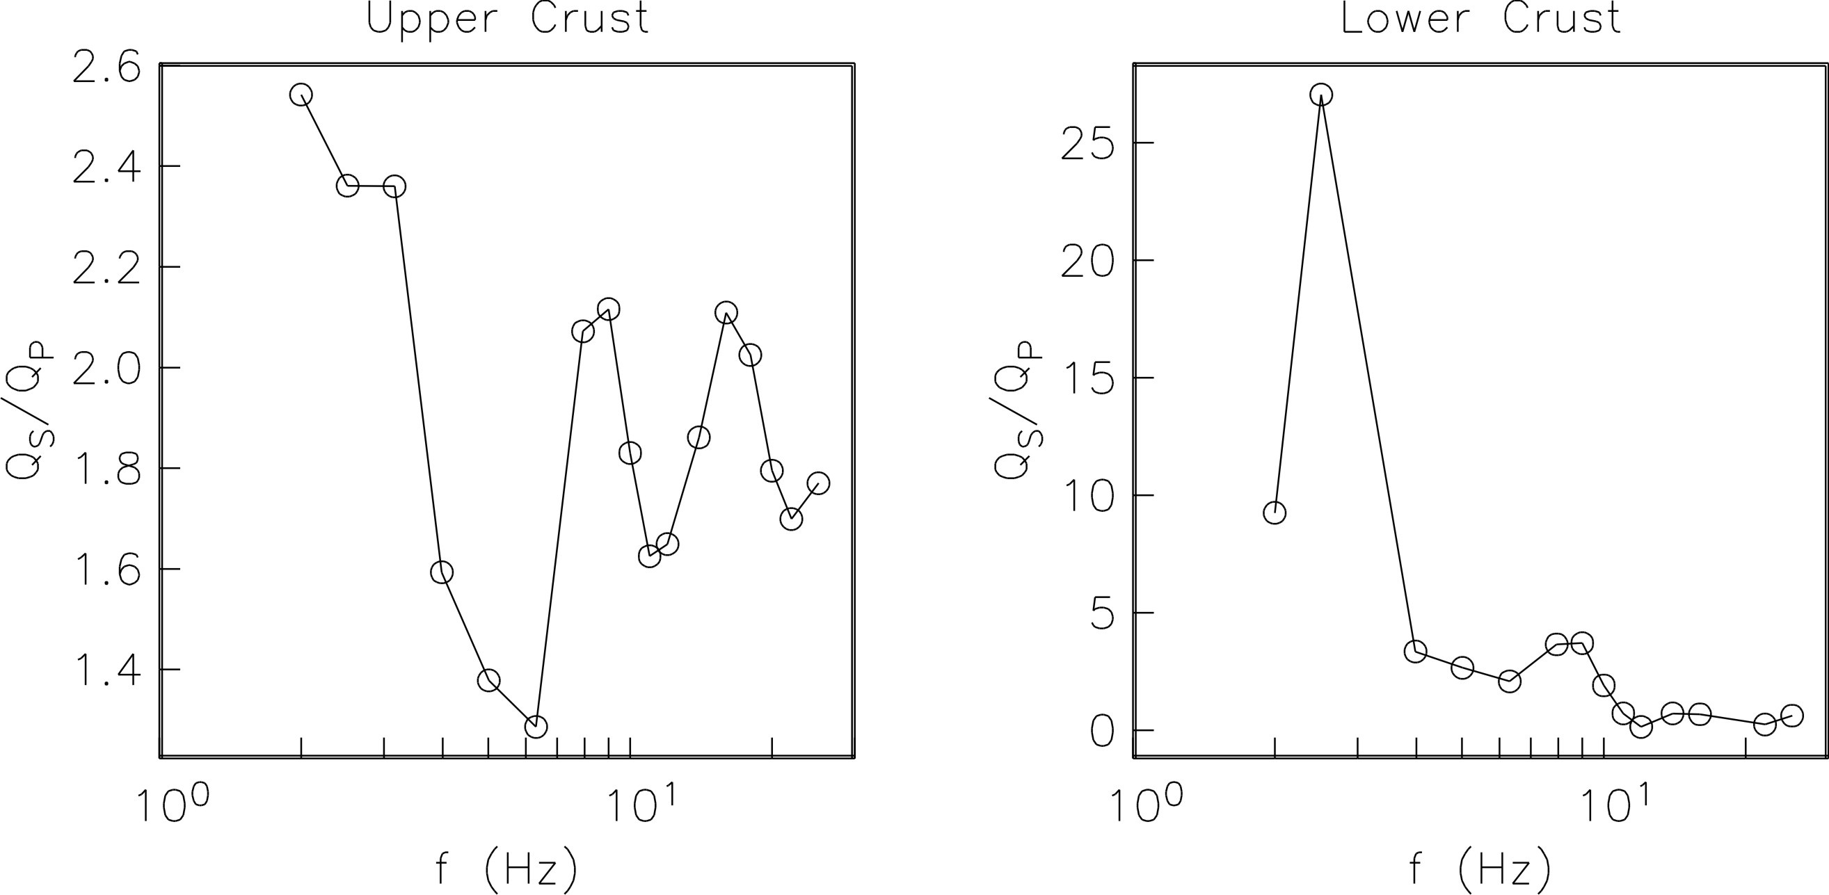

FIGURE 8

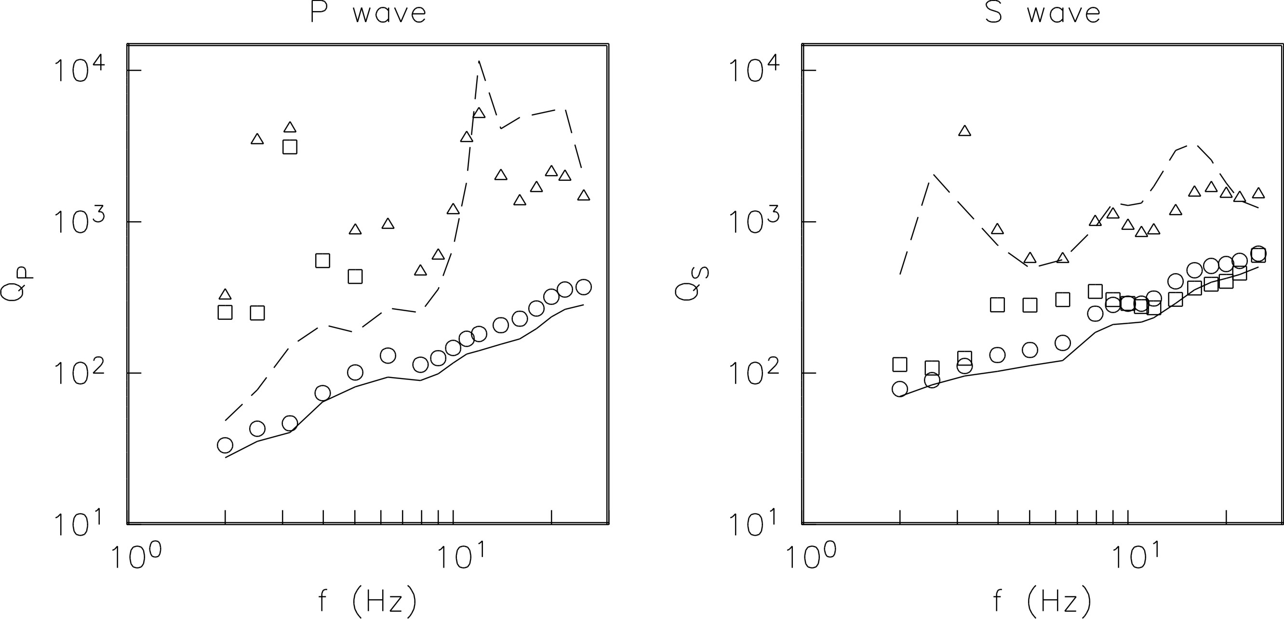

FIGURE 9

