DEEP WATER PRESTACK MULTIPLE SUPPRESSION ON REFLECTION DATA FROM IONIAN SEA (OFFSHORE WESTERN GREECE)

E. Kokinou¹, A. Vafidis² and E. Kamperis³

(¹) Lab. of Geophysics and Seismology, Department of Natural Resources and Environment, Technological Educational Institute Crete, 3 Romanou Str. Chalepa, Chania, Crete, GR-73133 Greece.
(²) Applied Geophysics Laboratory, Mineral Resources Engineering, Technical University of Crete, Chania 73100, Greece.
(³) Hellenic Petroleum (Exploration and Exploitation of Carbon Division), 199 Kifissias Av. 15124 Maroussi, Athens, Greece.

*Corresponding author: ekokinou@chania.teicrete.gr

ABSTRACT
Multiple attenuation comprises a very important phase of the seismic reflection processing because it removes undesirable effects occurred during the propagation of the seismic signal in the earth. The present work aims at presenting the effectiveness of modern multiple suppression methods applied on streamer seismic reflection data. The seismic dataset represents an area with moderately dipping seafloor. The specific dataset was chosen in order to present the elimination of the water-column reverberations and internal multiples in dipping layers.
Strong seafloor and internal multiples, lateral reflections and coherent noise impose difficulties in discriminating primary reflections in the seismic image of the present work. The prestack demultiple scheme combines wave equation method and deconvolution in order to predict and attenuate water-column reverberations and internal multiple reflections respectively.
In particular, the region of moderately dipping seafloor chosen for the application of the proposed scheme images the Frontal Bulge in the outer Hellenic arc. The prestack demultiple method improved the quality of the stacked and migrated sections, by attenuating the majority of multiple reflections and extracting information about the structural units of the study area.

Keywords: Deep reflection profiling, prestack multiple suppression, Ionian sea, Hellenic arc.

INTRODUCTION
In the present paper we divide the multiple reflections in two categories, i.e. the water-column reverberations and the internal multiples. Water-column reverberations are caused by the energy trap in the water layer, especially in areas with hard seafloor. The harder the seafloor, the greater the number of multiples, that have amplitudes comparable to the primaries. For simplicity reasons we include the receiver side multiples and the source side multiples in the term of the water-column reverberations. Under the term internal multiples we consider the multiple events that experience two or more upward reflections in the subsurface and have their downward reflection points below the free surface.
The techniques for suppressing multiples can be divided in three groups. The first group consists of techniques based on partial moveout such as frequency-wavenumber (F-K) and Radon filters (Fail and Grau, 1963; Schneider et al., 1965; Treitel et al., 1967). Deconvolution techniques attenuate multiples exhibiting periodicity (Backus, 1959; Peacock and Treitel, 1969; Griffiths et al., 1978). The last group includes wave equation methods (Wiggins, 1988).
Weglein (1999) presented an excellent review of recent advances in multiple attenuation on a special issue of the Leading Edge, while TenKroode (2002) proposed an asymptotic derivation of results due to Weglein et al. (1997), on the prediction of internal multiples in seismic reflection data. Matson et al. (1999) in the same issue of the Leading Edge compared three multiple attenuation methods, namely the wave equation multiple suppression, τ-p deconvolution and hyperbolic Radon multiple suppression. They reported that the combination of the first two methods as they were applied to a hard-bottom dataset gave better results. Berkhout (1999) proposed a wave method for multiple generation based on a feedback model, which is followed by an adaptive subtraction step, while Verschuur and Prein (1999) presented multiple removal results for subsalt and basalt layer environments. Ikelle et al. (2004) demonstrated a linear and non-iterative solution for attenuating all free-surface multiples in towed-streamer data, while Wang (2004) predicted surface-multiples through inversion, building the multiple model not by spatial convolution but by updating the attenuated multiple wavefield in the previous iteration to generate a multiple prediction for the new iteration. This method predicts multiples which are not only accurate kinematically but are also accurate in phase and amplitude.
Additionally, the technique of dual-sensor (hydrophone and geophone) recordings in bottom cable (OBC) experiments can effectively attenuate receiver-side multiples in both data types or combined to split the geophone data into upgoing P and S waves. Amundsen et al. (2000) reported a new formulae of OBC multiple attenuation and P/S splitting for the case of a heterogeneous seafloor.
This paper presents a prestack multiple attenuation method applied on deep water seismic data from seismic line ION - 7 and the information revealed. A short description of both the geographic and geologic setting of the studied area is followed by the presentation of the prestack multiple attenuation scheme. The results from the application of this method on seismic reflection data from the Ionian sea is finally discussed in detail. The field data used in the present paper was selected in 1992 with the support of the European Union (JOULE STREAMERS PROJECT), in order to obtain information about the structure of the crust, and probably the upper mantle (Hirn et al., 1996). Seven seismic lines (Fig. 1A) of total length 700 Km were scanned in the central Mediterranean sea. One of these lines namely ION – 7 (Fig. 1B) crosses the deep Ionian basin.

THE AREA OF STUDY
The seismic profile ION-7 (Fig. 1A) of 180 km total length crosses the western margin of the Hellenic arc (HA) from the deep Ionian basin (southwest) to the Gulf of Patras (northeast). It is located at the western part of the External Hellenides formed during Tertiary times as a result of the convergence between the Eurasia continent and Apulia microplate which initiated at the end of Cretaceous.
The External Hellenides foldbelt includes the Pre – Apulian (or Paxos) and Ionian geotectonic zones (Fig. 1B) which are present in Kefallinia and Zakynthos islands. Oceanic crust probably floors the Ionian Abyssal plain and is being subducted beneath the Hellenic and Calabrian arcs (Weigel, 1974; Makris and Stobbe, 1984). Fore-arc scarping has developed in response to subduction in both areas (Underhill, 1989). An active dextral wrench fault zone, the Kefalonia Transform Fault (Louvari et al., 1999; Sachpazi et al., 2000; Kokinou et al., 2006) separates the oceanic crust from the end - wedge of the Mediterranean ridge. The thrust and folding of the Ionian zone occurred in the late Early Miocene but it has not affected the Pre–Apulian zone.
The studied area (Fig. 1B) of the present work is located at the end of the Hellenic arc and is referred as Frontal Bulge (Hirn et al., 1996). Frontal Bulge probably comprises the outer part of the Pre- Apulian geotectonic zone, which is considered as a transition zone between the Apulian foreland and the Ionian basin. The tectonic regime changes from extension in the outer Hellenic arc to compression in the Hellenic Trench (Fig. 1B). Frontal Bulge together with the Hellenic Trench and the Mediterranean Ridge comprise an accretionary prism to the present day.
Frontal Bulge comprises a bathymetric high (55.8 Km - 72.6 Km of the seismic line ION-7) located in the outer Hellenic arc. This western part of the Hellenic arc is considered as the back section of the Mediterranean Ridge in the area of the seismic line ION-7 (Kokinou et al., 2005) formed as the result of accretionary processes: as the African plate is subducted beneath Aegean, part of its sedimentary cover is scarped off and accreted to the overriding Aegean plate as a huge pile of deforming, dewatering sediments. It was probably formed by the processes affected the Mediterranean Ridge. Fluids circulate through the tectonically deformed sediments of the Mediterranean Ridge and then vent into the sea. The venting of these fluids implies an elevated pressure to activate flow along faults and fractures (Moore, 1989; Moore and Vrolijk, 1992). Because of their effect on the strength of materials, they are significant to the dynamic earth processes whereby sediments can be piled several kilometers high.

MULTIPLE ATTENUATION METHOD

Prestack demultiple procedure
The proposed demultiple scheme consists of two basic steps:
1. Application of the wave equation in order to be predicted and attenuated the water-column reverberations (Wiggins, 1988). The wave field extrapolation method propagates the wavefield one round trip through the water column and then adaptively subtracts this up- and downward continued field from the observed wavefield (Weglein, 1999). In particular, water-column reverberations are attenuated by a two step procedure. The delay between the arrival of successive multiples and the reflectivity of the seafloor are calculated. The predicted multiple (consisting of the delayed waveform combined with the seafloor reflectivity) is subtracted from the raw data. Prediction and subtraction of water-column reverberations by wavefield extrapolation is an effective method of attenuating the above mentioned multiples even where the seafloor is very irregular.
2. Deconvolution in order to be eliminated the internal multiples (Backus, 1959; Peacock and Treitel, 1969; Griffiths et al., 1978). Deconvolution operators employed a minimum mean-square error criterion, i.e. Wiener filters, have been widely and successfully applied in seismic reflection processing. Especially predictive and further adaptive deconvolution comprises methods applicable in data containing multiples with periods that vary with traveltime. Predictive deconvolution is favorable for short period multiples exhibiting repeat interval of only a few times the duration of the source wavelet, so as they can be considered approximately periodic and further discriminated on the basis of their periodicity (Backus, 1959). When the multiple reflection path becomes long compared to the wavelet duration, the multiples are no longer periodic except for the special case of zero offset and exactly flat horizons. In this case adaptive deconvolution is preferable, based on the adaptive linear prediction operator (Griffiths et al., 1978). This filter predicts a trace sample from a subset of past trace values. The error is defined as the actual trace sample minus the predicted value. If this is equal to zero, the same filter is used to predict the next trace sample. If this is not the case, each filter coefficient is increased by an amount proportional to the corresponding trace value.
The demultiple scheme proposed in the present work combines the wave equation multiple rejection method and the adaptive deconvolution. Up to nowadays there is not any algorithm to eliminate all kinds of multiple reflections. This is the reason we have chosen, after many tests, the proposed scheme.
The pre-referred method is applied on shot records from a dipping seafloor area in order to attenuate water-column reverberations and internal multiples and to reveal primary reflections especially from the deeper part of the seismic section of ION-7. Water-column reverberations are well attenuated by the wave equation multiple rejection method, while internal multiples by the adaptive deconvolution filter. Many of the time-varying methods can successfully handle the time-varying multiple problem but most of them are applicable in high signal-to-noise ration environments. Adaptive deconvolution can also be effective in noisy environments.

STREAMERS DEEP REFLECTION DATA

Prestack multiple suppression at a moderately dipping seafloor region
The proposed prestack demultiple scheme was applied on a seismic dataset from a region with moderately dipping seafloor. The specific area was chosen because dipping seafloor and the layers underlain generally produce multiple reflections difficult to be attenuated in comparison to horizontally layered structure.
Picking of the primary reflection times at near-offsets was carried out in order to construct the seafloor depth model. The wave equation method subsequently generated water-column reverberations for this depth model. Prior seafloor multiple attenuation a top mute on common shot records was applied in order to remove events at times earlier than the seafloor reflection. For this purpose a file with the mute times was created. The seafloor multiple reflection wavefield was successfully simulated and then subtracted from the original wavefield. The seafloor multiples, especially at short offsets, were severe attenuated by the pre-mentioned procedure, but the internal multiples were still observable on the shot records.
In order to attenuate the internal multiples various types of deconvolution were applied. Proper selection of the predictive deconvolution operator parameters, such as its length and the lags, was accomplished by testing them. The prewhitening was kept at 0.1 %. The predictive deconvolution partly suppressed internal multiple reflections, but the seafloor multiple was still present at long offsets. The relative amplitude of the primaries was also influenced by predictive deconvolution.
Adaptive deconvolution is favorable for the elimination of multiples with varying periods. The range of the operator length was 3 to 4 s while the range of the prediction lag was 1 to 1.5 s. The range of the adaptation coefficient was 0.1 to 0.15. The adaptive deconvolution significantly attenuates the short-path multiples without affecting the relative amplitude of the primaries.
An original shot gather, located in the study area, is displayed in Figure 2. Strong seafloor and internal multiples are observed at times greater than 7.9 s TWT. Figure 3 displays the same common shot gather after the application of the pre-referred multiple attenuation procedure. Successful elimination of seafloor and internal multiples is observed at times greater than 7.9 s TWT, while at shorter times the signal is not influenced by the multiple attenuation procedure.
The wave equation multiple rejection method and the adaptive deconvolution, applied sequentially on the selected common shot data, substantially eliminate both water-column reverberations and internal multiples. On the stacked section (Fig. 4) of the study area prior the application of the pre-mentioned demultiple scheme, multiples arriving at times greater than 3.7s TWT (two-way time) are dominant and distort the primary reflections. After the application of the proposed demultiple procedure, the stacked section exhibits significant elimination of water-column reverberations and internal multiples revealing a number of primaries (Fig. 5). The improvement of the seismic reflection image, especially in its deeper part is presented in the Kirchhoff-migrated section of Figure 6.

DISCUSSION OF THE RESULTS
Purpose of the present work is to illustrate the effectiveness of the proposed demultiple scheme on marine seismic reflection data containing strong seafloor and internal multiples. In addition the selected part of the seismic reflection data set corresponds to a dipping seafloor, a fact that increases the difficulty factor in eliminating multiple reflections. Large amount of energy is reflected between the water-sediment interface and the water interface and subsequently decreases the signal-to-noise ratio of the data set.
Wave equation multiple rejection and the adaptive deconvolution were sequentially applied on selected common shot records and substantially eliminated both seafloor and internal multiples (Figs. 5, 6). On the stacked section, prior the application of the proposed demultiple scheme, the multiples arriving at times greater than 3.7s TWT (two-way time) are dominant and distort the primaries (Fig. 4). After the application of the demultiple procedure, the stacked section exhibits significant elimination of seafloor and internal multiples revealing a number of possible reflectors (Fig. 6, 7).
Other demultiple algorithms, such as the Karhunen – Loeve (K-L) decomposition, were also applied in the specific data set but without special improvement of the seismic image.
Figure 7 displays the time-migrated section of the studied area after demultiple procedure. A strong discontinuity is observed below the seafloor exhibiting a constant thickness (time length of 0.5 s TWT), underlain by a second discontinuity with varying thickness. The previous reflectors are possibly interrupted by faults. A third discontinuity is present at about 5 - 5.8 s TWT, showing different dipping in comparison with the discontinuities observed in earlier times. The continuity of all reflectors seems to end across a major tectonic feature possibly comprising the limit between the Frontal Bulge and the Hellenic Trench.

CONCLUSIONS
Marine reflection data often exhibits difficulties in the interpretation due to the presence of seafloor and internal multiples. Especially marine environments showing dipping seafloor and underlain layers generally produce low signal-to-noise ratio images.
The sequential application of wave equation multiple rejection and adaptive deconvolution, presented in this paper, was proved well for the attenuation of both seafloor and internal multiples. The stacked and further the time-migrated sections are satisfactory improved after the application of the proposed demultiple scheme. The part of the seismic section prior the presence of the first seafloor multiple reflection seems to be undistorted after the application of the demultiple scheme. The lower part of the section suffering of the multiples presence shows significant improvement and further is interpretable.

ACKNOWLEDGMENTS
The authors are deeply indebted to HELLENIC PETROLEUM Company (EL.PE) and the University of Athens for the data availability. Seismic acquisition and processing have been mainly supported by the Commission of the European Community, DG X11, program JOULE under contrast STREAMERS JOUG-90-CT-1003 (A. Hirn, E. Banda, D. Blundell, J. Drakopoulos, M. Loucogiannakis, L. Mendes-Victor, R. Nicolich).

REFERENCES
AMUNDSEN, L., L.T. IKELLE and J. MARTIN (2000): Multiple attenuation and P/S splitting of multicomponent OBC data at heterogeneous seafloor, Wave Motion, 32, 67-78.
BACKUS, M.M. (1959): Water reverberations – their Nature and Elimination, Geophysics 24, 233-261.
BERKHOUT, A.J. (1999): Multiple removal based on the feedback model, The Leading Edge 18, 1, 127–131.
CLEMENT, C., A. HIRN, P. CHARVIS, M. SACHPAZI and F. MARNELIS (2000): Seismic structure and the active Hellenic subduction in the Ionian islands, Tectonophysics 329, 141-156.
FAIL, J.P. and G. GRAU (1963): Les filtres en eventail, Geophysical Prospecting 11, 131–63.
GRIFFITHS, L.J., F.R. SMOLKA and L.D. TREMBLY (1978): Adaptive deconvolution: a new technique for processing time varying seismic data, Reprinted from Geophysics 42, 4, 742-759.
HIRN, A., M. SACHPAZI, R. SILIQI, J. McBRIDE, F. MARNELIS, L. CERNOBORI and THE STREAMERS – PROFILES GROUP (1996): A traverse of the Ionian islands front with coincident normal incidence/ and wide angle seismics, Tectonophysics 264, 35–49.
IKELLE, L.T., A. OSEN, L. AMUNDSEN and Y. SHEN, (2004): Non-iterative multiple-attenuation methods: linear inverse solutions to non linear inverse problems-II. BMG approximation, Geophys. J. Int., 159, 923-930.
KOKINOU, E., E. KAMBERIS, A. VAFIDIS, D. MONOPOLIS, G. ANANIADIS and A. ZELILIDIS (2005): Deep seismic reflection data from offshore western Greece: a new crustal model for the Ionian sea, Journal of Petroleum Geology, 28, 81–98.
KOKINOU, E., E. PAPADIMTRIOU, V. KARAKOSTAS, E. KAMBERIS, A. and F. VALLIANATOS. (2006): The Kefalonia Transform Zone (offshore Western Greece) with special emphasis to its prolongation towards the Ionian Abyssal Plain, Marine Geophysical Researches, in press.
LOUVARI, E., A.A. KIRATZI, and B.C. PAPAZACHOS (1999): The Cephalonia Transform Fault and its extension to western Lefkada Island (Greece), Tectonophysics 308, 223-236.
MAKRIS J. and C. STOBBE (1984): Physical properties and state of the crust and upper mantle of the eastern Mediterranean Sea deduced from geophysical data, Marine Geology 55, 347-363.
MATSON, K.H., D. PASCHAL and A.B. WEGLEIN (1999): A comparison of the three multiple – attenuation methods applied to a hard water – bottom data set, The leading Edge 18, 1, 120-124.
MOORE, J.C. (1989): Tectonics and hydrogeology of accretionary prisms: Role of the decollement zone, J. Struct. Geol. 11, 95-106.
MOORE, J.C. and P. VROLIJK (1992): Fluids in accretionary prisms, Rev. in Geophysics 30, 113-135.
PEACOCK, K.L. and S. TREITEL (1969): Predictive deconvolution: Theory and practice, Geophysics 34, 155-169.
SACHPAZI, M., A. HIRN, C. CLEMENT, F. HASLINGER, M. LAIGLE, E. KISSLING, P. CHARVIS, Y. HELLO, J.C. LEPINE, M. SAPINE and J. ANSORGE (2000): Western Hellenic subduction and Cephalonia Transform: local earthquakes and plate transport and strain. Tectonophysics, 319, 301-319.
SCHNEIDER, W.A., E.R. PRINCE and B.F. GILES (1965): A new data processing technique for multiple attenuation exploiting differential normal moveout, Geophysics 30, 348-362.
TEN KROODE, F. (2002): Prediction of internal multiples. Wave Motion 35, 315-338.
TREITEL, S., SHANKS J. L. and FRASIER C. W. (1967): Some aspects of fan filtering. Geophysics 32, 789 – 900.
UNDERHILL, J.R. (1989): Late Cenozoic deformation of the Hellenide foreland, western Greece. Geol. Soc. Am. Bull., 101, 613 – 634.
VERSHUUR, D.J. and R.J. PREIN (1999): Multiple removal results from Delft University, The Leading Edge 18, 1, 86-91.
WANG, Y. (2004): Multiple prediction through inversion: A fully data-driven concept for surface-related multiple attenuation, Geophysics, 69, 2, 547-553.
WEGLEIN, A.B., F.A. GASPAROTTO, P.M. CARVAHLO and R.H. STOLT (1997): An inverse-scattering series method for attenuating multiples in seismic reflection data, Geophysics, 62, 1975-1989.
WEGLEIN, A.B. (1999): Multiple attenuation: an overview of recent advances and the road ahead. The Leading Edge, Special section, 40-44.
WEIGEL, W., (1974): Crustal Structure under the Ionian Sea, Short Communications, J. Geophys. 40, 137-140.
WIGGINS, J.W. (1988): Attenuation of complex water bottom multiples by wave equation – based prediction and subtraction, Geophysics, 53, 12, 1527-1539.

FIGURE CAPTIONS
Figure 1: A. Map of STREAMERS, B. Schemetic map of the studied area where the main tectonic structures are marked.
Figure 2: Original common shot gather located in the study area, SFM: Seafloor multiple reflection, IM: Internal multiples.
Figure 3: Common shot gather located in the study area. Elimination of both seafloor and internal multiples by the sequential application of the wave equation multiple rejection and adaptive deconvolution filters.
Figure 4: Stacked section prior the application of the prestack demultiple procedure.
Figure 5 Stacked section after the application of the demultiple procedure. Seafloor and internal multiples have been removed.
Figure 6 Migrated seismic section of the study area after the demultiple procedure.
Figure 7 Migrated seismic section of the study area. The main reflectors and tectonic feature are marked by dashed line.

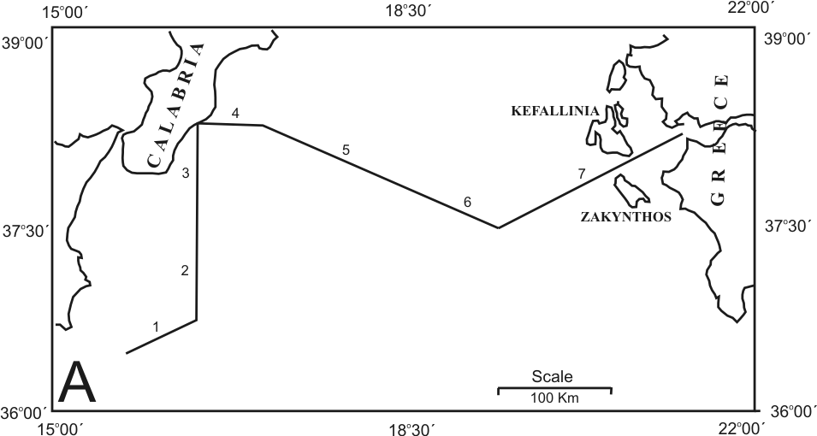

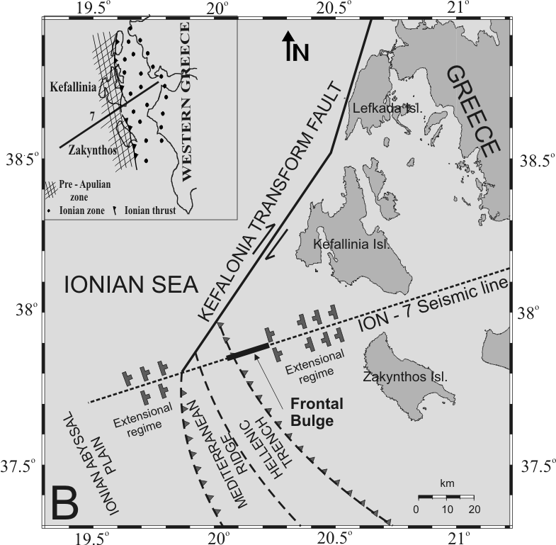

Figure 1 A. Map of STREAMERS – lines, B. Schemetic map of the studied area where the main tectonic structures are marked.

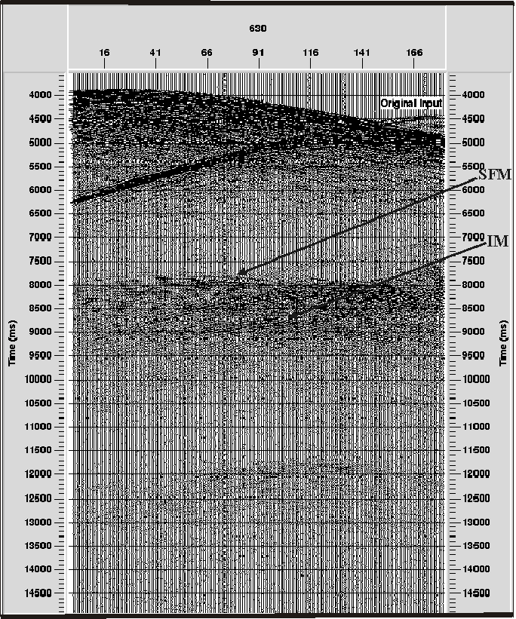

Figure 2 Original common shot gather located in the study area, SFM: Seafloor multiple reflection, IM: Internal multiples.

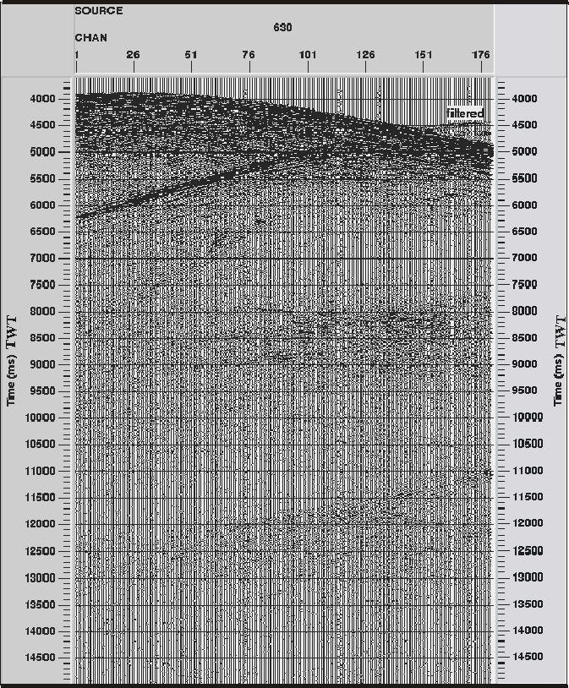

Figure 3 Common shot gather located in the study area. Elimination of both seafloor and internal multiples by the sequential application of the wave equation multiple rejection and adaptive deconvolution filters.

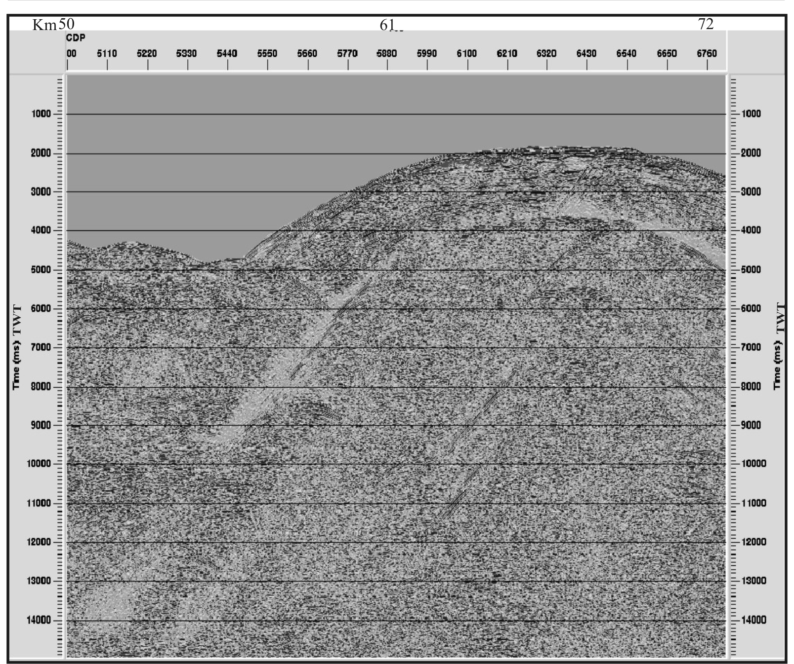

Figure 4 Stacked section prior the application of the prestack demultiple procedure.

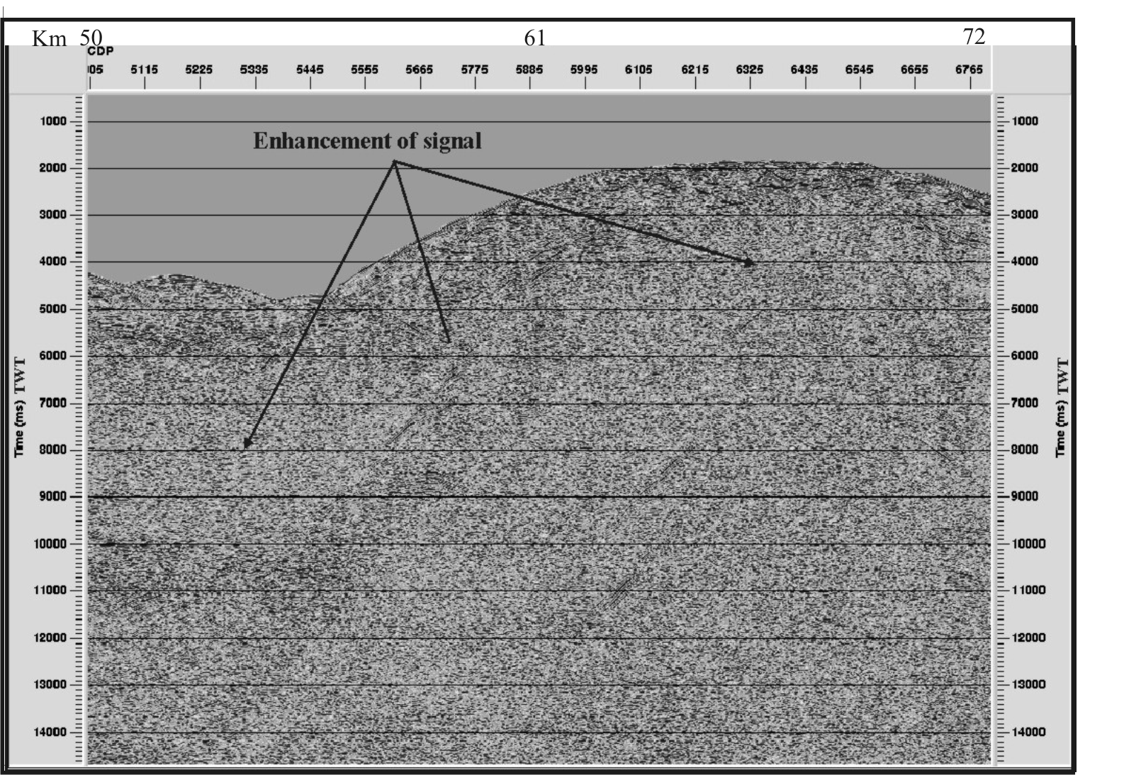

Figure 5 Stacked section after the application of the demultiple procedure. The seafloor and internal multiples have been removed.
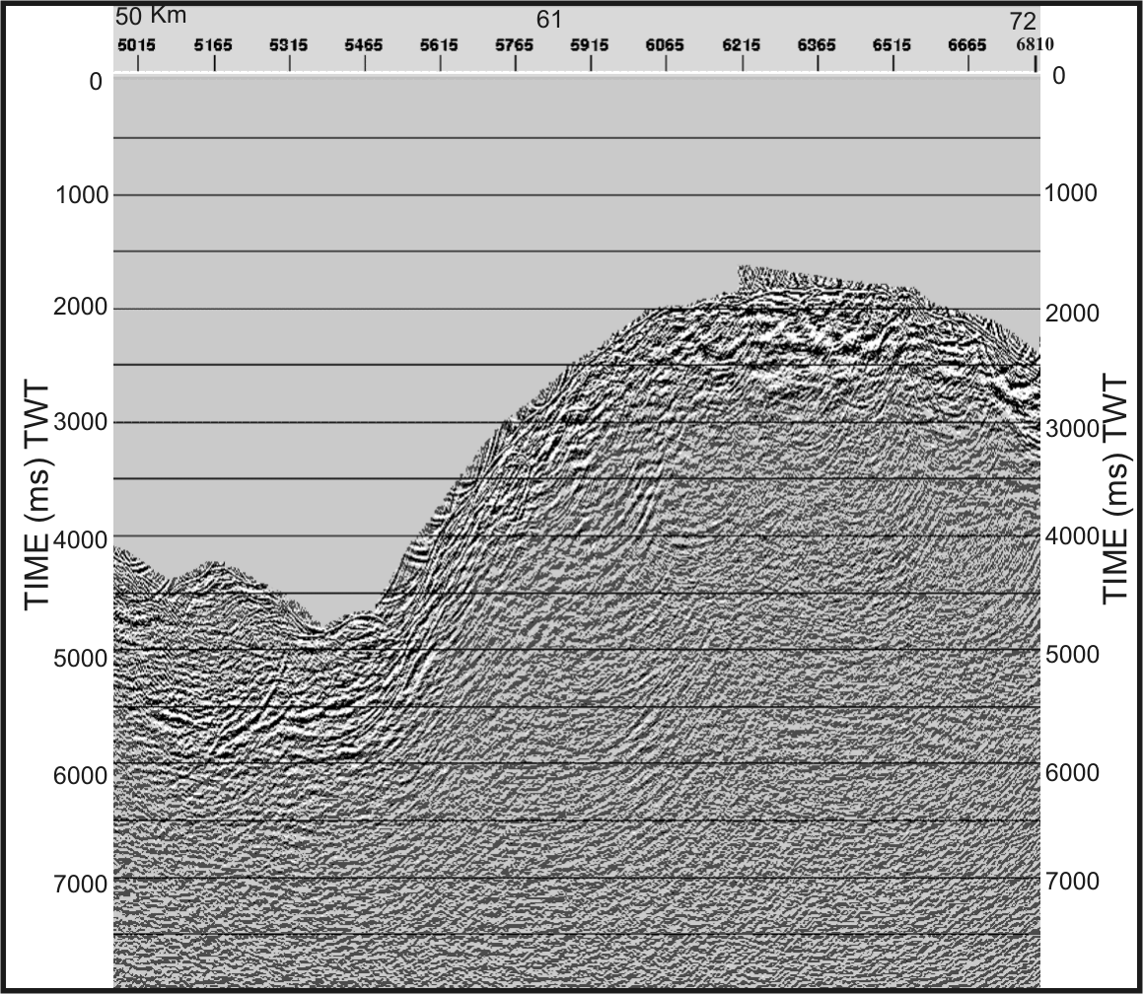

Figure 6 Migrated seismic section of the study area after the demultiple procedure.
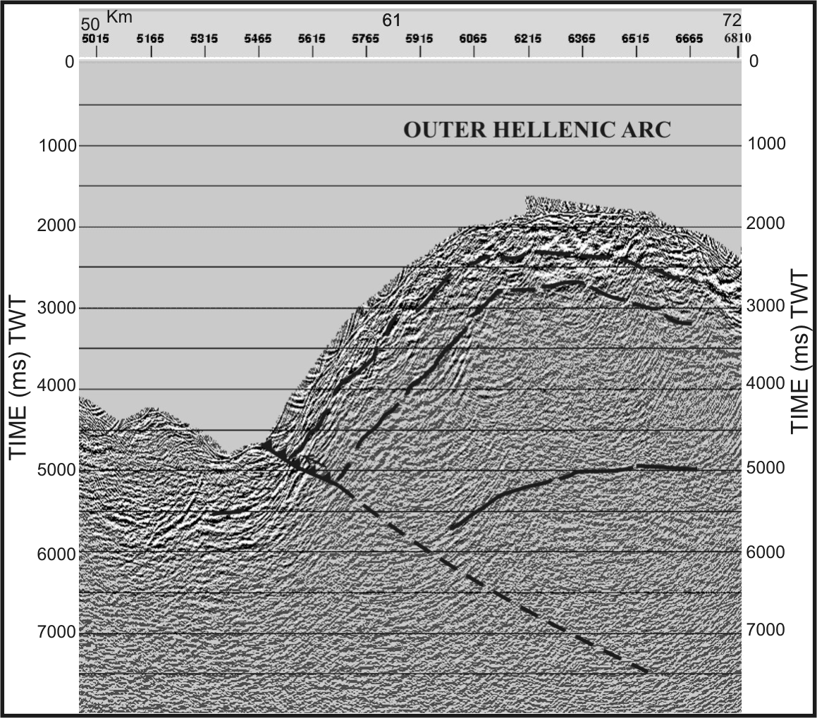
Figure 7 Migrated seismic section of the study area. The main reflectors and tectonic feature are marked by dashed line.

