New Inferences on Magma Dynamics in Melilitite-Carbonatite Volcanoes: The Case Study of Mt. Vulture (Southern Italy)
G. Carnevale¹, A. Caracausi², S. G. Rotolo^{1,2}, M. Paternoster^{2,3}, and V. Zanon⁴
¹ Dipartimento di Scienze della Terra e del Mare, Università degli Studi di Palermo, Palermo, Italy, ² Istituto Nazionale di Geofisica e Vulcanologia, Sezione di Palermo, Palermo, Italy, ³ Dipartimento di Scienze, Università degli Studi della Basilicata, Potenza, Italy, ⁴ Instituto de Vulcanologia e Avaliação de Riscos, Universidade dos Açores, Ponta Delgada, Portugal
Corresponding author: Gabriele Carnevale (gabriele.carnevale@unipa.it)

Key Points:
- Micro-thermometric analyses show the occurrence of high-density CO₂-rich fluid inclusions hosted by minerals within wehrlite xenoliths
- Ascent rate between melilitite-carbonatite (≈ 20 m/s) and kimberlite (≈ 45 m/s) magma is comparable
- Melilitite-carbonatite volcanoes can be hazardous even after long time of quiescence (> 10⁵ years)

Abstract
This study provides the first micro-thermometric data of fluid inclusions in mafic loose (disaggregated) xenocrysts and ultramafic xenoliths in explosive products of the melilitite-carbonatite Mt. Vulture volcano (southern Italy). Pure CO₂ late stage fluid inclusions hosted in rock-forming minerals of wehrlite xenoliths and clinopyroxene xenocrysts were trapped at the local crust-mantle boundary (32 km). In contrast, trapping pressures within the loose olivine xenocrysts are from 3.2 to 4.5 kbar (8-13 km). Considering the ongoing degassing of mantle-derived CO₂ rich gases, together with seismic evidences of the presence of low amount of melts at depth, and the tectonic control of the past volcanic activity, our study opens new perspective about the hazardous nature of the “quiescent” melilitite-carbonatite volcanoes.
Plain Language Summary
The study of fluid inclusions (small amount of fluid trapped within minerals) provides important information on variable environments and magmatological processes in which the host minerals were formed. Investigation of the fluid inclusions with respect to their composition, trapping pressure and temperature, allow us to constrain magma ascent history. To understand the last explosive volcanic activity of Mt. Vulture volcano (southern Italy), we investigated fluid inclusions in mafic minerals and mantle fragments brought to the surface by a melilitite-carbonatite magma. Our results show the presence of CO₂-rich fluid inclusions with trapping pressure corresponding to a depth of 32 km in mantle fragments, and a shallower depth (8-13 km) in mafic mineral. Estimates on magma ascent rate show rapid ascent dynamics to the surface. Our study emphasizes the importance of a multidisciplinary approach that combine geochemistry and petrology to investigate a volcanic system even if the volcano is considered “quiescent”, as is the case of Mt. Vulture volcano, where mantle degassing is still ongoing.

1 Introduction

Carbonatite magmatism is mainly associated with intraplate continental tectonic settings characterized by significant extension and even rifting, with a temporal distribution from Archean to the present (e.g., Jones et al., 2013; Woolley & Kjarsgaard, 2008; Yaxley et al., 2022), and currently, Oldoinyo Lengai (Tanzania) represents the only active carbonatite volcano, characterized by a natrocarbonatitic affinity (e.g., Berkesi et al., 2020). The growing number of carbonatite occurrences from unconventional tectonic settings, such as oceanic contexts (e.g., Carnevale et al., 2021; Day, 2022; Doucelance et al., 2010; Mata et al., 2010; Schmidt & Weidendorfer, 2018) or subduction zones (e.g., D’Orazio et al., 2007; Li et al., 2018; Lustrino et al., 2019, 2020), received considerable attention during last two decades, given their importance as source of rare elements such as La, Ce, Pr and Nd (Anenburg et al., 2021; Verplanck et al., 2016), and, most importantly, because they provide meaningful information on the geochemical cycle of carbon and mantle metasomatism as well (e.g., Bouabdellah et al., 2010; Horton, 2021).

Mt. Vulture (southern Italy) is an isolated volcano located between the Apulia foreland and the eastern side of the Apennine orogenic belt, in correspondence of the geodynamic context of the Apennine subduction zone (D’Orazio et al., 2007; Peccerillo, 2017). This volcano is located along the deep NE-SW lithospheric faults that represent a local vertical tear of the slab (e.g., Rosenbaum et al., 2008), a potential pathway for the ascent of melts (Caracausi et al., 2013a; D’Orazio et al., 2007).

The Vulture volcano is a small volcanic complex, with several eccentric eruptive vents, covering an area of approximately 70 km². Its eruptive activity started about 739 ± 12 ka (Villa & Buettner, 2009) and it continued until to 141 ± 11 ka (Villa & Buettner, 2009), with long inter-eruptive quiescence (> 10⁵ years, Buettner et al., 2006). The last volcanic event was a maar-forming eruption (Stoppa & Principe, 1997). Water of the two resulting crater lakes (Monticchio Lakes) dissolves CO₂-rich mantle-derived volatiles (Caracausi et al., 2009, 2013b; Paternoster et al., 2016), supporting the active degassing at this volcano (Caracausi et al., 2009, 2015). The last volcanic activity (identified as Monticchio Lakes Formation, Stoppa & Principe, 1997), fed by a melilitite-carbonatite magma, brought to the surface some pelletal lapilli (enclosing abundant ultramafic mantle xenoliths and xenocrysts) considered to be juvenile component, because they represent the interface between the erupting magma and the volatile component (Lloyd & Stoppa, 2003). These products are particularly useful to characterize the mantle source beneath Vulture volcano, providing important information about the melilitite-carbonatite magma ascent path and its mantle source.

To this aim, micro-thermometric data of fluid inclusions (FIs), hosted in the ultramafic xenolith cores of pelletal lapilli and in loose olivine and clinopyroxene xenocrysts, have been used together with mineral chemistry in order to describe the way in which these very particular magmas are transported to the surface and the possible implications in terms of volcanic hazard.

2 Sample Description

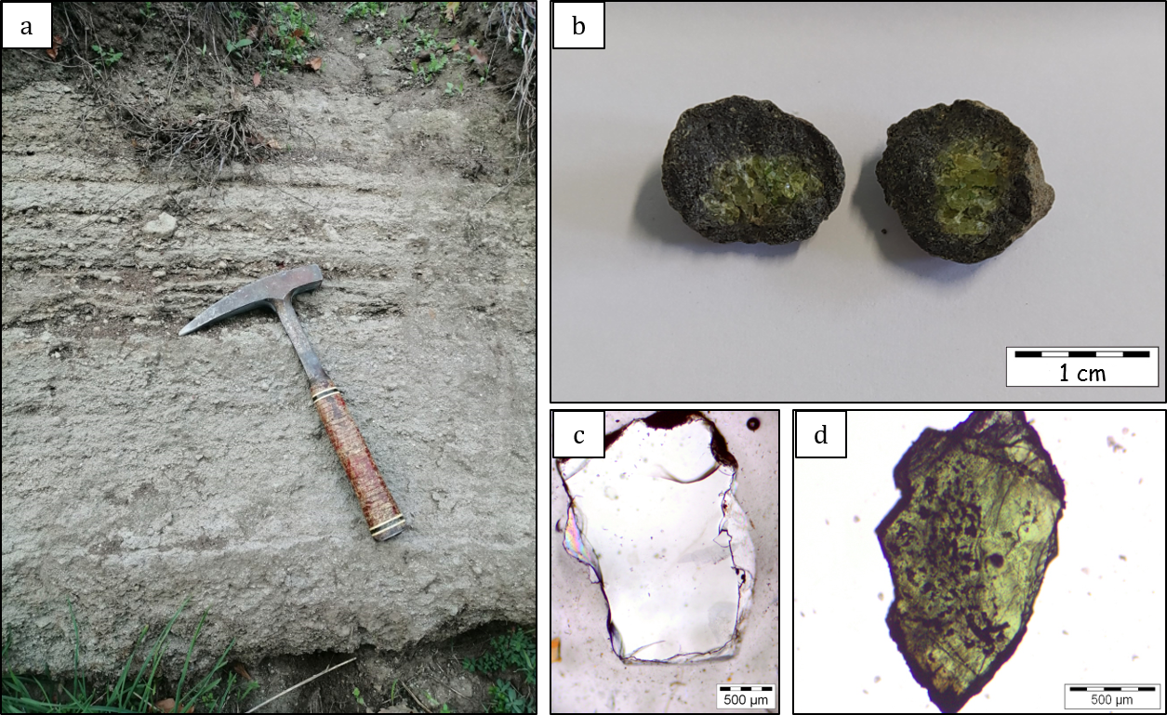
Samples were collected from the Lago Piccolo Subsynthem (Giannandrea et al., 2006) (Figure S1). Twenty-nine pelletal lapilli were sampled from a compact fine-grained carbonate-dominated matrix in an ash-tuff phreatomagmatic deposit. The ultramafic xenoliths (dominantly wehrlitic in modal composition) constitute the core of pelletal lapilli and are surrounded by a 3-10 mm thick rim of micro-phenocrysts (Figures 1a and 1b). We also selected approximately 200 olivine and 100 clinopyroxene (Cr-diopside) xenocrysts (Figures 1c and 1d) from the fine-grained carbonate-rich matrix, where xenocrysts of blackish clinopyroxene, amphibole, mica (phlogopite) and spinel, were also present. To compare the FIs within the xenocrysts with those trapped in the ultramafic xenolith cores of pelletal lapilli, we selected two wehrlite cores, three olivine and two clinopyroxene xenocrysts. We analysed 171 FIs in olivine xenocrysts, 107 in clinopyroxene xenocrysts, and 184 FIs in the ultramafic cores of studied lapilli, all being <10 µm in size and most of them in the range of 1-5 µm.

Figure 1. Photomicrographs of the sampling site together with pelletal lapilli and loose crystals. a) Ash-rich tuff surge deposit of Lago Piccolo Subsynthem. b) Pelletal lapilli with ultramafic xenolith cores. c) Olivine xenocryst from the fine-grained matrix (parallel polars). d) Clinopyroxene (Cr-diopside) xenocryst from the fine-grained matrix (parallel polars).

3 Results: Petrography, Mineral Chemistry and Fluid Inclusions

The ultramafic xenolith cores of pelletal lapilli (the diameter of enclaves vary from 6 to 17 mm) are characterised by the presence of Mg-rich olivine (Fo₉₀₋₉₁, NiO varying from 0.35 to 0.38 wt. %, Table S1) and diopside (Wo₄₆₋₄₈, En₄₇₋₄₈, Fs₄₋₅) with relatively high Cr₂O₃ content (1.3-1.5 wt. %, Table S2). The Mg# values of olivine and clinopyroxene in the ultramafic xenolith cores are uniform (0.90-0.92). The grain size of the ultramafic xenolith cores is fine- to medium-grained (300-600 µm) with granoblastic texture, interlocking with randomly oriented olivine and elongated clinopyroxene (Figure S2). The thick rim of fine-grained material surrounding the xenoliths, is composed essentially of häuyne micro-phenocrysts, with xenocrystic debris of olivine and clinopyroxene (Figure S3).

Olivine xenocrysts show very similar composition (Fo₈₉₋₉₂, NiO = 0.37-0.41 wt. %, Table S1) compared to olivine from the ultramafic xenolith cores of pelletal lapilli. Similarly, almost all clinopyroxene xenocrysts show akin composition (Wo₄₆₋₄₈, En₄₇₋₄₈, Fs₄₋₆, Cr₂O₃ = 0.4-1.3 wt. %) with respect to clinopyroxene from the ultramafic xenolith cores of pelletal lapilli (Table S2). The Mg# values in olivine and clinopyroxene xenocrysts are also uniform (0.89-0.92) (Figure S4).

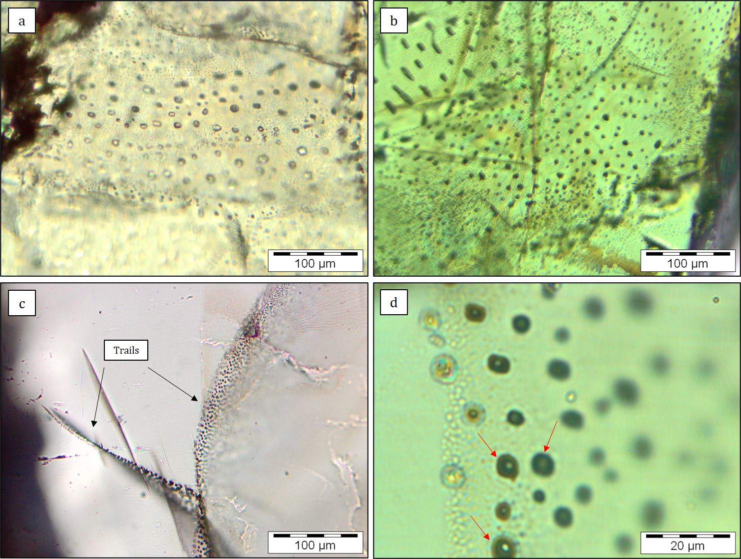
In all studied samples FIs are usually rounded and slightly stretched (Figures 2a-2d), and some of them form trails of variable length (0.1-1 mm), lined in sealed fractures (Figure 2c). Re-equilibration features in FIs are present (i.e., stretching and/or decrepitation process), as evidenced by the occurring of an outer dark halo around the FIs (Figure 2d). In the xenocrysts, secondary FIs (distinguished on the basis of their textural characteristics and distribution within the crystals, such as the presence of trails in sealed fractures) are more abundant than primary FIs and tend to be smaller than the primary ones. On the contrary, in olivine and clinopyroxene in the ultramafic cores of pelletal lapilli, early stage FIs are more abundant than late stage FIs. The studied FIs are characterised by pure CO₂, with melting temperatures (Tm) ranging in a very narrow interval between -56.6 (i.e., the triple point of pure CO₂ at 1 bar) and -56.8 °C ± 0.1. All FIs homogenized to a liquid phase with temperatures of homogenization (Th_{L}) ranging from 11.5 to 30.2 °C and from -20.0 to 13.2 °C, respectively for olivine and clinopyroxene xenocrysts, and corresponding to density range (ρ) of 0.58-0.85 g/cm³ and 0.84-1.03 g/cm³. In FIs hosted in ultramafic xenoliths, Th_{L} range from -27.3 to -8.5 °C (ρ = 0.98-1.06 g/cm³) in clinopyroxene crystals, and from -27.7 to -6.0 °C (ρ = 0.96-1.07 g/cm³) in olivine crystals. Values of Th_{L}, densities, corrected densities and number of measures are reported in Table S3. Further details, also about analytical methods, are reported in Supporting Information S1.

Figure 2. Photomicrographs (parallel polars) of FIs and their textural position. FIs enclosed by a) olivine and b) clinopyroxene xenocrysts. c) Intragranular trails (black arrows) of FIs in olivine xenocryst. (d) FIs with decrepitation features (red arrows) in clinopyroxene from the ultramafic core of a pelletal lapillus.

4 Significance of Fluid Inclusions Data

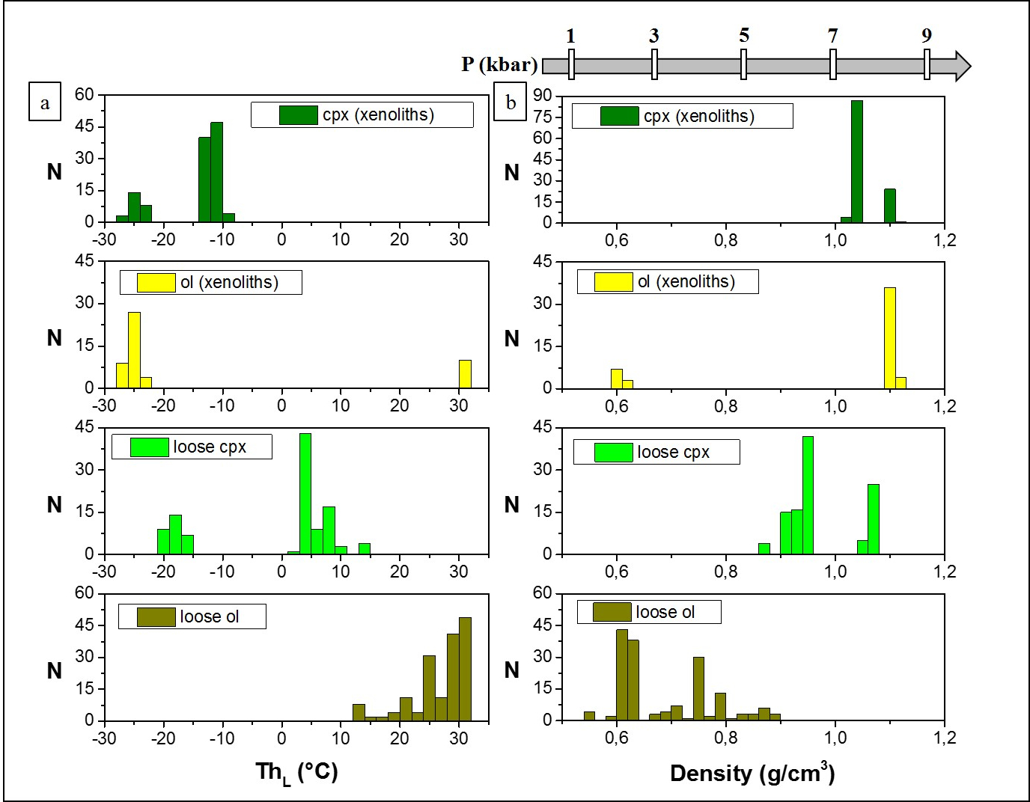
Histograms of homogenization temperatures (Figure 3a) and densities (Figure 3b) show polymodal skewed distributions. These distributions are due to fluid trapping episodes and re-equilibration that occur at different depth of the volcanic system. The highest corrected density values of FIs are in the ultramafic xenoliths (1.10-1.11 g/cm³), corresponding to minimum fluid pressure between 8.5 and 9.0 kbar (≈ 27-28 km). In the clinopyroxene xenocrysts FIs recorded fluid pressure of 8.2-8.7 kbar (≈ 26-27 km) and 6.7-7.2 kbar (≈ 21-22 km). FIs in olivine xenocrysts show fluid pressures of 2.8-3.1 kbar (≈ 8-9 km) and 4.1-4.5 kbar (≈ 12-13 km). The low-density peak (ρ = 0.63 g/cm³) is also present in ultramafic xenoliths. Trapping pressures and densities were estimated at the equilibrium temperature of 1100 °C, that is an intermediate value of the temperature in the range 1050-1150 °C previously inferred by Jones et al. (2000) on pyroxenes from mantle xenoliths.

Figure 3. Frequency distribution of a) homogenization temperatures (Th_{L}) and (b) densities of FIs hosted in olivine and clinopyroxene xenocrysts and in ultramafic cores of pelletal lapilli from Mt. Vulture. The number of the total measurements (N) is reported to the left of each graph.

All FIs show stretching and, most importantly, partial decrepitation process (Figure 2d), which is evidence of volumetric re-equilibration at high strain rates associated with a short-time scale event (e.g., Bodnar, 2003), and this is supported also by the skewed distribution of histograms. The pristine density of trapped fluid was therefore lowered during crustal ascent. Magma ascending through the lithosphere halted at important discontinuities marked by changes in chemical and physical properties of country rocks (Menand, 2011), the most important being the crust-mantle boundary. This is the case of the common depth registered by FIs in ultramafic xenoliths and clinopyroxene xenocrysts. Olivine composition (Fo% > 0.90, NiO > 0.35 wt.%), clinopyroxene Cr content (Cr₂O₃ > 1.3 wt. %) and spinel Cr# (Cr/Cr+Al) (> 0.38), strongly suggest that the studied wehrlitic cores are of mantle origin and are not cumulates produced by fractional crystallization in shallow level magma ponding stages (Beccaluva et al., 2002), although cumulates can be also formed by underplating in the vicinity of Moho (e.g., Kovács et al., 2004). Furthermore, the xenoliths have no cumulative or poikilitic textures, they lack plagioclase that often occurs in cumulates, and the chemical composition overlaps well with other xenoliths from previous studies (Figure S4). Coherently with the crust-mantle boundary inferred beneath the Vulture area with geophysical methods (magnetism and gravimetry) at a depth of about 32 km (Kelemework et al., 2021), the re-equilibration processes lowered by about 15 % the fluid density at the time of trapping. Thus, the xenoliths probably represent the shallowest upper mantle, and the FIs in the rock-forming minerals of these xenoliths suggest a minimum trapping pressure of 9-10 kbar, which is around the local Moho. FIs in loose clinopyroxene xenocrysts suggest a minimum trapping pressure of 7-9 kbar. Therefore, if we consider these clinopyroxenes as fragments of the xenoliths (as also witnessed by their similar chemical composition) it is likely that they crystallized nearby the Moho. The crystallization of loose olivine xenocrysts may have taken place at shallower, crustal depths, with FIs suggesting a minimum trapping pressure of 3-4 kbar.

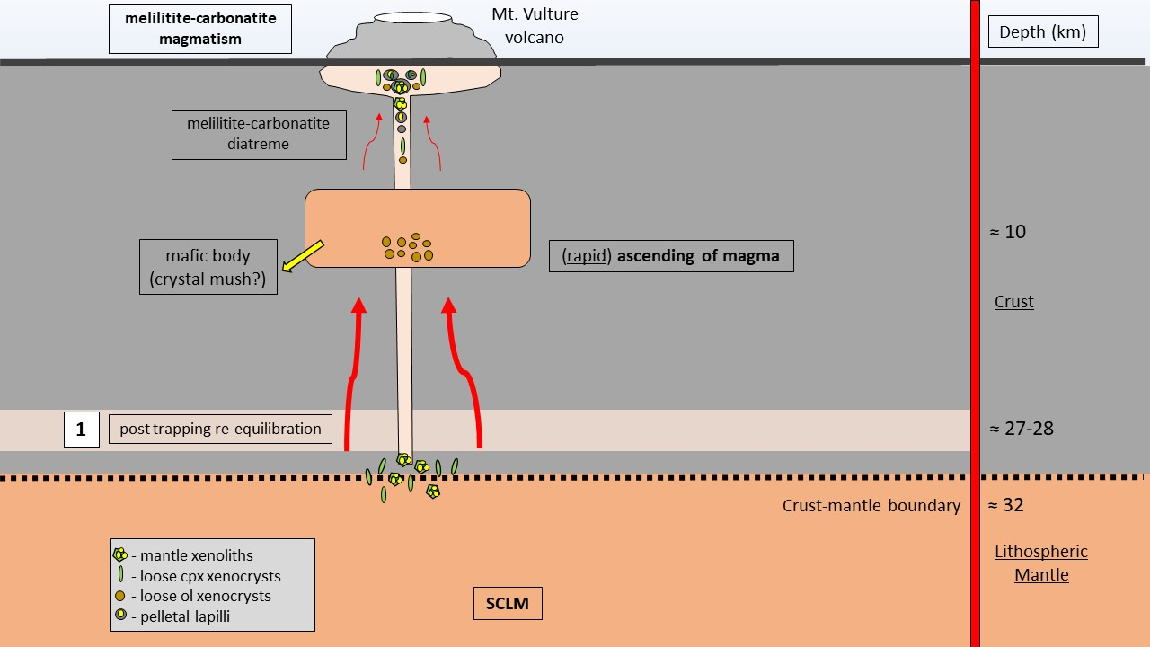
It is worthy of note that the shallowest trapping event in olivine xenocrysts occurring at depth of 8-13 km overlaps the depth (6-15 km) of a mafic body, probably a dense crystal mush, within the Vulture volcano magma system. Petrological investigation located a shallow magma reservoir down to 6 km (Beccaluva et al., 2002). To resume, the micro-thermometric data here presented and obtained from the crystal content from a single eruption, show a very good agreement with both geophysical and petrological data for this volcano. Figure 4 shows a simplified schematic profile view of Vulture volcano with our considerations.
Figure 4. Simplified cross section of Vulture volcano ponding stages. Olivine and clinopyroxene of wehrlite cores of pelletal lapilli, together with clinopyroxene xenocrysts register the same fluid trapping event at the local crust-mantle boundary. Olivine xenocrysts show a shallower signature of fluid entrapment, overlapping the depth of the mafic body within the Mt. Vulture magma system (Improta et al., 2014). The involvement of a carbon-rich subcontinental lithospheric mantle (SCLM) is from Bragagni et al. (2022).

5 Carbonatite Metasomatism and Magma Ascent Dynamics

The study of mantle xenoliths represents a great tool to understand the composition and possible modification of a mantle source influenced by metasomatic fluids. In this framework, the increase of modal clinopyroxene at the expense of orthopyroxene has been interpreted as a result of the interaction between ultramafic material and carbonate melts, and carbonatite metasomatism is accompanied by the formation of secondary clinopyroxene formed during the reaction of carbonatite melts with orthopyroxene (Dalton & Wood, 1993; Russell et al., 2012). Although interaction between peridotite wall rock and alkaline mafic melts normally lead to clinopyroxene enrichment in the mantle, with the consequent formation of wehrlites (e.g., Patkó et al., 2020), in our case study, the process of “wehrlitization” in the lithospheric mantle is primary due to carbonate melts instead of mafic silicate melts.

Among the Mt. Vulture mantle products, the presence of wehrlite xenoliths is widely recognized (e.g., Beccaluva et al., 2002; Downes et al., 2002; Jones et al., 2000) and is corroborated by our findings where pelletal lapilli cores are largely wehrlitic. According to Zong and Liu, (2018), specific crystallochemical patterns in clinopyroxenes (e.g., Mg# vs. Ca/Al; Ca/Al vs. ⁸⁷Sr/⁸⁶Sr) fall into the mantle-related carbonate metasomatism field (Figure S5), and (La/Yb)_{N} ratios (> 3-4), further suggest carbonatite metasomatism (Coltorti et al., 1999). Furthermore, the presence of carbonates and apatites in some wehrlites of the Mt. Vulture (Downes et al., 2002; Jones et al., 2000), reinforce the role of carbonatite melts instead of silicate melts in metasomatizing the wehrlite xenoliths. Rosatelli et al. (2007) also propose carbonatite melts as the main metasomatism agent of Mt. Vulture mantle source region, emphasizing the role of silicate-carbonatite magma immiscibility during the magma evolution at shallower depths (Solovova et al., 2005), supported by a number of experimental constrains underlying melilititic magma (the last erupted at Vulture volcano) as the best candidate to exsolve an immiscible carbonatite melt (Brooker & Kjarsgaard, 2011). Further evidence of metasomatism by carbonatite melts is given by the presence of interstitial calcite associated with Fe-Ni-sulphides between olivine grains in a mantle xenolith from Mt. Vulture (Blanks et al., 2020).

Despite the last eruptive event of Mt. Vulture dates back to 141 ± 11 ka (Villa & Buettner, 2009), geochemical evidences support that active degassing of mantle-derived volatiles is still ongoing in Mt. Vulture area (Caracausi et al., 2009, 2013a), showing how the relationship between the deep CO₂ release and the time of its last eruption could be an important tool for evaluating the state of current activity (Caracausi et al., 2015). Moreover, recent studies show how the source of CO₂ degassing in Mt. Vulture area is related to the presence of a subcontinental lithospheric mantle (SCLM), that sequesters large amounts of CO₂ due to the infiltration of fluids and melts during carbonatite-like metasomatism (Bragagni et al., 2022). In this scenario the He isotopic signature in fluid inclusions of the Vulture mantle xenoliths (<6.1Ra; Ra is the He isotopic signature in air) overlap the range of the SCLM He end member (6.1 ± 0.9; Gautheron & Moreira, 2002).

Considering, 1) the degassing of mantle-derived fluids in Mt. Vulture area (Caracausi et al., 2009, 2013a, 2013b, 2015), 2) the explosive behaviour associated with a maar-diatreme system of the Monticchio Lakes Synthem (Solovova et al., 2005; Stoppa & Principe, 1997), 3) the occurrence of small amounts of magma at the crust-mantle boundary depth (< 1.6 %, Tumanian et al., 2012), in absence of mantle upwelling or extensional tectonics that could favour decompression melting (Peccerillo & Frezzotti, 2015), 4) the role of tectonics in the transfer of the mantle-derived magma and volatiles and its control of the Vulture volcanism and outgassing (e.g., Caracausi et al., 2013a; D’Orazio et al., 2007; Rosenbaum et al., 2008), 5) the long inter-eruptive periods (> 140 ka, Buettner et al., 2006) and 6) the recognized occurring of volatiles rich magmas at the crust-mantle boundary (Section 4, Significance of Fluid Inclusions Data), we computed by using a simplified model the possible melilitite-carbonatite magma ascent rate to figure out fast vs. slow uprise of these magmas from the crust-mantle boundary, furnishing new elements to the knowledge of Mt. Vulture activity. In order to constrain the ascent velocity of the melilitite-carbonatite magma, we used the equation from Lister and Kerr (1991) and applied by Sparks et al. (2006) in their physical model, with the same approach also proposed by Moussallam et al. (2016).

Taking into consideration (i) a closed system during the magma ascent with a constant dike width of 1 m, (ii) a magma density of 2500 kg/m³, (iii) a constant viscosity of 0.6 Pa s, and (iv) a mean density of the crust of 2600 kg/m³, we obtain ascent rate of about 17 m/s (equation (8) from Sparks et al. 2006), assuming that the buoyancy is the main driving force. As there are no previous works that can help to fix the dike width in our case study, we assumed the unity (1 m) as a conservative dimension value, with the awareness of the non-linear correlation between the dike width and magma ascent rate, and the effect of different variables on dike propagation (e.g., uneven stress distribution within the crust). Magma viscosity value is taken from experimental studies of a representative melilitite synthetic melt (Stagno et al., 2020). Magma density is calculated using the model of Ochs and Lange (1999) at 1100 °C and 10 kbar, assuming a bulk composition from Stoppa and Principe (1997) with SiO₂ = 37 wt. %, and a mean CO₂ value of 7.5 wt. %, obtained from the H₂O-CO₂ solubility model proposed by Moussallam et al. (2016). Indeed, if we consider their model for a low SiO₂- and H₂O-free melts (our fluid inclusions study indicates the presence of pure CO₂ as the main volatile phase), at about 30 km depth, we obtain bulk CO₂ concentration between 5 and 10 wt. %. The model of Moussallam et al. (2016) is applied to a kimberlite magmatism (and to basalt magmatism) with 25 wt. % ≤ SiO₂ ≤ 32 wt. %, and it is comparable to the melilitite-carbonatite magmatism of Monticchio Lakes Syntheme with SiO₂ < 40 wt. % (Stoppa & Principe, 1997).

Our result of the ascent rate of the melilitite-carbonatite magma is in the same order of the ascent rates of kimberlite magmatism (e.g., Kelley & Wartho, 2000; Moussallam et al., 2016) and more than two times faster if compared with ascent rate calculated from other volcanic complexes where CO₂-rich fluid inclusions in metasomatized upper mantle xenoliths occur (e.g., 5 m/s, Szabó & Bodnar, 1996). In our simplified modelling the melilitite-carbonatite magmas could reach the surface from the depth of 30 km in less than an hour, considering, however, a single fast event without taking into account possible ponding level at crustal depth. If we consider also recent studies showing how volcanic systems where activity has remained dormant for protracted periods (> 100 ka) still have the potential for reactivation (e.g., Giordano & Caricchi, 2022; Harangi et al., 2015; Molnár et al., 2018, 2019), and in Mt. Vulture there is a possible link between the development of tear faults, magmatism and related magma ascent along these tectonic pathways (Peccerillo, 2017; Rosenbaum et al., 2008), our study highlight that the volcanological community should pose great attention to volcanic hazard in melilitite-carbonatite volcanoes, and it should be carefully evaluated even after long time of quiescence.

6 Conclusion

We analysed FIs hosted in rock-forming minerals of the wehrlitic cores of pelletal lapilli and in xenocrysts of olivine and clinopyroxene brought to the surface by a melilitite-carbonatite magma from the last eruption of Vulture volcano (Monticchio Lakes Syntheme, Lago Piccolo Subsynthem). We found pure CO₂ FIs with different trapping pressures (from 3.2 to 10.3 kbar) that correspond to magma storage at different depths within the volcano plumbing system. The deepest ponding stage is represented by the crust-mantle boundary (at a 32 km depth), while the shallower corresponds to a solidified magmatic body (former crystal mush) imaged by geophysical investigations (Improta et al., 2014). Modelling magma ascent rate results in quite high velocity (≈ 20 m/s) for melilitite-carbonatite magma from the crust-mantle boundary to the surface, and it is comparable with ascent rate of kimberlite magmatism (e.g., ≈ 45 m/s, Moussallam et al., 2016). These evidences, coupled to (i) the outgassing of magmatic volatiles at Mt. Vulture, which isotopic signature correspond to those in the FIs of the last activity of the volcano (Caracausi et al., 2009, 2013a), and to (ii) the presence of small amounts of melt (< 1,6%) at the crust-mantle boundary depth, add constraints for magma production and ascent pathways. Therefore, this study confirms that the scientific community must pay attention also to the inactive volcanoes, because they could be still hazardous systems notwithstanding the last volcanic activity occurred hundreds/thousands of years ago.
Data Availability Statement
The complete data set of chemical and micro-thermometric analyses of this study was uploaded to the Zenodo FAIR aligned repository (www.zenodo.org) and will be available for download at the required link: Carnevale et al. (2022). Micro-thermometry and minerochemical composition of ultramafic xenoliths and minerals from Mt. Vulture volcano (southern Italy) [Data set]. Zenodo. https://doi.org/10.5281/zenodo.6426785. Accessed 9 April 2022.
Acknowledgments
This study was partially funded by Fundação para a Ciência e Tecnologia, Portugal (MAGAT project, ref. CIRCNA/OCT/0016/2019). The Instituto de Investigação em Vulcanologia e Avaliação de Riscos (IVAR), Universidade dos Açores, is acknowledged for hosting GC and providing access to analytical facilities. We are grateful to F. Langone for sampling of some investigated pelletal lapilli, and to D. Mannetta for his contribution in sample preparation. We are grateful to the editors for the editorial assistance. We also thank L. Patkó and an anonymous reviewer, whose helpful comments and suggestions significantly improved the quality of the manuscript.
References
Anenburg, M., Broom-Fendley, S., & Chen, W. (2021). Formation of Rare Earth Deposits in Carbonatites. Elements, 17(5), 327–332. https://doi.org/10.2138/gselements.17.5.327
Beccaluva, L., Coltorti, M., Di Girolamo, P., Melluso, L., Milani, L., Morra, V., & Siena, F. (2002). Petrogenesis and evolution of Mt. Vulture alkaline volcanism (Southern Italy). Mineralogy and Petrology, 74(2–4), 277–297. https://doi.org/10.1007/s007100200007
Berkesi, M., Bali, E., Bodnar, R. J., Szabó, Á., & Guzmics, T. (2020). Carbonatite and highly peralkaline nephelinite melts from Oldoinyo Lengai Volcano, Tanzania: The role of natrite-normative fluid degassing. Gondwana Research, 85, 76-83. https://doi.org/10.1016/j.gr.2020.03.013
Blanks, D. E., Holwell, D. A., Fiorentini, M. L., Moroni, M., Giuliani, A., Tassara, S., et al. (2020). Fluxing of mantle carbon as a physical agent for metallogenic fertilization of the crust. Nature Communications, 11(1). https://doi.org/10.1038/s41467-020-18157-6
Bodnar, R. J. (2003). Reequilibration of fluid inclusions. In: I. Sampson, A. Anderson, D. Marshall (Eds.), Fluid Inclusions: Analysis and Interpretation (Vol. 32, pp. 213-230). Blacksburg, VA: Mineralogical Association of Canada.
Bouabdellah, M., Hoernle, K., Kchit, A., Duggen, S., Hauff, F., Klügel, A., et al. (2010). Petrogenesis of the Eocene Tamazert continental carbonatites (Central High Atlas, Morocco): Implications for a common source for the Tamazert and Canary and Cape Verde Island carbonatites. Journal of Petrology, 51, 1655–1686. https://doi.org/10.1093/petrology/egq033
Bragagni, A., Mastroianni, F., Münker, C., Conticelli, S., & Avanzinelli, R. (2022). A carbon-rich lithospheric mantle as a source for the large CO₂ emissions of Etna volcano (Italy). Geology, 50(4), 486–490. https://doi.org/10.1130/g49510.1
Brooker, R. A., & Kjarsgaard, B. A. (2011). Silicate-carbonate liquid immiscibility and phase relations in the system SiO₂-Na₂O-Al₂O₃-CaO-CO₂ at 0·1-2·5 GPa with applications to carbonatite genesis. Journal of Petrology, 52, 1281−1305. https://doi.org/10.1093/petrology/egq081
Buettner, A., Principe, C., Villa, I. M., & Bocchini, D. (2006). Geocronologia ³⁹Ar-⁴⁰Ar del Monte Vulture. In C. Principe (Ed.), La Geologia del Monte Vulture (pp. 73–86). Lavello.
Caracausi, A., Nuccio, P. M., Favara, R., Nicolosi, M., & Paternoster, M. (2009). Gas hazard assessment at the Monticchio crater lakes of Mt. Vulture, a volcano in Southern Italy. Terra Nova, 21(2), 83–87. https://doi.org/10.1111/j.1365-3121.2008.00858.x
Caracausi, A., Martelli, M., Nuccio, P. M., Paternoster, M., & Stuart, F. M. (2013a). Active degassing of mantle-derived fluid: A geochemical study along the Vulture line, southern Apennines (Italy). Journal of Volcanology and Geothermal Research, 253, 65–74. https://doi.org/10.1016/j.jvolgeores.2012.12.005
Caracausi, A., Nicolosi, M., Nuccio, P. M., Favara, R., Paternoster, M., & Rosciglione, A. (2013b). Geochemical insight into differences in the physical structures and dynamics of two adjacent maar lakes at Mt. Vulture volcano (southern Italy). Geochemistry, Geophysics, Geosystems, 14(5), 1411–1434. https://doi.org/10.1002/ggge.20111
Caracausi, A., Paternoster, M., & Nuccio, P. M. (2015). Mantle CO₂ degassing at Mt. Vulture volcano (Italy): Relationship between CO₂ outgassing of volcanoes and the time of their last eruption. Earth and Planetary Science Letters, 411, 268–280. https://doi.org/10.1016/j.epsl.2014.11.049
Carnevale, G., Caracausi, A., Correale, A., Italiano, L., & Rotolo, S. G. (2021). An overview of the geochemical characteristics of oceanic carbonatites: New insights from fuerteventura carbonatites (Canary islands). Minerals, 11(2). https://doi.org/10.3390/min11020203
Carnevale, G., Caracausi, A., Rotolo, S. G., Paternoster, M., & Zanon, V. (2022). Micro-thermometry and minerochemical composition of ultramafic xenoliths and minerals from Mt. Vulture volcano (southern Italy) [Data set]. Zenodo. https://doi.org/10.5281/zenodo.6426785
Coltorti, M., Bonadiman, C., Hinton, R. W., Siena, F., & Upton, B. G. J. (1999). Carbonatite Metasomatism of the Oceanic Upper Mantle: Evidence from Clinopyroxenes and Glasses in Ultramafic Xenoliths of Grande Comore, Indian Ocean. Journal of Petrology, 40(1), 133–165. https://doi.org/10.1093/petroj/40.1.133
D’Orazio, M., Innocenti, F., Tonarini, S., & Doglioni, C. (2007). Carbonatites in a subduction system: The Pleistocene alvikites from Mt. Vulture (southern Italy). Lithos, 98(1–4), 313–334. https://doi.org/10.1016/j.lithos.2007.05.004
Dalton, J. A., & Wood, B. J. (1993). The compositions of primary carbonate melts and their evolution through wallrock reaction in the mantle. Earth and Planetary Science Letters, 119, 511–525. https://doi.org/10.1016/0012-821X(93)90059-I
Day, J. M. D. (2022). Noble gas isotope systematics in the Canary Islands and implications for refractory mantle components. Geochimica et Cosmochimica Acta, 331, 35–47. https://doi.org/10.1016/j.gca.2022.06.002
Doucelance, R., Hammouda, T., Moreira, M., & Martins, J. C. (2010). Geochemical constraints on depth of origin of oceanic carbonatites: The Cape Verde case. Geochimica et Cosmochimica Acta, 74, 7261–7282. https://doi.org/10.1016/j.gca.2010.09.024
Downes, H., Kostoula, T., Jones, A. P., Beard, A. D., Thirlwall, M. F., & Bodinier, J. L. (2002). Geochemistry and Sr-Nd isotopic compositions of mantle xenoliths from the Monte Vulture carbonatite-melilitite volcano, central southern Italy. Contributions to Mineralogy and Petrology, 144(1), 78–92. https://doi.org/10.1007/s00410-002-0383-4
Gautheron, C., & Moreira, M. (2002). Helium signature of the subcontinental lithospheric mantle. Earth and Planetary Science Letters, 199, 39–47. https://doi.org/10.1016/S0012-821X(02)00563-0
Giannandrea, P., La Volpe, L., Principe, C., & Schiattarella, M. (2006). Unità stratigrafiche a limiti inconformi e storia evolutiva del vulcano medio-pleistocenico di Monte Vulture (Appennino meridionale, Italia). Bollettino Della Societa Geologica Italiana, 125(1), 67–92.
Giordano, G., & Caricchi, L. (2022). Determining the State of Activity of Transcrustal Magmatic Systems and Their Volcanoes. Annual Review of Earth and Planetary Sciences, 50, 231–259. https://doi.org/10.1146/annurev-earth-032320-084733
Harangi, S., Lukács, R., Schmitt, A. K., Dunkl, I., Molnár, K., Kiss, B., et al. (2015). Constraints on the timing of Quaternary volcanism and duration of magma residence at Ciomadul volcano, east-central Europe, from combined U-Th/He and U-Th zircon geochronology. Journal of Volcanology and Geothermal Research, 301, 66–80. https://doi.org/10.1016/j.jvolgeores.2015.05.002
Horton, F. (2021). Rapid recycling of subducted sedimentary carbon revealed by Afghanistan carbonatite volcano. Nature Geoscience, 14(7), 508–512. https://doi.org/10.1038/s41561-021-00764-7
Improta, L., De Gori, P., & Chiarabba, C. (2014). New insights into crustal structure, Cenozoic magmatism, CO₂ degassing, and seismogenesis in the southern Apennines and Irpinia region from local earthquake tomography. Journal of Geophysical Research: Solid Earth, 119(11), 8283–8311. https://doi.org/10.1002/2013JB010890
Jones, A. P., Kostoula, T., Stoppa, F., & Woolley, A. R. (2000). Petrography and mineral chemistry of mantle xenoliths in a carbonate-rich melilititic tuff from Mt. Vulture volcano, southern Italy. Mineralogical Magazine, 64(4), 593–613. https://doi.org/10.1180/002646100549634
Jones, A. P., Genge, M., & Carmody, L. (2013). Carbonate melts and carbonatites. Reviews in Mineralogy and Geochemistry, 75, 289–322. https://doi.org/10.2138/rmg.2013.75.10
Kelemework, Y., Milano, M., La Manna, M., de Alteriis, G., Iorio, M., & Fedi, M. (2021). Crustal structure in the Campanian region (Southern Apennines, Italy) from potential field modelling. Scientific Reports, 11(1), 1–18. https://doi.org/10.1038/s41598-021-93945-8
Kelley, S. P., & Wartho, J. A. (2000). Rapid kimberlite ascent and the significance of Ar-Ar ages in xenolith phlogopites. Science, 289(5479), 609-611. https://doi.org/10.1126/science.289.5479.609
Kovács, I., Zajacz, Z., & Szabó, C. (2004). Type-II xenoliths and related metasomatism from the Nógrád-Gömör Volcanic Field, Carpathian-Pannonian region (northern Hungary–southern Slovakia). Tectonophysics, 393(1-4), 139-161. https://doi.org/10.1016/j.tecto.2004.07.032
Li, Y., Zhang, J., Mostofa, K. M. G., Wang, Y., Yu, S., Cai, Z., et al. (2018). Petrogenesis of carbonatites in the Luliangshan region, North Qaidam, northern Tibet, China: Evidence for recycling of sedimentary carbonate and mantle metasomatism within a subduction zone. Lithos, 322, 148–165. https://doi.org/10.1016/j.lithos.2018.10.010
Lister, J. R., & Kerr, R. C. (1991). Fluid-mechanical models of crack propagation and their application to magma transport in dykes. Journal of Geophysical Research, 96(B6), 49–77. https://doi.org/10.1029/91jb00600
Lloyd, F. E., & Stoppa, F. (2003). Pelletal Lapilli in Diatremes – Some Inspiration from the Old Masters. GeoLines, 15, 65–71.
Lustrino, M., Luciani, N., & Stagno, V. (2019). Fuzzy petrology in the origin of carbonatitic/pseudocarbonatitic Ca-rich ultrabasic magma at Polino (central Italy). Scientific Reports, 9, 9212. https://doi.org/10.1038/s41598-019-45471-x
Lustrino, M., Ronca, S., Caracausi, A., Ventura-Bordenca, C., Agostini, S., & Faraone, D. B. (2020). Strongly SiO₂-undersaturated, CaO-rich kamafugitic Pleistocene magmatism in Central Italy (San Venanzo volcanic complex) and the role of shallow depth limestone assimilation. Earth-Science Reviews, 208, 103256. https://doi.org/10.1016/j.earscirev.2020.103256
Mata, J., Moreira, M., Doucelance, R., Ader, M., & Silva, L. C. (2010). Noble gas and carbon isotopic signatures of Cape Verde oceanic carbonatites: Implications for carbon provenance. Earth and Planetary Science Letters, 291, 70–83. https://doi.org/10.1016/j.epsl.2009.12.052
Menand, T. (2011). Physical controls and depth of emplacement of igneous bodies: A review. Tectonophysics, 500(1-4), 11-19. https://doi.org/10.1016/j.tecto.2009.10.016
Molnár, K., Harangi, S., Lukács, R., Dunkl, I., Schmitt, A. K., Kiss, B., et al. (2018). The onset of the volcanism in the Ciomadul Volcanic Dome Complex (Eastern Carpathians): Eruption chronology and magma type variation. Journal of Volcanology and Geothermal Research, 354, 39–56. https://doi.org/10.1016/j.jvolgeores.2018.01.025
Molnár, K., Lukács, R., Dunkl, I., Schmitt, A. K., Kiss, B., Seghedi, I., et al. (2019). Episodes of dormancy and eruption of the Late Pleistocene Ciomadul volcanic complex (Eastern Carpathians, Romania) constrained by zircon geochronology. Journal of Volcanology and Geothermal Research, 373, 133–147. https://doi.org/10.1016/j.jvolgeores.2019.01.025
Moussallam, Y., Morizet, Y., & Gaillard, F. (2016). H₂O–CO₂ solubility in low SiO₂-melts and the unique mode of kimberlite degassing and emplacement. Earth and Planetary Science Letters, 447, 151–160. https://doi.org/10.1016/j.epsl.2016.04.037
Ochs, F. A., & Lange, R. A. (1999). The density of hydrous magmatic liquids. Science, 283(5406), 1314–1317. https://doi.org/10.1126/science.283.5406.1314
Paternoster, M., Mongelli, G., Caracausi, A., & Favara, R. (2016). Depth influence on the distribution of chemical elements and saturation index of mineral phases in twins maar lakes: The case of the Monticchio lakes (southern Italy). Journal of Geochemical Exploration,163, 10–18. https://doi.org/10.1016/j.gexplo.2016.01.001
Patkó, L., Liptai, N., Aradi, L. E., Klébesz, R., Sendula, E., Bodnar, R. J., et al. (2020). Metasomatism-induced wehrlite formation in the upper mantle beneath the Nógrád-Gömör Volcanic Field (Northern Pannonian Basin): evidence from xenoliths. Geoscience Frontiers, 11 (3), 943–964. https://doi.org/10.1016/j.gsf.2019.09.012
Peccerillo, A., & Frezzotti, M. L. (2015). Magmatism, mantle evolution and geodynamics at the converging plate margins of Italy. Journal of the Geological Society, 172(4), 407–427. https://doi.org/10.1144/jgs2014-085
Peccerillo, A.. (2017). The Apulian Province (Mount Vulture). Advances in Volcanology, 203–216. https://doi.org/10.1007/978-3-319-42491-0_8
Rosatelli, G., Wall, F., & Stoppa, F. (2007). Calcio-carbonatite melts and metasomatism in the mantle beneath Mt. Vulture (Southern Italy). Lithos, 99(3–4), 229–248. https://doi.org/10.1016/j.lithos.2007.05.011
Rosenbaum, G., Gasparon, M., Lucente, F. P., Peccerillo, A., & Miller, M. S. (2008). Kinematics of slab tear faults during subduction segmentation and implications for Italian magmatism. Tectonics, 27(2), 1–16. https://doi.org/10.1029/2007TC002143
Russell, J. K., Porritt, L. A., Lavallé, Y., & Dingwell, D. B. (2012). Kimberlite ascent by assimilation-fuelled buoyancy. Nature, 481(7381), 352–356. https://doi.org/10.1038/nature10740
Schmidt, M. W., & Weidendorfer, D. (2018). Carbonatites in oceanic hotspots. Geology, 46, 435–438. https://doi.org/10.1130/G39621.1
Solovova, I. P., Girnis, A. V., Kogarko, L. N., Kononkova, N. N., Stoppa, F., & Rosatelli, G. (2005). Compositions of magmas and carbonate-silicate liquid immiscibility in the Vulture alkaline igneous complex, Italy. Lithos, 85(1-4 SPEC. ISS.), 113–128. https://doi.org/10.1016/j.lithos.2005.03.022
Sparks, R. S. J., Baker, L., Brown, R. J., Field, M., Schumacher, J., Stripp, G., & Walters, A. (2006). Dynamical constraints on kimberlite volcanism. Journal of Volcanology and Geothermal Research, 155(1–2), 18–48. https://doi.org/10.1016/j.jvolgeores.2006.02.010
Stagno, V., Stopponi, V., Kono, Y., D’arco, A., Lupi, S., Romano, C., et al. (2020). The viscosity and atomic structure of volatile‐bearing melilititic melts at high pressure and temperature and the transport of deep carbon. Minerals, 10(3), 1–13. https://doi.org/10.3390/min10030267
Stoppa, F., & Principe, C. (1997). Eruption style and petrology of a new carbonatitic suite from the Mt. Vulture Southern Italy /: The Monticchio Lakes Formation. Journal of Volcanology and Geothermal Research, 78(3–4), 251–265. https://doi.org/10.1016/S0377-0273(97)00004-8
Szabó, C., & Bodnar, R. J. (1996). Changing magma ascent rates in the Nograd-Gomor volcanic field northern Hungary southern Slovakia: evidence from CO₂-rich fluid inclusions in metasomatized upper mantle xenoliths. Petrology, 4(3), 240-249.
Tumanian, M., Frezzotti, M. L., Peccerillo, A., Brandmayr, E., & Panza, G. F. (2012). Thermal structure of the shallow upper mantle beneath Italy and neighbouring areas: Correlation with magmatic activity and geodynamic significance. Earth-Science Reviews, 114(3–4), 369–385. https://doi.org/10.1016/j.earscirev.2012.07.002
Verplanck, P. L., Mariano, A. N., & Mariano, A. (2016). Rare Earth Element Ore Geology of Carbonatites. Rare Earth and Critical Elements in Ore Deposits, 5–32. https://doi.org/10.5382/rev.18.01
Villa, I. M., & Buettner, A. (2009). Chronostratigraphy of Monte Vulture volcano (southern Italy): Secondary mineral microtextures and ³⁹Ar-⁴⁰Ar systematics. Bulletin of Volcanology, 71(10), 1195–1208. https://doi.org/10.1007/s00445-009-0294-6
Woolley, A. R., & Kjarsgaard, B. A. (2008). Carbonatite occurrences of the world: map and database. Geological Survey of Canada, 5796, 1–28. https://doi.org/https://doi.org/10.4095/225115
Yaxley, G. M., Anenburg, M., Tappe, S., Decree, S., & Guzmics, T. (2022). Carbonatites: Classification, Sources, Evolution, and Emplacement. Annual Review of Earth and Planetary Sciences, 50. https://doi.org/10.1146/annurev-earth-032320-104243
Zong, K., & Liu, Y. (2018). Carbonate metasomatism in the lithospheric mantle: Implications for cratonic destruction in North China. Science China Earth Sciences, 61(6), 711–729. https://doi.org/10.1007/s11430-017-9185-2
References From the Supporting Information
Bakker, R. J. (2003). Package FLUIDS 1. Computer programs for analysis of fluid inclusion data and for modelling bulk fluid properties. Chemical Geology, 194(1–3), 3–23. https://doi.org/10.1016/S0009-2541(02)00268-1
D’Orazio, M., Innocenti, F., Tonarini, S., & Doglioni, C. (2008). Reply to the discussion of: “Carbonatites in a subduction system: The Pleistocene alvikites from Mt. Vulture (Southern Italy)” by M. D’Orazio, F. Innocenti, S. Tonarini and C. Doglioni (Lithos 98, 313-334) by F. Stoppa, C. Principe and P. Giannandrea. Lithos, 103(3–4), 557–561. https://doi.org/10.1016/j.lithos.2007.10.010
Hansteen, T. H., & Klügel, A. (2008). Fluid inclusion thermobarometry as a tracer for magmatic processes. Reviews in Mineralogy and Geochemistry, 69(Roedder 1984), 143–177. https://doi.org/10.2138/rmg.2008.69.5
Scrocca, D., Sciamanna, S., Di Luzio, E., Tozzi, M., Nicolai, C., & Gambini, R. (2007). Structural setting along the CROP-04 deep seismic profile (Southern Apennines - Italy). Bollettino Della Società Geologica Italiana, Supplemento, 7, 283–296.
Sterner, S. M., & Bodnar, R. J. (1991). Synthetic fluid inclusions. X: Experimental determination of P-V-T-X properties in the CO₂-H₂O system to 6 kb and 700 °C. American Journal of Science, 291, 1–54. https://doi.org/https://doi.org/10.2475/ajs.291.1.1
Stoppa, F., Principe, C., & Giannandrea, P. (2008). Comments on: Carbonatites in a subduction system: The Pleistocene alvikites from Mt. Vulture (southern Italy) by d’Orazio et al., (2007). Lithos, 103(3–4), 550–556. https://doi.org/10.1016/j.lithos.2007.10.012

