Influence of Wind Speed on Volcano Ash Removal from Self-Cleaning Cover Films Dedicated for Photovoltaics
Aiman Roslizar, Member, IEEE, Jacopo Taddeucci, Ulrich W. Paetzold, Hendrik Hölscher and Bryce S. Richards, Senior Member, IEEE
Abstract— Soiling can significantly reduce the performance of photovoltaic (PV) modules. One source of soiling are volcano eruptions that eject dust contaminants, which can detrimentally affect PV systems. A microtextured fluoropolymer cover film for a PV module was evaluated as a passive anti-soiling solution. In this case, wind was investigated as a natural force to determine whether it can realize the desired self-cleaning functionality, instead of the more commonly employed water droplets. Removal of dust particles of different size categories were investigated inside a wind tunnel. The results demonstrate dust removal of up to ~90% from wind speeds of 8 m/s. Removal of small dust particles requires higher wind speeds compared to the larger dust particles. Smaller dust particles were observed to be trapped within the microtexture cavities. Based on a multi-crystalline PV mini-module, a performance recovery between 9.7–24.0% in terms of short-circuit current density (J_{SC}), relative to the soiled device, was projected. Utilization of wind for dust removal shows potential, but would require further optimization of the microtexture design to enhance the self-cleaning function.

Index Terms— Volcano ash, PV soiling, Microtextured cover film, Fluoropolymer, Wind removal

INTRODUCTION
T
HE performance of a photovoltaic (PV) system is strongly site dependent considering the environmental conditions of the location. A seldom studied but interesting phenomenon that can impact the performance of PV systems are volcano eruptions, with volcanic tephra being deposited on any exposed surfaces. This can be a far-reaching effect, with volcanic ash having been detected on PV modules that were located ~2700 km away [1]. Only a few studies have been reported on the impact of volcano residues on PV system output. From the study based on the 2010 eruption of Eyjafjallajökull volcano in Iceland, PV modules within a 300 km radius would have a high chance of being fully covered by volcanic tephra deposits, thus no longer producing any solar power [2]. Meanwhile, a 60 kW PV system installed at the University of Miyazaki, Japan, which is ~50 km away from the Shinmoedake volcano, suffered a ~67% performance drop due to volcanic ash deposition [3]. A more recent experimental work based on the volcanic ash from the Sakurajima volcano, Japan, reported a PV module power output reduction of > 40% [4]. This is made worse by the fact that volcanic pollutants can remain in the atmosphere for months due to the resuspension of deposited volcanic ash [5].
The problem of soiling is one that can severely reduce the output of a PV system unless a mitigation strategy is implemented. Several reviews can be found in the literature that provide a good overview of the wide range of mitigation strategies [6]–[10]. One soiling mitigation strategy is via surface modification to achieve a superhydrophobic self-cleaning top surface for a PV module [11]–[13]. This is a passive mitigation strategy, but the cleaning mechanism classically relies on naturally-occurring rainfall or water from an auxiliary system. Unfortunately, geographic locations that exhibit the highest solar energy potential are usually arid/semi-arid areas where water is scarce and rainfall is seasonal, at best, limiting the usefulness of such approaches [14], [15]. However, apart from rainfall, other potential forces in nature exist that can be harnessed to help remove deposited dust from PV modules, such as wind [15], gravity [16] and dew [17]. Due to the inter-relational complexity of these environmental aspects, this work will only focus on the investigation of wind as a factor to clean PV modules in cases where rainfall might not be abundant. With regards to volcanic ash, a recent work reports the resuspension of volcanic ash under the influence of wind, which indicates the potential to utilize wind for cleaning PV modules [18].
The study of PV soiling and dust removal has been widely reported over the past decades [6], [19]. Previous literature on mechanical dust removal reports that dust particles are displaced under three possible mechanisms: rolling, sliding, or lifting [20]. What determines if dust can be removed is whether the external force that acts upon the dust particles can overcome the adhesion between dust particles and the surface or the cohesion with other dust particles [21], [22]. Several factors that can influence the removal of dust, among others, includes dust particle size [21] and surface roughness [21], [23]. Thus, a lower surface contact area from the increased surface roughness of a microtextured cover film can reduce adhesion between the dust particles and the surface.
The flow characteristics, which are highly influenced by the surface roughness, also play a major role in dust removal. A turbulent flow will be more violent with changing velocity and direction, which will disrupt the static condition of deposited dust particles [24], [25]. Although this work will not include the observation of the flow profile, it was already widely reported that a microtextured surface will result in a turbulent flow due to its bulk roughness that can influence dust particle removal [26]–[28]. This suggests that a microtextured PV cover film has the potential to utilize wind for dust removal.
The investigation of dust removal in this work is conducted using artificial flows inside a wind tunnel. Removal of volcanic ash is compared to previously used reference dust particles: sea sand and Arizona test dust [11]. The dust removal capability is investigated by comparing the removal from a planar glass surface and a superhydrophobic microtextured surface. For simplicity, in terms of dust particles used, this work will only consider two different particle size categories in relation to the microtextures of the investigated superhydrophobic PV front cover film. Finally, the level of dust coverage is extrapolated (based on previous work [11]) to ascertain its effect on the PV parameters, most notably the short-circuit current density (J_{sc}).

Research Methodology
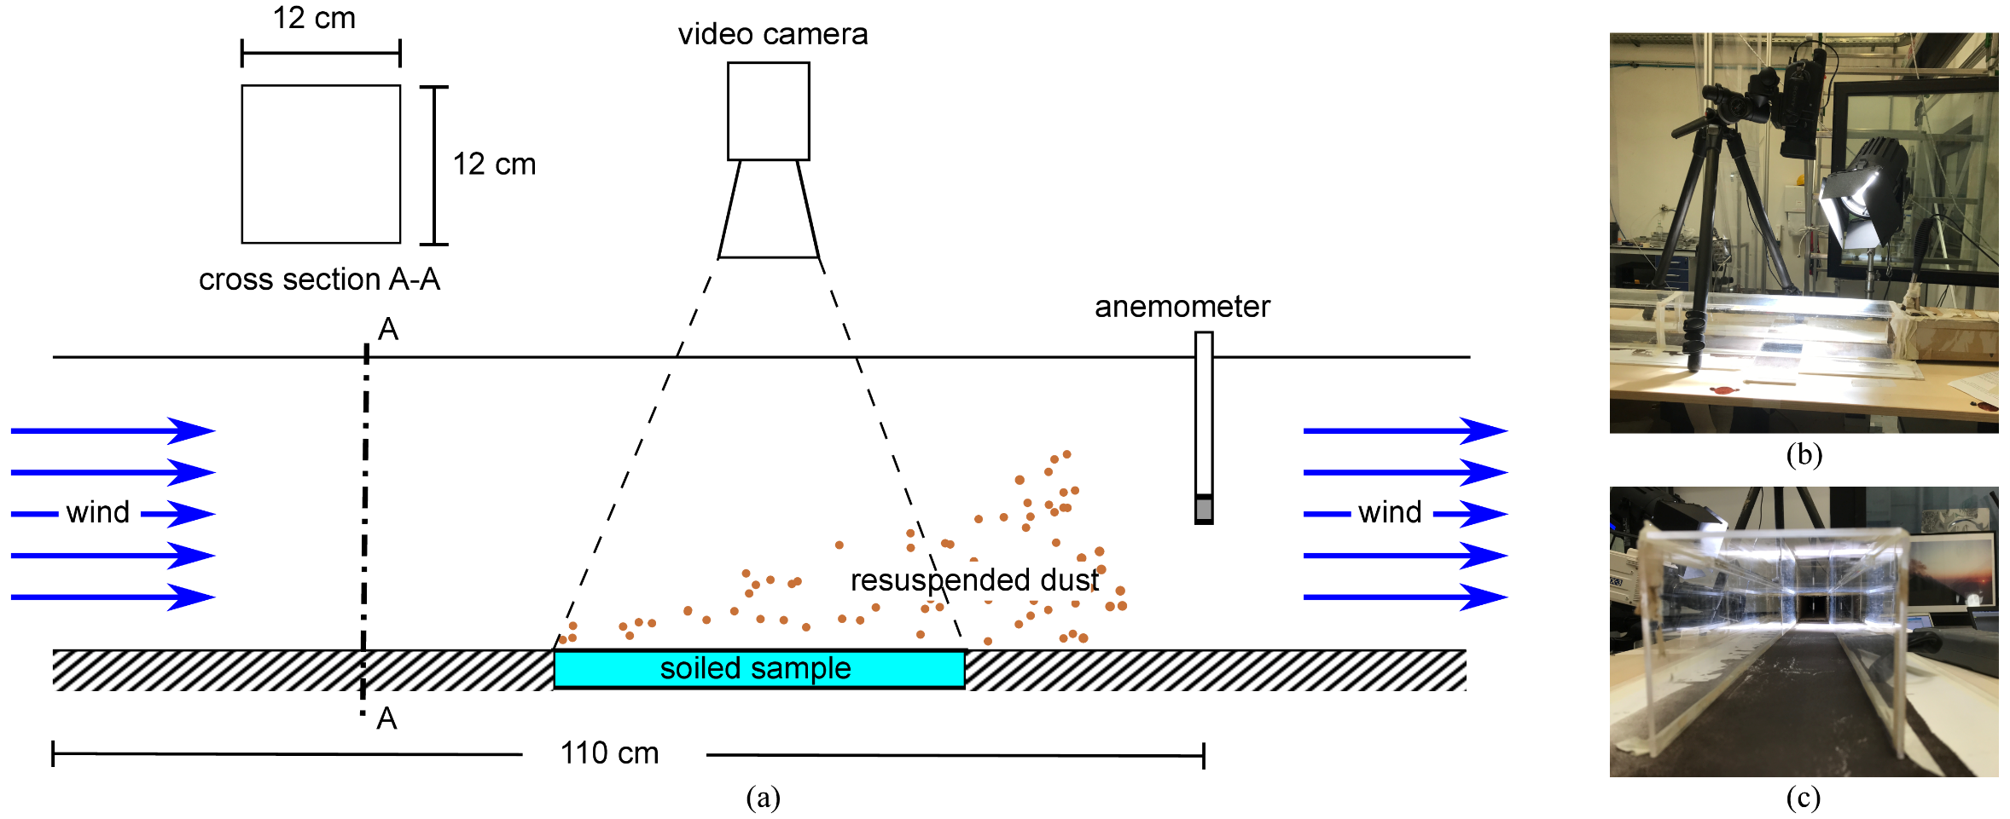This work compares the removal of dust contaminants from two different 10 cm × 10 cm surfaces: i) a planar low iron/borosilicate float glass surface (BF33, Schott, Germany); and ii) a superhydrophobic microtextured fluorinated ethylene propylene (FEP) surface. The former surface serves as a reference, being similar to the cover glass layer that is used in nearly all conventional PV modules. The latter microtextured FEP surface with an aspect ratio (height to diameter) of 0.7 was developed in a previous work as a superhydrophobic PV module cover layer [11]. The microtexture consists of hexagonally arranged microcones having a base diameter of 30 µm with a center-to-center spacing of 25 µm. From an optical property perspective, the microtextured FEP cover film results in a reduced reflectance by ~3.3% compared to a planar glass surface [11]. The small-area microcone-texture (1.1 cm × 1.1 cm) from the previous work was scaled up to a 10 cm × 10 cm area. The large-area sample was developed by fabricating a large number of the previously developed microcone-textures and manually stitching them together before developing a mold insert for the subsequent large area hot-embossing process using a similar process as the previous work. Briefly, the microtextured pattern from the large-area mold was transferred onto FEP films at temperatures of 270°C. This process was conducted in vacuum to prevent defects due to trapped air bubbles between the cavities of the mold. The large area microcone-textured FEP cover was then laminated onto a 10 cm × 10 cm glass piece with ethylene-vinyl acetate (EVA) (Evguard, Folienwerk, Germany) – a commonly used adhesive interlayer in the PV industry – using a vacuum laminator (Energy Environmental Technical Services, U.K.) at 140 °C with 4 mbar pressure for 30 minutes before cooling.
Fig. 1. The wind tunnel set-up. (a) Side view illustration during the wind tunnel operation, (b) main investigation area showing the sample and video camera placement and (c) view along mouth of wind tunnel.
The influence of wind on the removal of dust contaminants was investigated inside a custom-built portable wind tunnel at the Istituto Nazionale di Geofisica e Vulcanologia (INGV), Rome. The wind tunnel has a square cross-section (12 cm × 12 cm) and a length of 110 cm. Fig. 1 portrays how the test was set-up and how the observation was possible through the transparent walls of the tunnel. The wind tunnel was set-up such that the top surface of the samples was level with the wind flow to prevent any unintentional resistance to the air flow. Plan view images were extracted from the video camera (FDR-AX 100E, Sony, Japan) and used to analyze the removal 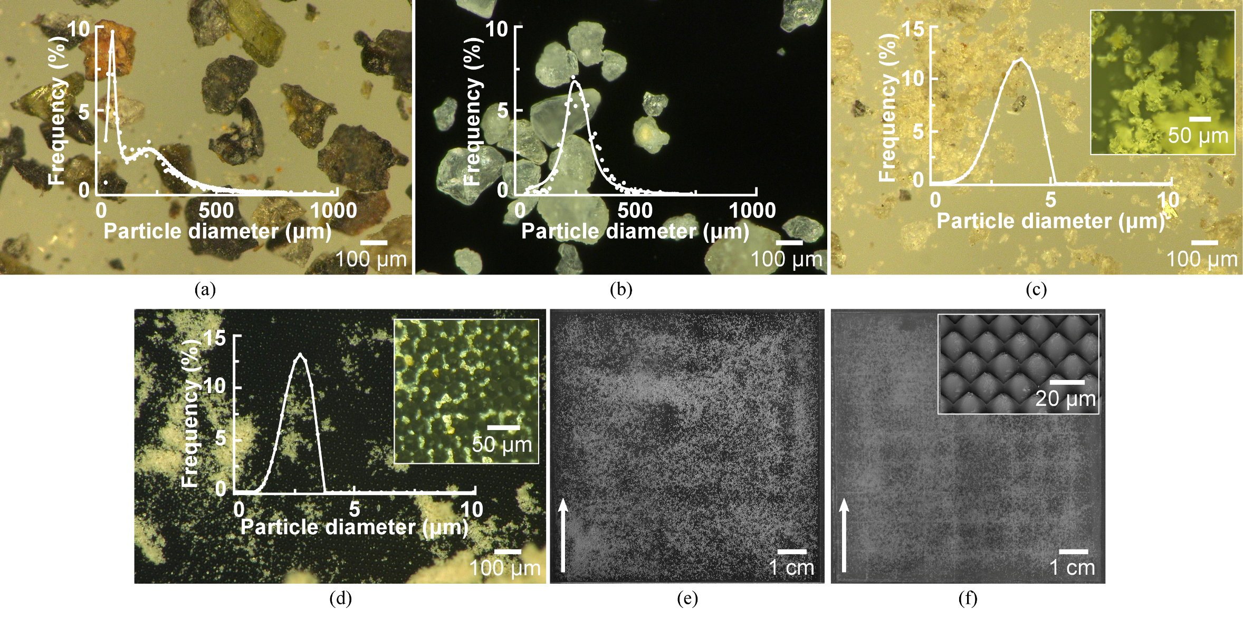of dust particles under the influence of wind. The wind flow velocity, generated from an electric motor of a commercial leaf blower (EB-26D, Dream Power, Japan), was increased stepwise (0.5 m/s) and kept at each velocity step for at least 1 minute to allow the dust removal to stabilize before increasing the wind velocity again. The amount of dust removal was then correlated with the corresponding wind velocity, measured by an anemometer (PCE-423, PCE Instruments, Germany) inside the wind tunnel. The dust deposition-cleaning experiments were conducted over a two-day period at an average temperature of 25.4 ± 0.7°C with an average relative humidity of 53.9 ± 5.8 %. The temperature and humidity were noted down at the beginning of each experiment with each test case repeated 3 times.
Fig. 2. Dust particles used to investigate removal by wind. Microscopy images showing the morphology of (a) Coarse volcano ash, (b) Sea sand, (c) fine volcano ash and (d) Arizona test dust. The insets are similar dusts viewed at higher magnification. The dust particles were deposited on the investigated samples having different front surfaces: (e) planar glass and (f) microtextured FEP with the detailed microtextures (aspect ratio = 0.7) shown in the inset. Sea sand was deposited here as an example. The arrows illustrate the direction of wind when placed inside the wind tunnel.
Four different dust particle types were employed as the contaminants in this work as presented in Fig. 2a–2d, divided into two categories, coarse and fine: (a) coarse volcano ash collected from the volcano Stromboli (Italy) was sieved to have particle sizes between 125–250 µm; (b) sea sand (Merck, Germany) having particle size rated between 100–300 µm; (c) fine volcano ash collected from the Campi Flegrei volcano (Italy) filtered using a sieve to have particle sizes < 63 µm; and (d) Arizona test dust (A1 fine particles, Fiatec, Germany) having particle sizes < 22 µm. It should be noted that the dust sizes in the environment greatly depends on the location. Previous studies reported that the majority of dust particles collected from PV modules have sizes < 63 µm [29], [30]. Nevertheless, sizes up to 400 µm have also been collected [31], [32]. Thus, the range of dust particles employed in this work broadly represent those occurring in nature. Since the focus of this work is on the microtextured cover film, the selection of the dust sizes used was relative to the microtextures spacing. Coarse particles being significantly larger than 25 µm; meanwhile fine particles were smaller than 25 µm.
To characterize the dust particles, the morphologies were observed using an optical microscope (VHX-500, Keyence Corporation, Japan) and the particle size distribution measured using methods suitable for their respective sizes. The size distribution of the larger dust particles was identified using microscopy analysis, captured by the optical microscope before analyzing using an image processing program, ImageJ. Due to the dust particles having irregular shapes, the size was defined based on the Feret diameter (maximum length between two points). Most importantly, the settings of the particle size analysis function in ImageJ were set such that each dust particle could best be individually identified. Meanwhile, the size distribution of the smaller dust particles was analysed using dynamic light scattering (Litesizer 500, Anton Paar, Germany). The measured particle size distributions are presented in Fig. 2a–2d, respectively. The dust particles were deposited onto the samples manually in a closed laboratory area with ~10 mg/cm² used for the large dust particles and ~1 mg/cm² used for the smaller dust particles, as illustrated in Fig. 2e and 2f, before loading each sample into the wind tunnel.

Results
The main experimental work revolves around the investigation of dust removal from various types of PV module surfaces. In the following sections, removal of different dust particle size categories is presented separately before discussing the influence of the microtextured cover film on dust removal and finally correlating the dust removal with PV output recovery in terms of J_{SC}.

Removal of large dust particles
Two types of dust particles larger than the spacing between the microtextures were selected — coarse volcano ash and sea sand. The dust removal was plotted as normalized dust removal in relation to different wind velocity as presented in Fig. 3. Several key observations can be made from these results. The graphs in Fig. 3 demonstrate that wind effectively removed the majority of deposited large dust particles, achieving removal between ~70–94% relative to the initial soiling for the different cases investigated in this work. This was in agreement with theory and previously reported experimental works, where the majority of large dust particles (> 100 µm) were removed from the surface [33]. This significant removal of large dust particles will eventually translate into a recovery of a PV module performance after suffering soiling losses.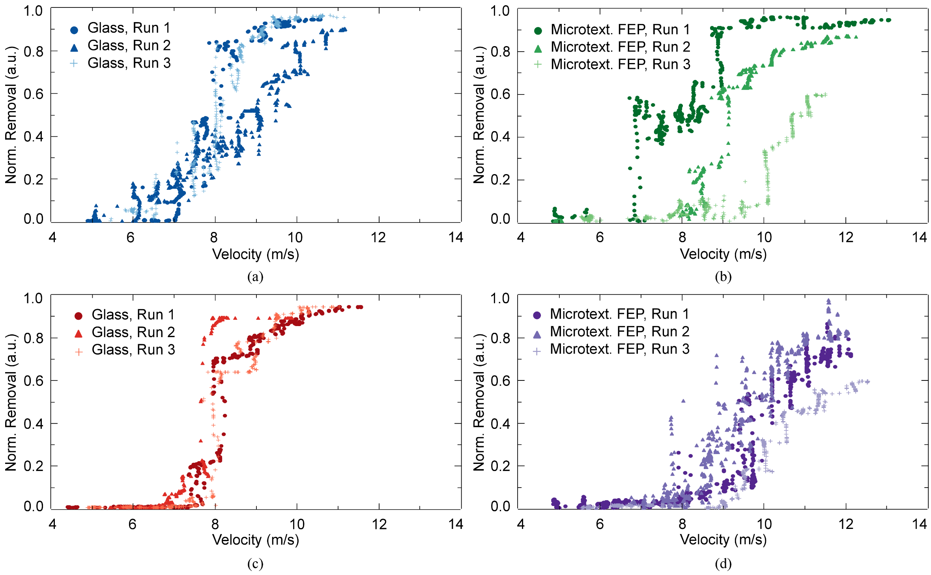
Fig. 3. Influence of wind velocity on the removal of large dust particles. The normalized removal of the different types of large dust particles from different top surfaces: (a) Coarse volcano ash on planar glass, (b) coarse volcano ash on microtextured FEP, (c) Sea sand on planar glass and (d) sea sand on microtextured FEP. Each case was repeated 3 times.
Another key factor to evaluate the potential of wind to remove dust is the initial removal velocity. The initial removal velocity can be understood as the wind speed sufficient to displace dust particles. At that moment, the force exerted on the dust particles by the wind flow was sufficient enough to overcome the adhesion from the particle-particle or particle-surface interaction. Removal of large dust particles began at different initial removal velocities for the different cases, all occurring within the range of 6.4—8.3 m/s (at 5% dust removal) as displayed in Fig. 3.
The spread of data points for the microtextured surface were more disperse compared to dust removal from planar glass (see Fig. 3). This can be related to both the wind profile (turbulent versus laminar) and the adhesion between the particles and the surface. The microtextured surface results in a more turbulent flow due to the higher surface roughness, resulting in a more sporadic dust removal pattern due to the irregular forces acting on the individual dust particles. This is consistent with previous works on surface roughness resulting in turbulent flows that would then influence dust particle removal [28], [34], [35]. Furthermore, as previously mentioned, the reduced surface contact area would influence the adhesion of each dust particle that needs to be overcome by the force from the wind [22]. It should also be noted that the dust particles have irregular rough surfaces (see Figs. 2a–2d), which would also influence the adhesion. The purpose of this current work was not to investigate the adhesion in relation to the different dust particle roughness. Nevertheless, due to the relatively high quantity of dust particles and the experiment repetitions, it is safe to assume that the particle-surface interaction will be averaged out in the different cases. What is most important, clear trends for each case for the dust removal can be observed from the plots in Fig. 3 and will also be discussed in detail below.

Removal of small dust particles
For the small dust particles, fine volcano ash and Arizona test dust were used. The resulting normalized dust removal in relation to the wind velocity was plotted for each case as shown in Fig. 4. One setback related to the fine volcano ash was that only one repetition was successfully obtained due to some technical difficulties, which was only realized later during data analysis. While this 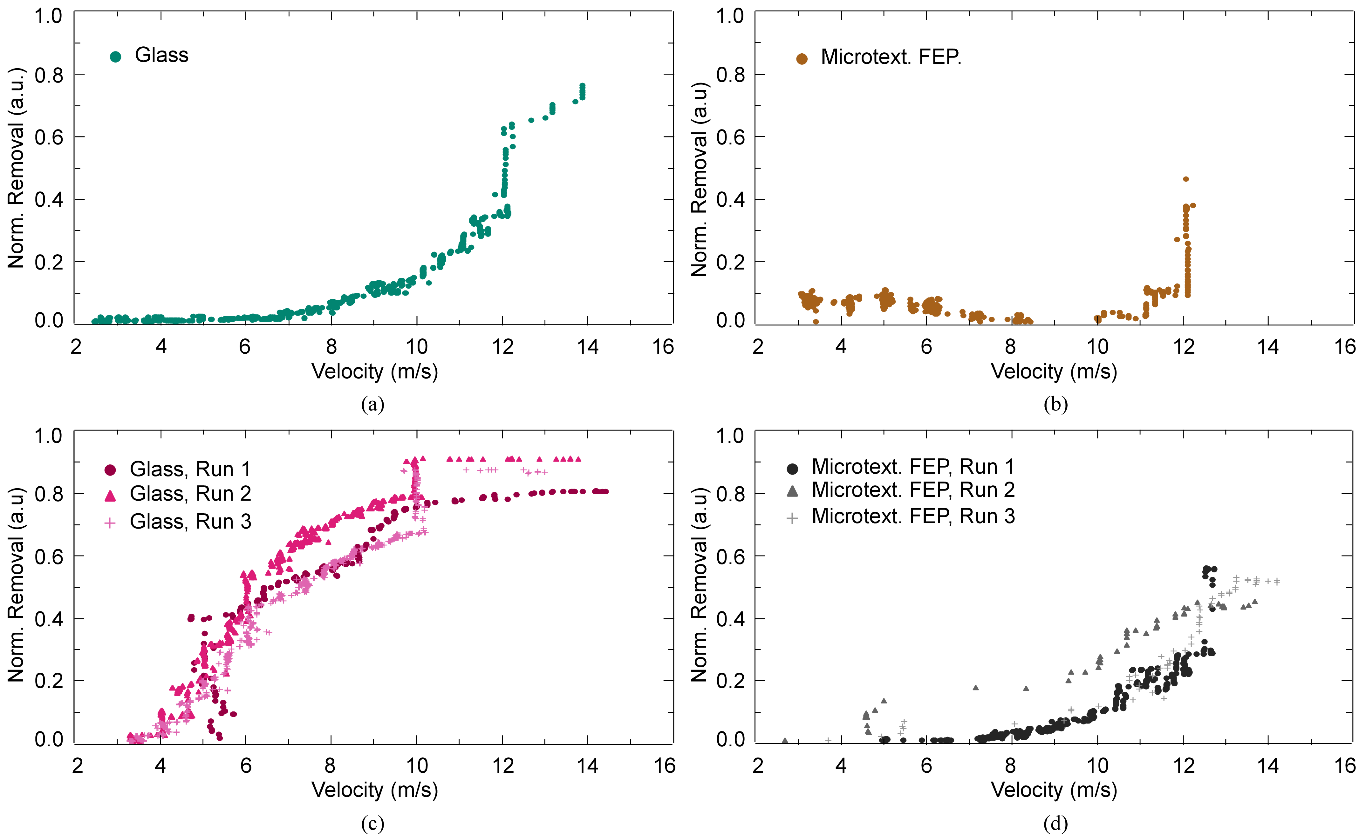might result in a less accurate result, the authors believe that the removal trend should still be a good approximation of the general dust removal behavior for those cases.
Fig. 4. Influence of wind velocity on the removal of small dust particles. The normalized removal of the different types of small dust particles from different top surfaces: (a) Fine volcano ash on planar glass, (b) fine volcano ash on microtextured FEP, (c) Arizona test dust on planar glass and (d) Arizona test dust on microtextured FEP.
Removal of dust particles smaller than the microtextured spacing was also possible, achieving dust removal between ~34–83% as demonstrated in Fig. 4. From a qualitative point of view, small dust particles exhibited a wider normalized removal range compared to the large dust particles (see Fig. 3). One reason being that some small dust particles would get trapped in between the microtexture cavities even after dust removal as demonstrated in the inset of Fig. 2d. This issue was also discussed in a previous work where small dust particles were trapped within the cavities even after cleaning with water [11]. Meanwhile, the initial removal velocity, was observed to begin between 4.0–11.2 m/s depending on the case as shown in Fig. 4. This means that in most cases, a higher wind velocity is required for removal of the smaller dust particles compared to the larger particles.
Although the purpose of this study was not to investigate the physics behind the dust removal process, the results does concur with observations where it was more challenging to remove the smaller dust compared to the larger dust particles [21], [36]–[39]. Commonly, small dust particles of sizes < 100 µm would be within the viscous sublayer (boundary layer close to surface) of the wind flow where turbulence was significantly reduced [21]. Thus, it would be probable that force, if any, exerted on the particles by the wind would not be sufficient to overcome the adhesion with the surface. Furthermore, Fig. 2c and 2d already demonstrated that the relatively small dust particles do not deposit individually but were attracted to each other and form clusters of dust particles. Higher cohesion between the small dust particles compared to the adhesion with the surface would also contribute to the higher wind requirement for small dust particle removal [40].

Discussion
One of the main objectives of this work was to investigate the potential of using wind to clean deposited soil from a previously developed superhydrophobic microtextured FEP PV module cover film in comparison to a planar glass surface.

Removal of dust particles from microtextured PV module cover films
To better discuss and compare the different cases as described in the previous section, trendlines were extracted from the raw dust removal results (Fig. 3 and Fig. 4) and plotted in Fig. 5 and Fig. 6 for the large and small dust particles, respectively. For the trendline generation, a Boltzmann fit was used due the sigmoidal (S-shaped) curve observed. Therefore, the qualitative values used in the discussion were approximations and not absolute values, but enabled better comparison of results.
The dust removal from the microtextured FEP surface was first analyzed with respect to the large dust particles. Fig. 5 demonstrates that the maximum removal of both coarse volcano ash (79%) and sea sand (70%) from the microtextured FEP surface was significantly lower compared to removal from a planar glass surface, 94% and 94%, respectively. Meanwhile, the removal of dust from the microtextured FEP surface required a slightly higher wind velocity before dust resuspension was initiated. The wind velocity at 5% dust removal began at 6.4 m/s (planar glass) compared to 6.8 m/s (microtextured FEP) for the coarse volcano ash and 7.3 m/s (planar glass) compared to 8.3 m/s (microtextured FEP) for the sea sand as can be observed in Fig. 5. The observation of both, the amount of dust removal and the initial dust removal velocity in this work implies that removal of dust particles was harder from microtextured FEP surface compared to planar glass. This was contrary to popular belief whereby an increase in surface roughness will result in a decreased adhesion, thus expecting easier dust removal [37], [41].
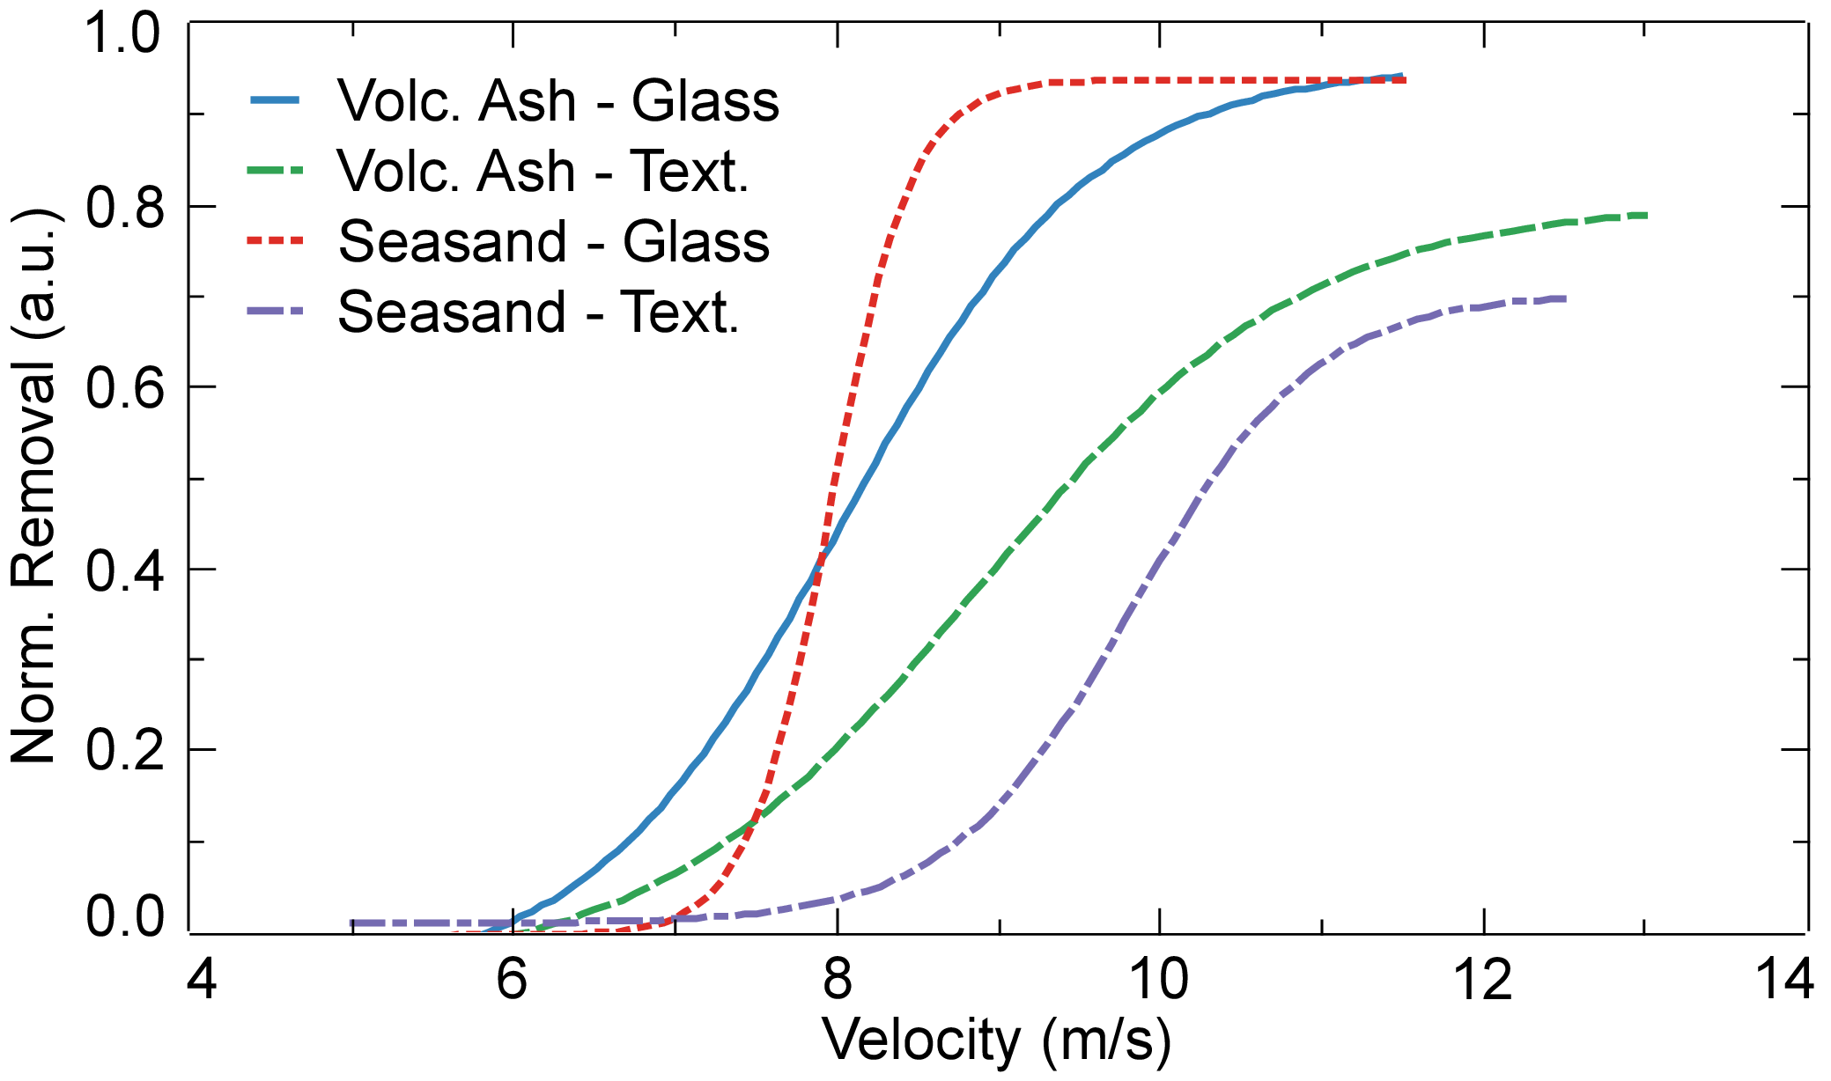In general, an increased surface roughness will result in both: (i) a reduced surface contact area, thus lower adhesion; and (ii) a turbulent flow, therefore an increased force acting on the particle. The near-wall turbulent flow will have a profound effect on the dust particle removal process. The turbulent unstable wind flow will destroy the viscous sublayer and increase the force acting on the dust particles [42]. Moreover, any turbulence ‘burst’ will result in an increased lift force to displace a particle from the surface [24]. This view contradicts with the observations in the present work (harder to remove dust particles from microtextured surface) and points towards a more complex understanding relating the surface roughness and dust resuspension. Ilse et al. reported that for dust resuspension, the surface roughness at the microscale was not decisive, but rather the properties at the nanoscale dominate dust particle adhesion and also removal [23]. This indicates that the scale of the surface roughness plays a huge role to determine the resuspension behavior of the dust particles. Research focusing on the particle-wall interaction provides a clearer explanation of this relation. Jiang et al. reported that for surface roughness in the nano-scale and submicron-scale, the particle resuspension shifts towards lower air velocities with increasing surface roughness [34]. Meanwhile, for micron-scale surface roughness, the particle resuspension shifts towards higher velocities [34]. This explains the observation in the present work where the microtextures, being in the micron-scale, resulted in an increase in the initial removal wind velocity as observed in Fig. 5. Furthermore, a large surface roughness could even become a hindrance towards the displacement mechanism of dust particle by providing more shielding and resistance to the displacement motions (rolling or sliding) [43].
Fig. 5. Trendlines of the dust removal behaviour for large dust particles comparing removal of coarse volcano ash and sea sand from planar glass and microtextured FEP.
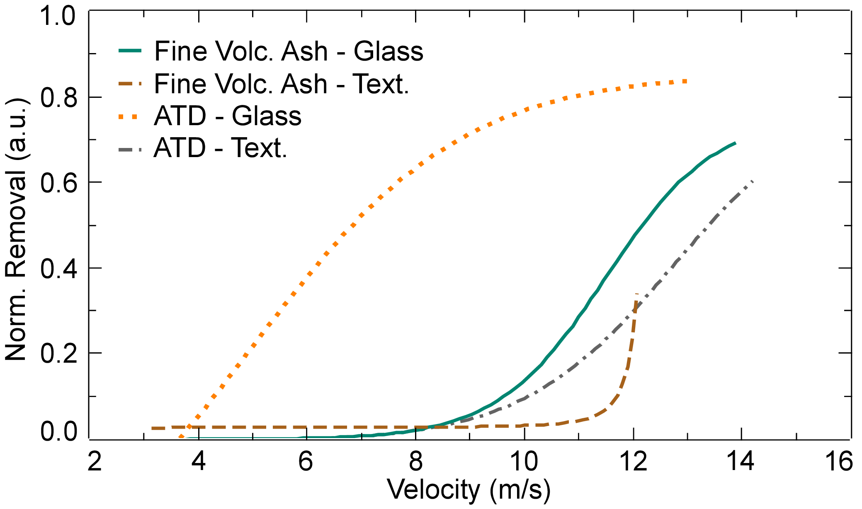Next, this section explores whether the observed dust removal behavior also holds for relatively small dust particles. In the case of small dust particles, removal of dust was also higher for planar glass compared to the microtextured FEP. Fig. 6 shows that the normalized removal of fine volcano ash and Arizona test dust from the planar glass achieved a maximum removal of 69% and 83% respectively. Meanwhile for the microtextured FEP, the maximum removal was 34% for fine volcano ash and 60% for Arizona test dust. In terms of initial removal velocity, a higher wind velocity was required for dust removal from the microtextured FEP surface (fine volcano ash = 11.2 m/s; Arizona test dust = 9.1 m/s) compared to planar glass (fine volcano ash = 8.9 m/s; Arizona test dust = 4.0 m/s). This was consistent with the observation of large dust particles in the previous section where the application of microtextured FEP resulted in higher wind speed requirement for dust removal. Moreover, this was worse for the small dust particles since it has the possibility to be trapped in between the microcavities as previously explained.
Fig. 6. Trendlines of the dust removal behaviour for small dust particles comparing removal of fine volcano ash and Arizona test dust from planar glass and microtextured FEP.

Limitations
It should be noted that the removal trend of fine volcano ash and Arizona test dust from planar glass exhibited completely different removal behavior, as demonstrated in Fig. 6. Since both are within similar size categories, it could have been expected that similar removal would have been achieved to the large dust particles in Fig. 5. From the results of this work, it was not possible to understand the different removal behavior between fine volcano ash and Arizona test dust from planar glass and further work is required to completely understand the observations. Nonetheless, as previously discussed, the dust removal behavior was influenced by multiple factors: wind velocity, surface roughness, particle size and scale of surface roughness (micron or sub-micron). Apart from that, there are other factors that were not considered for simplification purposes such as, among others: (i) wind direction; (ii) particle geometry; (iii) humidity; (iv) deposition behavior; or (v) particle-particle interaction [10], [44]. Furthermore, there are also occurrences that would influence the dust removal behavior such as: (vi) the splash phenomena, whereby resting particles become loose and are then resuspended due to the impact of displaced particles [45], [46]; or (vii) the rebound effect due to bouncing of dust particles during deposition and removal, which adds uncertainty in the interpretation apart from resuspension [23]. Further investigations should be conducted to fully understand the dust removal behavior while taking into consideration the aforementioned factors. Nevertheless, the macroscopic observation from this work was sufficient to investigate the influence of wind on volcano ash removal from a microtextured PV cover film.

Wind speed requirements in real-world conditions
The reported wind speeds (4.0–11.2 m/s) to initiate removal of dust particles was shown to depend heavily on dust size and surface roughness. Whether wind can be utilized in real world self-cleaning applications would then depend on the available wind speeds at ground level near the location of the PV system. A study on volcanic ash resuspension did report an annual average wind speed of 8.3 m/s in the Patagonian steppe of Argentina, but studies that report similar observations were almost non-existent [47]. Wind speeds reaching > 10 m/s were also reported for some locations, but were maximum wind speeds which might rarely occur in the form of a sudden gusts of winds or a desert storm [48], [49].
Fig. 7. Impact of dust removal on PV output in terms of J_{SC}. The groups represent the different dust contaminants cleaned from their respective surface (planar glass or microtextured FEP). The J_{SC} regained after dust removal from the soiled condition of a mc-Si PV mini-module is highlighted.
Before we can fully utilize wind for self-cleaning PV applications, further assessment should be conducted. For example, a more localized and specific measurement that defines the balance between adhesion and lift acting on the dust particles would be the threshold friction velocity [39]. This would be a more exact measurement of the required wind velocity near the surface boundary layer for dust removal that would enable us to evaluate the utilization of wind for self-cleaning. From another angle, modification to the microtexture design to reduce wind speed requirements could also be investigated.

PV module performance recovery
The significant removal of dust particles reported in this work can be translated into a recovery of the photocurrent generation of a PV module, which can be understood as how much output is regained compared to the otherwise lower output of a soiled PV module. An analysis was conducted based on a self-cleaning study from a previous where the short-circuit current density (J_{SC}) was measured [11]. A glass-encapsulated multi-crystalline silicon (mc-Si) PV mini-module was used as the reference device in that work. Previously, both sea sand and Arizona test dust was removed using water droplets that simulates self-cleaning by rainfall. The regained photocurrent, relative to the soiled PV mini-module, can be extrapolated for this work by replacing the amount of dust removed by water with the amount of dust removed by wind for the different cases, thus identifying the regained J_{SC} as shown in Fig. 7. The dust removal by wind in this work (33.8–94%) results in a regained J_{SC} between 2.6–6.5 mA/cm². This can be translated to a 9.7–24.0% PV output recovery in terms of J_{SC}, relative to the soiled condition of the PV mini-module.
Considering long term performance degradation of PV systems due to PV soiling, this performance recovery would be significant and result in higher PV device performance over a longer period of time [50]. This current work does not include the direct measurement of the PV module output, but the results does indicate the potential of wind as a cleaning factor to mitigate the problem of PV soiling. Thus, the potential PV output recovery presented in this work suggests the need of further optimization of the microtextured cover film to fully utilize wind for dust removal.

Conclusion
This work investigates the influence of wind to remove dust contaminants, especially volcano ash, from a self-cleaning superhydrophobic microtextured PV module cover film. In arid locations, wind was investigated as an alternative driving force for self-cleaning. Two particle size categories were chosen with respect to the microtexture spacing, volcano ash being the dust contaminant of interest due to the threat of volcano ash deposition on the performance of PV installations. For each dust size category, reference dust used in previous studies was also investigated for comparison. This work demonstrates that the self-cleaning of dust utilizing wind was possible, achieving dust removal > 60% in all cases except for one. The wind speeds for initial dust removal required for these cases (4.0 – 9.1 m/s) was almost never met by any location in terms of annual average wind speed at ground level. This means that although wind can potentially be used as an additional force for self-cleaning of soiled PV modules, further research is required. Moreover, the addition of a superhydrophobic microtextured FEP PV module cover films does not improve the removal of dust using wind. In fact, the microtextured FEP cover film made it harder to remove dust, although it was possible. Since the surface roughness was proven to influence dust removal, a further optimization of the microtextures design and dimensions should be conducted to be able to utilize wind as an additional self-cleaning force to produce a more robust self-cleaning PV module cover film.

Acknowledgment
This work was carried out with the support of the Karlsruhe Nano Micro Facility (KNMF) and the Karlsruhe School of Optics & Photonics (KSOP) at the Karlsruhe Institute of Technology (KIT).

References
- V. Schlosser, M. Drapalik, and G. Klinger, “About the usability of a photovoltaic module to monitor air pollution,” 3rd Int. Conf. Clean Electr. Power Renew. Energy Resour. Impact, ICCEP 2011, pp. 434–438, 2011.
- E. Zorn and T. R. Walter, “Influence of volcanic tephra on photovoltaic (PV)-modules: An experimental study with application to the 2010 Eyjafjallajökull eruption, Iceland,” J. Appl. Volcanol., vol. 5, no. 1, 2016.
- Y. Ota, K. Araki, and K. Nishioka, “Impact of volcanic ash on CPV system in Miyazaki Japan,” AIP Conf. Proc., vol. 1477, pp. 340–343, 2012.
- T. Hirayama et al., “Soiling by volcanic ash fall on photovoltaic modules and effects of hydrophilic coating on module cover glass,” Jpn. J. Appl. Phys., vol. 57, no. 8, pp. 4–9, 2018.
- M. K. Butwin, S. Von Löwis, M. A. Pfeffer, P. Dagsson-Waldhauserova, J. Thorsson, and T. Thorsteinsson, “Influence of weather conditions on particulate matter suspension following the 2010 Eyjafjallajökull volcanic eruption,” Earth Interact., vol. 24, no. 6, pp. 1–16, 2020.
- T. Sarver, A. Al-Qaraghuli, and L. L. Kazmerski, “A comprehensive review of the impact of dust on the use of solar energy: History, investigations, results, literature, and mitigation approaches,” Renew. Sustain. Energy Rev., vol. 22, pp. 698–733, 2013.
- S. C. S. Costa, A. S. A. C. Diniz, and L. L. Kazmerski, “Dust and soiling issues and impacts relating to solar energy systems: Literature review update for 2012-2015,” Renew. Sustain. Energy Rev., vol. 63, pp. 33–61, 2016.
- W. J. Jamil, H. Abdul Rahman, S. Shaari, and Z. Salam, “Performance degradation of photovoltaic power system: Review on mitigation methods,” Renew. Sustain. Energy Rev., vol. 67, pp. 876–891, 2017.
- K. K. Ilse, B. W. Figgis, V. Naumann, C. Hagendorf, J. Bagdahn, “Fundamentals of soiling processes on photovoltaic modules,” Renew. Sustain. Energy Rev., vol. 98, no. September, pp. 239–254, 2018.
- Y. N. Chanchangi, A. Ghosh, S. Sundaram, and T. K. Mallick, “Dust and PV Performance in Nigeria: A review,” Renew. Sustain. Energy Rev., vol. 121, no. December, p. 109704, 2020.
- A. Roslizar et al., “Hot-embossed microcone-textured fluoropolymer as self-cleaning and anti-reflective photovoltaic module covers,” Sol. Energy Mater. Sol. Cells, vol. 214, no. May, 2020.
- A. Roslizar et al., “Self-cleaning performance of superhydrophobic hot-embossed fluoropolymer films for photovoltaic modules,” Sol. Energy Mater. Sol. Cells, vol. 189, pp. 188–196, 2019.
- Y. N. Chanchangi, A. Roy, A. Ghosh, S. Sundaram, and T. K. Mallick, “In-situ assessment of photovoltaic soiling mitigation techniques in northern Nigeria,” Energy Convers. Manag., vol. 244, no. July, p. 114442, 2021.
- I. Hanukoglu, “Middle East Climate,” Israel Science and Technology Directory. [Online]. https://www.science.co.il/weather/middle-east-climate/, Accessed on: Mar. 04, 2021.
- Y. Jiang, L. Lu, A. R. Ferro, and G. Ahmadi, “Analyzing wind cleaning process on the accumulated dust on solar photovoltaic (PV) modules on flat surfaces,” Sol. Energy, vol. 159, pp. 1031–1036, 2018.
- J. F. Zhang, Y. Zhu, Z. H. Li, W. Zhou, J. C. Zheng, and D. Q. Yang, “Preparation of anti-reflection glass surface with self-cleaning and anti-dust by ammonium hydroxide hydrothermal method,” Mater. Express, vol. 5, no. 4, pp. 280–290, 2015.
- I. Nayshevsky, Q. Feng, G. Barahman, and A. M. Lyons, “Fluoropolymer coatings for solar cover glass: Anti-soiling mechanisms in the presence of dew,” Sol. Energy Mater. Sol. Cells, vol. 206, p. 110281, 2020.
- E. Del Bello et al., “Field-based measurements of volcanic ash resuspension by wind,” Earth Planet. Sci. Lett., vol. 554, p. 116684, 2021.
- M. Mani and R. Pillai, “Impact of dust on solar photovoltaic (PV) performance: Research status, challenges and recommendations,” Renew. Sustain. Energy Rev., vol. 14, no. 9, pp. 3124–3131, 2010.
- B. Nasr, S. Dhaniyala, and G. Ahmadi, “Particle resuspension from surfaces: Overview of theoretical models and experimental data,” in Overview of Theoretical Models and Experimental Data, vol. 10, Elsevier Inc., 2017, pp. 55-84.
- K. Ilse, M. Z. Khan, N. Voicu, V. Naumann, C. Hagendorf, and J. Bagdahn, “Advanced performance testing of anti-soiling coatings - Part II: Particle-size dependent analysis for physical understanding of dust removal processes and determination of adhesion forces,” Sol. Energy Mater. Sol. Cells, vol. 202, p. 110049, 2019.
- M. Götzinger and W. Peukert, “Particle adhesion force distributions on rough surfaces,” Langmuir, vol. 20, no. 13, pp. 5298–5303, 2004.
- K. K. Ilse et al., “Particle size-dependent adhesion forces and wind removal efficiency of anti-soiling coatings on textured solar glasses,” MRS Commun., vol. 9, no. 3, pp. 964–970, 2019.
- J. W. Cleaver and B. Yates, “Mechanism of detachment of colloidal particles from a flat substrate in a turbulent flow,” J. Colloid Interface Sci., vol. 44, no. 3, pp. 464–474, 1973.
- C. Tsai, D. Y. H. Pui, and B. Y. H. Liu, “Particle detachment from disk surfaces of computer disk drives,” Mech. Eng., vol. 22, no. 6, 1991.
- I. Goldasteh, G. Ahmadi, and A. Ferro, “A model for removal of compact, rough, irregularly shaped particles from surfaces in turbulent flows,” J. Adhes., vol. 88, no. 9, pp. 766–786, 2012.
- I. Goldasteh, G. Ahmadi, and A. R. Ferro, “Monte Carlo simulation of micron size spherical particle removal and resuspension from substrate under fluid flows,” J. Aerosol Sci., vol. 66, pp. 62–71, 2013.
- B. Nasr, G. Ahmadi, A. R. Ferro, and S. Dhaniyala, “A model for particle removal from surfaces with large-scale roughness in turbulent flows,” Aerosol Sci. Technol., vol. 54, no. 2, pp. 291-303, 2020.
- D. Olivares et al., “Characterization of soiling on PV modules in the Atacama Desert,” Energy Procedia, vol. 124, pp. 547–553, 2017.
- W. Javed, Y. Wubulikasimu, B. Figgis, and B. Guo, “Characterization of dust accumulated on photovoltaic panels in Doha, Qatar,” Sol. Energy, vol. 142, pp. 123–135, 2017.
- R. E. Cabanillas and H. Munguía, “Dust accumulation effect on efficiency of Si photovoltaic modules,” J. Renew. Sustain. Energy, vol. 3, no. 4, 2011.
- U. Mehmood, F. A. Al-sulaiman, and B. S. Yilbas, “Characterization of dust collected from PV modules in the area of Dhahran, Kingdom of Saudi Arabia, and its impact on protective transparent covers for photovoltaic applications,” Sol. Energy, vol. 141, pp. 203–209, 2017.
- K. Ilse, M. Z. Khan, N. Voicu, V. Naumann, C. Hagendorf, and J. Bagdahn, “Advanced performance testing of anti-soiling coatings – Part I: Sequential laboratory test methodology covering the physics of natural soiling processes,” Sol. Energy Mater. Sol. Cells, vol. 202, 2019.
- Y. Jiang, S. Matsusaka, H. Masuda, and Y. Qian, “Characterizing the effect of substrate surface roughness on particle – wall interaction with the airflow method,” Powder Technol., vol. 186, pp. 199–205, 2008.
- M. Soltani and G. Ahmadi, “Particle detachment from rough surfaces in turbulent flows,” J. Adhes., vol. 51, no. 1–4, pp. 105–123, 1995.
- N. S. Beattie, R. S. Moir, C. Chacko, G. Buffoni, S. H. Roberts, and N. M. Pearsall, “Understanding the effects of sand and dust accumulation on photovoltaic modules,” Renew. Energy, vol. 48, pp. 448–452, 2012.
- H. R. Moutinho et al., “Adhesion mechanisms on solar glass: Effects of relative humidity, surface roughness, and particle shape and size,” Sol. Energy Mater. Sol. Cells, vol. 172, pp. 145–153, 2017.
- E. F. Cuddihy, “Theoretical considerations of soil retention,” Sol. Energy Mater., vol. 3, pp. 21–33, 1980.
- E. Del Bello, J. Taddeucci, J. P. Merrison, S. Alois, J. J. Iversen, and P. Scarlato, “Experimental simulations of volcanic ash resuspension by wind under the effects of atmospheric humidity,” Sci. Rep., vol. 8, no. 1, pp. 1–11, 2018.
- L. L. Kazmerski et al., “Soiling particle interactions on PV modules: Surface and inter-particle adhesion and chemistry effects,” in 2016 IEEE 44th Photovolt. Spec. Conf. (PVSC), Portland, USA, 2016, pp. 1714-1717.
- R. J. Isaifan, D. Johnson, L. Ackermann, B. Figgis, and M. Ayoub, “Evaluation of the adhesion forces between dust particles and photovoltaic module surfaces,” Sol. Energy Mater. Sol. Cells, vol. 191, pp. 413–421, 2019.
- X. Du, F. Jiang, E. Liu, C. Wu, and F. H. Ghorbel, “Turbulent airflow dust particle removal from solar panel surface: Analysis and experiment,” J. Aerosol Sci., vol. 130, pp. 32–44, 2019.
- A. S. Kassab, V. M. Ugaz, M. D. King, and Y. A. Hassan, “High Resolution Study of Micrometer Particle Detachment on Different Surfaces,” Aerosol Sci. Technol., vol. 47, no. 4, pp. 351–360, 2013.
- Y. N. Chanchangi, A. Ghosh, S. Sundaram, and T. K. Mallick, “An analytical indoor experimental study on the effect of soiling on PV, focusing on dust properties and PV surface material,” Sol. Energy, vol. 203, no. March, pp. 46–68, 2020.
- D. Goossens, “Soiling of Photovoltaic Modules: Size Characterization of the Accumulated Dust,” J. Clean Energy Technol., vol. 7, no. 3, pp. 25–31, 2019.
- J. F. Kok, E. J. R. Parteli, T. I. Michaels, and D. B. Karam, “The physics of wind-blown sand and dust,” Reports Prog. Phys., vol. 75, no. 10, 2012.
- J. E. Panebianco, M. J. Mendez, D. E. Buschiazzo, D. Bran, and J. J. Gaitán, “Dynamics of volcanic ash remobilisation by wind through the Patagonian steppe after the eruption of Cordón Caulle, 2011,” Sci. Rep., vol. 7, pp. 1–11, 2017.
- J. E. Stout and R. Arimoto, “Threshold wind velocities for sand movement in the Mescalero Sands of southeastern New Mexico,” J. Arid Environ., vol. 74, no. 11, pp. 1456–1460, 2010.
- Q. Guan et al., “Climatological analysis of dust storms in the area surrounding the Tengger Desert during 1960–2007,” Clim. Dyn., vol. 45, no. 3–4, pp. 903–913, 2015.
- B. Bayandelger, Y. Ueda, B. Batbayar, A. Adiyabat, N. Enebish and K. Otani, “Long-term performance and degradation rate analyses of photovoltaic modules exposed in the Gobi Desert, Mongolia,” Jpn. J. Appl. Phys., vol. 57, 2018.

This work was funded by the Helmholtz Association, Germany, from the Research Field Energy – Program Materials and Technologies for the Energy Transition – Topic 1 Photovoltaics. H.H. acknowledges financial support through the “Ideenwettbewerb Biotechnologie—Von der Natur lernen” of the “Ministerium für Wissenschaft, Forschung und Kunst Baden-Württemberg” (7533-7-11.10-22.). A.R. gratefully acknowledges a scholarship from the Ministry of Higher Education, Malaysia and the Malaysian Technical University of Melaka (UTeM), Malaysia. A.R. was with the Institute of Microstructure Technology (IMT), Karlsruhe Institute of Technology (KIT), 76344, Germany. He is now with the Malaysian Technical University of Melaka (UTeM), 76100, Malaysia. (e-mail: aiman.roslizar@kit.edu; aiman@utem.edu.my). J.T. is with the Istituto Nazionale di Geofisica e Vulcanologia (INGV), Sezione di Roma 1, Via di Vigna Murata 605, 00143, Roma, Italy. (e-mail: jacopo.taddeucci@ingv.it). U.W.P., H.H. and B.S.R. are with the Institute of Microstructure Technology (IMT), Karlsruhe Institute of Technology (KIT), 76344, Germany. U.W.P. and B.S.R. are also with the Light Technology Institute (LTI), Karlsruhe Institute of Technology (KIT), 76131, Germany. (e-mail: ulrich.paetzold@kit.edu; hendrik.hoelscher@kit.edu; bryce.richards@kit.edu).

