Editorial: Unveiling Active Faults: Multiscale Perspectives and Alternative Approaches Addressing the Seismic Hazard Challenge

Authors:
Federica Ferrarini¹, Nathan A. Toké², Michele M. C. Carafa³, and J Ramón Arrowsmith⁴
¹ Department of Psychological, Health and Territorial Sciences, ‘G. d'Annunzio’ University of Chieti and Pescara, Chieti, Italy
² Department of Earth Science, Utah Valley University, Orem, Utah, United States
³ Istituto Nazionale di Geofisica e Vulcanologia (INGV), Rome, Italy
⁴ School of Earth and Space Exploration, College of Liberal Arts and Sciences, Arizona State University, Tempe, Arizona, United States

Keywords: active tectonics, seismic hazard, faulting, seismology, historical seismicity, paleoseismicity, geomorphology, high resolution topography, field geology, structural geology

Editorial on the Research Topic

Unveiling Active Faults: Multiscale Perspectives and Alternative Approaches Addressing the Seismic Hazard Challenge

Investigations of seismic hazard across the range of tectonic environments on Earth are challenging because they require high quality data from multiple disciplines (e.g., seismology, structural geology, geomorphology, geochronology, archaeology, and geodesy) covering a wide range of temporal (days to millennial) and spatial (e.g., microns to hundreds of kilometers) scales and because seismogenic conditions and drivers are variable and fluctuating. The international earthquake science community has become more disciplinarily integrative over the past several decades with the establishment of collaborative geological and geophysical centers such as (but not limited to) the Southern California Earthquake Center (SCEC, https://www.scec.org/), United States Geological Survey (USGS, https://earthquake.usgs.gov/), the National Institute of Geophysics and Volcanology (INGV, https://www.ingv.it/), the Interuniversity Center for 3D Seismotectonics with territorial applications (CRUST, https://www.crust.unich.it/).
Collaborations along with improvements in data sources such as the implementation of denser seismic and geodetic arrays, high resolution (meter-scale and better) topographic data, improvements in geochronology, and the widespread availability of catalogued geophysical data, all present opportunities to unveil new details about active faulting. With that in mind, we proposed this Frontiers in Earth Science Research Topic as a venue for publishing disparate approaches for addressing seismic hazard.
This Research Topic includes sixteen published articles investigating diverse tectonic regions of the Earth, at different time- and resolution scales, spanning from low-to-fast deformation rates contexts, using complementary data approaches spanning from earthquake geology to seismology, seismotectonics, and geomechanics (Figure 1). Here we provide a short review of the contributions organized by the investigation’s primary methodology.

long-term ACTIVE fault behavior from historical seismicity and palaeoseismology

Along the eastern margin of the Tibetan Plateau, Liang et al. present evidence for accelerating stress release along a section (Luhuo) of the Xianshuihe strike-slip fault. Field investigations, trench excavations, and analysis of historical earthquakes documented six seismic events that occurred in the past 3ky. Periods of slip pulses were identified along the fault section with slip rates 2–3 times higher than the average appraisable over the considered time window.

Pirrotta and Barbano provide a new analysis of the macroseismic data associated with the 1693 January 9 (M_{W}≈6.1) and 11 (M_{W}≈7.3) earthquakes that occurred in Sicily (Italy) and modelled new seismic sources. DEM analysis, field survey and morphotectonic study, pointed out recent activity along known normal fault systems and the previously never mapped normal- to normal-sinistral Canicattini-Villasmundo fault. The latter is a likely candidate for the 1693 earthquakes’ source (~35km length), given the consistency with the modelled seismogenic sources and the present regional stress.

Toké et al. conducted paleoseismic investigations along the Wasatch fault zone (Utah, USA) focusing on the impact that fault segmentation can have in modulating earthquake behaviour. The analysis in the Traverse Ridge trench site and radiocarbon dating demonstrates documenting at least 3 to 4 earthquakes that ruptured across this segment boundary during the Holocene, producing >1m surface ruptures and M_{W} > 6.7. A ‘leaky’ segment boundary model may explain the contrast of the estimated earthquake recurrence rates with those reported for adjacent fault segments.

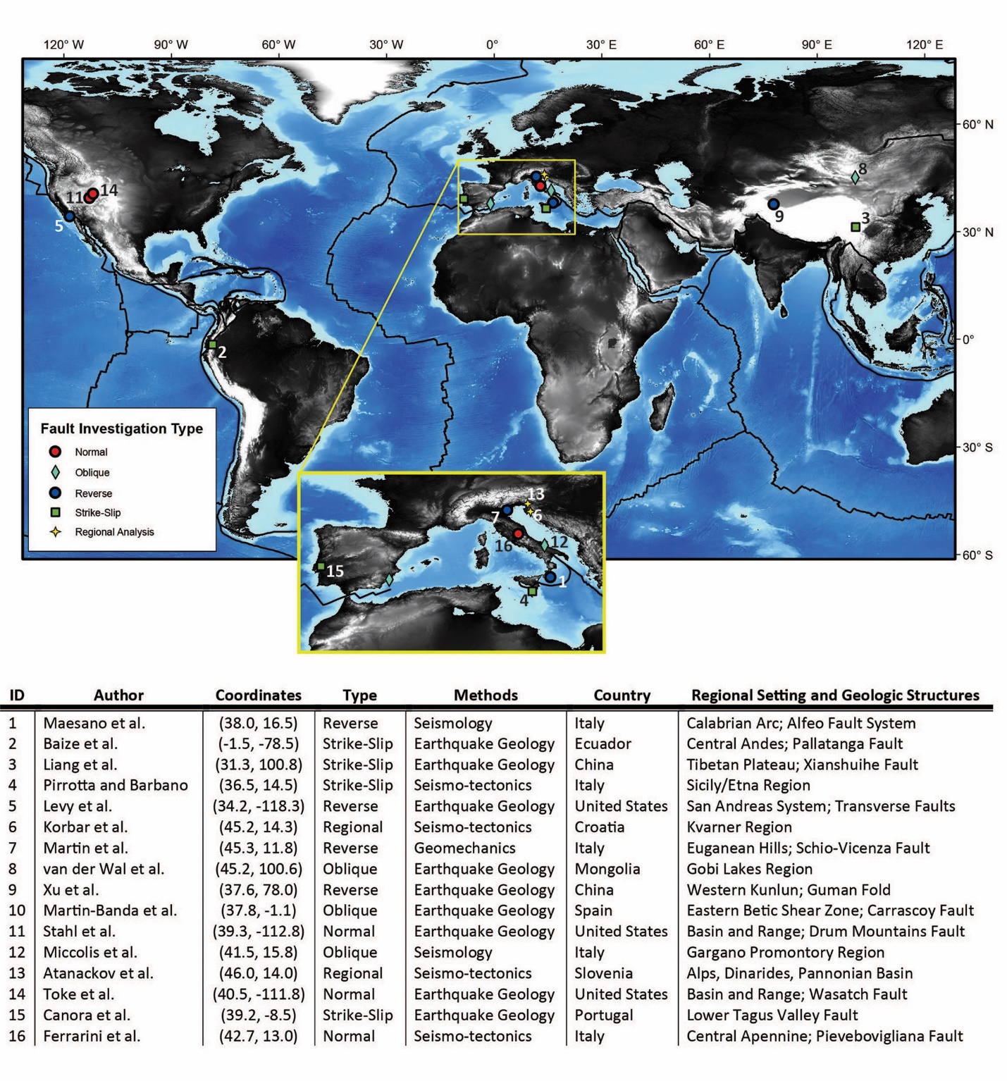
Investigating the Lower Tagus Valley Fault (Portugal), Canora et al. performed trench analyses to confirm its association with pre-historical (past 3000 years) and historical earthquakes known for the Greater Lisbon Area. Their analysis along the Alviela fault strand documented its activation and ground rupturing during both the 1344 AD and 1533 AD earthquakes. Ground motion scenarios confirm 40-60 km long ruptures in agreement with most of the macroseismic intensity data available for the 1533 earthquake and the magnitude range of M6.8–7.4.

Figure 1. Sixteen contributions were published as a part of this Frontier’s in Earth Science Research Topic. These studies sample a range of tectonic regions, styles of faulting, methods, and scales of analysis. The global 30-arc-second Digital Elevation Model is from NOOA (National Center for Environmental Information) at https://www.ngdc.noaa.gov/mgg/global/; tectonic plate boundaries are from PLATES project - UT Institute for Geophysics, at https://ig.utexas.edu/marine-and-tectonics/plates-project/.

ACTIVE fault detection THroUGH geoloGIC INVESTIGATIONS and tectonic geomorphology

Analysis of high-resolution DEM was used by Baize et al. to direct extensive field geology and provide detailed description of a ∼100 km-long strike-slip section (Pallatanga) of major active fault system (Chingual Cosanga Pallatanga Puna, Ecuador). The collected field evidence (e.g., faulted Holocene deposits and preserved coseismic ruptures) are the surface expression of large (M∼7.5) crustal historical earthquakes which have occurred along the Pallatanga fault. New age constraints allowed determination of fault slip-rates (∼1 to 6 mm/yr).

Levy et al. investigated the complex system of faults interacting in the San Fernando Valley (California, US), locus of the 1971 (M_{W} 6.7) San Fernando earthquake. Trenching along the Mission Hills blind anticline shed light on the associated fault propagation fold. Minimum structural relief of 37 m, accumulated since the late Pleistocene, was observed in large diameter borings across the Mission Hills. These observations suggest a minimum uplift rate of 0.5 mm/yr despite the lack of significant geomorphic fault expression. Trishear analysis supports southward migration of the frontal thrust through the Sylmar Basin and the Northridge Hills blind thrust, consistent with the overall deformation history of the area.

Martin et al. exploited gouges within Cretaceous limestones as valuable indicators of past seismic events occurred in the Euganean Hills (SW of Padua, Italy). Micropaleontological analyses indicate the source of the pulverized limestones while stress tests on intact specimens contribute to the determination of the minimum strain energy needed to shatter them (0.3–0.5 MJ/m³). The observed deformation in the area from GPS data (10–30 nanostrain y⁻¹), is insufficient to generate such energy, thus providing the rationale to reconsider the Schio-Vicenza Fault as the most probable source of possible earthquakes with M>5.

van der Wal al. investigated India-Eurasia active intraplate deformation responsible for several Mw∼8 earthquakes (western-southern Mongolia) in the past century. Despite seismic quiescence, remote sensing, tectono-morphometric techniques and cosmogenic nuclide dating unveiled recent deformation in the Valley of Gobi Lakes, along fault scarps cross-cutting Quaternary deposits. The mapping of >40–90 km long Valley of Gobi Lake active faults permits reconciling of the fault dimension with the occurrence of M∼7 earthquakes and (vertical) displacement rates ~0.27 ± 0.08 mm/yr.

To reconstruct the growth model of the active Guman fold (Western Kunlun Mountains - China), Xu et al. combined fluvial terrace analysis and high-resolution seismic reflection profile interpretation. They explore different kinematic solutions using Monte Carlo simulations to explain the Plio-Quaternary deformation history of the terrace. They propose as the most reliable growth model a fault-bend fold with lower flat-ramp-upper flat geometry producing kink-band migration. This deformation mechanism would explain why the Guman fold shortening is blind to the relative movement of GPS, located to the north and south of the structure.

Martin-Banda et al. test slip rate variability, in the last ∼210ky, while investigating the left-lateral reverse Carrascoy Fault (Spain). By modelling the growth of the discordance observed in calcrete deposits and dating them with Uranium Series they calculated vertical slip rates in a first site. Geomorphological analysis of faulted Upper Pleistocene alluvial fans provided for slip rates in a second site. Even considering the influence of several factors in estimating net slip rates, their results suggest the existence along the Carrascoy Fault of long periods of low activity disturbed by short high strain release periods (super-cycles); this outcome has interesting implications for the seismogenic behavior of (the rest) of the slow faults within the Eastern Betic Shear Zone.

In the eastern Basin and Range province (Utah, US), Stahl et al. demonstrate that legacy aerial-photographs can be used to generate Digital Elevation Models that are effective for investigating active tectonics even where deformation is diffuse. The ~8-km-wide Drum Mountains fault zone has been mapped, and constraints on net extension rates (0.1–0.4 mm yr⁻¹ in the last 35ky) have been computed by using optically stimulated luminescence ages and scarp profiles. The deformation rates, even though faster than previously estimated along surrounding faults, comply with a model of deformation which forecasts the reactivation of pre-existing, cross-cutting faults in a structurally complex fault zone between other fault systems.

new outcomes from seismology and sEismotectonics
Maesano et al. use dense high-penetration multichannel seismic reflection profiles to build a three-dimensional model that spanning 180 km of the Alfeo Fault System (SW of the Calabrian Arc subduction zone, Italy). They propose this fault as offsetting, in a scissor-like mode, the lower plate and subduction interface, and only partially propagating across the accretionary wedge (upper plate). Variable age of inception (2.6 to 1.3 Ma in the northern- and southern AFS sectors, respectively), throw rates (2.31 to 1 mm/y), and decreasing propagation rates (62 to 15 mm/y) during the Pliocene-Pleistocene are also estimated.

Korbar et al. integrated geological mapping, structural analysis, offshore shallow seismic surveys and 3D seismicity analysis to identify active structures in the Kvarner region (Dinarides, Croatia). They pointed out the clustering of recent seismicity along predominantly sub-vertical-, transversal and steeply NE-dipping planes, as well as local deformations of Late Pleistocene deposits possibly related to historic earthquakes. The model they propose envisages the recent activity of blind active faults located below thin-skinned and highly deformed early-orogenic structures, while near-surface preexisting faults could also accommodate part of the deformation.
Miccolis et al. present a detailed study on focal mechanisms and micro-seismicity in the Gargano Promontory (Italy). The analysis of the earthquake locations, focal mechanisms and the computed stress field provided support for the existence of a low-angle compressional structure responsible for the deepest seismicity while the shallower events locate along the (pre-existing) E-W dextral Mattinata strike-slip Fault.

Atanackov et al. present the compilation of a new database of active faults in Slovenia aiming at introducing geological data for the national seismic hazard model. The database includes active, probably active and potentially active faults with trace lengths >5 km. All faults in the database (~100) are parametrized with spatial, geometric, kinematic and activity data. The related information is optimized for compatibility with other current maps of active faults at national and EU levels.

Ferrarini et al. provided multiples lines of evidence supporting the existence of a previously unknown seismogenic source activated during the Norcia 2016 (M_{W}6.5) extensional seismic sequence (central Apennines, Italy). Field geology, morphometric-, morphotectonic- and 3D seismic analysis, and Coulomb stress transfer modelling show distributed deformation along the ~13 km long Pievebovigliana normal fault, the latter responsible for low seismic release during 2 years following the main sequences.

Boosting OUR skills to unveil active faults and address seismic hazard problems
In summary, the diverse works presented in this collection represent a valuable collection for researchers and experts on the matter of active tectonics. The variety of methodological approaches and data used to unveil ongoing active tectonic processes confirms, in particular, the benefit which derives from using multiscale- and multidisciplinary analyses especially where peculiar structural-geological settings, dense vegetation or strong anthropogenic modifications challenge the seismic hazard assessment.

AcknoWledgements
We thank the authors, reviewers and editorial staff for their efforts to pull together this impressive collection during the challenging year of 2020.

