Reply to: Comment on the paper by Barreca et al.: “The Strait of Messina: Seismotectonics and the source of the 1908 earthquake” by G. Barreca, F. Gross, L. Scarfì, C. Monaco, S. Krastel (Earth-Science Reviews 218, 2021, 103685).

G. Barreca ^{a,b,*}, F. Gross ^{c,e}, L. Scarfì ^{d}, M. Aloisi ^{d}, C. Monaco ^{a,b,d}, S. Krastel ^{e}

a) Dipartimento di Scienze Biologiche, Geologiche e Ambientali, Universit`a di Catania, Italy
b) CRUST - Interuniversity Center for 3D Seismotectonics with territorial applications, Italy
c) Center for Ocean and Society, Kiel University, Kiel, Germany
d) Istituto Nazionale di Geofisica e Vulcanologia – Osservatorio Etneo, Catania, Italy
e) Institute of Geosciences, Kiel University, Kiel, Germany

*Corresponding author:
Giovanni Barreca
Dipartimento di Scienze Biologiche, Geologiche e Ambientali, Università di Catania, Italy
C,so Italia 57, I-95123 Catania (Italy)
Phone: +39 0957197703
Email: g.barreca@unict.it

Abstract

Pino et al. (2021, hereinafter PIN2021) commented on the paper by Barreca et al. (2021, hereinafter B2021) titled: “The Strait of Messina: Seismotectonics and the source of the 1908 earthquake”, which was published in the journal Earth-Sciences Reviews in May 2021. PIN2021 argued both on the “source model of the 1908 EQ”, as proposed by B2021, and on the existence of the newly discovered causative fault (i.e. the B2021W-Fault). Based on “objective reading of achieved results along with other existing geophysical information…“, PIN2021 conclude: “the source mechanism for the 1908 EQ is based on incorrect assumptions, while their results are internally inconsistent and with other independent observations”. According to PIN2021, the inconsistency of the proposed “source mechanism”, which foresaw the possibility of an aseismic slip on a low-angle discontinuity preceding the 1908 mainshock (see B2021), would be mainly demonstrated by “the lack of significant variations of the relative sea level in the Messina harbor area, in the time period relevant for the levelling data (1907-1908) ……. and at least for the decade preceding the event”. Moreover, to demonstrate that the deformation is mostly coseismic, PIN2021 proposes a sea level diagram based on unreliable data from the Messina tide gauge. In this paper, we demonstrate that the comments by PIN2021 are unfounded. We strongly confirm the scientific validity of the model proposed in B2021.

- Introduction

We reply to the comments by Pino et al. (2021), hereinafter PIN2021) to our work (Barreca et al., 2021, hereinafter B2021) on the seimotectonics model of the Strait of Messina and on the source of the 1908 EQ, taking the opportunity to clarify some aspects of our research. Our paper takes a cue from a new dataset of sub-seafloor geophysical soundings with unprecedented resolution and from relocated seismicity and available V_{P} model. Starting from the interpretation of these important data sets, morphotectonic investigations and a new inverse modelling of levelling data collected by Loperfido (1909) were performed providing therefore additional constraints on the deformation mechanisms and seismotectonics of the Strait of Messina area. Fitting of the whole data set allowed us to propose a new composite model of deformation consisting of a normal aseismic slip on a low-angle discontinuity and a transtensional (slightly left-lateral) coseismic motion on a ~35 km-long high angle, east-dipping associated fault (the W-Fault). This tectonic structure, previously unknown, is evidenced by seafloor displacement and could have produced large earthquakes in the Strait of Messina area.
We think that PIN2021 have mainly based their comment on a misleading diagram obtained from the tide gauge data of the port of Messina. In the other comments, the authors criticize our work primarily regarding forward and inverse modelling. In this Reply we clarify our methodology and respond point to point to the comments.

- On the issue 2.1 “Aseismic creeping on the low-angle discontinuity”

PIN2021 referred to tide gauge data from the Messina Harbour recorded in the time interval 1897-1923 to affirm that: “the hypothesis of a pre-earthquake aseismic slip along a low-angle discontinuity is incorrect, being contradicted by the tide gauge measurements collected at the Messina harbor during the 1897-1923 period”. PIN2021 also provide the web-link where tide gauge data are currently stored (https://www.psmsl.org/data/obtaining/stations/115.php). The provided link gives directly access the Messina Harbour data list. However, in the PSMSL web page, a WARNING regarding the use of the “metric” Messina Harbour tide gauge data is provided (Fig. 1). The alert reports: “this is not research quality data, use with extreme caution”. Further, in the description of data format (see https://www.psmsl.org/data/obtaining/psmsl.hel), a suggestion about the use of “metric” data is also reported: “Metric records should NEVER be used for time series analysis or for the computation of secular trends; without datum continuity their only use is in studies of the seasonal cycle of mean sea level “.

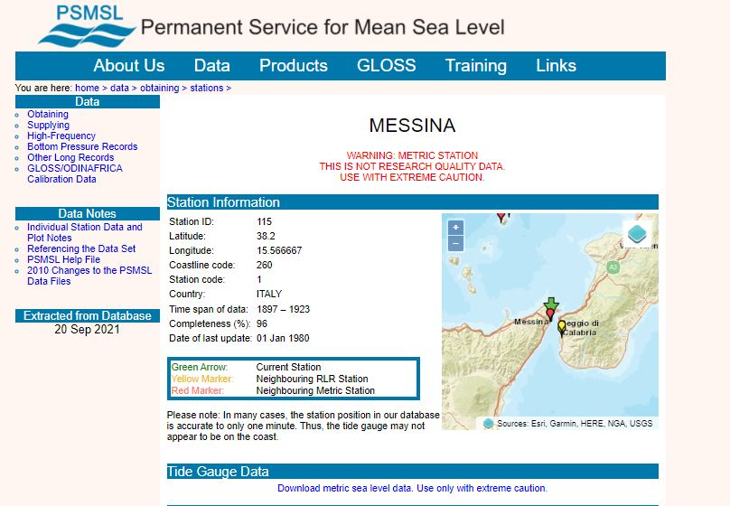
Fig. 1 - Layout of the PSMSL web page, which warns against the inappropriate use of data from the Messina tide gauge station.

According to the provided data list, no data were recorded between December 1908 and March 1909 because the Messina Harbour station was destroyed by the seismic event and by the subsequent destructive tsunami (Omori, 1913). In fact, the station was located on a sector of the Messina harbour that collapsed during the seismic event (see arrow in Fig. 2). These data were previously exploited by Cannelli et al. (2013) where, about the “coseismic sea level change”, the authors wrote: “finally, we must consider that the 1908 tsunami damaged the Messina tide gauge station, that was restored a few months later; it is not unlikely that in this process a shift of the reference datum has occurred. For these reasons, we expect that modelled coseismic sea level change may be biased by unphysical artefacts…………”. Following this limitation, the author analysed only the post-seismic sea level change without mentioning the ~0.4 m presumed coseismic step shown in Fig. 1 of PIN2021. As a demonstration of what we affirm, Cannelli et al. (2013) in their Fig. 1 clearly show a discontinuity of the sea level signal from tide gauge station of Messina in correspondence of the 1908 seismic event. It’s worth noting that Amoruso et al. (2002), in one of the most cited papers on the 1908 EQ, wrote “No data exist for the period 1908–1912 because of the damage due to the main shock”. In conclusion, the ~0.4 m step in the sea level data reported in Fig. 1 of PIN2021 is unreliable.
We were already aware of this issue and this was the reason why we did not consider tide gauge data from the “metric” Messina harbour station. Indeed, previous papers on the 1908 EQ by N.A. Pino (one of the authors of PIN2021) never reported data from the Messina harbour tide gauge for the computation of secular trends (e.g. Pino et al., 2000;2009). In PIN2021 the authors tried to provide a sort of data validation by quoting Olivieri et al. (2015). These authors, in fact, analysed a newly disclosed sea level record from the Mazara del Vallo tide gauge (on the other side of Sicily, about 270 km west of the Strait of Messina), finding a trend change point in late 1909. Conversely, Olivieri et al. (2015) interpreted it as an oceanic signal.

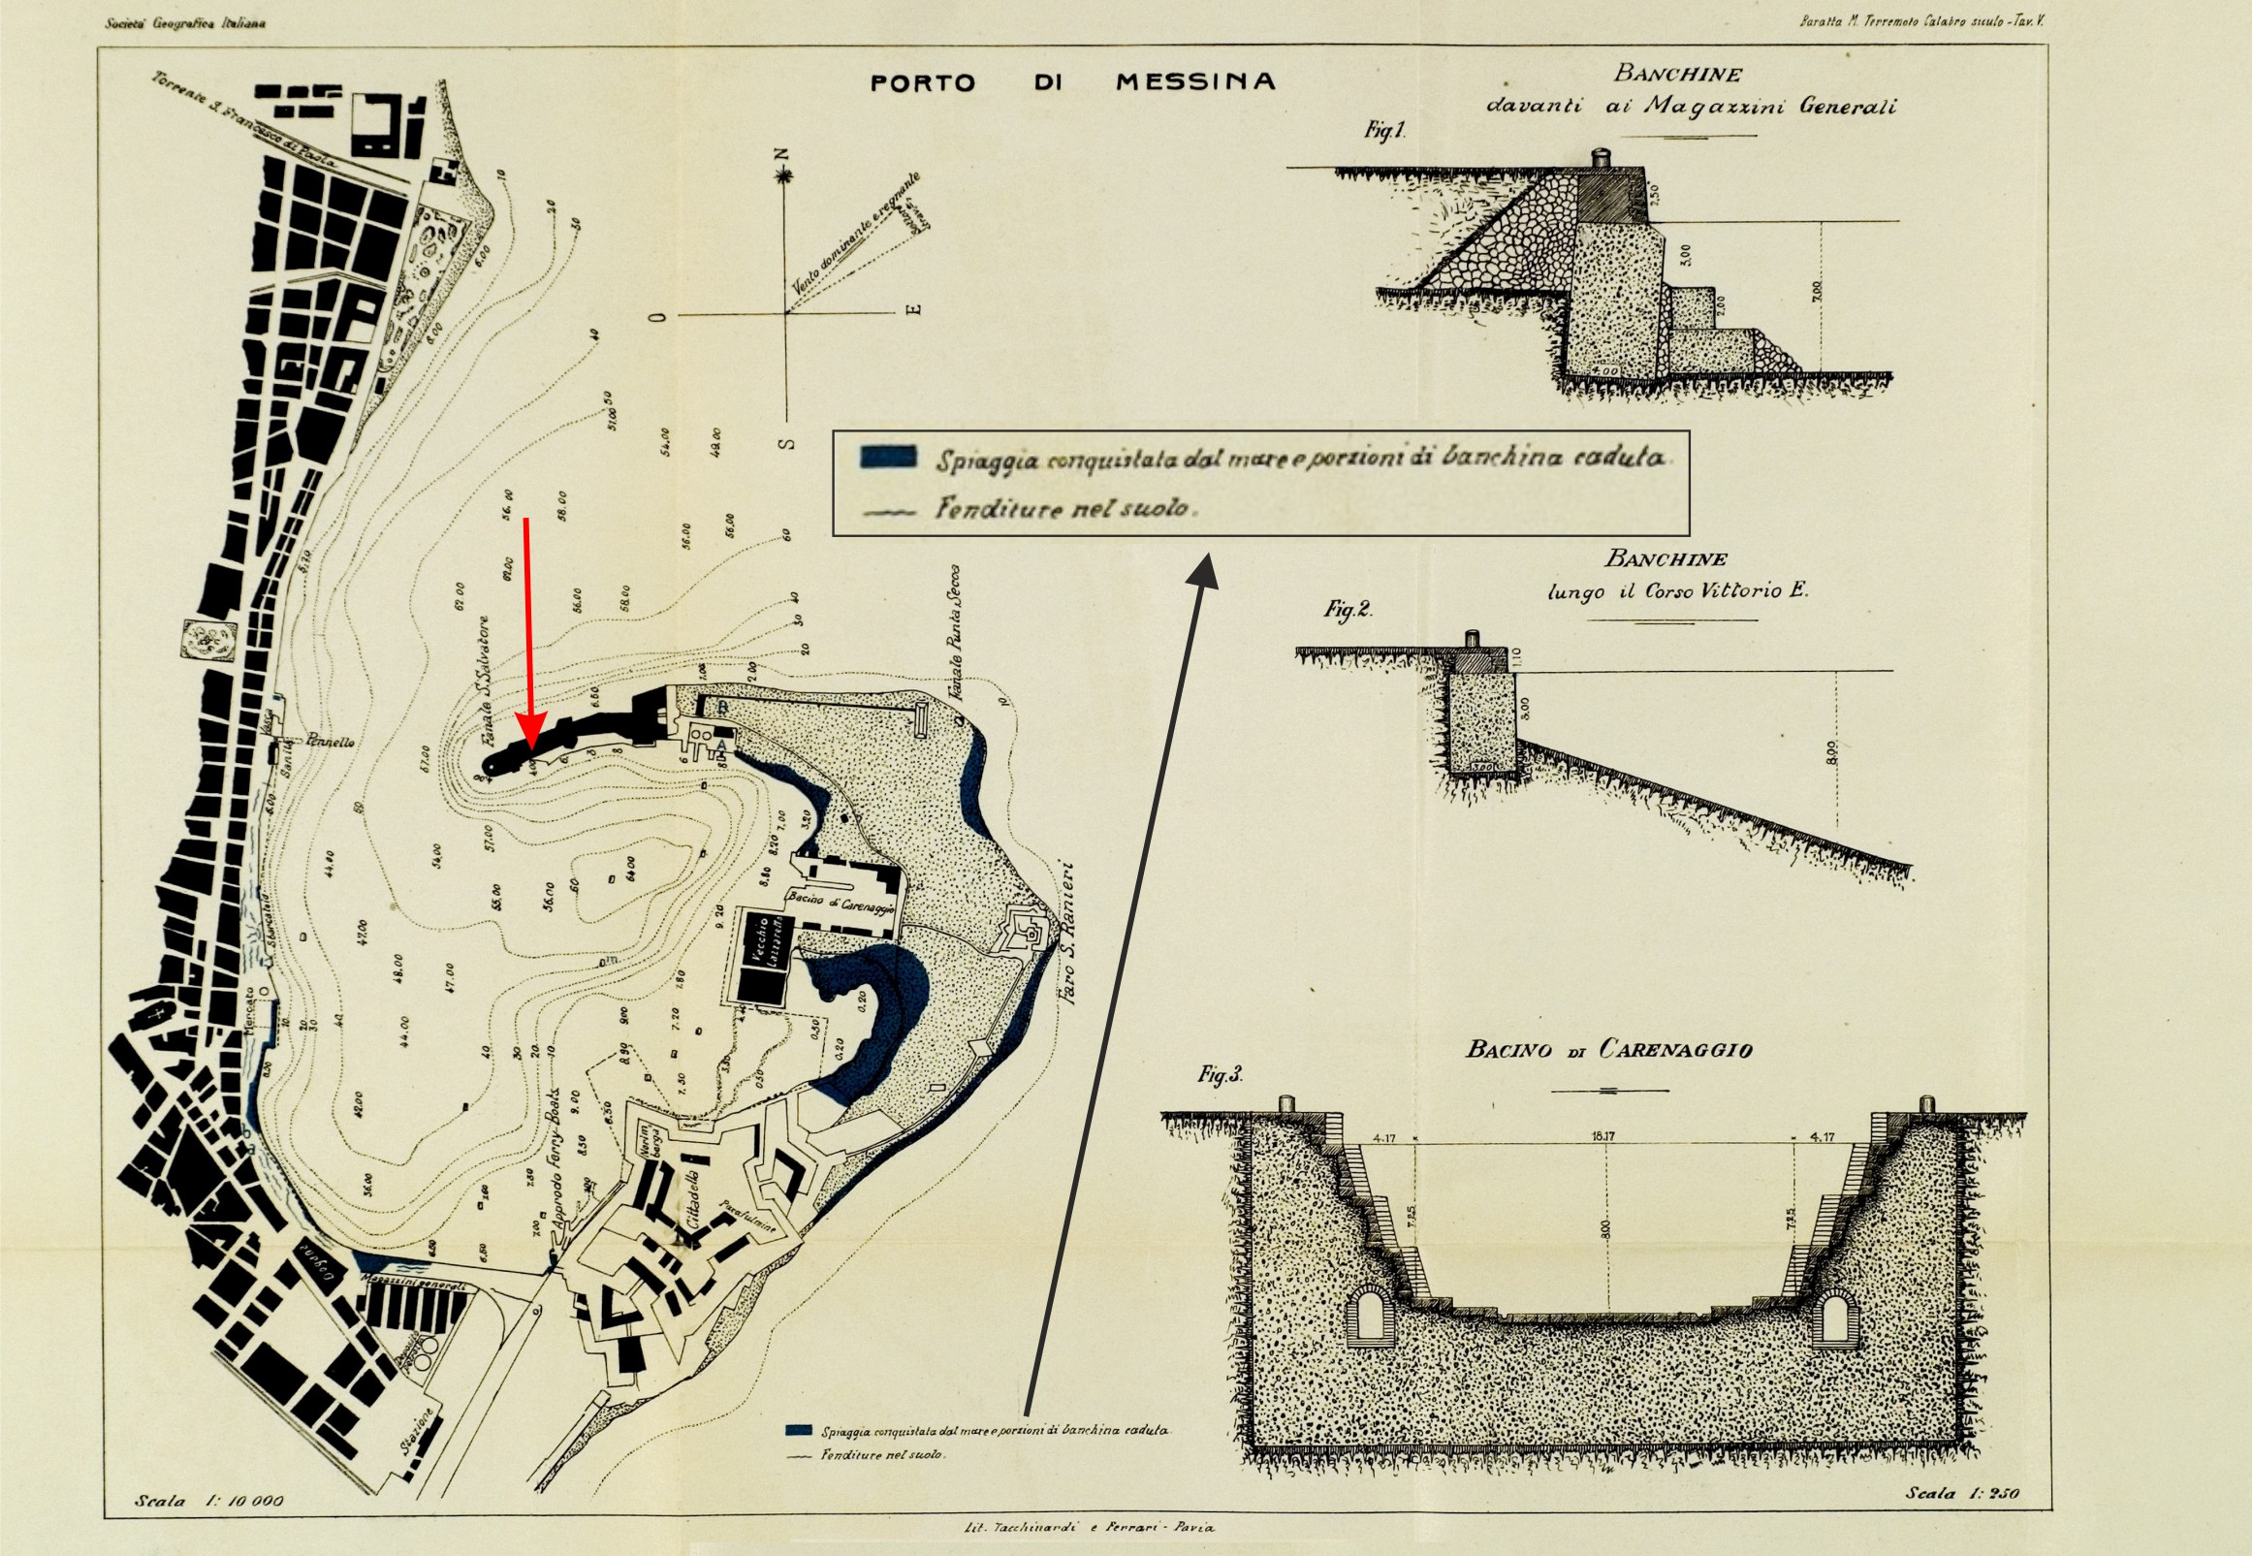
Fig. 2 - Map of the Messina natural harbour (from Baratta, 1910) showing collapsed sectors inside (black areas) and ground fractures (small lines parallel to the coastline). Red arrow shows the location of the tide gauge in a collapsed sector (location from https://www.psmsl.org/data/obtaining/stations/115.php).

Moreover, PIN2021 claim that the pre-earthquake levelling measures in the Calabrian side of the Messina Strait were carried out by Loperfido (1909) during 1906-1908, ending in December 1908, and for this reason the deformation should be all coseismic. We answer that no information regarding the measurement times was provided by Loperfido (1909) in his tables, so we are not sure if the levelling in southern Calabria was carried out two years, one year or one month before the seismic event, making it impossible to establish whether the deformation measured by the author was all coseismic or partially aseismic.
Conversely to PIN2021, we retain that the comparison with the tidal data clearly shows that the deformation was already in place several years before the earthquake. In fact, by using data from the same tide gauge, scholars such as Mulargia and Boschi (1983), Baldi et al. (1983), De Natale and Pingue (1991), Bottari et al. (1992), came to different conclusions from what is sustained by PIN2021. These authors, analysing the pre-earthquake recording (to note: no continuity of data to the post-earthquake period) highlighted uplift of the coast at a rate of 16 mm yr ⁻¹ in the period before 1900, subsidence of ~3 mm yr ⁻¹ in the period 1900–1906, and subsidence of more than 2 cm yr ⁻¹ in the periods 1906–1908. These independent outcomes clearly support the model proposed by B2021, who inferred a relationship between the subsidence and the occurrence of aseismic slip on the low-angle discontinuity before the 1908 EQ.
Finally, PIN2021 pointed out that we excluded in our analysis the benchmarks located in the Sicilian side of the Messina Strait, where levelling measurements were carried out in 1898-1899 (Loperfido, 1909). We highlighted the reason in B2021: “levelling benchmarks on the Sicilian side were excluded because the chosen referring point (S. Rizzo hill…..) is probably too close to the area affected by the subsidence (Loperfido, 1909)…….” Moreover, benchmarks located inside the Messina harbour were probably affected by gravitational collapses, resulting in excessive subsidence values (see Aloisi et al., 2014).

- On the issue 2.2 “Seismic cut-off of crustal seismicity”

PIN2021 also questioned the existence of the seismicity cut-off beneath the Strait of Messina. By using earthquake locations provided by B2021, PIN2021 provide a “new version” of the B2021 Fig. 8C, by removing “any additional line to drive the interpretation” (PIN2021 Fig. 2A). Following their “new version”, PIN2021 argued that the seismicity cut-off “is not distinguishable”. Substantially, PIN2021 stated that B2021 only imaged the seismicity cut-off and that the “additional line” was drawn to influence the readers. We do not accept this inappropriate insinuation.
Going deeper into the argument, in the analysis of the spatial distribution of seismic events, PIN2021 criticize our use of the available catalogue of earthquakes covering the last 40 years, because a filter by the magnitude of completeness, i.e. the magnitude threshold of complete recording, is not considered. Indeed, completeness in detecting earthquakes is a crucial parameter when dealing with some statistical studies, such as the probabilistic analysis of seismic risk or computing b-values of the Gutenberg-Richter distribution (e.g., Schorlemmer et al., 2010); these issues were not within the scope of our study. On the other hand, in seismic tomography studies (see Scarfì et al., 2018) and detailed analysis of the spatial pattern of earthquakes, the commonly used approach is to consider all available good quality data. In fact, the alignment of hypocenters, even of small earthquakes, gives important clues on the geometrical characteristics of faults, in particular those buried at depth and hidden to geologists, on the properties (elastic and rheological) of the material hosting the seismic source, and on the parameters governing the propagation of seismic energy (e.g. Scarfì et al., 2016).
However, even if the “new version” of the seismic section provided by PIN2021 in Fig. 2B is considered, one can note that the sloped seismicity cut-off remains well detectable; certainly, by removing all the earthquakes with M<2, that and other features become less evident. It is also the case to remark that the seismicity cut-off is a very clear characteristic element observed in eight crustal sections across the Strait of Messina region (see Fig. 5 of B2021 supplementary material). Therefore, also considering the suggestion by PIN2021, we can state that the main highlights outlined in B2021 and related to the distribution of earthquakes are preserved. A similar feature can be found also in the recently published paper of Neri et al. (2021), where Authors marked “the existence of seismogenic rock volumes” (see Fig. 5 of Neri et al., 2021), even if the authors propose different conclusions about seismicity related to the shallower faults.
Since the late 1990s, in eastern Sicily and southern Calabria, the earthquake detection capability has been significantly improved through the installation of numerous stations (see e.g. Scarfì et al., 2005, 2009). The configuration of the seismic network can be considered quite stable over the last 20 years. Thus, as an additional test, we calculated the magnitude of completeness of our seismic dataset, in the period 1999-2019, by the maximum curvature and the 90% quantile methods; this resulted in a value of 1.6. Therefore, we computed a new seismic profile by plotting all the earthquakes with M≥1.6, which again highlights the same features argued in B2021 (Fig. 3).

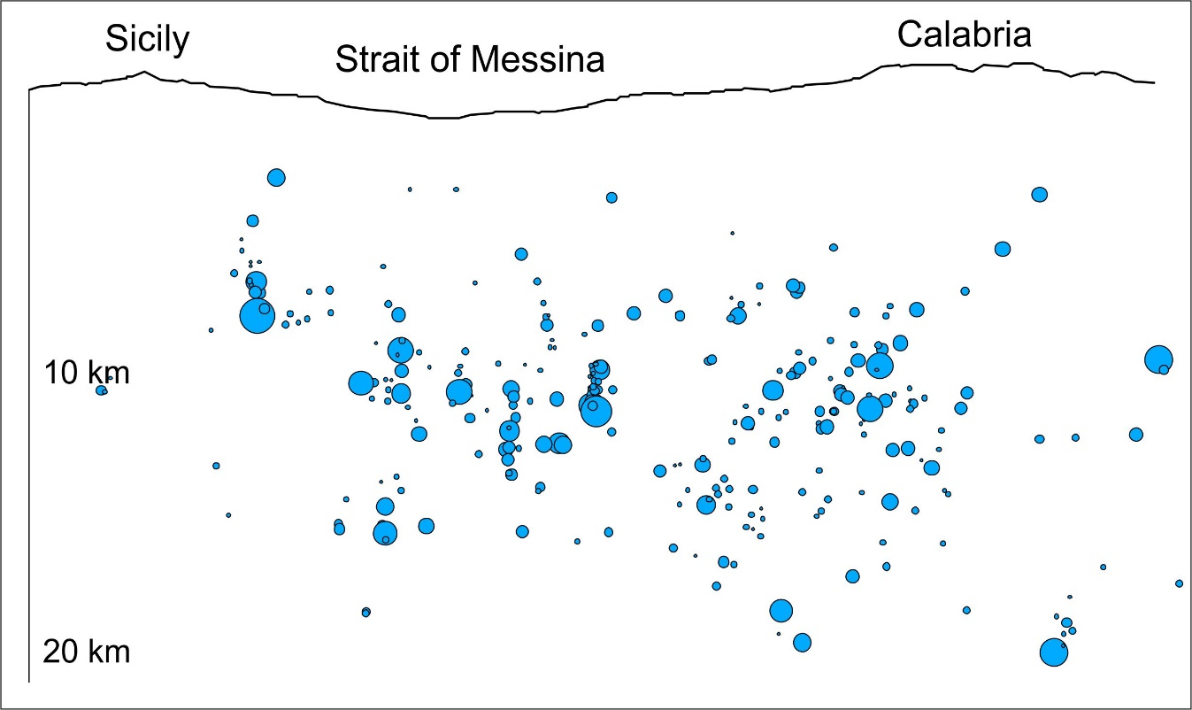
Fig. 3 – Distribution with depth of seismicity across the Strait of Messina (profile A-A’ in Fig. 8C of B2021) redrawn according to the calculated magnitude of completeness (M=1.6), to which original data were filtered.

Finally, PIN2021 also argued that the decollement level hypothesized by B2021 is not supported by the tomographic data reported in Fig. 9B. In line with the tectonic history of the area, B2021 interpreted the seismicity cut-off, which depicts a low-angle foreland-dipping discontinuity, as a former decollement level originally separating a rigid hanging-wall block (crystalline) from under-thrusted and less rigid sediments. Contradicting this interpretation, PIN2021 stated that the hypothesis “requires a decrease of P-wave velocity with depth, which however is not supported by the tomographic data reported in Fig. 9B of B2021”. Indeed, the tomographic section clearly shows a relative low velocity wedge, extending just below the considered decollement (see Fig. 9B of B2021). This feature is further evident by analysing the same section plotted in terms of velocity variations; in this case, the considered area is represented by a negative anomaly, i.e. a relative velocity decrease (Fig. 4). Perhaps PIN2021 expected that the interpreted slip zone (the decollement) would be resolved along the provided crustal tomographic section (i.e. the Fig. 9B of B2021). Usually, local or regional tomographies have a resolution suitable to imagine some kilometres-scale features. Fault-related slip zones within the crust typically do not exceed thickness of a few tens of meters.

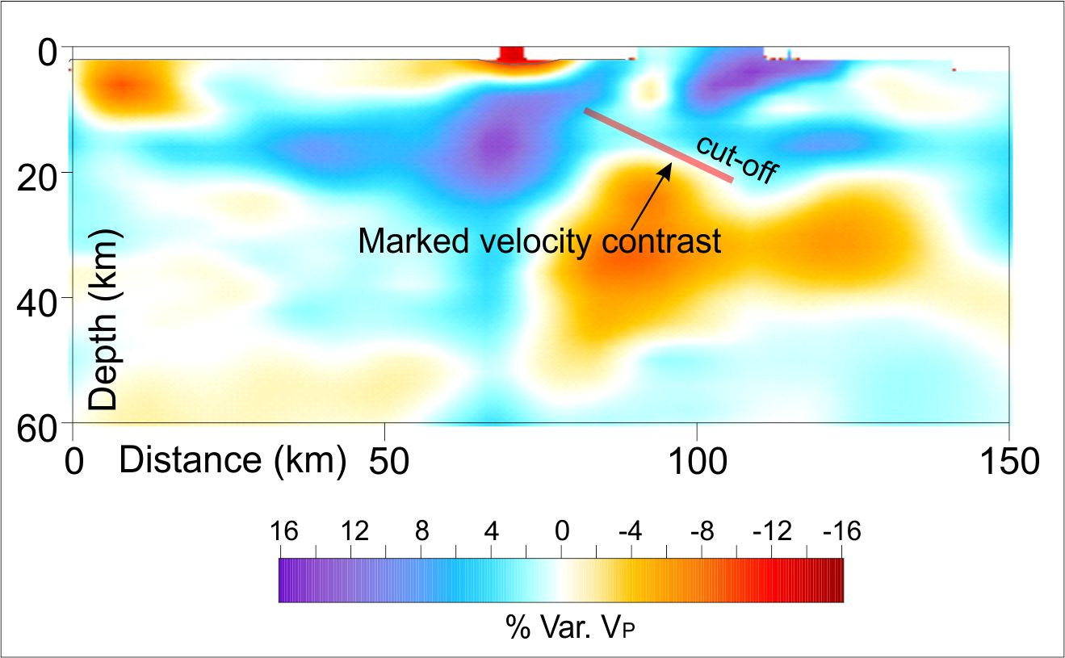

Fig. 4 - Tomographic section (Fig. 9B of B2021) plotted in terms of velocity perturbation (%) relative to the initial velocity model.

- On the issue 2.3 “Geodetic strain-rate across the Messina Strait”

About the strain-rate across the Strait of Messina, PIN2021 seem to question also on the scientific validity of previous papers dealing with the issue, which were quoted by B2021 to support their model. As far as we understand, PIN2021 seems to prefer Serpelloni et al. (2010) instead of Mattia et al. (2009), even if the two papers are both based on “a dataset of episodic and continuous GNSS measurements”. Serpelloni et al. (2010) is then preferred since the provided outcomes are “in agreement with other recent studies (e.g.……. Palano et al., 2012; Chiarabba and Palano, 2017)”, namely published by M. Palano, one of the authors of PIN2021 comment.. Going into the scientific matter, a poster co-authored by E. Serpelloni, and presented at EGU in 2009 (https://www.earth-prints.org/bitstream/2122/5709/1/poster_EGU2009.pdf), highlights that ~ 90 nanostrain/yr of extensional rate is oriented perpendicularly to the coasts of Sicily. We simply used averaged value between Mattia et al. (2009) (150 nanostrain/yr) and Mastrolembo Ventura et al. (2009) (90 nanostrain/yr) to state that a high strain-rate was resolved along the Strait of Messina.
. For the seek of clarity, at page 15 of B2021 the quotation of Serpelloni et al. (2010) after Mattia et al. (2009) was placed in a wrong position. Serpelloni et al. (2010) was instead correctly quoted in the sentence after since the author modelled the interseismic strain in the Strait of Messina region as produced by a 3.5 mm/yr (not just “a few mm/yr”) dip-slip motion along a low-angle and E-dipping discontinuity. Therefore, we want to remark that outcomes from Serpelloni et al. (2010) again confirm the seismotectonic model proposed in B2021.

- On the issue 3.1 “Coulomb stress change calculation”

We did not understand which scientific approach PIN2021 followed to also criticize the CSC analysis carried out by B2021. According to their “inspection” and without providing any further simulations, PIN2021 argued that being the left-lateral component “primarily” encouraged along the W-Fault, the oblique (normal and left-lateral) motion associated with to the W-fault by B2021 is incorrect. In our opinion, the PIN2021 approach is not supported by new analysis and forward simulations but, probably, only by visual “inspection”. In fact, PIN2021, by ignoring the expected normal component (see Fig. 13E of B2021), hint that only a pure left-lateral motion is encouraged along the W-Fault (e.g. the Fig. 3 of PIN2021). It is quite clear that the W-Fault is encouraged to move not as different sub-segments but entirely along its extension, following a normal-oblique left-lateral motion. In contrast, PIN2021’s criticisms of B2021’CSC analysis seem to follow the erroneous assumption of a “composite W-fault” according to which the W-fault is wrongly believed to be a segmented tectonic structure. This misunderstanding probably derives from the assumption made by B2021 in the inversion of the levelling data where “to obtain a more realistic configuration of the faults, the non-linear W-fault plane was split into four patches” (see below). This is a geometric simplification to allow the software computing simulation. Conversely, PIN2021 treated the W-Fault as a “composite” structure where segments (e.g. “the WF1 segment”, “strike-slip motion has been inferred for WF1, WF2, and WF4 segments” and so on) can slip independently from each other. As stated above, this assumption is inconsistent since the W-Fault is a single structure as revealed by the new sub-seafloor geophysical soundings (see B2021). Accordingly, we did not perform the inversion of levelling data “to infer the strike- and dip-slip displacements on a set of multiple sources”.
Moreover, following the stress transfer theory, in one of the first and most quoted manuscript on this topic (King et al., 1994) is clearly reported: “..... encourage us to apply stress interaction techniques to estimate how the potential for failure along parts of the San Andreas earthquake.....”; “..........moderate events prior to the Landers earthquake increased the potential for failure along most of the future Landers rupture zone.....”; “....were stresses redistributed in such a way as to increase the likelihood of future San Andreas earthquakes?......”. From these sentences that report words as “potential” and “likelihood”, it is very clear that the Coulomb stress change must be regarded as a perturbation of the “potentiality” of slip of the fault plane in response to the current stress state of the medium (e.g. co-seismic and post-seismic stress change, regional stress, etc.). Therefore, our results demonstrated that the W-Fault is encouraged to move as a normal and as an oblique left-lateral fault, but one does not exclude the other or one is not predominant on the other, as reported by PIN2021.
Having clarified these important aspects, we reject all the criticisms raised by PIN2021 about the CSC analysis.

- On the issue 3.2 “Modelling of the levelling measurements”

In the following we reply to comments on the inversion of levelling data:

- The stress field derived from the inversion of the focal mechanisms of the Strait of Messina area is essentially normal. However, the dataset used is limited; this means that the hypothesized oblique movement on the fault cannot be considered incongruent with this seismological stress field and its related uncertainty.
- the maximum displacement on the WF3 is not “~5 m” but instead 4.46 m (means ~4.5 m) (see table I in B2021). 35% was a typing error. 45% is the correct value;
- Again, wrongly considering the W-Fault as a “set of multiple sources” PIN2021 erroneously attributed a “dominant left-lateral strike-slip motion” to the “WF1, WF2, and WF4 segments”. We confirm that the W-Fault is a single structure and, as said before, we used a geometric simplification to allow the software computing simulation;
- Considering the oblique motion expected on the whole W-Fault, “coseismic differential motions up to ~2 meters” are not expected between the northern and southern sides of the Catona River. Even assuming this “differential motions “as reliable (but it’s not, since coseismic deformation dissipates towards the fault terminations), “well-marked surface fractures along most of the Catona River” are not expected considering the incoherent nature of the fluvial sediments outcropping in the area. Moreover, field observations, carried out by Baratta (1910) after the 1908 EQ, reported ground fractures not only in “correspondence with the coastal belt” but also several kilometers toward East in the Calabrian inland (see Fig. 15 of B2021). About the morpho-structural analysis, PIN2021 also claim, “The existence of the WF1 segment appears questionable since it has not been reported in recent detailed morphostructural studies carried out along the Catona river basin (Pirotta et al., 2016; Monaco et al., 2017).” We found it an unjustified comment. PIN2021 refer to an alleged contradiction with the work of Monaco et al. (2017), in which the authors did not deal at all with the Catona river and the fault along it (which we have only recently modeled, see B2021), but they only analyzed the terraces north of the river particularly those of the Campo Piale High and the Tyrrhenian coast between Villa San Giovanni and Scilla. PIN2021 also refers to an alleged contradiction with the work of Pirrotta et al. (2016), of which C. Monaco is a co-author. B2021 simply deepened the morphometric analysis, extending it to the deformation of the terraces thanks to the use of very high-resolution DEMs that were not previously available.
Moreover, PIN2021 observed that “Another relevant feature is that the low-angle discontinuity with a “creeping” dip-slip motion of 1.13 m accounts for 50% of the total moment (equivalent to a M6.9 earthquake), while the remaining 50% of the moment is accounted by the W-fault (the contribute by the Armo fault is negligible)”. We do not understand if this is a further criticism or just an observation.

- On the issue 3.3 “Other incongruences and formal errors in the B2021 paper”

We acknowledge PIN2021 for spending their time to check carefully throughout the text for formal errors. Effectively, some not-conceptual errors (e.g. Fig. 1D and 8C) are present in the text making the effort made by PIN2021 appreciated.

The “other incongruences”, are again discussed and rejected below:

- Following the same misunderstanding of “a set of multiple sources” (see above), PIN2021 continue to consider the W-Fault as a segmented structure. They in fact state that: “3/4 of the unknown extensional fault are characterized by a prevailing strike-slip motion”. According to a homogeneous slip on the single W-fault, the ¾ of the fault cannot move independently from the other ¼, where a normal slip of ~ 4.5 m is expected (see table I of B2021). We therefore remark that an oblique (normal/left-lateral) motion is expected along the single W-Fault. Induced stress (i.e. the three components) on the receiver W-Fault is clearly reported in Fig. 13C of B2021.
- The cluster “deeper than the active W-fault highlighted in Fig. 8C” cannot be related to the W-Fault. In the map view (Fig. 8A of B2021), the considered cluster is located further west of the W-Fault. PIN2021 did not consider that the W-fault has a dip-angle of 45°.
- Again, without performing any forward simulation, PIN2021 assert that “significant variations of the CSC pattern are expected” by considering the “right equation” and, by the way, the recalculated value of Young’s modulus E (63 GPa). Therefore, we performed a new fault response modelling simulation by using the new E value provided by PIN2021. Forward modelling confirms once again that the W-Fault is mainly encouraged to slip according to normal and left-lateral movement while the right-lateral component remains negligible. Any significant variation of the CSC patterns is observed considering the suggested E. Of course, only a small reduction (~10%) in the modules of the induced stress is accounted (Fig. 5). Furthermore, the resulting displacement vector field is now overlaid to the W-fault to reinforce the concept of a transtensional (slightly left-lateral) motion on the fault.

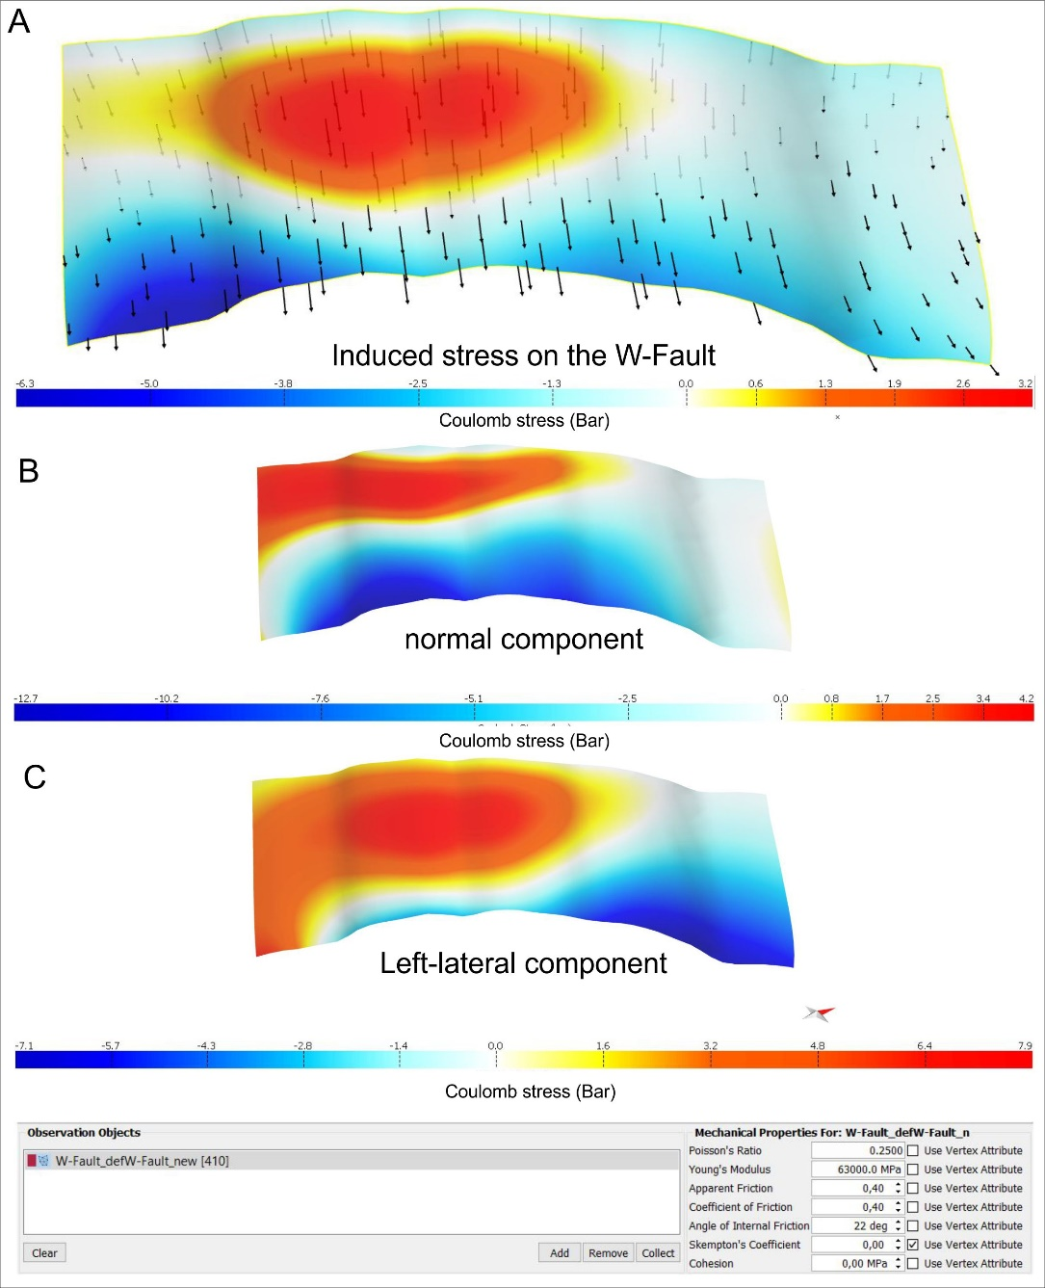

Fig. 5 – Coulomb stress transferred on the W-Fault by simulating a dip-slip movement on the low-angle discontinuity. Induced stress is recalculated according to the Young’s modulus E of 63 GPa provided by PIN2021. A) Total induced stress and resulting slip vectors (black arrows); B) Normal component of motion; C) left-lateral component of motion. Mechanical properties of the medium are reported at the bottom following suggestions of PIN2021.

- On the issue 4. “B2021 results and incongruences with other geophysical observations”

PIN2021, wrongly considering the W-Fault as a “composite fault”, where each segment can slip independently from the other, try to disprove also the location provide by B2021 for the W-fault stating that: “the W-fault is incompatible with source directivity observations”.
As already demonstrated by Aloisi et al. (2014) in their Reply to the comment of De Natale and Pino (2014) to another study of our research group on the 1908 EQ (see Aloisi et al., 2012), we can assert that seismological data suffer of the poor quality of the original record. In fact, the polarities are often of doubtful quality and the areal coverage of the few usable stations is very poor. We list once again the same statements found in literature about the original seismic data collected during the 1908 earthquake and the derived analysis (see also Aloisi et al., 2014):
- From Pino et al. (2000): “Besides, some of the stations are almost nodal, and the polarity is not always clear. Because of the poor azimuthal and distance coverage of the usable waveforms it is not possible to obtain an unambiguous discrimination between the different solutions of Fig. 2”. In their Fig. 2 the authors propose the focal mechanisms for the 1908 Messina Straits earthquake as determined by six different authors.
- Always from Pino et al. (2000): “With the assumption of a realistic rupture propagation velocity we determined the slip distribution. Because of the poor azimuthal and distance coverage, we could not determine a focal mechanism, nor discriminate between the published solutions, which generally display only minor differences”. For the sake of clarity, the azimuthal coverage of the recording points (except for one among the 6 used stations) spans from 12° to 16° and the minimum distance of the recording station is 1000 km. The seismic data from stations closer to Messina and Reggio were unusable because the limited dynamic range produced waveforms severely saturated and distorted.
- From Amoruso et al. (2002): “The 1908 Messina earthquake was recorded by 110 seismographic stations around the world (Rizzo, 1910). Since it occurred before a global homogeneous network was organized and installed, seismological data are far from being precise, and many original records are no longer available. As a consequence, seismological analyses have to rely mostly upon polarity determinations dating back to that period, and the focal mechanism is not well constrained because of the poor coverage of the focal sphere by the stations for which data are available”.
Consequently, we rebut once again any consideration on polarities by PIN2021, as inconsistent (they used uncertain data). Also, we have split the non-linear W-fault plane into four patches (WF1-WF4) solely to make it easier the inversion of the geodetic levelling data. It is an artefact that can only be used to run the software and not applicable to seismological considerations.

- Conclusions

We stand by our model and do not accept the criticisms of PIN2021”. We confirm that aseismic slip “may have mechanically destabilized the overlying and already tectonically stressed brittle faults”. In the case study, based i) on the occurrence of a seismic cut-off within the crustal domain, ii) on the pattern of recorded subsidence (see Loperfido, 1909), and iii)on the high strain-rate recorded in the Strait of Messina region, we infer that an additional stress, probably caused by an aseismic slip (see also Doglioni et al., 2005) along a low-angle discontinuity (marked by the seismicity cut-off), could have been transferred to the nearby shallow brittle faults (see the Coulomb stress-transfer criterion for further details), therefore favouring them to rupture in large earthquakes. In other words, according to our hypothesis of composite source model for the 1908 EQ, the aseismic slip along the low-angle discontinuity, which accommodates most of the regional extension, triggered coseismic failure along the previously unknown W-Fault. The geometry of this fault has been reconstructed by a new dataset of sub-seafloor geophysical soundings and by morphotectonic analysis. Contrary to PIN2021’s comment that the fault is a structure split into four patches, it is a single segment.
In conclusion, we have demonstrated the scientific inconsistency of the criticisms of PIN2021 and stand by our published results. Finally, we provide a corrigendum for some formal errors found by PIN2021 throughout the manuscript.

Corrigendum
- In the caption of Fig. 1 D, “in the Nubia reference frame” is instead in the Eurasian reference frame. The acronym CF is instead CTF.
- Focal solutions in the section of Fig. 8C are affected by a graphic error. The corrected Fig. 8 C in now provided.
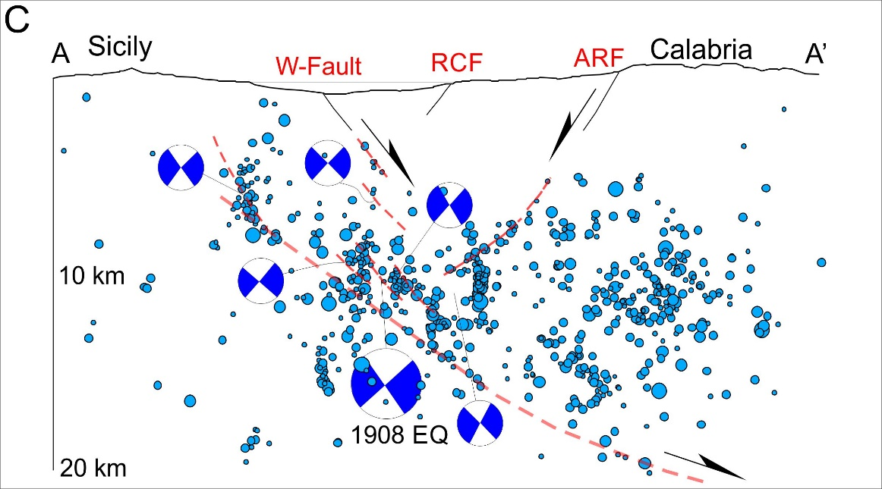
Fig. 8C corrected

- At page 15 of Barreca et al., (2021), the quotation Serpelloni et al., (2010) after Mattia et al., (2009), is not correctly placed, and should not be considered for what concerning the statement above.

References

Aloisi, M., Bruno, V., Cannavo’, F., Ferranti, L., Mattia, M., Monaco, C., Palano, M., 2013. Are the source models of the M 7.1 1908 Strait of Messina earthquake reliable? Insights from a novel inversion and a sensitivity analysis of leveling data. Geophys. J. Int. 192 (3), 1025–1041. https://doi.org/10.1093/gji/ggs062.

Aloisi M., Bruno V.,Cannavò F., Ferranti L., Mattia M. and C. Monaco, 2014. Reply to ‘Comments on the paper “Are the source models of theM7.1 1908 Messina Straits earthquake reliable? Insights from a novel inversion and sensitivity analysis of levelling data” by Aloisi et al. (2012)’. Geophysical Journal International, doi: 10.1093/gji/ggu116.

Amoruso, A., Crescentini, L., Scarpa, R., 2002. Source parameters of the 1908 Messina Straits, Italy, earthquake from geodetic and seismic data. J. Geophys. Res. 107 https://doi.org/10.1029/2001JB000434.

Baldi, P., Achilli, V., Mulargia, F., 1983.Geodetic surveys in Messina Straits area, Bull. Geod., 57, 283–293,

Baratta, M., 1910. La catastrofe sismica calabro-messinese 28 dicembre 1908, relazione. Soc. Geogr. It, Rome.

Barreca, G., Gross, F., Scarfì, L., Aloisi, M., Monaco, C., Krastel, S. 2021. The Strait of Messina: Seismotectonics and the source of the 1908 earthquake. Earth-Sci. Rev. 103685. https://doi.org/10.1016/j.earscirev.2021.103685.

Bottari, A., Carveni, P., Lo Giudice, E. Nikonov, A., and Rasa`, R., 1992. Anomalous crustal movements prior to great earthquakes as derived from tide gauge records: The Messina, 1908 I = XI, earthquake case history, Tectonophysics, 202, 269–275.

Chiarabba C., Palano, M., 2017. Progressive migration of slab break-off along the southern Tyrrhenian plate boundary: Constraints for the present-day kinematics. J. Geodyn. 105, 51- 61. https://doi.org/10.1016/j.jog.2017.01.006.

De Natale, G., Pingue, F., 1991. A variable slip fault model for the 1908 Messina Straits (Italy) earthquake, by inversion of levelling data, Geophys. J. Int., 104, 73–84, 1991.

De Natale, G., Pino, N. A., 2014, Comment on ‘Are the source models of the M 7.1 1908 Messina Straits earthquake reliable? Insights from a novel inversion and sensitivity analysis of levelling data’ by M. Aloisi, V. Bruno, F. Cannavò, L. Ferranti, M. Mattia, C. Monaco and M. Palano. Geophys. J. Int. 197, 1399-1402. https://doi.org/10.1093/gji/ggu063.

Doglioni, C., Carminati, E., Petricca, P., Riguzzi, F., 2005. Normal fault earthquakes or graviquakes. Sci. Rep. 5, 12110. https://doi.org/10.1038/srep12110.

King, G. C. P., R. S. Stein, and J. Lin (1994), Static stress changes and the triggering of earthquakes, Bull. Seismol. Soc. Am., 84, 935–953.

Loperfido, A., 1909. Livellazione geometrica di precisione eseguita dall’I.G.M. sulla costa orientale della Sicilia, da Messina a Catania, a Gesso ed a Faro Peloro e sulla costa occidentale della Calabria da Gioia Tauro a Melito di Porto Salvo. In: Relazione della Commissione Reale incaricata di designare le zone più adatte per la ricostruzione degli abitati colpiti dal terremoto del 28 dicembre 1908 o da altri precedenti. Accademia Nazionale dei Lincei, Roma, pp. 131-156.

Mastrolembo Ventura, B., Serpelloni, E., Burgmann, R., Anzidei, M., Baldi, P., Cavaliere, A., 2009. Active strain-rate Across the Messina Straits and Kinematics of Sicily and Calabria From GPS Data. EGU Poster 9870.

Mattia, M., Palano, M., Bruno, V., Cannav`o, F., 2009. Crustal motion along the Calabro- Peloritano Arc as imaged by twelve years of measurements on a dense GPS network. Tectonophysics 476, 528–537.

Monaco, C., Barreca, G., Di Stefano, A., 2017. Quaternary marine terraces and fault activity in the northern mainland sectors of the Messina Strait (southern Italy). Ital. J. Geosci. https://doi.org/10.3301/IJG.2016.10.

Mulargia, F., Boschi, E., 1983. The 1908 Messina earthquake and related seismicity, in Earthquakes: Observations, Theory and Interpretation, edited by H. Kanamori and E. Boschi, pp. 493 – 518, North-Holland, New York, 1983.

Neri, G., Orecchio B., Presti D., Scolaro S., Totaro, C., 2021. Recent Seismicity in the Area of the Major, 1908 Messina Straits Earthquake, South Italy. Front. Earth Sci. 9:667501. https://doi.org/10.3389/feart.2021.667501.

Olivieri, M., Spada, G., Antonioli, A., Galassi, G., 2015. Mazara del Vallo tide gauge observations (1906–16): land subsidence or sea level rise? J. Coast. Res. 31, 69-75. https://doi.org/10.2112/JCOASTRES-D-12-00233.1

Omori, F., Preliminary report on the Messina-Reggio earthquake of Dec. 28 1908, Bull. Imp. Earthquake Invest. Comm., 3(2), 37– 46, 1909.

Palano, M., Ferranti, L., Monaco, C., Mattia, M., Aloisi, M., Bruno, V., Cannavò, F., Siligato, G., 2012. GPS velocity and strain fields in Sicily and southern Calabria, Italy: Updated geodetic constraints on tectonic block interaction in the central Mediterranean, J. Geophys. Res., 117, B07401. https://doi.org/10.1029/2012JB009254.

Pino, N.A., Giardini, D., Boschi, E., 2000. The December 28, 1908, Messina Straits, southern Italy, earthquake: waveform modeling of regional seismograms. J. Geophys. Res. 105 (B11), 25 473–25 492.

Pino, A., Piatanesi, A., Valensise, G., Boschi, E., 2009. The 28 December 1908 Messina Straits earthquake (Mw 7.1): a great earthquake throughout a century of seismology. Seismol. Res. Lett. 80 (2), 243–259.

Pino, N.A., Palano, M., Ventura, G., 2021. Comment on the paper by Barreca et al.: “The Strait of Messina: Seismotectonics and the source of the 1908 earthquake” (Earth-Science Reviews 218, 2021, 103685).

Pirotta, C., Barbano, S., Monaco, C., 2016. Evidence of active tectonics in southern Calabria (Italy) by geomorphic analysis: the examples of the Catona and Petrace rivers. Ital. J. Geosci. 135(1), 142-156. https://doi.org/10.3301/IJG.2015.20

Rizzo, G. B., 1910. Sulla propagazione dei movimenti prodotti dal terremoto di Messina del 28 Dicembre 1908, Rend. Accad. Sci. Torino, Ser. II, LXI, 355– 417.

Scarfì L., Langer H., Scaltrito A., 2005. Relocation of microearthquake swarms in the Peloritani mountains - Implications on the interpretation of seismotectonic patterns in NE Sicily, Italy. Geophys. J. Int., 163, 225-237, doi: 10.1111/j.1365-246X.2005.02720.x.

Scarfi, L., Barberi, G., Musumeci, C., Patane, D., 2016. Seismotectonics of northeastern Sicily and southern Calabria (Italy): New constraints on the tectonic structures featuring in a crucial sector for the Central Mediterranean geodynamics. Tectonics 35, 812–832. https://doi.org/10.1002/2015TC004022.

Scarfi, L., Barberi, G., Barreca, G., Cannavo, F., Koulakov, I., Patane, D., 2018. Slab narrowing in the Central Mediterranean: the Calabro-Ionian subduction zone as imaged by high resolution seismic tomography. Sci. Rep. 2018 (8), 5178. https:// doi.org/10.1038/s41598-018-23543-8.

Scarfì, L., Langer, H., Scaltrito, A. 2009. Seismicity, seismotectonics and crustal velocity structure of the Messina Strait (Italy). Phys. Earth Planet. Inter. 177(1-2), 65-78. https://doi.org/10.1016/j.pepi.2009.07.010.

Serpelloni, E., Bürgmann, R., Anzidei, M., Baldi, P., Mastrolembo, B., Boschi, E., 2010. Strain accumulation across the Messina Straits and kinematics of Sicily and Calabria from GPS data and dislocation modeling. Earth Planet. Sci. Lett. 298 (3–4), 347–360.

Schorlemmer, D., F. Mele, and W. Marzocchi (2010), A completeness analysis of the National Seismic Network of Italy,J. Geophys. Res., 115, B04308, doi:10.1029/2008JB006097

