Velocity profile report at the seismic stations IT.ATI – Atina (FR)

Report sul profilo di velocità sismica per il sito della stazione sismica IT.ATI – Atina (FR)

Working Group:  Giovanna Cultrera  Rocco Cogliano  Giuliano Milana  Stefania Pucillo  Gaetano Riccio | Date: December 2019
Subject: Final report illustrating measurements, analysis and results for Vs profile at seismic station IT.ATI

Summary

1. Introduction 3
2. Geophysical investigation 4
2.1 H/V spectral ratio from temporary seismic noise measurements 5
2.2 Results from 1D MASW analysis 6
2.3 Results from 2D Geophones Array 7
3. 1D seismic velocity model 8
Disclaimer and limits of use of information 14
Esclusione di responsabilità e limiti di uso delle informazioni 15

Introduction

In this report, we present the geophysical measurements and the results obtained in the framework of the 2019-2021 agreement between INGV and DPC, called Allegato B2: Obiettivo 1 – Task B: Caratterizzazione siti accelerometrici (Coord.: G. Cultrera, F. Pacor) for the characterization of sites of the Italian National Seismic Network (RSN) with accelerometers.
The report characterizes the velocity profile for the IT.ATI station. The performed geophysical prospecting consists in one MASW profile and two ambient vibration H/V spectral ratios. Using surface-wave frequency-wavenumber analysis and H/V ambient vibration spectral ratios, we provide results in terms of resonant peaks and dispersion curves inverted to obtain shear-wave velocity (V_{s}) profiles for the studied area. The inverted models are suitable for determination of the average Vs velocity in the uppermost 30 m (V_{s30}) and assigning then the soil class category as prescribed by building codes (EC8, NC8 or NC18).

Geophysical investigation

IT.ATI strong motion station is positioned on the N-W section of the hill were the historical city centre is located. The station stands on a slope with an elevation of about 50 meters above the alluvial plain surrounding the hill. The site is classified in topographic class T3. Due to the limitation of the area surrounding the station and its position along the slope, it is not possible to deploy either big aperture 2D seismic array or long MASW linear deployments. The only possibility was to deploy a linear MASW deployment based on 48 vertical geophones with natural frequency oh 4.5 Hz and sensors spacing of 1 meter. The ATI station is installed on the hill slope on a fractured dolostone formation as described in the companion geological report. To better constrain the data inversion two stand-alone seismic stations were also installed to evaluate H/V spectral ratio on ambient vibration data (Figure 1). The site logistic forced to deploy our equipment on the flat space close to the ATI site where it is possible to find some landfill layer that can affect the results of the performed investigations.
Geophysical data were collected on October 24,2019.

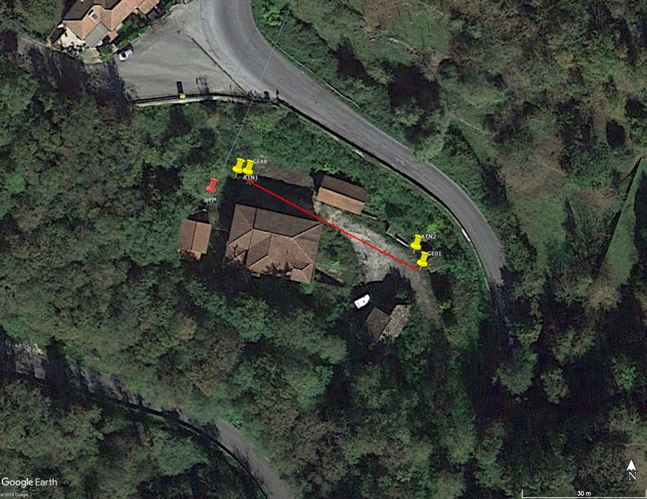
Figure 1: Plan view of the 1D MASW line deployed at ATI site. The first and last geophones of the line are shown along with the two stations used to perform H/V analysis (yellow markers). ATI station is also shown (red marker).

H/V spectral ratio from temporary seismic noise measurements

Figures 2 shows the H/V curves for the two stand-alone stations shown in Figure 1 (ATN1 and ATN2).
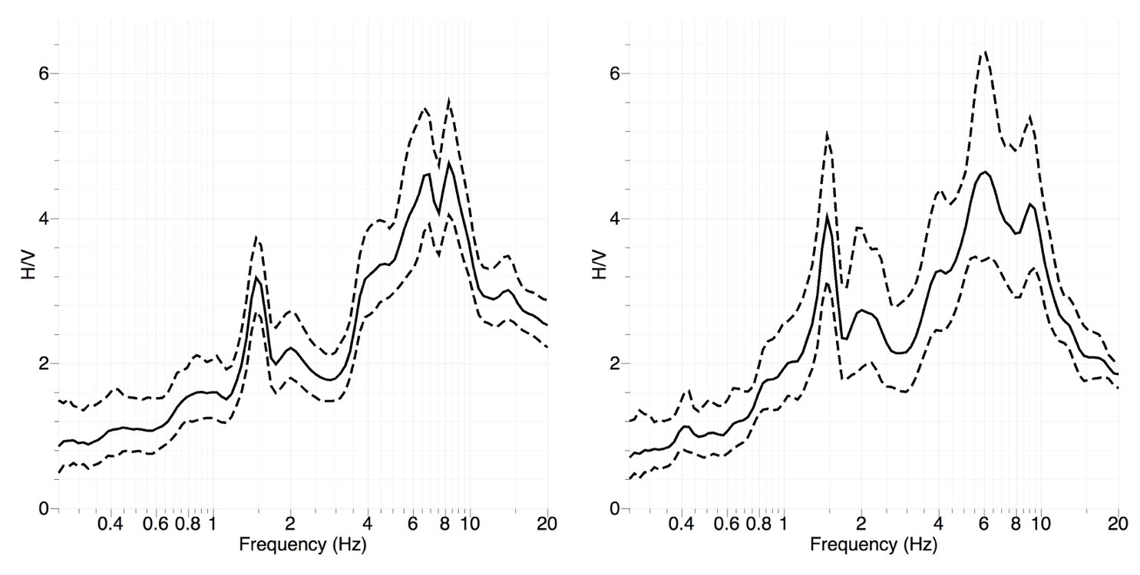
Figure 2: H/V ambient noise spectral ratio at ATN1 (left panel) and ATN2 (right panel) stand-alone temporary stations.

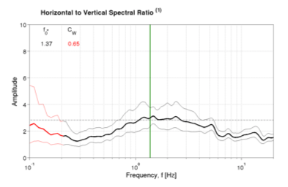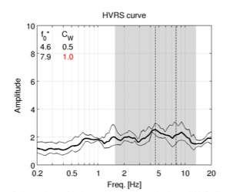

Figure 3: H/V from ambient noise data (left panel) and earthquake data (right panel) at IT.ATI station.

The H/V data show a clear narrow-band peak centred at about 1.5 Hz related to some anthropic disturbance and a broad peak, with a complex shape in the 4 – 10 Hz frequency band and with important differences between the two recording sites. A comparison with H/V data obtained using both ambient vibration and earthquake records at ATI site, Figure 3, shows important differences in terms of both frequency and amplitude values. This observation supports the hypothesis of the presence of landfill in the area where the presented geophysical investigations were performed.
The rotational H/V spectral ratio, Figure 4, shows some directional effect with maxima centred at about 50 degrees probably related to the influence of the topography on the wavefield.
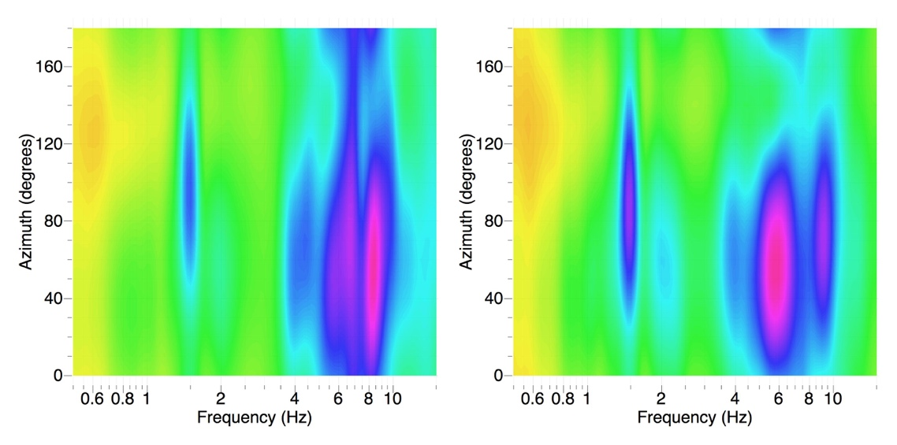
Figure 4: Rotational H/V ambient noise spectral ratio at ATN1 (left panel) and ATN2 (right panel) stand-alone temporary station.

Results from 1D MASW analysis

The MASW deployment was based on 48 4.5 Hz geophones connected to a couple of Geometrics-geode 24 channels recording systems. The two dataloggers were connected by a LAN cable. Data per recorded on a field laptop computer. Geophones spacing was set to one meter, sample interval was fixed at 0.125 ms for a record duration of 2 seconds. A sledgehammer was used as source, the shot points were put at distances of 2 and 1 meter from both geophones 1 and 48. Another shot point was selected at the centre of deployment. Three shot were executed at each energizing point. Data were analysed in terms of conventional frequency-wavenumber (FK) analysis and the results were interpreted in terms of Rayleigh surface-waves (http://www.geopsy.org). The results of MASW analysis are shown in Figure 5 for the studied shot points at both deployment ends.

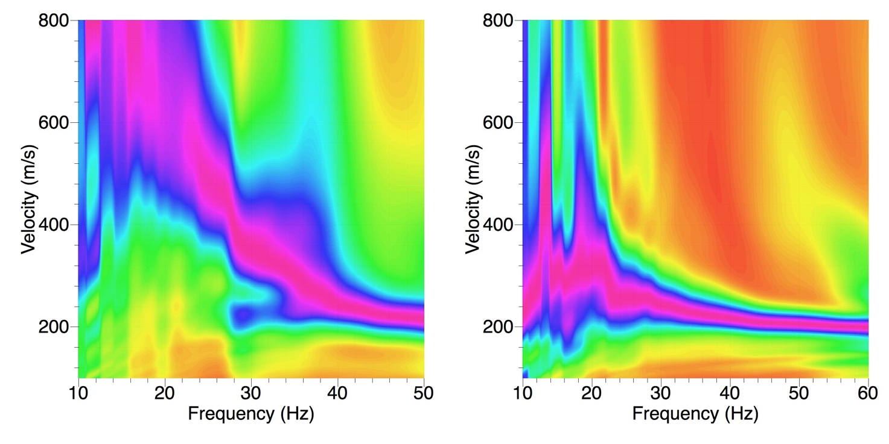
Figure 5: FK results for shot point located 2 meters apart from the geophone #1 (left panel) and #48 (right panel).

The Figure 5 shows a clear asymmetry in the MASW results indicating some difference in the geological setting along the array. In both cases the high frequency part of the dispersion pattern relates to low velocity values (about 200 m/s) indicating again the presence of low velocity outcropping materials.

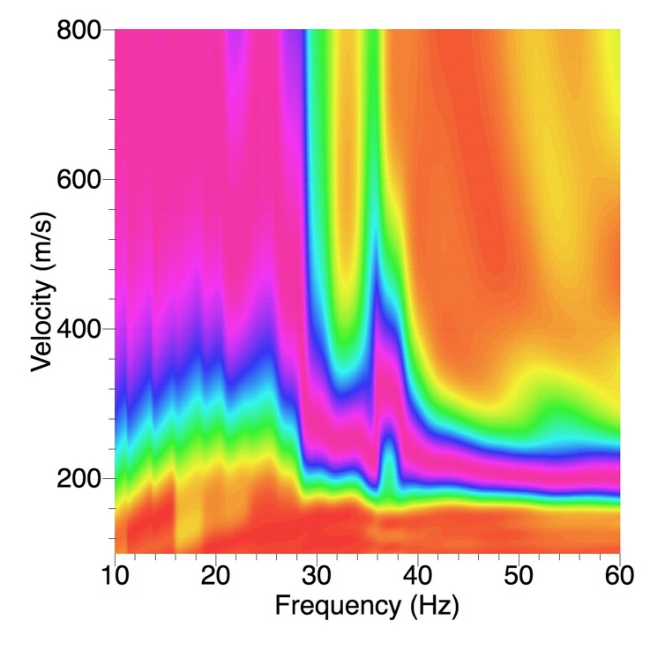
Figure 6: FK results for shot point located 2 meters apart from the geophone #1 obtained after the exclusion of the first 10 geophones
In order to check the reason of this asymmetry we analysed again the data relative at the first shot point removing the first group of geophones. The results are presented in Figure 6 that shows results more similar to the ones obtained for the shot point close to geophone 48. This observation suggests that the instabilities in the results are mainly due to the first few geophones in the deployment and that the dispersion curve obtained using the shots close to sensor 48 can be assumed as representative of the site.

3. 1D seismic velocity model

The selected dispersion curve has been associated with the fundamental and first higher mode of Rayleigh surface-waves. In order to enlarge the frequency band to be used in the inversion procedure and, as a direct consequence the investigation depth, we performed a joined inversion of both Rayleigh waves dispersion curve and the H/V spectral ratio curve interpreted as Rayleigh waves ellipticity curve. The parametrization was chosen in order to include the presence of a low velocity layer related to the landfill material present at the deployment site over imposed to a layer characterized by a linear increase of velocity. Not constraint was put in the velocity range in this layer to take into account for the possible influence of fractured rock in the upperpart of the dolostone formation. The results of the analysis are shown in Figure 7.

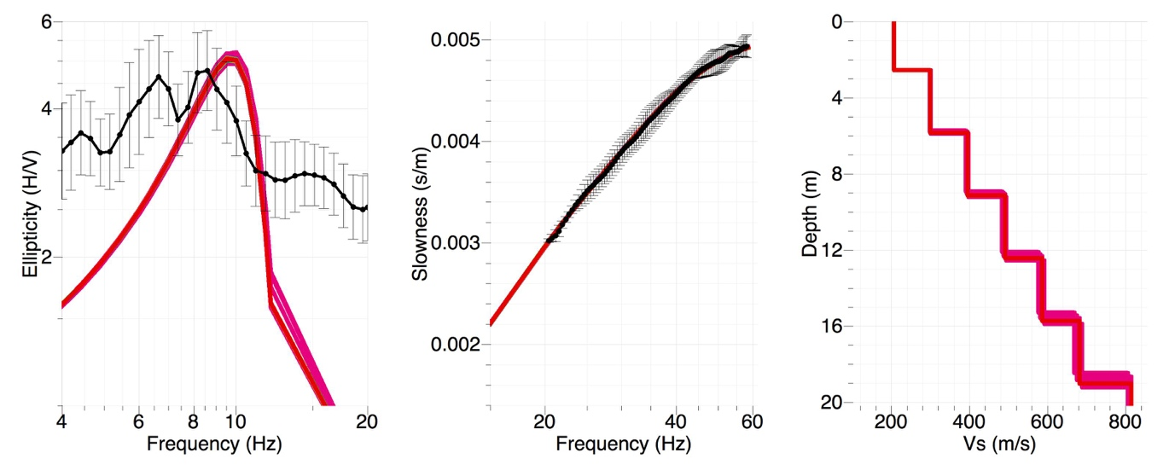
Figure 7: Fit between observed and modelled ellipticity curve (left panel), fundamental mode Rayleigh waves dispersion (central panel). The right panel shows the inverted best models.

It is worth to observe that the fit with the ellipticity curve it is not too good, but, due to the quality of data it is not possible to improve it. The dispersion curve fit is quite satisfactory and the velocity models are compatible with a fractured rock formation with velocity values that are increasing quickly reaching the 800 m/s value at a depth of about 19 meters..
The best Vs model derived from the inversion is presented in Table 1, these data can be used for evaluating the soil class for ATI station.

From (m) | To (m) | Thickness (m) | Vs (m/s) | Vp(m/s)
0 | 2.5 | 2.5 | 206 | 926
2.5 | 5.8 | 3.3 | 299 | 1118
5.8 | 9.1 | 3.3 | 395 | 1118
9.1 | 12.4 | 3.3 | 490 | 1118
12.4 | 15.7 | 3.3 | 586 | 1118
15.7 | 19.0 | 3.3 | 681 | 1118
19.0 |  |  | 814 | 1337

Table 1: Parameters of the best model derived from the inversion procedure.

4. CONCLUSIONS

Surface-wave analysis at IT.ATI station indicates a site of soil class B (Table 2).
Ambient vibration H/V spectral ratio shows a peak in the 4 – 10 Hz frequency range probably related to some landfill at the MASW site. Since the station in deployed directly on the dolostone unit the contribution of this layer must be avoided in evaluating the soil class for the station. The dispersion curve shows an increasing velocity suggesting the presence of a rigid layer below the outcropping unit. The joint inversion of dispersion and ellipticity curves provides a Vs with a velocity increasing with dept until it reaches a value higher than 800 m/s at a depth of about 19 meters.
The V_{S30} retrieved from the best inverted model is 564 m/s (Table 2), then IT.ATI station can be classified following EC8 or NTC08 as soil class B. Using the concept of V_{S,eq} as in NTC18 the site is still in class B with a velocity of 450 m/s.

V_{S30} (NTC08 or EC8) | Soil Class
564 m/s | B
V_{S,eq} (NTC18) | Soil Class
450 | B

Table 2: Soil class following NTC08 and NTC18.

5. REFERENCES

EC8. CEN (2004), Eurocode (EC) 8: Design of structures for earthquake resistance – Part 1 General rules, seismic actions and rules for buildings (EN 1998-1), Brussels

Luzi L, Puglia R, Russo E & ORFEUS WG5 (2016). Engineering Strong Motion Database, version 1.0. Istituto Nazionale di Geofisica e Vulcanologia, Observatories & Research Facilities for European Seismology. doi: 10.13127/ESM"

Microzonazione Sismica Livello 1, Regione Lazio comune di Sora (201). Responsabile scientifico G. Scarascia Mugnozza. http://www.regione.lazio.it/prl_ambiente/?pg=17&vw=uas. Last acces December 2019

NTC08, 2008. Ministero delle infrastrutture e dei Trasporti (2008). Norme Tecniche per le Costruzioni (NTC08). Decreto Ministero Infrastrutture. GU Serie Generale n. 29 del 04-02-2008 - Suppl. Ordinario n. 30

NTC18, 2018. Ministero delle infrastrutture e dei Trasporti (2018). Norme Tecniche per le Costruzioni (NTC18). Decreto Ministero Infrastrutture. GU Serie Generale n. 42 del 20-02-2018 – Suppl. Ordinario n. 8

Working group INGV "Agreement DPC-INGV 2019-21, All.B2- WP1, Task 2”, (2019). Geological report at the seismic station IT.ATI – Sora. http://hdl.handle.net/2122/

Disclaimer and limits of use of information

The INGV, in accordance with the Article 2 of Decree Law 381/1999, carries out seismic and volcanic monitoring of the Italian national territory, providing for the organization of integrated national seismic network and the coordination of local and regional seismic networks as described in the agreement with the Department of Civil Protection.
INGV contributes, within the limits of its skills, to the evaluation of seismic and volcanic hazard in the Country, according to the mode agreed in the ten-year program between INGV and DPC February 2, 2012 (Prot. INGV 2052 of 27/2/2012), and to the activities planned as part of the National Civil Protection System.
In particular, this document1 has informative purposes concerning the observations and the data collected from the monitoring and observational networks managed by INGV.
INGV provides scientific information using the best scientific knowledge available at the time of the drafting of the documents produced; However, due to the complexity of natural phenomena in question, nothing can be blamed to INGV about the possible incompleteness and uncertainty of the reported data.
INGV is not responsible for any use, even partial, of the contents of this document by third parties and any damage caused to third parties resulting from its use.
The data contained in this document is the property of the INGV.

This document is licensed under License
Attribution – No derivatives 4.0 International (CC BY-ND 4.0)

_______________________________________________
¹This document is level 3 as defined in the "Principi della politica dei dati dell’INGV (D.P. n. 200 del 26.04.2016)"

Esclusione di responsabilità e limiti di uso delle informazioni

L'INGV, in ottemperanza a quanto disposto dall'Art.2 del D.L. 381/1999, svolge funzioni di sorveglianza sismica e vulcanica del territorio nazionale, provvedendo all’organizzazione della rete sismica nazionale integrata e al coordinamento delle reti sismiche regionali e locali in regime di convenzione con il Dipartimento della Protezione Civile.
L'INGV concorre, nei limiti delle proprie competenze inerenti la valutazione della Pericolosità sismica e vulcanica nel territorio nazionale e secondo le modalità concordate dall'Accordo di programma decennale stipulato tra lo stesso INGV e il DPC in data 2 febbraio 2012 (Prot. INGV 2052 del 27/2/2012), alle attività previste nell'ambito del Sistema Nazionale di Protezione Civile.
In particolare, questo documento1 ha finalità informative circa le osservazioni e i dati acquisiti dalle Reti di monitoraggio e osservative gestite dall'INGV.
L'INGV fornisce informazioni scientifiche utilizzando le migliori conoscenze scientifiche disponibili al momento della stesura dei documenti prodotti; tuttavia, in conseguenza della complessità dei fenomeni naturali in oggetto, nulla può essere imputato all'INGV circa l'eventuale incompletezza ed incertezza dei dati riportati.
L'INGV non è responsabile dell’utilizzo, anche parziale, dei contenuti di questo documento da parte di terzi e di eventuali danni arrecati a terzi derivanti dal suo utilizzo.
La proprietà dei dati contenuti in questo documento è dell’INGV.

Quest'opera è distribuita con Licenza
Creative Commons Attribuzione - Non opere derivate 4.0 Internazionale.
_______________________________________
¹Questo documento rientra nella categoria di livello 3 come definita nei “Principi della politica dei dati dell’INGV (D.P. n. 200 del 26.04.2016)”.

