Supplementary Material for

The influence of faulting style on the size-distribution of global earthquakes
A. Petruccelli, D. Schorlemmer, T. Tormann, A. P. Rinaldi, S. Wiemer, P. Gasperini, G. Vannucci
Correspondence: antonio.petruccelli@sed.ethz.ch
Overview
This file contains Supplementary Figures cited along the main manuscript. See figures captions for a more detailed description.
Content
Fig. S1: Empirical CDFs for the sum residuals of the Fig. 5B.
Fig. S2: b-value dependence on rake angle λ for different time-γ selections.
Fig. S3: Ternary b-value mapping with different number of neighbors.
Fig. S4: b-depth analysis for Global CMT and ISC-GEM catalogue.

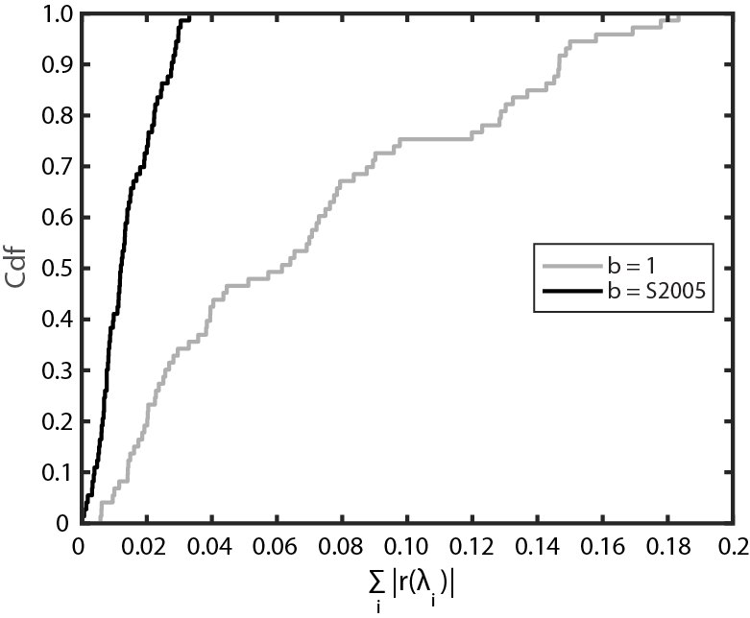
Figure S1. Empirical cumulative density functions (Cdf) for the sum residuals of the Fig. 5B (γ=40°) data with respect to a constant b=1 model (grey) and to S2005 (black) data. The two curves are significantly different at 0.01.

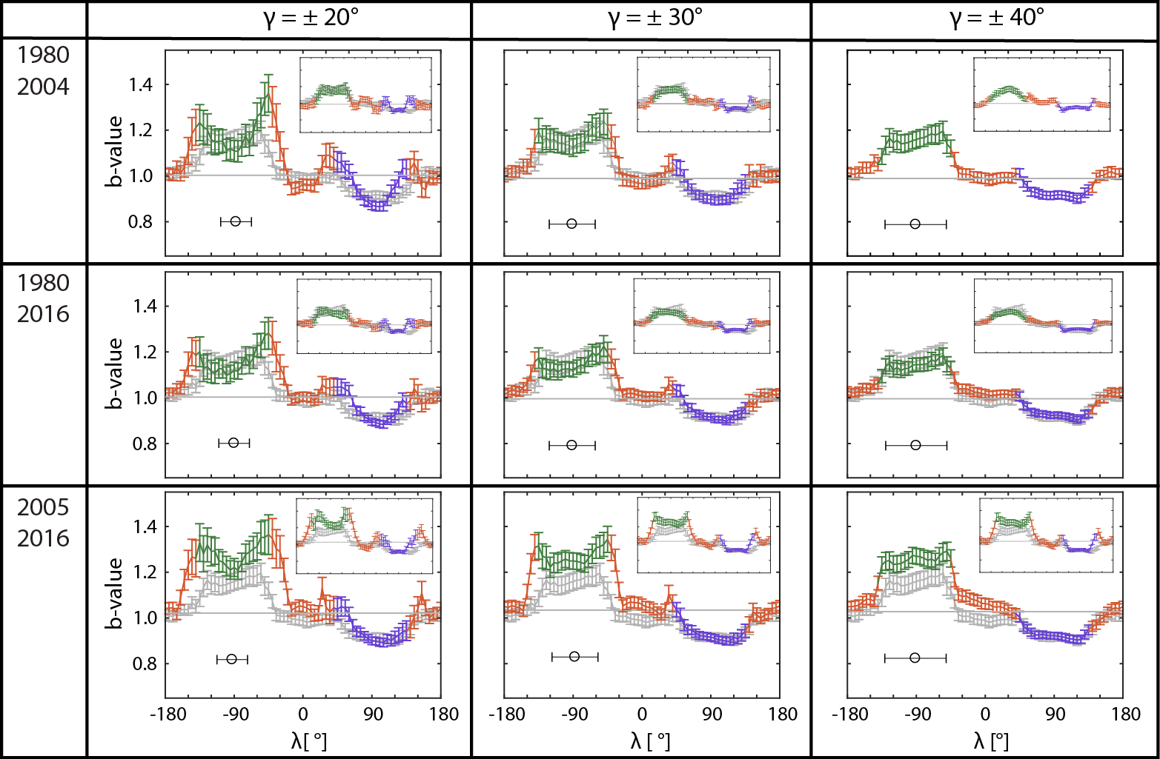
Figure S2. Frames of the b-value dependence on rake angle λ for different time-γ selections (1980–2016, γ = ±20°, ±30°, ±40°, common of depth = 0–50 km). Rows show different periods while columns refer to different γ value (showed as a horizontal black error bar centred at λ = -90°). Grey b-λ dependence from the original (1980–2004, γ = ±40°) is in the background. Horizontal grey line refers to mean b-value for the specific time-γ subset. Inset upper panels are the analyses for the second nodal plane.

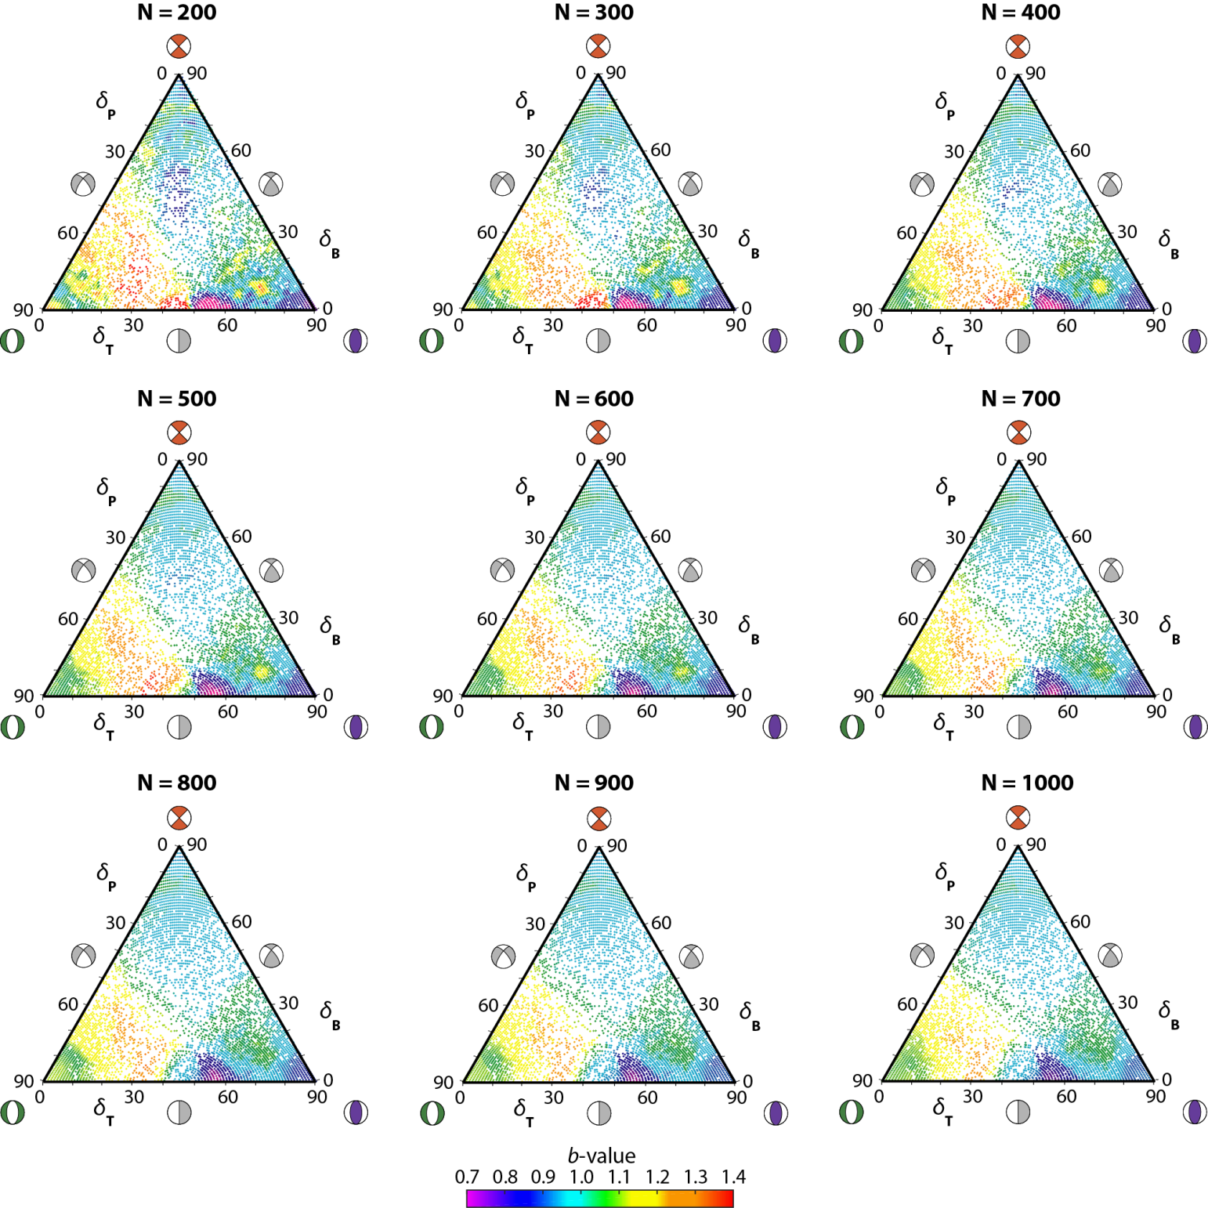
Figure S3. Ternary b-value mapping with different number of neighbours N (from 200 to 1000).

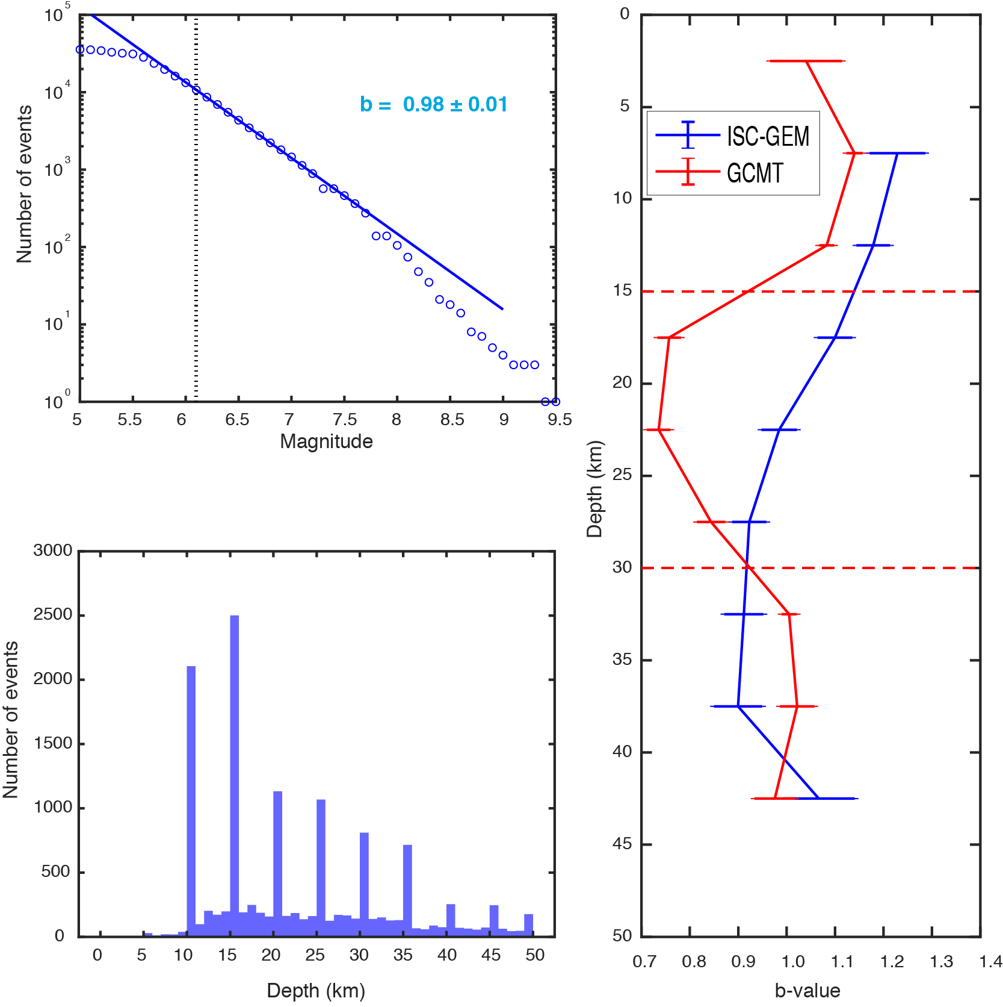
Fig. S4. Jointed b-depth analysis for Global CMT (red) and ISC-GEM catalog (blue) (Storchak et al., 2013, 2015; Di Giacomo et al., 2018), data from 1980-2016 in the first 50 km. Left, top: frequency-magnitude distribution of ISC-GEM dataset, Mc (6.1) indicated as a dotted vertical line, overall b-value (~0.98) indicated with a solid line. Left, bottom: depth distribution (sampling bin 1 km). Right: b-value – depth sampling (5 km width windows, b-values estimated using Equation (1) with a minimum threshold of 50 events) for ISC-GEM and GCMT dataset. Horizontal dashed lines correspond to the chosen depths for the modeling part (see main text).

References
Di Giacomo, D., Engdahl, E.R., Storchak, D.A., 2018. The ISC-GEM Earthquake Catalogue (1904–2014): status after the Extension Project. Earth Syst. Sci. Data 10, 1877–1899. https://doi.org/10.5194/essd-10-1877-2018
Storchak, D.A., Di Giacomo, D., Bondar, I., Engdahl, E.R., Harris, J., Lee, W.H.K., Villasenor, A., Bormann, P., 2013. Public Release of the ISC-GEM Global Instrumental Earthquake Catalogue (1900-2009). Seismol. Res. Lett. 84, 810–815. https://doi.org/10.1785/0220130034
Storchak, D.A., Di Giacomo, D., Engdahl, E.R., Harris, J., Bondár, I., Lee, W.H.K., Bormann, P., Villaseñor, A., 2015. The ISC-GEM Global Instrumental Earthquake Catalogue (1900–2009): Introduction. Phys. Earth Planet. Inter. 239, 48–63. https://doi.org/10.1016/J.PEPI.2014.06.009

