**Study of the F3 and StF4 layers at Tucumán near the southern crest of the EIA in western South America**

**Tardelli A.1, Pezzopane M.2, Fagundes P. R.1, Venkatesh K.1, Pillat V. G.1, Cabrera M. A.3,4,and Ezquer R. G.4,5,6**

1. *Instituto de Pesquisas e Desenvolvimento (IP&D), Universidade do Vale do Paraíba (UNIVAP), São José dos Campos, Brazil.*
2. *Istituto Nazionale di Geoﬁsica e Vulcanologia (INGV), Via di Vigna Murata 605, 00143 Rome, Italy.*
3. *Laboratorio de Telecomunicaciones, FACET, Universidad Nacional de Tucumán, Av. Independencia 1800, 4000 S. M. Tucumán, Argentina*
4. *CIASUR, Facultad Regional Tucumán, Universidad Tecnológia Nacional, Tucumán, Argentina*
5. *Laboratório de Ionósfera, Dto. de Física, FACET, Universidad Nacional de Tucumán, Independencia 1800, 4000 S. M. Tucumán, Argentina*
6. *Consejo Nacional de Investigaciones Cientificas y Técnicas (CONICET), Buenos Aires, Argentina*

**Abstract**

The present investigation reports for the first time seasonal and solar activity variations of F3 and StF4 layers at the low-latitude station of Tucumán (26.9ºS, 65.4ºW; dip latitude 13.9°S), Argentina, by considering ionograms recorded from 2007 to 2015 by an AIS-INGV digital ionosonde. F3 and stF4 layer occurrences are found to be higher during summer months, while they are almost null in winter. Moreover, F3 and StF4 layer occurrences show a solar activity dependence with higher values during high solar activity. The solar activity dependence of F3 over Tucumán is similar to that reported earlier for the low-latitude station of São José dos Campos, Brazil (dip latitude 14.1°S), but different than that reported for the near-equatorial station of Palmas (dip latitude 6.6°S), Brazil. On the other hand, the solar cycle dependence of StF4 layer is consistent with the one obtained at Palmas. This highlights the complex nature of electrodynamics characterizing the ionosphere from the magnetic equatorial to low latitudes. Moreover, as shown in previous studies, the StF4 layer is always preceded and followed by the F3 layer, and it shows a shorter lifetime than that of the F3 layer. During the considered period, 1812 days were analyzed and the F3 layer was found in 370 days (20.4%), while the StF4 layer was found in 41 days (2.3%). This means that the StF4 stratification is seen during 11% of F3 layer days.

1. **Introduction**

One of the interesting aspects of the ionospheric electrodynamics day-to-day variability is the multiple stratification that can characterizes the ionospheric F region. In this sense, Bailey [1948] presented experimental evidences of the F-layer tendency to present multiple stratifications. Investigating the F2 layer stratification near the magnetic equator at Singapore, Sen [1949] reported a triple F2 layer stratification and named it as F’2, F’’2, and F2. For a couple of decades, the study of F-region multiple stratifications has been focused on the formation of the F3 layer at magnetic equatorial and low-latitude regions [Balan and Bailey, 1995; Balan et al., 1997, 1998, 2000, 2008; Jenkins et al., 1997; Lynn et al., 2000; Batista et al., 2000, 2002, 2003, 2017; Uemoto et al., 2006, 2011; Fagundes et al., 2007, 2011; Paznukhov et al., 2007; Sreeja et al., 2009, 2010; Klimenko et al., 2011, 2012a, 2012b; Karpachev et al., 2012, 2013; Zhao et al., 2014; Mridula and Pant, 2015]. Using satellite observations, Zhao et al. [2011b] presented a statistical study of the location of the F3 layer occurrence on a global scale. Zhang et al. [2016] instead, using incoherent scatter radar measurements over Jicamarca (12°S, 283.2°E), presented a study about the equatorial plasma drift enhancement near sunrise which was named as sunrise enhancement, and they highlihted a possible connection between it and the F3 layer appearance.

Several studies were made to better understand the behavior and physical mechanisms of the F3 layer formation. Among these, Balan et al. [1998] proposed a mechanism based on a joint action of the daytime **E** x **B** plasma drift and thermospheric meridional winds. However, it has been reported that F3 layer occurrence characteristics at low-latitudes, and near EIA (Equatorial Ionization Anomaly) crests regions, are different from those recorded at regions around the magnetic equator. In order to account for these differences, other F3 layer triggering factors such as planetary waves, medium-scale traveling ionospheric disturbances (MSTIDs) and gravity waves (GWs) were proposed, in addition to that by Balan et al. [1998]. In this context, Vasil’yev [1967] reported the important role of internal gravity waves in the formation of the F2 layer stratifications at low latitudes and near EIA crests regions. Fagundes et al. [2007] reported that gravity waves with vertical wavelengths greater than the vertical extent of the F-region can create favorable conditions for the F3 layer formation. Klimenko et al. [2011, 2012a, 2012b] proposed that a non-uniform electric field can generate a non-uniform vertical **E** x **B** plasma drift that can give rise to the formation of additional F-layer stratifications.

Batista et al., [2017] studied the F3 layer characteristics during quiet and disturbed periods, using Digisonde observations from two conjugate Brazilian locations at the north and south of the magnetic equator. They found that the F3 layer occurrence is higher in the southern hemisphere (97%) than in the northern one (4%) during December solstice, while it is higher in the northern hemisphere (82%) than in the southern one (16%) during June solstice. They have also found that in the equinoctial month of March, the F3 layer occurrence is low in both hemispheres (4% North, and 7% South).

Tardelli and Fagundes [2015] observed for the first time an StF4 layer in the American sector during a study focused on the F3 layer occurrence at the near-equatorial ionospheric station of Palmas (10.3ºS, 48.3ºW; dip latitude 6.6ºS), Brazil (according also to Uemoto et al. [2011] and Zhu et al. [2013], when talking about near-equatorial regions, we mean northern and southern magnetic latitude bands between 2.5° and 7.5°). Following that study, Tardelli et al. [2016] investigated the seasonal and solar cycle features of F3 and StF4 layers at Palmas using ionosonde observations recorded from 2002 to 2006 (from high to low solar activity). They reported that: a) out of 857 analyzed days, F3 and StF4 layers were found in 542 days (63%) and 78 days (9%) respectively; b) the F3 layer presents a semiannual variation with a main maximum during local summer and a secondary maximum during local winter; c) the StF4 layer occurrence presents an annual variation with a local winter maximum. They further reported that the StF4 layer frequency of occurrence has a direct and clear dependence on the solar activity.

Since the StF4 layer was initially found near the magnetic equator , it is interesting to investigate whether this fourth stratification of the F-layer is also a low-latitude feature (according also to Uemoto et al. [2011] and Zhu et al. [2013], when talking about low-latitude regions, we mean northern and southern magnetic latitude bands between 7.5° and 25.0°). The study that will be described in this paper is based on ionograms recorded at Tucumán (26.9ºS, 65.4ºW; dip latitude 13.9°S), Argentina, close to the southern crest of EIA (Figure 1). Since 2007, several works based on Tucumán ionograms have been done [Pezzopane et al., 2007, 2013; Cabrera et al., 2010; Alfonsi et al., 2013; Ezquer et al., 2014; Perna et al., 2014], but this paper represents the first study focused on F-layer multiple stratifications. Specifically, this paper reports and discusses F3 and StF4 layers occurrences, and their seasonal and solar cycle dependence.

1. **Data and method**

The study is based on ionograms recorded at Tucumán (TUC) by an AIS-INGV ionosonde [Zuccheretti et al., 2003; Pezzopane et al., 2007] from 2007 to 2015, a time window going from low solar activity (LSA) to high solar activity (HSA) (see panel *a*) of Figure 5 to see corresponding values of the solar flux index *F*10.7). The AIS-INGV ionosonde operates by transmitting radio wave pulses from 1 to 20 MHz with a peak power of 250 W in linear conditions. Pulses have a length of 30 µs, which gives a height resolution of about ± 5 km [Arokisamy et al., 2002; Zuccheretti et al., 2003]. TUC ionograms can be downloaded from the electronic Space Weather upper atmosphere database (eSWua) (http://www.eswua.ingv.it/) [Romano et al., 2008]. It is important to mention that, during the considered period, the ionograms were obtained with different sounding repetition rates: 5, 10, or 15 minutes. Figure 1 shows the location of TUC (low-latitude region) and also that of Palmas (PAL, near-equatorial region), where the StF4 layer was observed in the American sector for the first time [Tardelli and Fagundes, 2015]. Besides showing the location of TUC, Fig. 1 shows also the location of PAL, because similarities and differences of F3 and StF4 occurrences as recorded at both low-latitude and near-equatorial regions in the South America sector will be discussed. Since the appearance of F-layer stratifications is mostly a daytime phenomenon [Balan, et al., 1998; Batista et al., 2002; Tardelli and Fagundes, 2015; Tardelli et al., 2016], ionograms recorded at TUC from 7 to 17 LT were considered.

During the F3 layer formation, an inflection characterizing the F2 layer takes place, thus dividing it into two new layers; the layer immediately above the F1 layer is named F2, while the highest one is named F3 [Balan et al., 1998]. Similarly to the F3 layer formation, the StF4 layer appears between two layers already well established (either between F1/F2 or F2/F3). Figure 2a clarifies the issue about the F3 and StF4 formation, and Figures 2b,c,d report several ionograms characterized by the triple and quadruple stratifications, recorded at TUC from 2007 to 2015.

1. **Results**

Figures 3a, 3b, and 3c show the day-to-day variability of F3 and StF4 layers occurrences, and the corresponding time duration, for three different years (2008, 2011, and 2014) representative of low, medium, and high solar activity. Thick blue bars indicate the occurrence of the F3 layer, thick red bars indicate the presence of the StF4 layer, thin black lines indicate no F3/StF4, and thin white lines indicate lack of data. It can be observed that all StF4 cases are always preceded and followed by the apperance of the F3 layer, with the lifetime of the StF4 layer, varying from 10 to 30 minutes, by far shorter than that of the F3 layer.

F3 and StF4 layers were studied from 2007 to 2015, and the number of days with data during 2007, 2008, 2009, 2010, 2011, 2012, 2013, 2014, and 2015 were 117, 269, 279, 247, 208, 213, 47, 315, and 117, respectively. The statistical analysis performed from 2007 to 2015 showed that: days characterized by the presence of the F3 layer are respectively 18 (15.4%), 29 (10.8%), 15 (5.4%), 45 (18.2%), 46 (22.1%), 33 (15.5%), 40 (85.1%), 97 (30.8%), and 47 (40.2%); days characterized by the presence of the StF4 layer are respectively 1 (0.9%), 0 (0%), 0 (0%), 5 (2%), 9 (4.3%), 1 (0.5%), 4 (8.5%), 13 (4.1%), and 8 (6.8%). Tables 1 and 2 summarize in detail monthly and annual variabilities of F3 and StF4 layers.

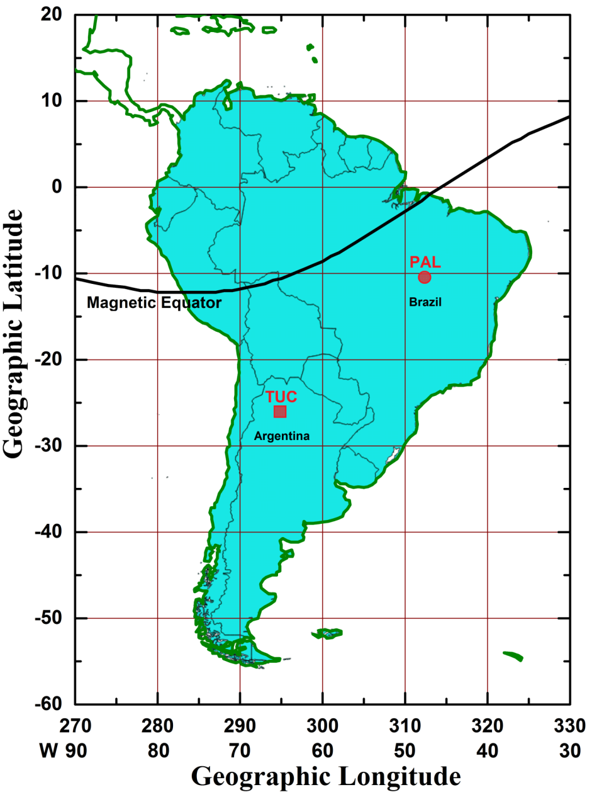

**Figure 1 –** South Americanmap showing the Tucumán (TUC, red square) and Palmas (PAL, red circle) locations. The black curve represent the magnetic equator.

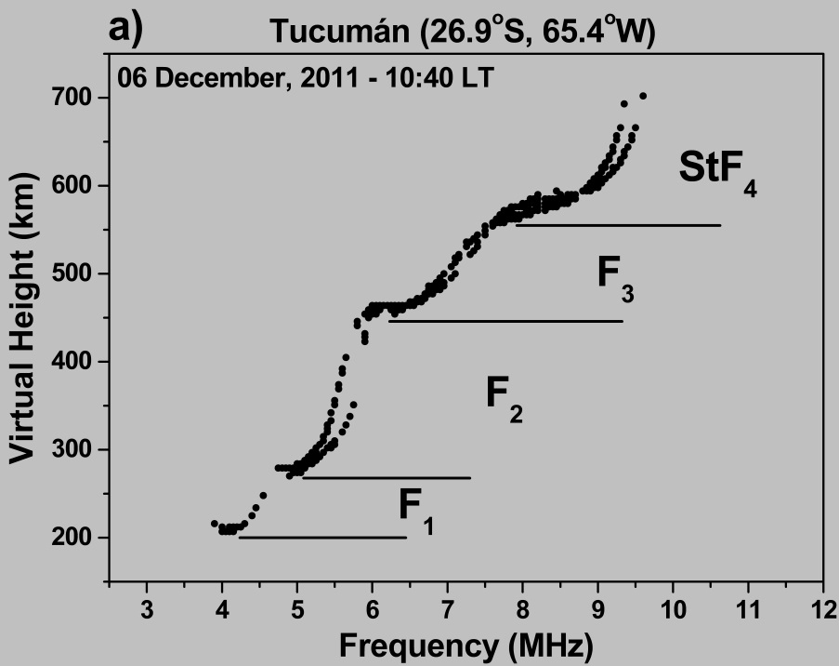

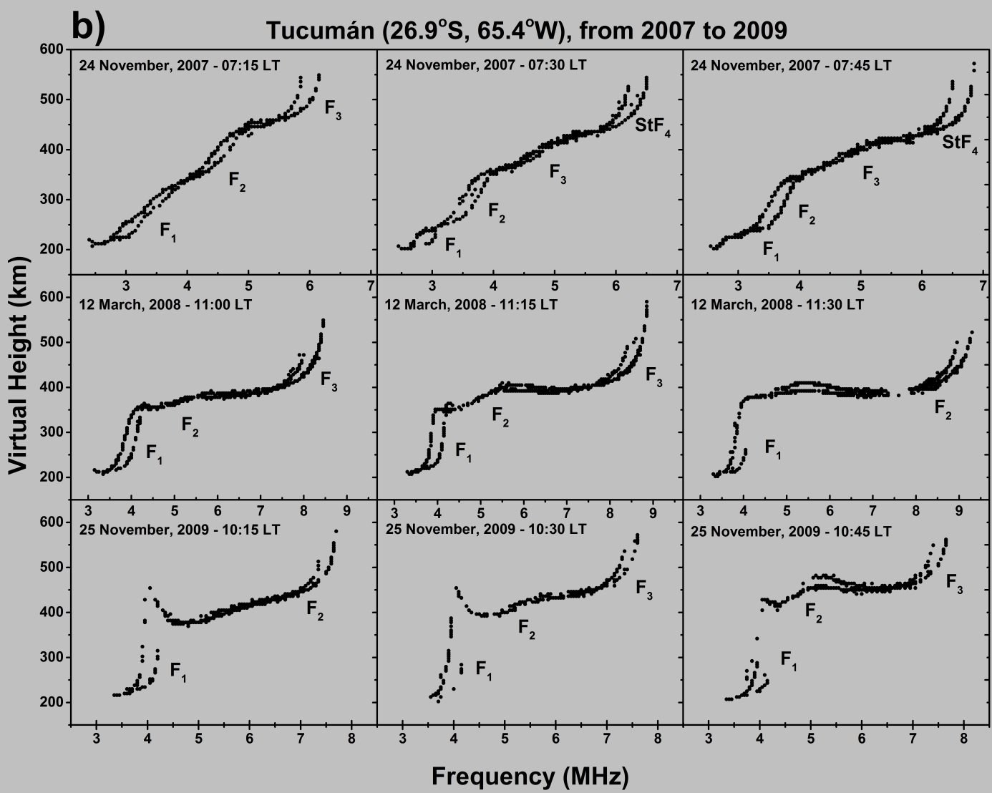

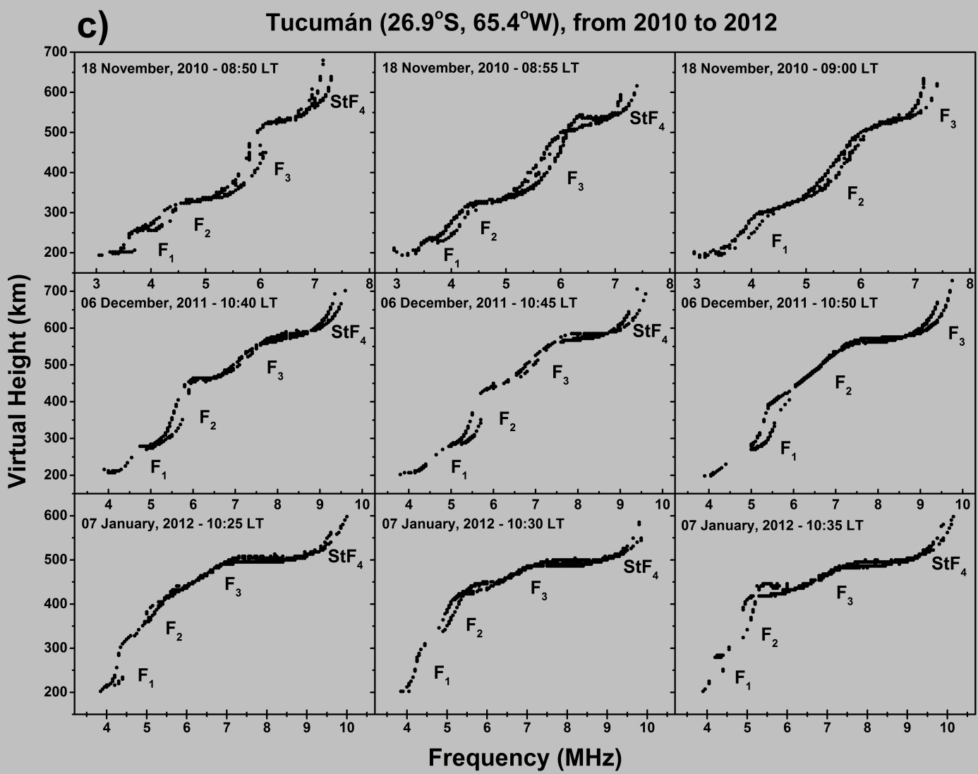

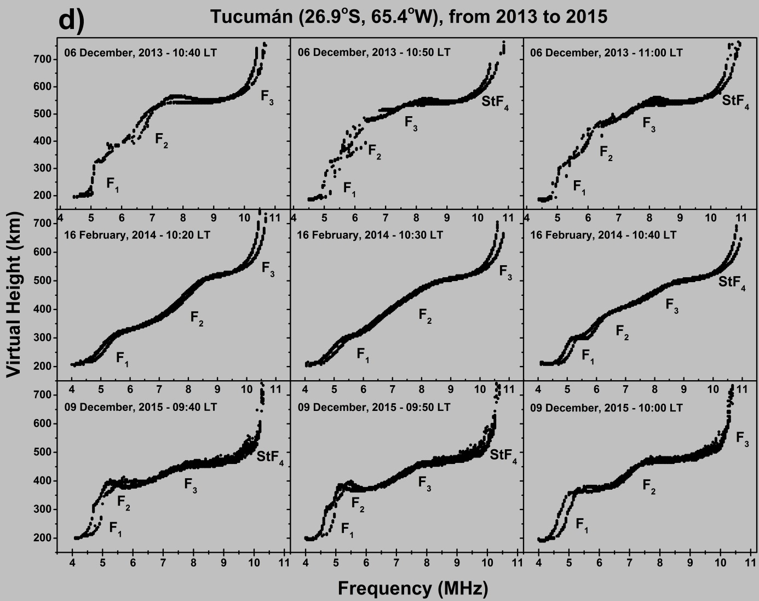

**Figure 2 –** *a)*Ionogram showing the F-layer multiple stratification at Tucumán, with the presence of the F1, F2, F3, and StF4 layers on 06 December 2011 at 10:40 LT. Examples of ionograms showing F3 and StF4 layers recorded at Tucumán in: *b*) November 2007, March 2008, and November 2009; *c)* November 2010, December 2011, and January 2012; *d*) December 2013, February 2014, and December 2015.

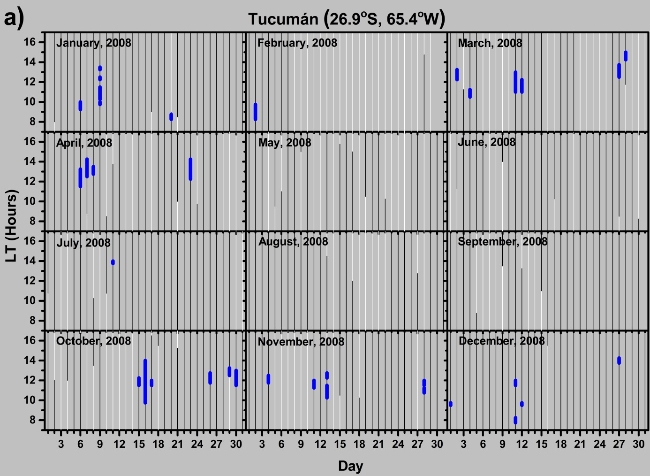

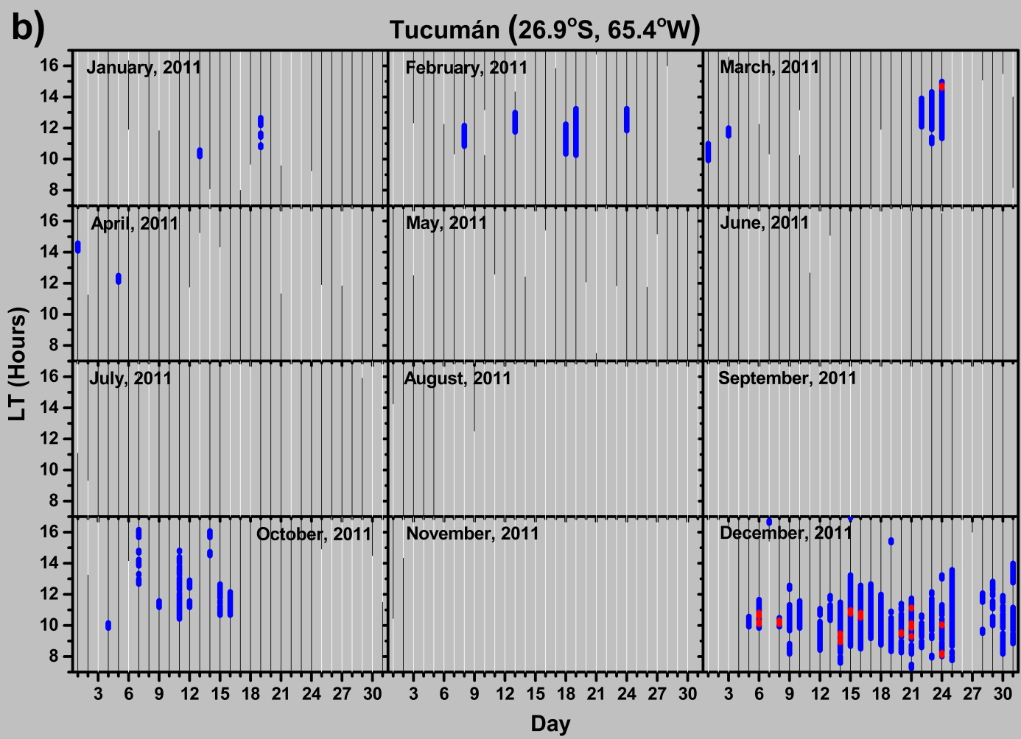

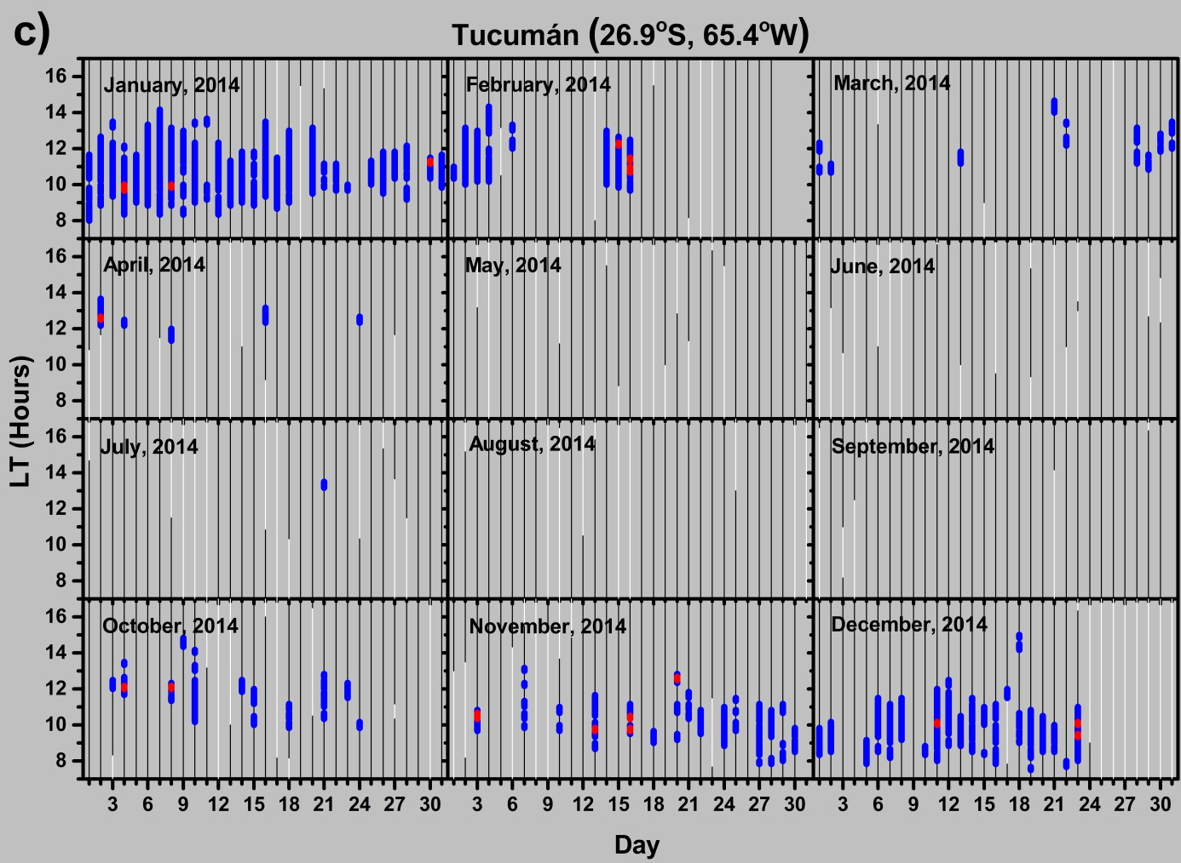

**Figure 3 –** Day-to-day variability of F3 and StF4 layers occurrences for all months of (*a*) 2008, (*b*) 2011, and (*c*) 2014 as representative of period of low, medium, and high solar activity, respectively. Blue bars, red bars, thin black lines, and thin white lines indicate the occurrence of the F3 layer, the occurrence of the StF4 layer, no F3/StF4 layers, and no data, respectively.

* 1. **F3 and StF4 Seasonal Variation**

Figures 4a and 4b show monthly occurrence characteristics of the F3 layer as recorded at TUC. Specifically, Figure 4a shows the monthly percentage of days for which the F3 layer occurred, while Figure 4b shows the monthly percentage time duration of the F3 layer. Percentages of Figures 4a and 4b are respectively calculated by dividing the monthly number of days and the monthly number of hours, with occurrence of the F3 layer and the F3/StF4 layers, by the total monthly number of days and hours with observations. Both analyses show an annual variation of the F3 layer, with a maximum during summertime (November, December, and January) and a minimum during wintertime (June, July, and August).

Figures 4c and 4d show the same analysis for the StF4 layer. It can be seen from these figures that the StF4 layer is absent during 6 months (from April to September). Both the monthly percentage of days and the monthly percentage time duration show a clear StF4 annual variation, with a maximum during summertime (November, December, and January) and a minimum from April to September, similar to that characterizing the F3 layer.

**3.2 Solar cycle dependence of F3 and StF4 occurrences**

Figure 5 presents the occurrence of F3 and StF4 during the whole considered period (2007-2015), characterized by a low-medium-high solar activity. Variations of the solar flux index *F*10.7 are shown in Figure 5a, while the total number of days with F3 and StF4 layers in each month is highlighted in Figure 5b. Both F3 and StF4 layers show a clear solar cycle dependence with a maximum during HSA and a minimum during LSA. It is worth noting that during the very low solar activity characterizing years 2008 and 2009 there is no formation of the StF4 layer.

**Table 1 –** Seasonal variations of the monthly F3 and StF4 layers occurrence, from 2007 to 2010.



**Table 2 –** Seasonal variations of the monthly F3 and StF4 layers occurrence, from 2011 to 2015.



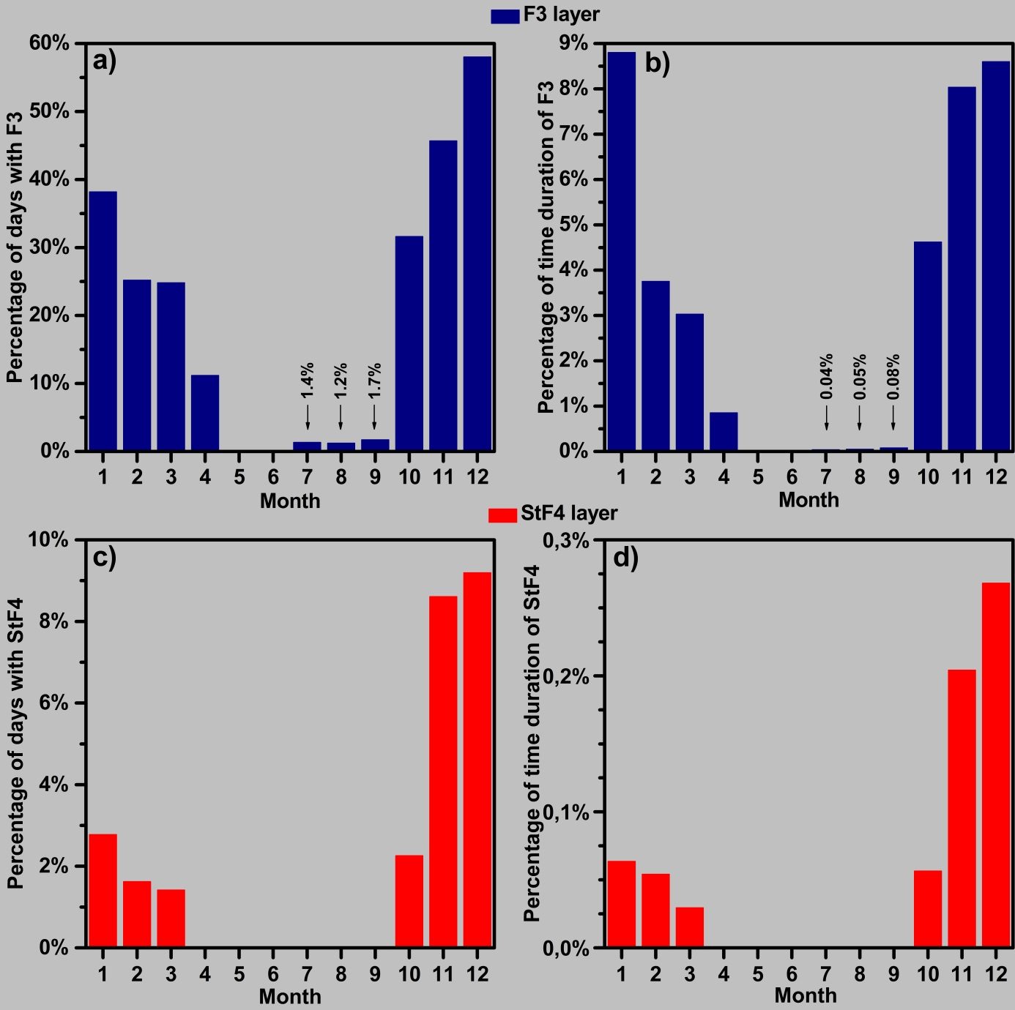

**Figure 4 –** Seasonal characteristics of (panels *a* and *b*) the F3 layer (blue bars) and (panels *c* and *d*) the StF4 layer (red bars). Monthly percentages were calculated using the number of days of each month with occurrence of the F3 layer or the StF4 layer and the total number of days per month with observations, combining data from 2007 to 2015.

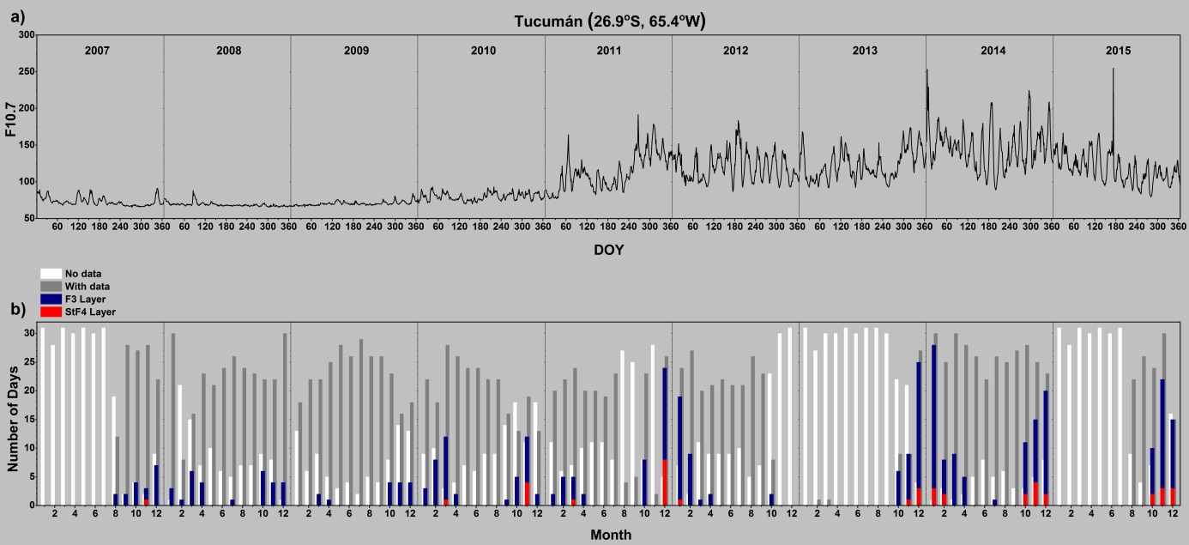

**Figure 5 –** (*a*) Solar flux index *F*10.7 from 2007 to 2015. (*b*) Monthly number of days with F3 layer (blue bars), monthly number of days with StF4 layer (red bars), number of days with available data (gray bars), and days with no data (white bars), from 2007 to 2015.

**4. Discussion**

F3 layer characteristics have been studied during quite and disturbed periods from the equatorial region (according also to Uemoto et al. [2011] and Zhu et al. [2013], when talking about the equatorial region, we mean a magnetic latitude band between 2.5° N and 2.5° S) to low latitudes in many sectors (American, Indian, and Chinese). From previous studies, the physical mechanism behind the F3 layer generation at equatorial/near-equatorial regions has been well understood [Balan et al.,1998], that is a joint action of the daytime **E** x **B** plasma drift and thermospheric meridional winds. The F2 peak is uplifted by the **E** x **B** action to higher altitudes and the subsequent diffusion along magnetic field lines is prevented if an equatorward neutral wind is present; this gives rise to the formation of the F3 layer, while the F2 layer appears at lower altitudes due to the usual photochemical and dynamical processes. Uemoto et al. [2007, 2011] tried to improve the mechanism proposed by Balan et al. [1998] by including the field-aligned diffusion of plasma. They claimed that the magnetic latitudinal dependence of the F3 layer is not caused only by the merdional neutral wind but also by the field-aligned diffusion. Pavan Chaitanya et al. [2013] highlighted the limitations of the available wind models to reproduce the F3-layer observations, underlining the requirement for neutral wind measurements. Mridula and Kumar Pant [2015], considering ionograms recorded at Thiruvananthapuram (dip latitude 0.5°N), India, have shown that the coupling between the equatorial thermospheric zonal wind and an enhanced ionospheric density at low altitudes can trigger the F3-layer formation through the ion-drag process. Nevertheless, at low latitudes the F3 layer generation process is still under debate, since many factors as MSTIDs, GWs and non-uniform electric fields (which means non-uniform vertical **E** x **B** plasma drift) can play an important role [Fagundes et al., 2007; Klimenko et al., 2011, 2012a, 2012b, Nayak et al., 2014]. More specifically, the magnetic latitude dependence of F-layer multiple stratifications is still an open question [Uemoto et al., 2011; Zhu et al., 2013]. The purpose of this study is to give an additional contribution to this issue, presenting the F3 and StF4 layers day-to-day, seasonal and solar cycle variations obtained for the low-latitude station of TUC. Moreover, studies on F3 and StF4 layers as recorded at PAL were pioneering investigations [Tardelli and Fagundes, 2015; Tardelli et al., 2016]. Therefore, comparing the F3/StF4 layer day-to-day and seasonal variations, as recorded in the South American sector at TUC (low-latitude region) and PAL (near-equatorial region), is of interest to better understand the F-layer multiple stratification mechanism from equatorial to low latitudes.

Concerning the occurrence percentages, the analysis carried out for Tucumán shows that out of 1812 analyzed days, the F3 layer is found in 370 days (20.4%), while the StF4 layer is observed in 41 days (2.3%). These percentages are much lower than those recorded at PAL, which are 63% and 9% respectively [Tardelli et al., 2016]. This confirms what was found by Thampi et al. [2007], namely the highest occurrence of F-layer multiple stratifications appears at dip latitude ±8° (a few degrees within the EIA), and reinforces the idea that the F3/StF4 formation mechanism at low latitudes is different than that at equatorial/near-equatorial latitudes, or that the mechanism proposed by Balan et al. [1998] is less efficient at low latitudes, where the weight of the F3-layer trigger caused by GWs becomes instead significant [Fagundes et al., 2007].

From a seasonal point of view, Figures 3, 4, and 5 show that the F3 layer occurrence at TUC presents an annual variation with a maximum in summer and a minimum in winter. This annual variation was recorded also at other low-latitude stations: São José dos Campos (Brazil; dip latitude 17.6°S), Waltair (India; dip latitude 10.6°N), and Vanimo (Papua New Guinea; dip latitude 11.2°S) [Rama Rao et al., 2005; Fagundes et al., 2011; Zhu et al., 2013]. Notwithstanding, Tardelli et al. [2016] have recently reported that the F3 layer occurrence at the near-equatorial site of PAL presents a semiannual variation, with a main maximum during summertime and a secondary maximum during wintertime. This result confirmed what was previously found at other South American equatorial/near-equatorial stations, Fortaleza (Brazil; dip latitude 4.4ºS), São Luis (Brazil; dip latitude 2.0ºS), and Jicamarca (Peru; dip latitude 0.2ºS) [Balan et al., 1998; Batista et al., 2002; Zhao et al., 2011a], proving that in the South American sector the F3 layer at equatorial/near-equatorial regions presents a definite semiannual seasonal variation. Balan et al. (1998) attributed the presence of the secondary winter maximum of the F3 layer occurrence to a combination of local high values of the **E** x **B** drift with meridional winds less poleward than expected. The confirmation that the appearance of the winter secondary maximum is however a local feature, mainly depending on the longitudinal structureof the **E** x **B** drift intensity [e. g., Yizengaw et al., 2014], is confirmed by studies performed at equatorial/near-equatorial sites in different sectors like Trivandrum (India; dip latitude 0.5°N), Kwajalein (Marshall Islands; dip latitude 3.8°N), and Chumphon (Thailand; dip latitude 3.2°N), showing an annual variation of the F3 layer occurrence [Sreeja et al., 2010; Uemoto et al., 2011].

Taking into account what was proposed by Fagundes et al. [2007], namely that the presence of powerful GWs in a vertically extended F layer can trigger the F3-F2 stratification, the F3-layer annual variation with a maximum in summer, recorded at TUC, as well as at Waltair and Vanimo, can be ascribed to the fact that in the low-latitude South American sector the GW activity is greater in summer than in other seasons [Klausner et al., 2009]. However, F3-layer semiannual variations were found at low-latitude sites in other longitudinal sectors: Sanya (China; dip latitude 12.6°N), and Chiang Mai (Thailand; dip latitude 9.0°N) [Zhu et al., 2013; Uemoto et al., 2011]. This means that at low latitudes there are sectors, the ones showing an F3-layer annual variation, for which GWs affect significantly the F3-layer formation, while there are other sectors, the ones showing an F3-layer semiannual variation, for which the GW action is counterbalanced by the mechanism proposed by Balan et al. [1998].

With regard to the StF4 stratification, the results shown in the previous section confirm those of Tardelli and Fagundes [2015] and Tardelli et al. [2016], that is the StF4 layer is always preceded and followed by the apperance of an F3 layer, with the corresponding lifetime, ranging from 10 to 30 minutes, by far shorter than that of the F3 layer. This highlights that: a) the connection between StF4 and F3 layers is strong, at both low and near-equatorial latitudes, independently of the F3 layer triggering mechanism; b) the StF4 layer is really a transient phenomenon. The latter is most likely due to the fact that, when the four stratifications are present, at least two of them are very close to each other in altitude (see Figure 2) and it is sufficient a slight vertical plasma redistribution, caused by either a small variation of the zonal electric field at the base of the plasma uplift [Klimenko et al., 2011, 2012a, 2012b] or a slight variation of the TID wavelike oscillation [Tardelli and Fagundes, 2015], to make a layer disappear and come back to a triple stratification.

Figure 5 shows that at TUC the F3 layer has a clear direct dependence on solar activity, the higher the solar activity, the greater the F3-layer occurrence. This confirms the study by Fagundes et al. [2011] for SJC, and more generally the fact that at low latitudes the relationship (F3 layer vs solar activity) is direct, while at equatorial/near-equatorial latitudes is usually reversed, that is the F3-layer occurrence is higher for LSA than for HSA [Balan et al., 1998, Batista et al., 2002; Rama Rao et al., 2005; Sreeja et al., 2010; Nayak et al., 2014]. Balan and Bailey [1995] and Balan et al. [1998] justified the reverse proportionality between the F3-layer occurrence and the solar activity at equatorial/near-equatorial latitudes saying that the morning-noon ionosphere becomes broad and intense as the solar activity increases, while the **E** x **B** drift and neutral winds remain more or less constant, this making the upward force insufficient to uplift the morning F2 peak to the topside altitudes to form a clear F3 layer. This suggests again that mechanisms behind the F3-layer occurrence at low latitudes and equatorial/near-equatorial latitudes cannot be the same. The direct proportionality between the F3-layer occurrence and the solar activity is an additional evidence that GWs are most likely the main triggering factor of the F3-layer formation at low latitudes. This is because, according to Klausner et al. [2009], the GW occurrence at low latitudes is higher for HSA than for LSA.

The same can also be said for the StF4 layer occurrence recorded at TUC, which presents itself, as the F3 layer one, a direct proportionality with the solar activity. Tardelli and Fagundes [2015], when reporting for the first time the StF4 stratification in the South American sector, suggested as a possible mechanism of formation wavelike oscillations caused by GWs which, in combination with the **E** x **B** vertical drift. The fact that the direct proportionality between the StF4 layer occurrence and the solar activity, unlike what happens for the F3 layer, characterizes both low and near-equatorial latitudes, suggests that GWs play a key role to trigger the appearance of the StF4 layer independently of the latitude.

The most striking feature characterizing the results showed in the previous section is however the seasonally dependence of the StF4-layer occurrence. In fact, if at TUC as expected the StF4 occurrence presents a maximum in summer, at PAL the StF4 occurrence maximum is instead recorded in winter. This is a really challenging issue to be explained. One can think that at PAL the winter anomaly could play a significant role concerning the StF4 layer formation. The winter anomaly consists of the observation of daytime maximum electron density values lower in summer than in winter. It has been suggested that this anomaly is linked to changes in the neutral composition of the atmosphere, caused by a heating of the summer hemisphere, which gives rise to a convection of lighter neutral elements toward the winter sector, which causes changes in the ratio of [O]/[N2] in both hemispheres [Johnson, 1964; Rishbeth and Setty, 1961; Torr and Torr, 1973]. This anomaly depends significantly on solar activity, and at low latitudes tends to disappear for low solar activity [e.g., Ezquer et al., 2014; Perna et al., 2017]. Taking into account the F3-layer formation mechanism proposed by Mridula and Kumar Pant [2015], the fact that at PAL the StF4 occurrence presents a maximum for HSA in winter could be ascribed to a joint action of three factors: 1) the GW propagation; 2) an enhanced daytime ionospheric density due to the winter anomaly; 3) a fast wind jet characteristic of the Earth’s dip equator due to thermospheric zonal winds [Liu et al., 2009]. Anyhow, this remains an outstanding issue that the authors will surely investigate more deeply as soon as longer time series of ionograms at PAL and TUC are available, but mostly considering different sectors.

With regard to the puzzling multiple F-layer stratification dependence on the season, magnetic latitude and solar activity, we want to conclude by highlighting what Karpachev et al. [2013] and Klimenko et al. [2012a,b] have said, namely that simultaneous ground-based and satellites observations, as well as comprehensive study based on both the observation and modeling, are needed.

1. **Conclusions**

This investigation presents the daytime seasonal and solar cycle variations of the F-layer multiple stratification (F3 and StF4), using ionograms recorded by an AIS-INGV ionosonde installed at TUC, Argentina, near the EIA southern crest in the west South American sector. Corresponding results are then compared with those reported earlier by Tardelli et al. [2016] for PAL, Brazil, a near-equatorial station. The main outcomes of the study are:

1. The formation mechanisms of the F3 layer at near-equatorial and low latitudes are different. At near-equatorial latitudes the mechanism proposed by Balan and Bailey [1995] and Balan et al. [1998], based on a joint action of the daytime **E** x **B** plasma drift and thermospheric meridional winds, meets pretty well the recorded F3-layer occurrence. At low latitudes instead there are sectors, the ones showing an F3-layer annual variation, for which GWs affect significantly the F3-layer formation, while there are other sectors, the ones showing an F3-layer semiannual variation, for which the GW action is counterbalanced by the mechanism proposed by Balan and Bailey [1995] and Balan et al. [1998];
2. The StF4 layer occurrence recorded at TUC, as well as the one recorded at PAL, presents a direct proportionality with the solar activity, just like the F3 layer occurrence recorded at TUC, and more generally at low latitudes. This suggests that the mechanism proposed by Tardelli and Fagundes [2015], that is a joint action of wavelike oscillations caused by GWs which and the **E** x **B** vertical drift, can account for the quadruple stratification independently of the latitude;
3. The StF4 stratification is always preceded and followed by the apperance of an F3 layer, with the corresponding lifetime by far shorter than that of the F3 layer. This underlines on the one hand that the connection between StF4 and F3 layers is strong, at both low and near-equatorial latitudes, independently of the F3 layer triggering mechanism, and on the other hand that the StF4 layer is really a transient phenomenon. The transience of the phenomenon is most likely due to the fact that, when the four stratifications are present, at least two of them are very close to each other in altitude and it is sufficient a slight vertical plasma redistribution, caused by either a small variation of the zonal electric field at the base of the plasma uplift or a slight variation of the TID wavelike oscillation, to make a layer disappear and come back to a triple stratification;
4. At TUC the StF4 occurrence presents a maximum in summer, while at PAL unexpectedly the maximum is recorded in winter. The winter maximum recorded at PAL could be ascribed to a joint action of three factors: 1) the GW propagation; 2) an enhanced daytime ionospheric density due to the winter anomaly; 3) a fast wind jet characteristic of the Earth’s dip equator due to thermospheric zonal winds. This remains however an outstanding issue that needs additional investigations both at PAL and TUC, but also in different sectors.

**Acknowledgments**

We wish to express our sincere thanks to the Fundação de Amparo à Pesquisa do Estado de São Paulo (FAPESP), for providing financial support through the process № 2015/24791-2, № 2012/08445-9 and № 2013/17380-0, CNPq grants № 302927/2013-1, and FINEP № 01.100661-00 for the partial financial support. We thank the OMNIWEB (<http://omniweb.gsfc.nasa.gov>) for providing the solar flux index data. The ionospheric data from Tucumán are available at the webpage of the electronic Space Weather upper atmosphere database, INGV, Italy (<http://www.eswua.ingv.it>). We also thanks Agencia Nacional de Promoción Científica y Tecnológica, Universidad Tecnológica Nacional and Universidad Nacional de Tucumán, Argentina, for partial financial support of High Atmosphere Tucumán Observatory at Low Latitude through the Projects PICT2011-1008, PICT 2015-0511 (FONCyT-MINCyT), PID UTI3805TC, and PIUNT 26E/508.

**References:**

Alfonsi, L., L. Spogli, M. Pezzopane, V. Romano, E. Zuccheretti, G. De Franceschi, M. A. Cabrera, and R. G. Ezquer (2013), Comparative analysis of spread-F signature and GPS scintillation occurrences at Tucumán, Argentina, *J. Geophys. Res. Space Physics,* 118, 4483–4502, doi:10.1002/jgra.50378.

Arokiasamy, B. J., C. Bianchi, U. Sciacca, G. Tutone, and E. Zuccheretti (2002), The new AIS-INGV digital ionosonde design report, *INGV Internal Tech. Rep. No. 12.*

Bailey, D. K. (1948), The geomagnetic nature of the F2-Layer longitude-effect, *Terrestrial Magnetism and Atmospheric Electricity*, vol. 53, no. 1, pp. 35–39.

Balan, N., and G. J. Bailey (1995), Equatorial plasma fountain and its effects: Possibility of an additional layer, *J. Geophys. Res.,* 100(A11), 21,421–21,432, doi:10.1029/95JA01555.

Balan, N., G. J. Bailey, M. A. Abdu, K. I. Oyama, P. G. Richards, J. Macdougall, and I. S. Batista (1997), Equatorial plasma fountain and its effects over three locations: Evidence for an additional layer, the F3 layer, *J. Geophys. Res*., 102(A2), 2047-2056, doi:10.1029/95JA02639.

Balan N., I. S. Batista, M. A. Abdu, J. Macdougall, and G. J. Bailey (1998), Physical mechanism and statistics of occurrence of an additional layer in the equatorial ionosphere, *J. Geophys. Res.*, 103, 29,169-29,181, doi:10.1029/98JA02823.

Balan N., I. S. Batista, M. A. Abdu, G. J. Bailey, S. Watanabe, J. MacDougall, and J. H. A. Sobral (2000), Variability of an additional layer in the equatorial ionosphere over Fortaleza, *J. Geophys. Res*., 105, 10,603-10,613, doi:10.1029/1999JA000020.

Balan N., S. V. Thampi, K. Lynn, Y. Otsuka, H. Alleyne, S. Watanabe, M. A. Abdu, and B. G. Fejer (2008), F3 layer during penetration electric field, *J. Geophys. Res*., 113, A00A07, doi:10.1029/2008JA013206.

Batista, I. S., N. Balan, M. A. Abdu, J. MacDougall, and P. F. Barbosa Neto (2000), F3 layer observations at low and equatorial latitudes in Brazil, *Geofis. Int*., 39(1), 57-64.

Batista I.S., M.A. Abdu, J. MacDougall, J.R. Souza (2002), Long term trends in the frequency of occurrence of the F3 layer over Fortaleza, Brazil. *J. Atmos. Sol. Terr. Phys.*, 64, 1409-1412.

Batista I.S., M.A. Abdu, A.M. da Silva, and J.R. Souza (2003), Ionospheric F3 layer: Implications for the IRI model. *Adv. Space Res*., 31(3), 607-611.

Batista, I. S., C. M. N. Candido, J. R. Souza, M. A. Abdu, R. C. de Araujo, L. C. A. Resende, and A. M. Santos (2017), F3 layer development during quiet and disturbed periods as observed at conjugate locations in Brazil: The role of the meridional wind, *J. Geophys. Res. Space Physics,* 122, doi:10.1002/2016JA023724.

Cabrera, M. A., M. Pezzopane, E. Zuccheretti, and R. G. Ezquer, (2010), Satellite traces, range spread-F occurrence, and gravity wave propagation at the southern anomaly crest, *Ann. Geophys.,* 28, 1133–1140, doi:10.5194/angeo-28-1133-2010.

Pavan Chaitanya, P., A. K. Patra, N. Balan, and S. V. B. Rao (2013), First simultaneous observations of F3 layer and E_B drift in Indian sector and modeling, J. Geophys. Res. Space Physics, 118, 3527–3539, doi:10.1002/jgra.50298.

Ezquer, R.G., J. L. López, L. A. Scidá, M. A. Cabrera, B. Zolesi, C. Bianchi, M. Pezzopane, E. Zuccheretti, and M. Mosert (2014), Behaviour of ionospheric magnitudes of F2 region over Tucumán during a deep solar minimum and comparison with the IRI 2012 model predictions, *J. Atmos. Sol. Terr. Phys.*, 107, 89-98, http://doi.org/10.1016/j.jastp.2013.11.010.

Fagundes P. R., V. Klausner, Y. Sahai, V. G. Pillat, F. Becker-Guedes, F. C. P. Bertoni, M. J. A. Bolzan, and J. R. Abalde (2007), Observations of daytime F2-layer stratification under the southern crest of the equatorial ionization anomaly region. *J. Geophys. Res*., 112(A4), A04302, doi:10.1029/2006JA011888.

Fagundes P. R., V. Klausner, J. A. Bittencourt, Y. Sahai, and J. R. Abalde (2011), Seasonal and solar cycle dependence of F3-layer near the southern crest of the equatorial ionospheric anomaly. *Adv. Space Res*., 48(3), 472-477, doi:10.1016/j.asr.2011.04.003.

Jenkins B., G. J. Bailey, M. A. Abdu, I. S. Batista, and N. Balan (1997), Observations and model calculations of an additional layer in the topside ionosphere above Fortaleza, Brazil. *Ann. Geophys*., 15(6), 753-759, doi:10.1007/s00585-997-0753-3.

Johnson, F.S., 1964. Composition changes in the upper atmosphere. In: Thrane, E. (Ed.), Electron Density Distributions in the Ionosphere and Exosphere. North Holland, pp. 81–84.

Karpachev, A. T., M. V. Klimenko, V. V. Klimenko, G. A. Zhbankov, and V. A. Telegin (2012), Latitudinal structure of the equatorial F3 layer based on the Intercosmos-19 topside sounding data, *J. Atmos. Sol. Terr. Phys.,* 77, 186–193, doi:10.1016/j.jastp.2011.12.018.

Karpachev, A. T., M. V. Klimenko, V. V. Klimenko, G. A. Zhbankov, and V. P. Kuleshova (2013), Statistical study of the F3 layer characteristics retrieved from Intercosmos-19 satellite data, *J. Atmos. Sol. Terr. Phys.,* 103, 121–128, doi:10.1016/j.jastp.2013.01.010.

Klausner, V., P. R. Fagundes, Y. Sahai, C. M. Wrasse, V. G. Pillat, and F. Becker-Guedes (2009), Observations of GW/TID oscillations in the F2 layer at low latitude during high and low solar activity, geomagnetic quiet and disturbed periods, J. Geophys. Res., 114, A02313, doi:10.1029/2008JA013448.

Klimenko, M. V., V. V. Klimenko, K. G. Rastovsky, L. P. Goncharenko, Y. Sahai, P. R. Fagundes, R. de Jesus, A. J. de Abreu, and A. M. Vesnin (2011), Numerical modeling of ionospheric effects in the middle- and low-latitude F region during geomagnetic storm sequence of 9-14 September 2005. *Radio Science*, 46, RS0D03, doi.org/10.1029/2010RS004590.

Klimenko, M. V., V. V. Klimenko, and A. T. Karpachev (2012a), Formation mechanism of additional layers above regular F2 layer in the near-equatorial ionosphere during quiet period, *J. Atmos. Sol. Terr. Phys.,* 90–91, 179–185, doi:10.1016/j.jastp.2012.02.011.

Klimenko, M. V., B. Zhao, A. T. Karpachev, and V. V. Klimenko (2012b), Stratification of the low-latitude and near-equatorial F2 layer, topside ionization ledge, and F3 layer: what we know about this? A review, *Int. J. Geophys.,* 2012, 938057, 22, doi:10.1155/2012/938057.

Liu, H., S. Watanabe, and T. Kondo, (2009), Fast thermospheric wind jet at the Earth's dip equator. Geophys. Res. Lett., 36, L08103, doi:10.1029/ 2009GL037377.

Lynn, K. J. W., T. J. Harris, and M. Sjarifudin (2000), Stratification of the F2 layer observed in Southeast Asia, *J. Geophys. Res.,* 105, 27, 147–27, 156, doi:10.1029/2000JA900056.

Mridula, N. and Tarun Kumar Pant (2015), On the possible role of zonal dynamics in the formation and evolution of F3 layers over equator, *J. Atmos. Terr. Phys*.,134, 69-77, doi.org/10.1016/j.jastp.2015.09.019.

Nayak, C. K., V. Yadav, B. Kakad, S. Sripathi, K. Emperumal, T. K. Pant, A. Bhattacharyya, and S. Jin (2014), Peculiar features of ionospheric F3 layer during prolonged solar minimum (2007–2009), *J. Geophys. Res. Space Physics*, 119, 8685–8696, doi:10.1002/2014JA020135.

Paznukhov, V. V., B. W. Reinisch, P. Song, X. Huang, T. W. Bullett, and O. Veliz (2007), Formation of an F3 layer in the equatorial ionosphere: A result from strong IMF changes, *J. Atmos. Sol. Terr. Phys.,* 69, 1292–1304, doi:10.1016/j.jastp.2006.08.019.

Perna, L., M. Pezzopane, E. Zuccheretti, P. R. Fagundes, R. de Jesus, M. A. Cabrera, and R. G. Ezquer (2014), Unusual nighttime impulsive foF2 enhancements at low latitudes: Phenomenology and possible explanations, *Adv. Space Res*., 54(3), 369-384, doi:10.1016/j.asr.2013.05.014.

Perna, L., M. Pezzopane, R. Ezquer, M. Cabrera, and J.A. Baskaradas (2017), NmF2 trends at low and mid latitudes for the recent solar minima and comparison with IRI-2012 model, *Adv*. *Space* *Res*., 60(2), doi:10.1016/j.asr.2016.09.025.

Pezzopane, E. Zuccheretti, C. Bianchi, C. Scotto, B. Zolesi, M. A. Cabrera, and R. G. Ezquer (2007), The new ionospheric station of Tucumán: first results, *Annals of Geophysics*, 50(3), 483-492, <http://dx.doi.org/10.4401/ag-4426>.

Pezzopane, M., E. Zuccheretti, P. Abadi, A. J. de Abreu, R. de Jesus, P. R. Fagundes, P. Supnithi, S. Rungraengwajiake, T. Nagatsuma, T. Tsugawa, M. A. Cabrera, R. G. Ezquer (2013), Low-latitude equinoctial spread-F occurrence at different longitude sectors under low solar activity. *Ann. Geophys.* 31, 153–162, <http://dx.doi.org/10.5194/angeo->31-153-2013.

Rama Rao, P. V. S., K. Niranjan, D. S. V. V. D. Prasad, and P. S. Brahmanandam (2005), Features of additional stratification in ionospheric F2 layer observed for half a solar cycle over Indian low latitudes. *J. Geophys. Res*., 110, doi:10.1029/2004JA010646.

Rishbeth, H., C. S. G. K. Setty (1961), The F-layer at sunrise, *J*. *Atmos*. *Terr*. *Phys*., 35, 2237–2251.

Romano, V., S. Pau, M. Pezzopane, E. Zuccheretti, B. Zolesi, G. De Franceschi, and S. Locatelli (2008), The electronic Space Weather upper atmosphere (eSWua) project at INGV: Advancements and state of the art. *Ann*. *Geophys*., 26, 345–351, doi:10.5194/angeo-26-345-2008.

Sen, H. Y. (1949), Stratification of the F2-layer of the ionosphere over Singapore. *J. Geophys. Res*., 54(4), 363-366, doi:10.1029/JZ054i004p00363.

Sreeja, V., N. Balan, S. Ravindran, T. K. Pant, R. Sridharan, and G. J. Bailey (2009), Additional stratifications in the equatorial F region at dawn and dusk during geomagnetic storms: Role of electrodynamics, *J. Geophys. Res.,* 114, A08309, doi:10.1029/2009JA014373.

Sreeja, V., S. Ravindran and T. K. Pant (2010), Features of F3 layer occurrence over the equatorial location of Trivandrum, *Ann. Geophys.,* 28 (2010), pp. 1741–1747.

Tardelli A., and P. R. Fagundes (2015), Observations of ionospheric *F* layer quadruple stratification near equatorial region, *J. Geophys. Res***.**, 120, 834-840, doi:10.1002/2014JA020653.

Tardelli, A., P. R. Fagundes, M. Pezzopane, K. Venkatesh, and V. G. Pillat (2016), Seasonal and solar activity variations of F3 layer and quadruple stratification (StF-4) near the equatorial region, *J. Geophys. Res. Space Physics,* 121, doi:10.1002/2016JA023580.

Torr, M. R. and D. G. Torr (1973), The seasonal behavior of the F2-layer of the ionosphere, *J*. *Atmos*. *Terr*. *Phys*., 35, 2237–2251.

Thampi, S.V., Balan, N., Ravindran, S., Pant, T.K., Devasia ,C.V., Sreelatha, P., Sridharan, R., Bailey, G.J., 2007. An additional layer in the low-latitude ionosphere in Indian longitudes: total electron content observations and modeling, *J. Geophys. Res. Space Physics*, 112, A06301, doi:10.1029/ 2006JA011974.

Uemoto, J., T. Ono, A. Kumamoto, and M. Iizima (2006), Statistical analysis of the ionization ledge in the equatorial ionosphere observed from topside sounder satellites, *J. Atmos. Sol. Terr. Phys.,* 68(12), 1340–1351, doi:10.1016/j.jastp.2006.05.

Uemoto, J., T. Ono, T. Maruyama, S. Saito, M. Iizima, and A. Kumamoto (2007), Magnetic conjugate observation of the F3 layer using the SEALION ionosonde network, Geophys. Res. Lett., 34, L02110, doi:10.1029/2006GL028783.

Uemoto, J., T. Maruyama, T. Ono, S. Saito, M. Iizima, and A. Kumamoto (2011), Observations and model calculations of the F3 layer in the Southeast Asian equatorial ionosphere, *J. Geophys. Res.*, 116, A03311, doi:10.1029/2010JA016086.

Vasil’yev, K. N. (1967), Geomagnetic effect in the vertical movements of ionization in the ionosphere F region, *Geomagnetism and Aeronomy,* 7, 3, 469-474 (Russian).

Yizengaw, E., M.B. Moldwin, E. Zesta, C.M. Biouele, B. Damtie, A. Mebrahtu, B. Rablu, C.F. Valladares, and R.A. Stoneback (2014). The longitudinal variability of equatorial electrojet and vertical drift velocity in the African and American sectors. *Ann. Geophys*. 32, 231–238. doi:10.5194/angeo-32-231-2014.

Zhang, R., L. Liu, H. Le, and Y. Chen (2016), Evidence and effects of the sunrise enhancement of the equatorial vertical plasma drift in the F region ionosphere, *J. Geophys. Res. Space Physics*, 121, 4826–4834, doi:10.1002/2016JA022491.

Zhao, B., W. Wan, B. Reinisch, X. Yue, H. Le, J. Liu, and B. Xiong (2011a), Features of the F3 layer in the low‐latitude ionosphere at sunset, *J. Geophys. Res.*, 116, A01313, doi:10.1029/2010JA016111.

Zhao, B., W. Wan, X. Yue, L. Liu, Z. Ren, M. He, and J. Liu (2011b), Global characteristics of occurrence of an additional layer in the ionosphere observed by COSMIC/FORMOSAT-3, *Geophys. Res. Lett.*, 38, L02101, doi:10.1029/2010GL045744.

Zhao, B., J. Zhu, B. Xiong, X. Yue, M. Zhang, M. Wang, and W. Wan (2014), An empirical model of the occurrence of an additional layer in the ionosphere from the occultation technique: Preliminary results, *J. Geophys. Res. Space Physics,*119, 10,204–10,218, doi:10.1002/2014JA020220.

Zhu, J., B. Zhao, W. Wan, and B. Ning (2013), An investigation of the formation patterns of the ionospheric F3 layer in low and equatorial latitudes, J. Atmos. Sol. Terr. Phys., 102, doi:10.1016/j.jastp.2013.04.015.

Zuccheretti, E., G. Tutone, U. Sciacca, C. Bianchi, and B. J. Arokiasamy (2003), The new AIS-INGV digital ionosonde, *Ann. Geophys.*, Italy, 46(4), 647–659.

**Table 1 –** Seasonal variations of the monthly F3 and StF4 layers occurrence, from 2007 to 2010.

**Table 2 –** Seasonal variations of the monthly F3 and StF4 layers occurrence, from 2011 to 2015.

**Figure Captions:**

**Figure 1 –** South Americanmap showing the Tucumán (TUC, red square) and Palmas (PAL, red circle) locations. The black curve represent the magnetic equator.

**Figure 2 –** *a)*Ionogram showing the F-layer multiple stratification at Tucumán, with the presence of the F1, F2, F3, and StF4 layers on 06 December 2011 at 10:40 LT. Examples of ionograms showing F3 and StF4 layers recorded at TUC in: *b*) November 2007, March 2008, and November 2009; *c)* November 2010, December 2011, and January 2012; *d*) December 2013, February 2014, and December 2015.

**Figure 3 –** Day-to-day variability of F3 and StF4 layers occurrences for all months of (*a*) 2008, (*b*) 2011, and (*c*) 2014 as representative of period of LSA, MSA, and HSA, respectively. Blue bars, red bars, thin black lines, and thin white lines indicate the occurrence of the F3 layer, the occurrence of the StF4 layer, no F3/StF4 layers, and no data, respectively.

**Figure 4 –** Seasonal characteristics of (panels *a* and *b*) the F3 layer (blue bars) and (panels *c* and *d*) the StF4 layer (red bars). Monthly percentages were calculated using the number of days of each month with occurrence of the F3 layer or the StF4 layer and the total number of days per month with observations, combining data from 2007 to 2015.

**Figure 5 –** (*a*) Solar flux index *F*10.7 from 2007 to 2015. (*b*) Monthly number of days with F3 layer (blue bars), monthly number of days with StF4 layer (red bars), number of days with available data (gray bars), and days with no data (white bars), from 2007 to 2015.