Consistency and fidelity of Indonesian-throughflow total volume transport estimated by 14 ocean data assimilation products

Tong Lee^{1,*}, Toshiyuki Awaji², Magdalena Balmaseda³, Nicolas Ferry⁴, Yosuke Fujii⁵, Ichiro Fukumori¹, Benjamin Giese⁶, Patrick Heimbach⁷, Armin Köhl⁸, Simona Masina⁹, Elisabeth Remy⁴, Anthony Rosati¹⁰, Michael Schodlok¹, Detlef Stammer⁸, Anthony Weaver¹¹

¹*Jet Propulsion Laboratory, California Institute of Technology, 4800 Oak Grove Dr., Pasadena, California 91109, USA
²Kyoto University, Kyoto, Japan
³European Centre for Medium-Range Weather Forecast, Reading, United Kingdom
⁴Mercator-Ocean, Toulouse, France
⁵Meteorological Research Institute, Japan Meteorological Agency, Tokyo, Japan
⁶Texas A&M University, College Station, Texas, USA
⁷Massachusetts Institute of Technology, Massachusetts, USA
⁸Institut für Meereskunde, KlimaCampus, Universität Hamburg, Germany
⁹Centro Euro-Mediterraneo per i Cambiamenti Climatici, and Istituto Nazionale di Geofisica e Vulcanologia, Bologna, Italy
¹⁰Geophysical Fluid Dynamics Laboratory, National Oceanic and Atmospheric Administration, Princeton, New Jersey, USA
¹¹Centre Européen de Recherche et de Formation Avancée en Calcul Scientifique, Toulouse, France

*Corresponding author: Phone: +1-818-354-1401. Fax: +1-818-354-0966
Abstract
Monthly averaged total volume transport of the Indonesian throughflow (ITF) estimated by 14 global ocean data assimilation (ODA) products that are decade to multi-decade long are compared among themselves and with observations from the INSTANT Program (2004-2006). The ensemble averaged, time-mean value of ODA estimates is 13.6 Sv (1 Sv = 10⁶ m³/s) for the common 1993-2001 period and 13.9 Sv for the 2004-2006 INSTANT Program period. These values are close to the 15-Sv estimate derived from INSTANT observations. All but one ODA time-mean estimate fall within the range of uncertainty of the INSTANT estimate. In terms of temporal variability, the average scatter among different ODA estimates is 1.7 Sv, which is substantially smaller than the magnitude of the temporal variability simulated by the ODA systems. Therefore, the overall “signal-to-noise” ratio for the ensemble estimates is larger than one. The best consistency among the products occurs on seasonal-to-interannual time scales, with generally stronger (weaker) ITF during boreal summer (winter) and during La Nina (El Nino) events. The averaged scatter among different products for seasonal-to-interannual time scales is approximately 1 Sv. Despite the good consistency, systematic difference is found between most ODA products and the INSTANT observations. All but the highest-resolution (18-km) ODA product show a dominant annual cycle while the INSTANT estimate and the 18-km product exhibit a strong semi-annual signal. The coarse resolution is an important factor that limits the level of agreement between ODA and INSTANT estimates. Decadal signals with periods of 10-15 years are seen. The most conspicuous and consistent decadal change is a relatively sharp increase in ITF transport during 1993-2000 associated with the strengthening tropical Pacific trade wind. Most products do not show a weakening ITF after the mid-1970s’ associated with the weakened Pacific trade wind. The scatter of ODA estimates is smaller after than before 1980, reflecting the impact of the enhanced observations after the 1980s. To assess the representativeness of using the average over a three-year period (e.g., the span of the INSTANT Program) to describe longer-term mean, we investigate the temporal variations of the three-year low-pass ODA estimates. The median range of variation is about 3.2 Sv, which is largely due to the increase of ITF transport from 1993 to 2000. However, the three-year average during the 2004-2006 INSTANT Program period is within 0.5 Sv of the long-term mean for the past few decades.
1. Introduction
The Indonesian throughflow (ITF) is the only low-latitude connection between major oceans. Many studies have discussed the important roles of ITF in global ocean circulation and climate on a wide range of time scales (e.g., Gordon 1986 and 2001, Hirst and Godfrey 1993 and 1994, Godfrey 1996, Schneider and Barnett 1997, Schneider 1998, Murtugudde et al. 1998, Rodgers et al. 1999, Wajsowicz et al. 2001, Lee et al. 2002, Vranes et al. 2002, Song et al. 2007, McCreary et al. 2007, Potemra and Schneider 2007a). The knowledge about the variability of ITF transport is vital to the understanding of the underlying physics and the potential impact on global ocean circulation and climate variability.
Observations of ITF transport have been difficult because of the complicated geometry in the Indonesian Seas with many passages into the Indian Ocean. This is compounded by the fact that the ITF is associated with large variability over a wide range of time scales. As a result, past estimates of ITF transport based on various in-situ measurements with limited spatial scope and temporal duration exhibit relatively large differences with a range from almost 0 to 30 Sv (1 Sv = 10⁶ m³/s) (see the summary by Godfrey 1996). The recent observational program International
Nusantara Stratification and Transport (INSTANT, http://http://www.marine.csiro.au/~cow074/index.htm) provided the first comprehensive direct measurements of ITF properties through various passages in the Indonesian Seas (Gordon et al. 2008, Sprintall et al. 2009, and Van Aken et al. 2009). The transport estimates derived from the INSTANT Program serve as an important source to understand the ITF and to evaluate modeling assimilation products. Global ocean data assimilation (ODA) products synthesize various observations and offer a potentially important tool to study the ITF and provide feedback to observational systems, especially on longer time scales where sustained direct measurements of the ITF are not yet accomplished. However, the consistency and fidelity of these products need to be investigated. In this study, ITF transports estimated by 14 ODA products are intercompared to examine their consistency. The estimates that cover the 2004-2006 INSTANT period are also compared with ITF transport estimate derived from INSTANT observations to evaluate their fidelity. All the global ODA systems strive to improve the simulation of the climatically important ITF transport given the constraints on available resources. Therefore, the evaluation of the consistency and fidelity of their estimated ITF transport would provide useful feedback to ocean modeling and assimilation efforts. Moreover, the discrepancy (or consistency) among the ODA estimates also provide a metric for the accuracy of observational estimate that can distinguish the quality of different ODA estimates.
The specific questions that are addressed in this study are: (1) How consistent are the estimates of ITF transport derived from various ODA products? (2) Is the consistency better for some time scales than others? (3) Is the discrepancy among the ODA estimates large enough to overwhelm the variability represented by the ODA estimates? (4) Does the consistency of the ODA estimates improve as the volume of observational data being assimilated increase in time? (5) What can we learn from the comparison among the ODA products and with the INSTANT estimate in terms of improvements needed for the modeling and assimilation systems? (6) How representative would a three-year average (e.g., during the INSTANT Program period) be in describing a longer term mean? (7) What is the accuracy of observational estimate that can help distinguish the quality of different ODA estimates? The answers to these questions would be useful to the modeling, assimilation, and observational communities. The paper is organized as follows: the ODA systems and products are briefly described in the next section; section 3 presents the results of the intercomparison among ODA products and with INSTANT estimate. The findings are summarized in section 4.
2. Ocean Data Assimilation Products
Over the course of the past 10 to 15 years, a number of global ocean data assimilation (ODA) systems have been developed to synthesize various observations with the physics described by global ocean general circulation models (OGCMs) to estimate the time-evolving, three-dimensional state of ocean circulation. There have been increasing numbers of studies that utilize the products from these systems to study various aspects of ocean circulation and climate variability (Lee et al. 2009). Starting in the mid 2006, over a dozen assimilation groups from the
United States, Europe, and Japan have participated in a global ocean reanalysis evaluation effort that was coordinated by the Global Synthesis and Observations Panel (GSOP) of the Climate
Variability and Predictability (CLIVAR) Program and by the Global Ocean Data Assimilation
Experiment (GODAE). As part of this effort, a large suite of indices and diagnostic quantities obtained from various ODA products are intercompared and evaluated using observations where available. For example, Carton and Santorelli (2009) examined the consistency of the temporal variation of global heat content in nine ODA products. Gemmell et al. (2009) evaluated water-mass characteristics of a suite of ODA products against hydrography.
Total ITF transport is one of the quantities provided by various groups for the intercomparison effort mentioned above. The fourteen estimates of total ITF volume transports provided by thirteen ODA groups are the basis for the analysis in this paper. The total ITF volume transport is estimated by each group by integrating the volume transport through the Sunda Passages that connect the Indonesian Seas and the Indian Ocean (i.e., the Lombok Strait, Omabi Strait, and Timor Passage). These products are denoted by their acronyms listed below in alphabetical order. The websites for the corresponding project home page or data server are also provided along with references that describe the modeling and assimilation systems.
Table 1 summarizes the major characteristics of these ODA systems, including the model, its resolution, assimilation method, data assimilated, and the periods of the ITF transport estimate available for this intercomparison. The end times listed are simply the end times of the time series provided for this intercomparison study. Many of the assimilation systems have extended their output beyond the end times listed. The intercomparison effort started in the fall of 2006 (for output up to 2005) and involved a large suite of diagnostic quantities in addition to ITF transports. Recently, a few groups have provided estimates that go beyond 2005. Seven of the products are multi-decade long (starting from the 1950s or 1960s). One of the products starts from the 1980s. The remaining 5 products start from the early- to mid1990s when altimeter data from the TOPEX/Poseidon satellite become available.
The ODA systems involve 6 different OGCMs: HOPE, MITgcm, MOM (version 3 or 4), MRI.COM, OPA, and POP. Because performing assimilation over a long period of time for climate applications requires considerable resources, none of the models is eddy-resolving in terms of the global ocean. Most of the models have relatively coarse resolution (0.5°-2°), often with enhanced resolution in the tropics. The high-resolution models are those used by SODA (0.25°x0.4°) and ECCO2 (18x18 km). The latter is eddy-resolving in the tropics. In the rest of the paper, we refer to ECCO2 as an eddy-resolving system. However, one should bear in mind that at higher latitudes it is only eddy-permitting. A variety of assimilation methods are used by different systems, ranging from Optimal Interpolation (OI) method and three-dimensional variatonal (3DVAR) methods to the more advanced methods such as Kalman filter and smoother and adjoint.
The data assimilated into the models include various types of in-situ and satellite observations, but there are certain commonalities among them. All the systems assimilate in-situ temperature-profile data (e.g., from XBT, CTD, Argo, and moorings). However, the source and the quality controlled procedure are not necessarily the same. Most systems assimilate satellite-derived sea surface temperature (SST), altimeter-derived sea surface height (SSH) anomaly, and salinity profile data from Argo and CTD. Some of the systems also assimilate other data (e.g., in-situ sea surface salinity, observations from scatterometers, tide gauges, RAPID mooring array, and southern elephant seals, etc.).
One may question the justification of comparing systems that have different resolutions. One of the main finding of this study is in fact the stark contrast in model-data agreement between non eddy-resolving and eddy-resolving models in simulating the semi-annual signal. This also helps understand why previous modeling studies of the ITF, mostly based on non eddy-resolving models, fail to simulate the dominance of the semi-annual signal. Moreover, our study illustrates the qualitative similarity of interannual variability simulated by low- and high-resolution models. One may also be concerned about the use of different models and assimilations by these systems. We show that the impact of resolution far out-weights the impact of different models and assimilations in terms of the simulation of ITF transport. Moreover, we also discuss the advantage of C- versus B-grid models in simulating the flow throughflow the narrow ITF channels. Note that B-grid models may have advantages in other aspects of oceanic flow (e.g., Wubs et al. 2005). The comparison of products based on different models and assimilations also allow us to better quantify the uncertainty of the ensemble ITF transport estimates without being subject to the limitation or bias associated with a particular model or a particular assimilation method. In this sense they provide a more complete ensemble space than that for products based on a particular model or a particular assimilation method. Atmospheric reanalysis products (e.g., the NCEP/NCAR reanalysis I and II, ECMWF and ERA-40 reanalysis, JRA-25 reanalysis) are also based on different models and assimilations. Comparisons of these atmospheric reanalysis products are useful for climate research. The same argument applies to the comparison of ocean reanalysis products that use different models and assimilations.
The products listed in Table 1 cover different time periods. However, the statistics for the comparison are based on products that cover the same time period. For example, the time-mean values and standard deviations for all products are based on the common period of 1993-2001. For the comparison with the INSTANT time series, only the products that cover the 2004-2006 INSTANT periods are used. The investigation of the change in the ensemble spread in different decades is based on 7 of the products that cover the period from 1960s to the 1990s.
Some additional description of the ODA systems are provided below, including the hyperlinks for detailed descriptions of the ODA projects and the data servers when available, as well as some relevant references.
(1) CERFACS
(http://www.ecmwf.int/research/EU_projects/ENSEMBLES/data/data_dissemination.html generated by the Centre Européen de Recherche et de Formation Avancée en Calcul Scientifique, France (see Madec et al. 1998 and Daget et al. 2009 for descriptions of the model and assimilation systems, respectively).
(2) ECCO-GODAE (http://www.ecco-group.org): from the Consortium for Estimating the Circulation and Climate of the Ocean (ECCO), generated by Massachusetts Institute of Technology (MIT) and Atmospheric and Environmental Research (AER). The version 2 of ECCO-GODAE product is used here (Wunsch and Heimbach 2006).
(3) ECCO-JPL (http://www.jpl.nasa.gov or http://www.ecco-group.org): from the ECCO Consortium, generated by the National Aeronautic and Space Administration (NASA) Jet Propulsion Laboratory (JPL). See Fukumori (2002) for a description of the assimilation method and Lee et al. (2002) for the configuration of the model.
(4) ECCO-SIO (http://www.ecco-group.org): from the ECCO Consortium, generated by Scripps Institution of Oceanography (SIO) (Stammer et al. 2002).
(5) ECCO2 (http://www.ecco2.org): from the ECCO Consortium, generated by NASA JPL in collaboration with various ECCO2 partners (Menemenlis et al. 2005, Volkov et al. 2008).
(6) ECMWF ORAS3 (ensembles.ecmwf.int/thredds/ocean/ecmwf/catalog.html): the Operational Ocean Reanalysis System 3 (ORSA3) produced by the European Centre for Medium-Range Weather Forecast (ECMWF) (Balmaseda et al. 2008).
(7) G-ECCO (http://www.ecco-group.org): Germany ECCO product, generated by Institut für Meereskunde, KlimaCampus, Universität Hamburg (Köhl and Stammer 2008).
(8) GFDL (Data1.gfdl.noaa.gov/nomads/forms/assimilation.html): generated by the Geophysical Fluid Dynamics Laboratory (GFDL) of the National Oceanic and Atmospheric Administration (NOAA) (Rosati et al. 1994). GFDL has also produced a coupled oceanatmosphere assimilation product for a shorter period (Zhang et al. 2007), which is not used in this study as the ITF transport estimate from this product was not provided.
(9) INGV (http://www.bo.ingv.it/contents/Scientific-Research/Projects/oceans/enact1.html): generated by Istituto Nazionale di Geofisica e Vulcanologia (INGV), Italy (Bellucci et al., 2007).
(10) K-7 (http://www.jamstec.go.jp/frcgc/k-7-dbase2/): an ODA product generated by Japan Agency for Marine-Earth Science and Technology (JAMSTEC, http://www.jamstec.go.jp) and Kyoto University, Japan (Masuda et al. 2006).
(11-12) MERCATOR-2 and -3 (http://www.mercator-ocean.fr): generated by the Mercator- Ocean of France. The MERCATOR project itself focuses on operational ocean forecast using eddy-resolving models. However, MERCATOR-2 and -3 are non-eddy resolving versions of MERCATOR that cover a much longer period than the eddy-resolving systems. The model configuration is the same as that of CERFACS (see (1) above). The descriptions of the assimilation method in MERCATOR-2 can be found in Testut et al. (2003) and Tranchant et al. (2008). The MERCATOR-3 system is a close variant of the CERFACS system (1).
(13) MOVE-G (http://www.mri-jma.go.jp/Dep/oc/oc.html): Multivariate Ocean Variational Estimation – Global Version produced by the Meteorological Research Institute (MIR) of Japan (Usui et al. 2006). It is also employed in the operation by Japan Meteorological Agency.
(14) SODA (http://www.atmos.umd.edu/~ocean/data.html or soda.tamu.edu): Simple Ocean Data Assimilation product generated jointly by University of Maryland and Texas A&M University (Carton and Giese 2008).
The relationship among some of the systems deserves some explanations. CERFACS,
INGV, MERCATOR-2, and MERCATOR-3 use the same model and configuration. These groups were all involved in European Union’s ENSEMBLES project (http://ensembleseu. metoffice.com/). The in-situ data that they assimilate come from the same source: temperature and salinity profiles from EN3, an in-situ dataset for temperature and salinity profiles from the quality-controlled EN3 dataset provided by UK Met Office as part of the EU-funded ENSEMBLES project. CERFACS does not assimilate altimeter data but MERCATOR-2 and -3 systems do. MERCATOR-2 uses a fixed-basis version of the Singular Evolutive Extended Kalman (SEEK) filter (Pham et al. 1998) whereas MERCATOR-3 uses a close variant of the three-dimensional variational (3D-VAR) CERFACS system. MERCATOR-3 covers a shorter period than MERCATOR-2, but extends further in time.
There are five products with various “ECCO” labels. ECCO (http://http://www.eccog-roup.org) is a consortium effort funded under the US’s National Ocean Partnership Program with funding from the National Aeronautic and Space Administration, Office of Naval Research, National Oceanic and Atmospheric Administration, and National Science Foundation. ECCOSIO is the first decade-long ECCO adjoint product generated by SIO in collaboration with MIT and other ECCO partners. ECCO-GODAE goes beyond ECCO-SIO by including improve models and error statistics, additional observations and control vectors, and extended period of estimation. G-ECCO is based on the ECCO-SIO system, but extended back in time to include the estimation from 1950 to 1992. All three systems use the adjoint method with a 1° MITgcm with 23 vertical levels. ECCO-JPL system uses a Kalman filter and smoother assimilation method with a higher resolution MITgcm. ECCO2 is an eddy-permitting ocean-sea ice model-data synthesis effort funded by NASA using MITgcm on a cubed-sphere grid. It uses Green’s Function assimilation method, which is not as sophisticated as the adjoint and Kalman filter/smoother methods used by other ECCO products. This is because the Green’s Function Method implemented by ECCO2 has much less degrees of freedom in controlling the model state than those used by the adjoint and Kalman filter/smoother implemented by other ECCO projects.
3. Results
The monthly time series of ITF volume transport estimated by the 14 products are presented in Figure 1a. As the time axis in Figure 1 is highly compressed, we also present the time series for the past one and half decades (Figure 2) to help visualize the temporal variability. Much of the scatter among the products is related to the difference in time-mean values. Figure 3a is a bar graph showing the temporal average for each product for the common period of 1993- 2001 (i.e., the period covered by all products). The ensemble mean for this period is 13.6 Sv. There are 7 products that cover the entire INSTANT period of 2004-2006. The ensemble mean of those estimates for the INSTANT period is 13.9 Sv. The mean estimate from INSTANT observations is 15 Sv (Sprintall et al. 2009). The range of uncertainty for this estimate reported by Sprintall et al. (2009) is between 10.7 and 18.7 Sv. Given the observational error, the ensemble mean of the ODA estimate is consistent with the INSTANT estimate. In fact, almost all the time-mean values from ODA estimates are within the range of observational uncertainty (except for one product that has a mean value over 20 Sv). The time-mean magnitude of the simulated ITF transport can be affected by many factors, including time-mean forcing, mixing, model geometry and topography, assimilation, etc.. These factors should be investigated by different groups to understand the cause for the differences in time-mean ITF transport estimates.
When the respective time-mean value for the 1993-2001 period is removed from the entire time series of each product, the envelope of the ensemble estimates is much narrower (Figure 1b). Is the scatter of the estimated ITF transport anomalies seen in Figure 1b large enough to overwhelm the variability represented by different products? Define 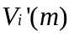as the ITF transport anomaly for product at month , where the represents the deviation from the 1993-2001 time mean. The r.m.s. difference of for the 14 products at month is denoted by 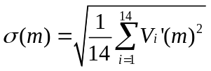. The temporal average of 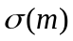 over all the months within the 1993-2001 period, 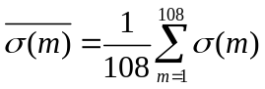 (where 108 is the number of months within the 1993-2001 period), represents the average scatter among the different products. The value of 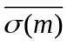 is 1.7 Sv. One could consider this number as the “noise” in the ensemble estimates. Let temporal r.m.s. variation of is given by 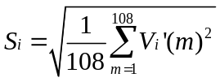 (again, 108 is the number of months within the 1993-2001 period). The value of 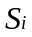, representing the magnitude of temporal variation for a given ODA product, ranges from 2.5 to 4.2 Sv (Figure 3b). The 14-product average 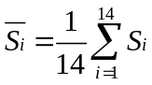 is 3.2 Sv (Figure 3b). The latter number could be considered as the averaged magnitude of the “signal” represented by the ensemble estimates. Therefore, the “signal-to-noise” ratio for the ensemble estimates of ITF transport variability, 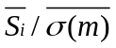, is larger than 1. In other words, the scatter of the anomalies among different products does not mask out the variability simulated by various products.
Figure 2b suggests that much of the consistency is associated with the seasonal variability. The averaged seasonal anomalies for the 1993-2001 period (i.e., the average for the same calendar month but different years) are shown in Figure 4 (color curves). The ensemble average is indicated by the black solid curve in Figure 4. Except for ECCO2 (solid aqua blue curve), all other estimates are dominated by the annual cycle with stronger ITF (more negative anomaly) during boreal summer and weaker ITF (more positive anomaly) during boreal winter. The semiannual signal is very weak in most products. The annual cycle in ITF transport reflect the influence of monsoonal forcing (e.g., Wyrtki 1987, Gordon and Susanto 2001): the southeast monsoon during June to August causes Ekman transport to go from the Indonesian Seas towards the Indian Ocean, enhancing the ITF transport; vice versa during the northwest monsoon from December to February. The r.m.s. difference of the seasonal anomalies for the 14 products averaged over the 1993-2001 period is about 1 Sv (i.e., the value of as defined above except that now represents the seasonal anomaly instead of total anomaly). Therefore, the scatter among different products for seasonal anomaly is smaller than that for total anomaly (1.7 Sv). The peak-to-trough magnitude of the seasonal cycle for different products ranges from 4.9 to 8.7 Sv, with an average of 6.8 Sv. This is much larger than 1-Sv scatter of seasonal anomalies among different products.
Most model simulations of the ITF documented in the literature (e.g., Masumoto and Yamagata 1996, Lee et al. 2002) show a dominant annual cycle and a weak semi-annual signal. Masumoto and Yamagata (1996) showed that the seasonal variation in total ITF transport simulated by their model agreed nicely with the estimate using Godfrey’s Island Rule (Godfrey 1989). However, the estimate from INSTANT observations has a very weak annual signal but very strong semi-annual signal (black dashed curve in Figure 4a). Note that this is a monthly composite from 2004-2006 (same calendar month of different years), not a semi-annual harmonic fit to the data as was done by Sprintall et al. (2009). The ECCO2 estimate, which differs from other ODA products by showing a strong semi-annual signal and little annual signal, is actually most similar to the INSTANT estimate. Overall speaking, the discrepancy among the ODA estimates (solid curve in Figure 4b) is smaller than that between the ODA ensemble average and the INSTANT estimate (dashed curve in Figure 4b). To a large extent, the difference between ODA and INSTANT estimates is not due to the difference in periods over which the seasonal variations are computed. We have examined the seasonal variation averaged over 2004-2006 from ODA products that cover this period, and found that the ODA estimates are still dominated by the annual cycle (except for ECCO2).
The cause for the small magnitude of the annual signal in ECCO2 and dominant annual signal in all other products is discussed in the following. The semi-annual zonal wind over the equatorial Indian Ocean causes the spring and fall Wyrtki Jets (Wyrtki 1973). The associated semi-annual downwelling Kelvin waves travel a great distance down the coast of Java and into the ITF channels (Wijffels and Meyers 2004). Sprintall et al. (2009) found that the semi-annual signal dominate the seasonal transport anomalies in all the Sunda passages (Lombok, Ombai, and Timor) from the thermocline to the bottom. The annual signal is dominant only in and above the thermocline that react more directly to the monsoon forcing near the Indonesian Seas. Moreover, the annual cycle has a complex vertical structure in terms of phasing above the thermocline such that the seasonal transports near the surface and at 100 m are out of phase. The depth integrated seasonal transports through the Lombok and Ombai Straits are strongly out of phase with that through the Timor Passage, which effectively reduces the annual signal in the total ITF transport and leaves the semi-annual signal (that dominant the sub-thermocline transport) more prominent.
The weak semi-annual signal in most ODA estimates is likely due to the coarse resolution of the models. The models used by most ODA products have a 0.5°-2° zonal resolution (except for SODA that has a 1/4° resolution and ECCO2 that has a18-km resolution). The 0.5°-2° zonal resolution is insufficient to resolve the narrow straits and passages of the ITF, especially towards greater depths when the straits become even narrower. Bin-averaging of high-resolution topography onto such coarse resolutions would result in sill depths that are too shallow (unless manual “digging” is performed), which exclude part of the deep flow that are dominated by semi-annual signal. Coarse resolution means that some of the channels would be represented by only one grid cell. For B-grid models, a one-grid cell channel precludes any throughflow because the along-channel velocity is located at the land boundary. As Redler and Böning (1997) pointed out, B-grid models require special attention in model topography because the deep flow in these models depends crucially on artificially widened fracture zones if these fracture zones are not adequately resolved. For C-grid models, flow can still go through a one-grid cell channel because the velocity goes through the center of the grid cell. However, the physics of the throughflow may not be correctly represented with a one-grid cell channel. If the flow inside such a channel is primarily driven by along-channel pressure gradient (e.g., the pressure gradient between the Indonesian Seas and the Indian Ocean), the model could represent this dominant process. If the flow inside a channel is primarily associated with cross-channel pressure gradient (e.g., in geostrophic balance), however, at least two grid cells are required in the cross-channel direction to resolve the cross-channel pressure gradient. In this case, a one-grid cell channel would not be able to capture the variability of the geostrophic flow. These limitations associated with coarse resolution (or smoothed topography) may reduce the flow at depths where the semi-annual signal is dominant, and leave the annual signal to stand out because the near surface flow is primarily driven by the seasonal monsoon forcing.
Vertical distributions of the ITF transport from most ODA products are not available. Here we only analyze the two products that are in house at JPL, the ECCO-JPL and ECCO2 products, for the vertical partition of the throughflow variability. The zonal resolutions of these two products are 1° and 18 km, respectively. Figure 5 shows the climatological seasonal anomalies of ITF transport per unit depth as a function of depth from these two products. In the upper 100 m, the seasonal transport anomalies for both of these products are dominated by the annual cycle with larger ITF transport (more negative) in boreal summer and weaker ITF (more positive) in boreal winter (Figures 5a and b). The integrated seasonal ITF transports for the two products have similar phase and magnitude of the annual cycle in the upper 100 m (Figure 6b). The signal in this depth range is largely driven by local forcing as well as remote forcing in the tropical Pacific, both having a dominant annual cycle. At greater depths, ECCO-JPL has a much smaller magnitude of transport variability than ECCO2 (Figures 5c and d). The semi-annual signal in ECCO-JPL is barely visible for the 100 m-bottom integrated transport (the slight bumps in May and November in Figure 6c). Because of the weak variability at depth, the full-depth integrated ITF transport in ECCO-JPL is dominated by the top 100 m that has a strong annual cycle. For ECCO2, the transport below 100 m exhibits an annual signal that is more or less out of phase with that in the upper 100 m (Figure 6c), which cancels out some annual signal upon full-depth average (Figure 6a). On the other hand, the semi-annual signals associated with the spring Wyrtki Jet (the “bump” in April-May) above and below 100 m somewhat reinforce each other. Moreover, the signature associated with the fall Wyrtki Jet is clear below 100 m but not above. Therefore, the semi-annual signal stands out in the top to bottom integrated transport while the annual signal is weakened. The weak variability of deep flow in the coarse-resolution ECCO-JPL product prevents some vertical cancellation of the annual signal and the vertical reinforcement of the semi-annual signal. This may be one of the reasons (if not the main one) that ODA estimates based on coarse-resolution models are dominated by the annual signal.
The resolution of the SODA product (1/4° or 27 km near the Sunda passages) is not much coarser than that of ECCO2 (18 km). However, the SODA product also has a dominant annual cycle in its seasonal distribution of ITF transport. This may be because SODA is based on POP, a B-grid model (McClean et al. 1997). As discussed earlier (also see Redler and Böning 1997), B-grid models require more than one grid cell (across a channel) to allow throughflow. If no artificial widening is performed, B-grid models would require higher resolution than C-grid models (e.g., ECCO2 model) to resolve the flow through a channel of the same width.
Is the lack of semi-annual signal in ITF transport estimated by all but the ECCO2 product due to the lack of the same signal in wind forcing over the Indian Ocean? Most of the ODA products use NCEP/NCAR or ERA-40 reanalysis products as prior wind forcing. ECCO2’s wind forcing is a weighted average of these reanalysis wind and satellite scatterometer wind products (using a Green’s function method). Figure 7 shows the seasonal anomalies of zonal wind stress obtained from QuikSCAT (black), NCEP/NCAR (red), and ERA-40 (blue) averaged over the equatorial Indian Ocean (50°-100°E, 2°S-2°N). The semi-annual signal is clearly dominant in all three products, though the magnitude of semi-annual signal in ERA-40 is somewhat weaker than that in NCEP/NCAR and QuikSCAT. Therefore, wind forcing does not seem to be the major factor in causing the lack of semi-annual signal in ODA estimates of ITF transport. In fact, using QuikSCAT wind to force the ECCO-JPL model does not result in a significant enhancement of the semi-annual signal in the estimated ITF transport (not shown). This indicates that resolution, model grid, and topography have larger effects on the representation of the semi-annual signal in ITF transport.
How do the non-seasonal anomalies of ITF transport inferred from the ODA products compare with those estimated from INSTANT observations? To allow a consistent comparison, we remove the seasonal cycle averaged over the 2004-2006 period from the total ITF transport for each ODA product that covers this period. The same is applied to the INSTANT estimate. The respective non-seasonal anomalies for various ODA products and from INSTANT data are shown in Figure 8a. Figure 8b compares the ensemble average of the ODA estimates (blue curve) with the INSTANT estimate (black curve). The correlation between the two is only 0.4. The phase of the intra-seasonal variation in the ensemble ODA estimate agrees reasonably well with the INSTANT estimate. The correlation of 3-month high-pass anomalies between the ensemble ODA and INSTANT estimates is 0.73. However, the magnitude of the intra-seasonal variation in the ensemble ODA estimate is only 60% of that of the INSTANT estimate. On interannual time scales, the ensemble ODA estimate is somewhat similar to the INSTANT estimate for the first but not the second half of the record. The positive “trend” in the second half of the INSTANT estimate is not captured by most ODA products.
ECCO2 (red curve in Figure 8b), which has a seasonal variation similar to INSTANT (see Figure 4a), is able to capture the positive “trend” in the second half of the record although it did not capture the large negative anomaly in late 2005 and early 2006. The correlation between ECCO2 and INSTANT estimates (including all frequencies) is 0.68. Sprintall et al. (2009) discussed the potential role of Kelvin waves originated from the Indian Ocean in affecting the second part of the INSTANT observation record. The better agreement between ECCO2 and INSTANT than that between the coarser ODA estimates with INSTANT in the second half of the record may again be related to the better ability of the high-resolution model in capturing the deep signal from the Indian Ocean.
To quantify the difference between individual ODA products and INSTANT estimate, we compute the temporal standard deviation of the ODA-INSTANT difference for each ODA product that covers the entire INSTANT period (2004-2006) 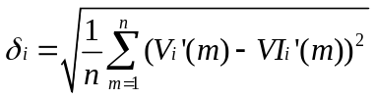. As before, is a product index, is month, denotes anomaly (here it is relative to the 2004-2006 time mean). and 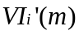 represent ODA and INSTANT estimates of ITF transport anomaly, respectively. For seasonal anomaly, 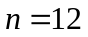 (from January to December). For non-seasonal anomaly, 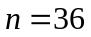 (36 months within the 2004-2006 period). The results of 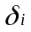 are shown in Figure 9a for seasonal anomaly and Figure 9b for non-seasonal anomalies. Figure 10 presents the correlation between individual ODA products and INSTANT estimate for both seasonal and non-seasonal time scales. The eddy-resolving, C-grid ECCO2 system shows a consistently better skill than the rest of the systems, with about 1.6-Sv r.m.s. difference from the INSTANT estimate and a correlation with the INSTANT estimate of approximately 0.7. The poor correlation and larger discrepancy between the coarse-resolution ODA products and INSTANT estimate (or with ECCO2) are largely because of (1) lack of semi-annual signal and (2) the mis-match in the timing of intra-seasonal events. As we discuss in the following, on interannual the low- and high-resolutions estimates are reasonably consistent.
To examine the consistency of interannual anomalies over a longer period, we remove the respective seasonal cycle for the 1993-2001 period from each ODA product. The resultant non-seasonal anomalies (Figure 11) illustrate the consistency on interannual time scales. The averaged spread among different products for interannual and longer time scales during the 1993-2001 period is 0.8 Sv, which is substantially smaller than the magnitude of the interannual-decadal anomalies. Therefore, the “signal-to-noise” ratio for interannual and longer variability is also larger than 1 for this period. Consistent with previous studies (e.g., Meyers 1996, England and Huang 2005, Potemra and Schneider 2007b), the estimated ITF transport tends to be weaker (stronger) during warm (cold) events in the eastern equatorial Pacific such as during El Nino (La Nina) events (a more positive value of the anomaly corresponds to a weaker ITF). This is related to interannual variation of the trade wind in the tropical Pacific: a stronger trade wind associated with La Nina events is accompanied by a higher sea level (deeper thermocline) in the northwestern tropical Pacific. This tends to increase the pressure gradient between the northwestern tropical Pacific Ocean and southeast tropical Indian Ocean, causing a stronger ITF. The opposite situation occurs during El Nino events. The relatively consistent interannual and decadal signals for low- and high-resolution systems may be related to the ability of the low-resolution systems in capturing the dominant signals in the upper thermocline transmitted from the Pacific or caused by local surface forcing.
Interannual variations of tropical Indian Ocean wind such as those associated with events of Indian-Ocean Zonal Dipole Mode also exert influence on ITF transport (e.g., Masumoto 2002, Potemra et al. 2003, and Sprintall et al. 2009). Wijffels and Meyers (2004) systematically described the wave guides that allow Rossby and Kelvin waves to carry the influences of tropical Pacific and Indian Ocean wind forcing to affect the ITF. Note that the interannual anomaly of the ECCO2 product is qualitatively similar to the other ODA products despite their difference in the seasonal distribution. INSTANT observations show that the interannual signals in the Lombok and Ombai Straits and Timor Passage are remarkably similar in phase in the upper 150 m despite the complex phase relation on seasonal time scales (Sprintall et al. 2009). This feature of reinforcing interannual signals in the Sunda passages may explain the better consistency of the interannual signal between ECCO2 and other products despite the difference in seasonal variability.
To illustrate the level of consistency on decadal time scales, the five-year low-pass time series of ITF transport anomalies and their ensemble average are presented in Figure 12. Most of the products show that the ITF is the weakest in the early-to-mid 1990s and strongest around year 2000. The increase in ITF transport from 1992-1993 to 2000 is the most pronounced decadal change. This is followed by a subsequent weakening into the mid 2000s. Using satellite scatterometer and altimeter data, Lee and McPhaden (2008) reported a strengthening of the trade wind over the tropical Pacific from 1993 to 2000 and a subsequent weakening, causing sea level to rise in the western tropical Pacific from 1993 to 2000 and to fall after 2000. The change of estimated ITF transport during this period is consistent with the observed changes in the wind and sea level.
Before the 1990s, there is also some level of agreement for a weaker ITF in the mid-to late 1960s and early 1980s, and a stronger ITF in the mid 1970s and late 1980s. The average period of the decadal signals in the past few decades is 10-15 years. We have also computed the ensemble averages from the 7 products that cover a four-decade period from 1962 to 2001. The decadal variations from the 7-product ensemble average (not shown) are fairly similar to those from the 14-product ensemble average shown in Figure 12. The local maximum and minima in the ensemble ITF transport anomaly (Figure 13a) generally correspond to local minima and maxima in the Southern-Oscillation Index (SOI) (Figure 13b). The correlation between the 5- year low-pass ensemble averaged ITF transport anomaly and SOI is -0.46 from 1965 to 2005 and -0.84 from 1990 to 2005. Since the early 1990s, the decadal variations in the ensemble ITF transport also exhibits a moderate correlation (0.53) with the Pacific Decadal Oscillation (PDO) Index (Figure 13c). The SOI and PDO index show a relatively abrupt change in the mid-to-late 1970s. An analysis of XBT data along the IX1 line by Wainwright et al. (2008) suggest a 2.5-Sv decrease of ITF transport in the upper 800 m. They attributed the change to the weakening tropical Pacific trade wind that occurred during that period. However, most of the ODA products do not show a pronounced weakening in the total ITF transport before and after 1976.
Given the interannual-decadal variability, how representative is it to use a three-year average such as that during the period of the INSTANT program to infer longer term mean? To address this issue, we present the 3-year low-pass time series of ITF transport anomaly from various ODA products (Figure 14). This is a similar presentation to Figure 12 except that a 3-year instead of 5-year low-pass filter is used. The 5-year filter, which is more effective in suppressing dominant interannual variability (e.g., those associated with the dominant 4-year ENSO cycle and biennial Indian-Ocean Zonal/Dipole Mode), is more suitable to examine decadal variability than the 3-year filter. But the 3-year filter is needed to obtain time series of the 3-year moving averages.
The 3-year low-pass time series of the ensemble mean is shown by the black curve in Figure 14. The average for the 2004-2006 period (the period of the INSTANT Program) is only about 0.5 Sv stronger than the average over the past four and half decades. The 3-year average centered in 1992 is substantially weaker than that centered in 2000. Figure 15 shows the ranges of the variation of 3-year low-pass ITF transport from various products (the difference between maximum and minimum for each product). They range from about 1.6 to 10.4 Sv with a mean of 4 Sv and a median of 3.2 Sv.
The volume of data being assimilated generally increase with time. The observations that are used to constrain the model are primarily XBT and sparse CTD data before the 1980s. The TOGA-TAO arrays have introduced sustained observations in the tropical Pacific since the 1980s. From 1992 and on, TOPEX/Poseidon and JASON-1 altimeters have provided SSH measurements over much of the global oceans. In the past few years, Argo float data have become an important source of observational constraint for models. One might expect the r.m.s. difference among different products to be smaller as the volume of observational data being assimilated increases. To ensure stable statistics in time, we choose to analyze only the 7 multi-decadal products. The r.m.s. difference averaged after 1980 is 1.6 Sv, which is somewhat smaller than the 1.8 Sv before 1980 (Figure 16). The difference is statistically significant. However, the r.m.s. difference since 1992 (the altimetry era) is actually slightly larger than that in the 1980s. This indicates a need to assimilate altimeter data more consistently and effectively to bring about better consistency among the different products. Note that the better consistency among ODA products in the 1980s and 1990s may also be related to more consistent wind forcing obtained from atmospheric reanalysis products as a result of enhanced observations used by these reanalysis (especially from satellites).
4. Concluding remarks
Volume transport of the Indonesian throughflow (ITF) estimated by 14 ocean data assimilation products generated by various groups from the United States, Europe, and Japan are compared to evaluate their consistency on different time scales. The fidelity of the products is evaluated using total ITF transport estimate derived from observational data collected by the INSTANT Program that took place during 2004-2006. The ensemble averaged time-mean value of the ODA product for 1993 to 2001, a period common to all ODA products, is 13.6. This is consistent with recent estimate based on INSTANT observation (Sprintall et al. 2009) of 15 Sv to within the observational uncertainty. In terms of temporal variability, the averaged scatter among different products (i.e., the r.m.s. difference among different products averaged over time), 1.7 Sv, is significantly smaller than the averaged variability of various ODA estimates of ITF transport, 3.2 Sv. Therefore, the overall “signal-to-noise” ratio of the ensemble ODA estimates is larger than 1.
The best consistency among ODA estimates occurs on seasonal and interannual time scales: different products generally show stronger (weaker) ITF during boreal summer (winter) and during La Nina (El Nino) events. The averaged r.m.s. difference for seasonal-to-interannual anomalies is approximately 1 Sv. On decadal time scales, the ODA estimates show decadal variations with an averaged period of about 10-15 years. The most consistent and conspicuous decadal variation is the increase in ITF transport from the early 1990s to 2000 (by about an average of 2-4 Sv depending on the length of the interannual low-pass filter). This is followed by a relaxation into the mid 2000s. These decadal changes are consistent with the variability of the trade wind and sea level anomaly in the tropical Pacific observed by satellite scatterometers and altimeters (Lee and McPhaden 2008). Most products do not show a significant weakening of the ITF after the mid-1970s (associated with the weakened Pacific trade wind), an inference of the upper 800-m throughflow using XBT data along the IX1 line (Wainwright et al. 2008).
Despite the good consistency on seasonal time scales, all ODA products except the 18-km resolution ECCO2 product show a dominant annual cycle while the INSTANT estimate shows a strong semi-annual and weak annual cycle (Sprintall et al. 2009). Intra-seasonal anomaly derived from ensemble ODA estimates agree relatively well with those captured by INSTANT observations during 2004-2006. On interannual time scales, the ODA estimates capture the change in the first but not the second half of the INSTANT observations. These discrepancies between ODA and INSTANT estimates on seasonal-interannual time scales are attributable to the coarse model resolution (compounded by the use of B-grid model in some cases). The coarse resolution would make the variability of the deep flow too weak, thus suppressing the semi-annual signal at depth and letting the annual cycle in the upper 100 m to stand out. The ECCO2 product, with an 18-km resolution that is the highest among the 14 ODA products, is the most similar to the INSTANT estimate both for seasonal and interannual variations with an averaged model-data r.m.s. difference of about 1.6 Sv and a correlation of about 0.7. The SODA product’s resolution (0.25°) is close to that of ECCO2 but could simulate the dominance of the semi-annual signal. This is attributed to the use of a B-grid model (in contrast to the C-grid ECCO2 model).
The scatter of temporal anomalies among the ODA products after 1980 is significantly smaller after than that before 1980, reflecting the impact of the enhanced oceanic and atmospheric observations since the 1980s. However, the scatter since the 1990s where altimeter observations become available is not smaller than that in the 1980s. This suggests that more effort is needed to synthesize the altimeter data consistently to improve the consistency of the ODA estimates.
To assess the representativeness of using the average over a three-year period (e.g., the span of the INSTANT Program) to represent longer-term mean, we investigate the temporal variations of the three-year low-pass ensemble average time series. The median range of variation is about 3 Sv, which is largely due to the increase of ITF transport from 1993 to 2000. However, the three-year average during the period of the INSTANT Program is within 0.5 Sv of the long-term mean for the past few decades.
The scope of this study is somewhat limited because it is based mostly on ITF volume transport estimates that integrate over all depths and over all the Sunda Passages (i.e., the Lombok and Ombai Straits and Timor Passage). However, it marks the first step towards a more in-depth evaluation of the ODA products. The findings provide some basis upon which further investigations can be made by various groups, ideally in a coordinated fashion, in terms of the distribution of the ITF among various channels and over different depths, the sill depths, and the propagation of wave signals from the Pacific and Indian Oceans.
Acknowledgement:
We would like to thank Dr. Janet Sprintall for providing the monthly values of total ITF transport estimate derived from INSTANT observations. The contributions of ITF transport estimates from assimilation groups listed in Table 1 are appreciated. We would also like to acknowledge Drs. Peter Hacker, Jim Potemra, and Ms. Sharon DeCarlo of the Asian-Pacific Data-Research Center, University of Hawaii for assisting the CLIVAR/GODAE Global Ocean Reanalysis Evaluation effort by providing a data repository and managing the files contributed by various ocean data assimilation groups. The research described in this paper was in part carried out at the Jet Propulsion Laboratory, California Institute of Technology, under a contract with the National Aeronautics and Space Administration (NASA).
References:
Balmaseda, M., A. Vidard, and D. Anderson 2008: The ECMWF System 3 ocean analysis system. Mon. Wea. Rev., 136, 3018-3034.
Bellucci A., S. Masina., P. Di Pietro, and A. Navarra. Using temperature-salinity relations in a global ocean implementation of a multivariate data assimilation scheme. Mon. Wea. Rev., 135, 3785-3807.
Carton, J.A. and B.S. Giese, 2008: A reanalysis of ocean climate using Simple Ocean Data Assimilation (SODA). Mon. Wea. Rev., 146, 2999-3017.
Carton, J.A. and A. Santorelli, 2009: Global Decadal Upper-Ocean Heat Content as Viewed in Nine Analyses. J. Clim., 21, 6015-6035.
Daget, N., Weaver, A. T. and M. A. Balmaseda, 2009: Ensemble estimation of background-error variances in a three-dimensional variational data assimilation system for the global ocean. Quart. J. Roy. Meteor. Soc., 135, 1071-1094.
England M. H., and F. Huang, 2005: On the interannual variability of the Indonesian Throughflow and its linkage with ENSO. J. Climate, 18, 1435–1444.
Fukumori, I. 2002: A partitioned Kalman filter and smoother, Mon. Wea. Rev., 140, 1470-1483.
Gemmell, A. G. Smith, K. Haines and J. Blower, 2009: Validation of ocean model syntheses against hydrography using a new web application J.Op. Oceangr., in press.
Godfrey, J. S., 1989: A Sverdrup model of the depth-integrated flow for the world ocean allowing for island circulations, Geophys. Astrophys. Fluid Dyn., 45, 89– 112.
Godfrey J. S., 1996: The effects of the Indonesian throughflow on ocean circulation and heat exchange with the atmosphere: A review. J. Geophys. Res., 101, 14217–14237.
Gordon A. L., 1986: Interocean exchange of thermocline water. J. Geophys. Res., 91, 5037–5047.
Gordon A. L., 2001: Interocean exchange. Ocean Circulation and Climate, G. Siedler, J. Church, and J. Gould, Eds., Academic Press, 303–314.
Gordon, A. L., and R. D. Susanto, 2001: Banda Sea surface-layer divergence, Ocean Dyn., 52, 2 – 10.
Gordon, A. L., R. D. Susanto, A. Ffield, B. A. Huber, W. Pranowo, and S. Wirasantosa, 2008: Makassar Strait throughflow, 2004 to 2006, Geophys. Res. Lett., 35, L24605, doi:10.1029/2008GL036372.
Hirst A. C., and J. S. Godfrey, 1993: The role of Indonesian throughflow in a global ocean GCM. J. Phys. Oceanogr., 23, 1057–1086.
Hirst A., and J. S. Godfrey, 1994: The response to a sudden change in Indonesian throughflow in a global ocean GCM. J. Phys. Oceanogr., 24, 1895–1910.
Köhl, A. and D. Stammer, 2008: Variability of the meridional overturning in the North Atlantic from the 50-year GECCO state estimation. J. Phys. Oceanogr., 38, 1914-1930.
Lee, T., I. Fukumori, D. Menemenlis, Z. Xing, and L.-L. Fu, 2002: Effects of the Indonesian Throughflow on the Pacific and Indian Ocean. J. Phys. Oceanogr., 32, 1404-1429.
Lee, T., and M. J. McPhaden, 2008: Decadal phase change in large-scale sea level and winds in the Indo-Pacific region at the end of the 20th century. Geophys. Res. Lett., 35, L01605, doi:10.1029/2007GL032419.
Lee, T., T. Awaji, M. Balmaseda, E. Greiner, and D. Stammer, 2009: Ocean state estimation for climate research, TOS, Oceanography, 22, 160-167.
Madec, G., Delecluse, P., Imbard, M. and C. Levy, 1998: OPA8.1 Ocean General Circulation Model reference manual.Technical note No. 11. LODYC/IPSL, Universite Pierre et Marie Curie, Paris, France.
Masumoto, Y. and T. Yamagata, 1996: Seasonal variations of the Indonesian throughflow in a general ocean circulation model. J. Geophys. Res., 101, 12,287-12,293.
Masumoto, Y. (2002), Effects of interannual variability in the eastern Indian Ocean on the Indonesian Throughflow, J. Oceanogr. Jpn., 58, 175–182.
Masuda, S., T. Awaji, N. Sugiura, et al. 2006: Interannual variability of temperature inversions in the subarctic North Pacific. Geophys. Res. Lett., 33, L24610, doi:10.1029/2006GL027865.
Menemenlis, D., C. Hill, A. Adcroft, et al. 2005: NASA Supercomputer Improves Prospects for Ocean Climate Research. EOS Transactions AGU, 86(9), p. 89.
McCreary, J.P., T. Miyama, R. Furue, et al. 2007: Interactions between the Indonesian throughflow and circulations in the Indian and Pacific Oceans. 75, 70-114.
McClean, J.L., A.J. Semtner, and V. Zlotnicki, 1997: Comparison of mesoscale variability in the Semtner-Chervin 1/4° model, the Los Alamos Parallel Ocean Program 1/6° model, and TOPPEX/POSEIDON data. J. Geophys. Res., 102, 25203-25226.
Meyers, G., R. J. Bailey, and A. P. Worby, 1995: Geostrophic transport of Indonesian Throughflow. Deep-Sea Res., 42, 1163–1174.
Meyers G., 1996: Variation of Indonesian throughflow and the El Niño-Southern Oscillation. J. Geophys. Res., 101, 14255–14264.
Murtugudde R., A. J. Busalacchi, and J. Beauchamp, 1998: Seasonal-to-interannual effects of the Indonesian throughflow on the tropical Indo-Pacific basin. J. Geophys. Res., 103, 21425– 21441.
Pham, D. T., J. Verron, and M.C. Roubaud, 1998: A singular evolutive extended Kalman filter for data assimilation in oceanography. J. Mar. Sys., 16, 323-340.
Potemra, J.T., S.L. Hautala, and J. Sprintall, 2003: Vertical structure of the Indonesian throughflow. Deep Sea. Res., Part II, 50, 2143-2162.
Potemra, J.T., and N. Schneider, 2007a: Influence of low-frequency Indonesian throughflow transport on temperatures in the Indian Ocean in a coupled model. J. Clim., 20, 1439-1452.
Potemra, J.T., and N. Schneider, 2007b: Interannual variations of the Indonesian throughflow. J. Geophys. Res., 112, C05035, doi:10.1029/2006JC003808.
Redler, R., and C.W. Böning, 1997: Effect of the overflows on the circulation in the subpolar North Atlantic. A regional model study. J. Geophys. Res., 102, 18529-18552.
Rosati, A., R. Gudgel, and K. Miayakoda, 1994: Decadal analysis produced from an ocean data assimilation system. Mon. Wea. Rev., 123, 2206-2227.
Rodgers K. B., M. A. Cane, and N. H. Naik, 1999: The role of the Indonesian throughflow in equatorial Pacific thermocline ventilation. J. Geophys. Res., 104, 20551–20570.
Schiller, A., J.S. Godfrey, P.C. McTintosh, et al., 1998: Seasonal near-surface dynamics and thermodynamics of the Indian Ocean and IOndonesian throughflow in a global ocean general circulation model. J. Phys. Oceanogr., 28, 2288-2312.
Schneider N., and T. Barnett, 1997: Indonesian throughflow in a coupled general circulation model. J. Geophys. Res., 102, 14341–14358.
Schneider N., 1998: Indonesian throughflow and the global climate system. J. Climate, 11, 676– 689.
Song, Q., G.A. Vecchi, and A.J. Rosati, 2007: The role of the Indonesian Throughflow in the Indo-Pacific climate variability in the GFDL Coupled Climate Model . 20, 2434-2451.
Stammer, D., C. Wunsch, R. Giering, et al., 2002: Global ocean circulation during 1992-1997, estimated from ocean observations and a general circulation model. J. Geophys. Res., 107, 3118, doi:10.1029/2001JC000888.
Testut, C.E., P. Brasseur, J.-M. Brankart and J. Verron, 2003: Assimilation of sea surface temperature and altimetric observations during 1992-1993 into an eddy-permitting primitive equation model of the North Atlantic Ocean, J. Mar. Syst., 40-41, pp 291-316.
Tranchant, B., C.-E. Testut, L. Renault, N. Ferry, F. Birol, P. Brasseur, 2008: Expected impact of the future SMOS and Aquarius Ocean surface salinity missions in the Mercator Ocean operational systems: New perspectives to monitor the ocean circulation. Remote Sensing of Environment, 112, 1476-1487.
Usui, N., S. Ichizaki, Y. Fujii, et al. 2006: Meteorological Research Institute multivariate ocean variational estimation (MOVE) system: Some early results. Natural Harzards and Oceanographic Processes From Satellite Data Book Series: Adv. in Space Res.. 37, 806-822.
Van Aken, H.M, I.S.Brodjonegoro, and Indra Jaya, The deep-water motion through the Lifamatola Passage and its contribution to the Indonesian throughflow. Deep-Sea Research I, 56, 1203–1216.
Volkov, D., T. Lee, and L. Fu, 2008: Eddy-induced meridional heat transport in the ocean. Geophys. Res. Lett., 35, L20601.
Vranes K., A. L. Gordon, and A. Field, 2002: The heat transport of the Indonesian Throughflow and implications for the Indian Ocean heat budget. Deep-Sea Res. II, 49, 1491–1410.
Wainwright, L., G. Meyers, and S. Wijffels, et al. 2008: Change in the Indonesian Throughflow with the climatic shift of 1976/77. Geophys. Res. Lett., 35, L03604, doi:10.1029/2007GL031911.
Wajsowicz, R. C., and E. K. Schneider, 2001: The Indonesian Throughflow’s effect on global climate determined from the COLA Coupled Climate System. J. Climate, 14, 3029–3042.
Wijffels, S., and G. Meyers, 2004: An intersection of oceanic waveguides: Variability in the Indonesian Throughflow region, J. Phys. Oceanogr., 34, 1232– 1253.
Wijffels, S., J. Sprintall, M. Fieux, and N. Bray, 2002: The JADE and WOCE I10/IR6 Throughflow sections in the Southeast Indian Ocean. Part 1: Water mass distribution and variability, Deep Sea Res., Part II, 49, 1341– 1362.
Wijffels, S., G. Meyers, and J. S. Godfrey, 2008: A Twenty Year Average of the Indonesian Throughflow: Regional currents and the interbasin exchange, J. Phys. Oceanogr., 38, 1965– 1978.
Wubs, F., A.C. de Niet, and H.A. Dijkstra, 2005: The performance of implicit ocean models on B- and C-grids. J. Comp. Phys., 211, 210-228.
Wunsch, C. and P. Heimbach, 2006: Practical global oceanic state estimation. Physica D Nonlinear Phenomena. 230, 197-208.
Wyrtki, K., 1973: An equatorial jet in the Indian Ocean, Science, 181, 262–264.
Wyrtki K., 1987: Indonesian throughflow and the associated pressure gradient. J. Geophys. Res., 92, 14941–14946.
Zhang, S., M.J. Harrison, A. Rosati et al, 2007: System Design and Evaluation of Coupled Ensemble Data Assimilation for Global Oceanic Studies. Mon. Wea. Rev., 145, 3541-3564.
Table and Figure Captions
Table 1. Summary of the characteristics of the 14 ocean data assimilation systems.
Figure1. Monthly time series of ITF volume transports estimated by 14 ODA products (a) and the anomalies referenced to the respective mean for the 1993-2001 period (b).
Figure 2. Same as Figure 1 except only showing the period from 1993 and on.
Figure 3. Time-mean values of ITF volume transports (a) and the standard deviation of temporal anomalies of the ITF transport estimates (b) for the 1993-2001 period derived from different products.
Figure 4. (a) Seasonal anomalies of estimated ITF volume transports for 1993-2001 from the 14 ODA products (color curves), their ensemble average (black solid curve), and INSTANT estimate for 2004-2006 (black dashed curve), and (b) r.m.s. difference of seasonal anomalies among the ODA estimates (solid curve) and r.m.s. difference of the ODA estimates from the INSTANT estimate (dashed curve).
Figure 5. Seasonal anomalies of ITF transport per unit depth from ECCO-JPL (a, c) and ECCO2 (b, d) products. The upper and lower panels show the depth range of 0-200 and 200- 1800 m, respectively.
Figure 6. ITF volume transport integrated over full depth (a), surface to 100 m (b), and 100 m to bottom (c) from ECCO-JPL (solid) and ECCO2 (dash) products.
Figure 7. Comparison of seasonal anomalies of zonal wind stress averaged over the equatorial Indian Ocean from QuikSCAT measurements for the period of 2000-2008 (black), NCEP/NCAR (red), and ERA-40 (blue) reanalysis products for the period of 1993-2001.
Figure 8. Comparison of non-seasonal anomalies among 7 ODA products (color curves) that cover the 2004-2006 period with INSTANT estimates (black) (a) and the ensemble mean of ODA products (blue), ECCO2 (red), and INSTANT (black) estimates (b). The non-seasonal anomalies are determined by removing the three-year averaged monthly estimates (i.e. averaged seasonal cycle) from the corresponding total estimates.
Figure 9. r.m.s. differences between individual ODA and INSTANT estimates for (a) seasonal and (b) non-seasonal anomalies. Only ODA estimates that cover the entire INSTANT periods are shown.
Figure 10. Correlation between individual ODA and INSTANT estimates for (a) seasonal and (b) non-seasonal anomalies. Only ODA estimates that cover the entire INSTANT periods are shown.
Figure 11. Non-seasonal anomalies of ITF volume transport referenced to the respective 1993- 2001 averaged seasonal cycle for the common period of 1993-2001 (a) and for a multidecade period.
Figure 12. Temporal variations of five-year running averaged ITF transport anomalies (color curves) and their ensemble average (black curve). The anomalies are referenced to the respective 1993-2001 mean values.
Figure 13. Five-year low-passed time series of (a) 14-product ensemble mean ITF transport anomaly, (b) Southern-Oscillation index, and (c) Pacific Decadal Oscillation index.
Figure 14. Temporal variations of three-year running averaged ITF transport anomaly (color curves) and their ensemble average (black curve). The anomalies are referenced to the respective 1993-2001 mean values.
Figure 15. The range of variations (maximum-minimum) for the three-year running averages shown in Figure 12.
Figure 16. Root-mean-squared difference of ITF volume transport among the 7 multi-decadal products. A five-year running average was applied.
Table 1. Summary of the characteristics of the 14 ocean data assimilation systems
 | System | Model and resolution | Assimilation method | Data assimilated | Period
1 | CERFACS, France | OPA8.1-ORCA2 2°x(0.5°-2°), 31 levels | 3D-VAR | SST, T & S profiles from EN3 dataset of the ENSEMBLES Project (XBT, CTD, Argo, TOGA-TAO) | 1960-2005
2 | ECCO-GODAE –v3 (MIT-AER), USA | MITOGCM, 1°x1°, 23 levels | Adjoint | Altimetry; scatterometry; tide gauges; gravity; SST, SSS; T & S profiles from XBT, CTD, Argo, TAO & other buoys, elephant seals (SeaOS); Florida Current; RAPID moorings | 1992-2006.5
3 | ECCO-JPL, USA | MITOGCM, 1°x(0.3°-1°), 46 levels | Kalman filter and RTS smoother | Altimetry, T profiles from XBT/CDT, Argo, TAO and other buoys | 1993-2009
4 | ECCO-SIO | MITOGCM, 1°x1°, 23 levels | Adjoint | Altimetry; scatterometry; tide gauges; geoid; SST, SSS; T & S profiles from XBT, CTD, Argo, TAO & other buoys | 1993-2001
5 | ECCO2 | MITOGCM (Cubed-sphere grid), 18x18 km, 50 levels | Green’s functions | Altimetry; T & S profiles from XBT, CTD, Argo, in-situ sea ice concentration | 1992-2007
6 | ECMWF ORAS3, EU | HOPE, 1°x(0.3°-1°), 29 levels | 3-D OI with online bias correction | Altimeter (sea level anomalies and global trends), SST, T & S from XBT, CTD, Argo, TAO | 1959-2009
7 | G-ECCO, Germany | MITOGCM, 1°x1°, 23 levels | Adjoint | Altimetry; scatterometry; tide gauges; geoid; SST, SSS; T & S profiles from XBT, CTD, Argo, TAO & other buoys | 1952-2001

8 | GFDL, USA | MOM3, 0.5°x(1/3°-0.5°), 31 levels | 3D-VAR | SST, T profiles from XBT, CTD, ARGO, TAO & S profiles from CTD, Argo | 1960-2005
9 | INGV, Italy | MOM, 2°x(0.5°-2°), 31 levels | OI | T & S profiles from EN3 dataset of the ENSEMBLES Project (XBT, CTD, Argo, TOGA-TAO) | 1957-2007
10 | K-7, Japan | MOM3, 1°x1°, 36 levels | Adjoint | Altimetry, SST, T from XBT, CTD, Argo, TAO | 1987-2004
11 | MERCATOR-2, France | OPA8.1-ORCA2, 2°x(0.5°-2°), 31 levels | Fixed-basis SEEK filter | Altimetry, SST, T & S profiles from EN3 dataset of the ENSEMBLES Project (XBT, CTD, Argo, TOGA-TAO) | 1993-2008
12 | MERCATOR-3, France | OPA8.1-ORCA2, 2°x(0.5°-2°), 31 levels | 3D-VAR | Altimetry, SST, T & S profiles from EN3 dataset of the ENSEMBLES Project (XBT, CTD, Argo, TOGA-TAO) | 1960-2005
13 | MOVE-G, Japan | MRI.COM, 1°x(0.3°-1°), 50 levels | 3D-VAR | Altimetry, SST, T & S from XBT, CTD, Argo, TAO | 1992-2009
14 | SODA, USA | POP, 0.25°x0.4°, 40 levels | OI | Altimetry, Satellite and in-situ SST, T & S profiles from MBT, XBT, CTD, Argo and other float data, TAO and other buoys | 1958-2007
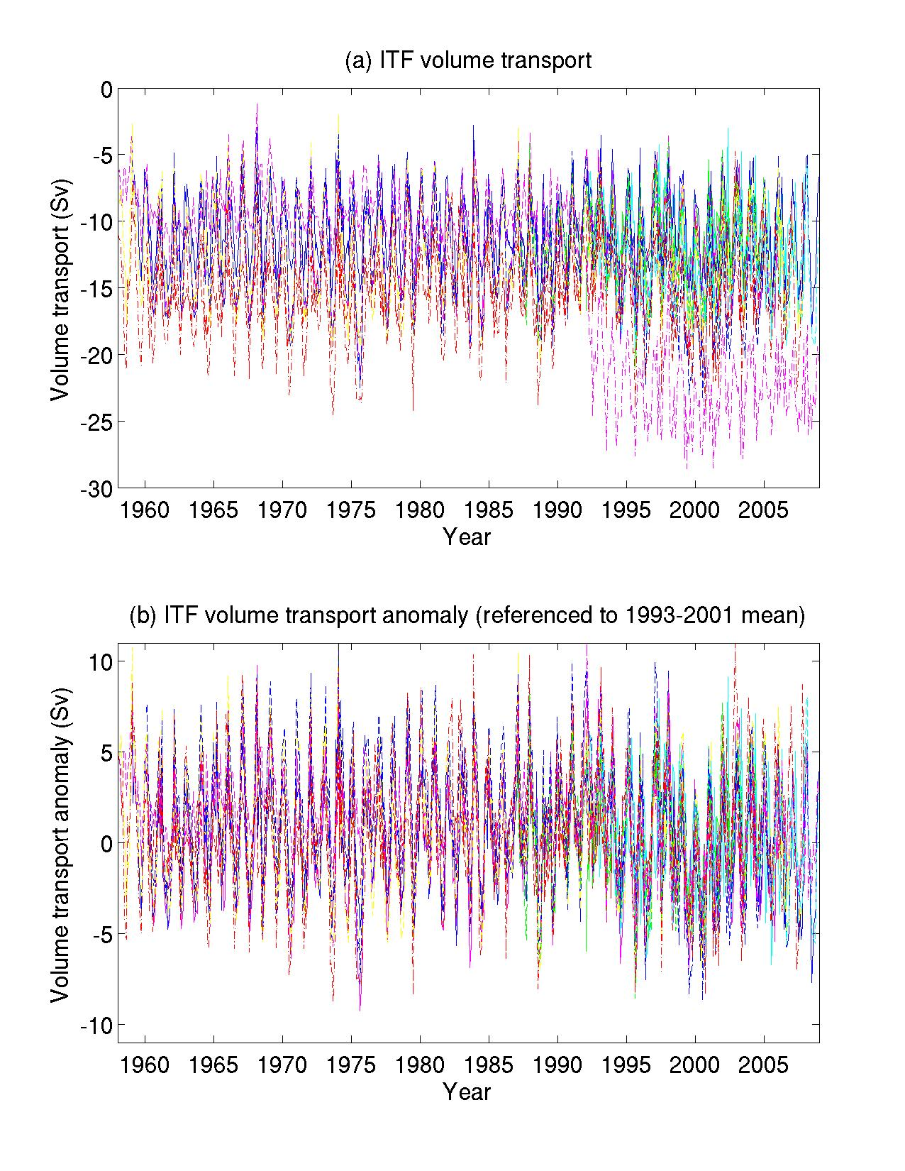
Figure1. Monthly time series of ITF volume transports estimated by 14 ODA products (a) and the anomalies referenced to the respective mean for the 1993-2001 period (b).
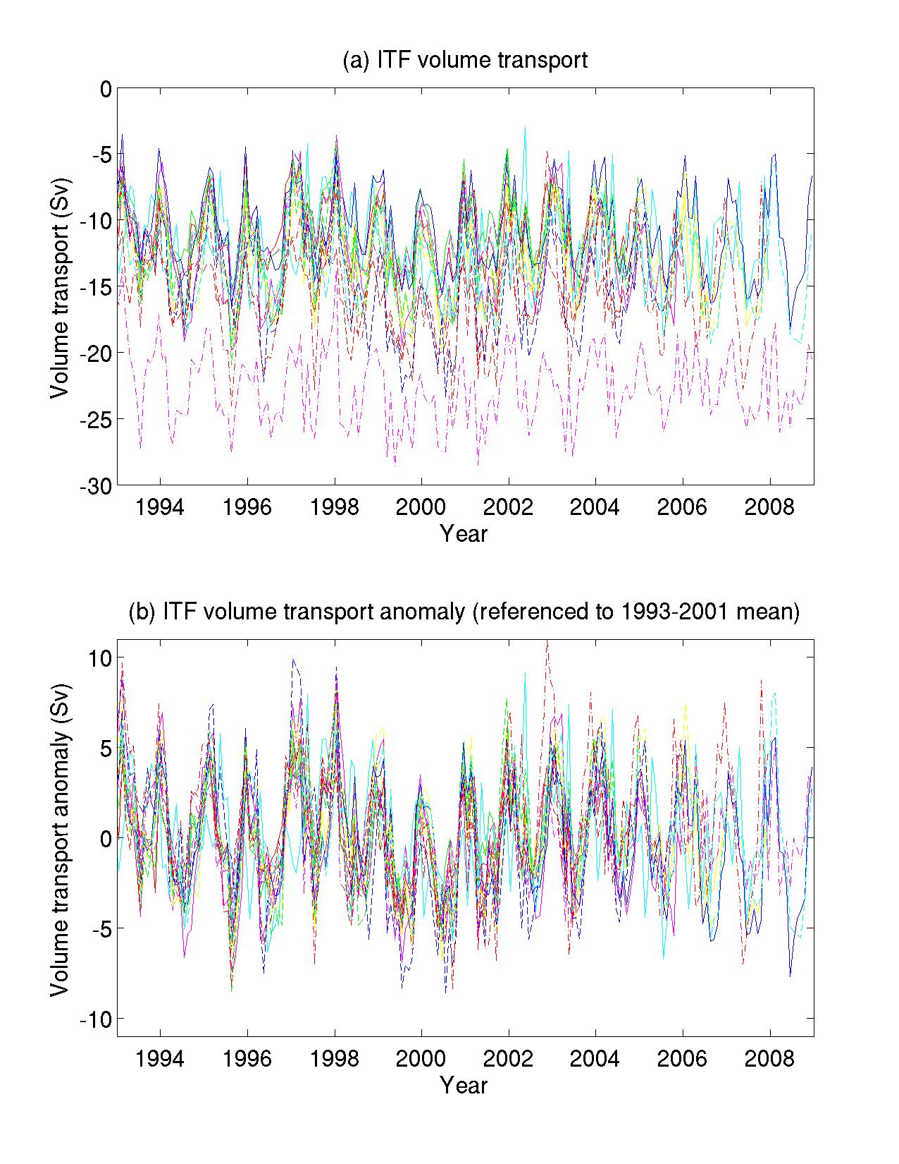
Figure 2. Same as Figure 1 except only showing the period from 1993 and on.
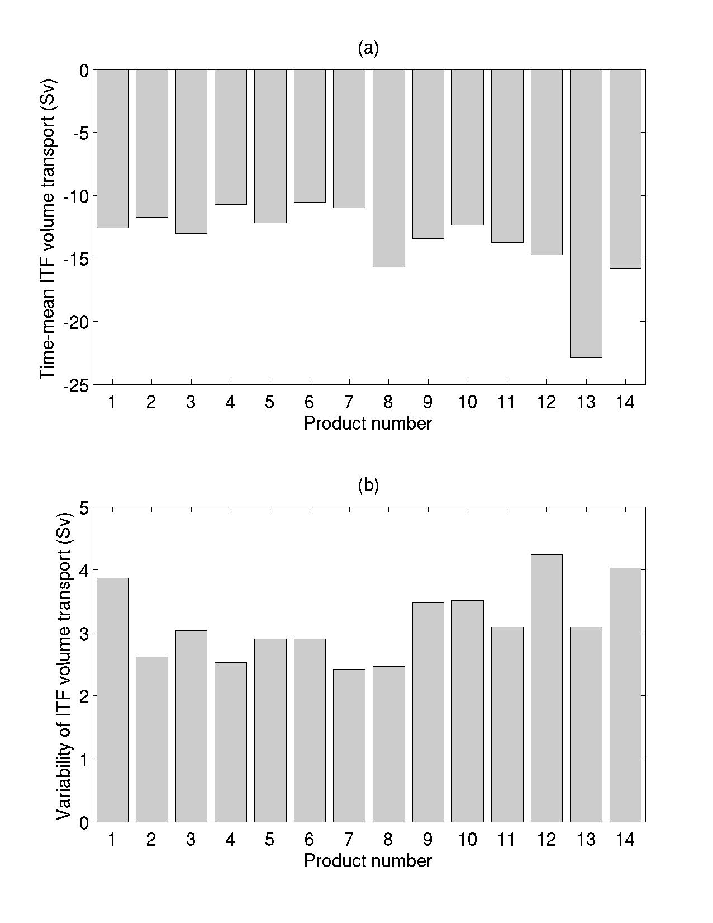
Figure 3. Time-mean values of ITF volume transports (a) and the standard deviation off temporal anomalies of the ITF transport estimates (b) for the 1993-2001 period derived from different products.
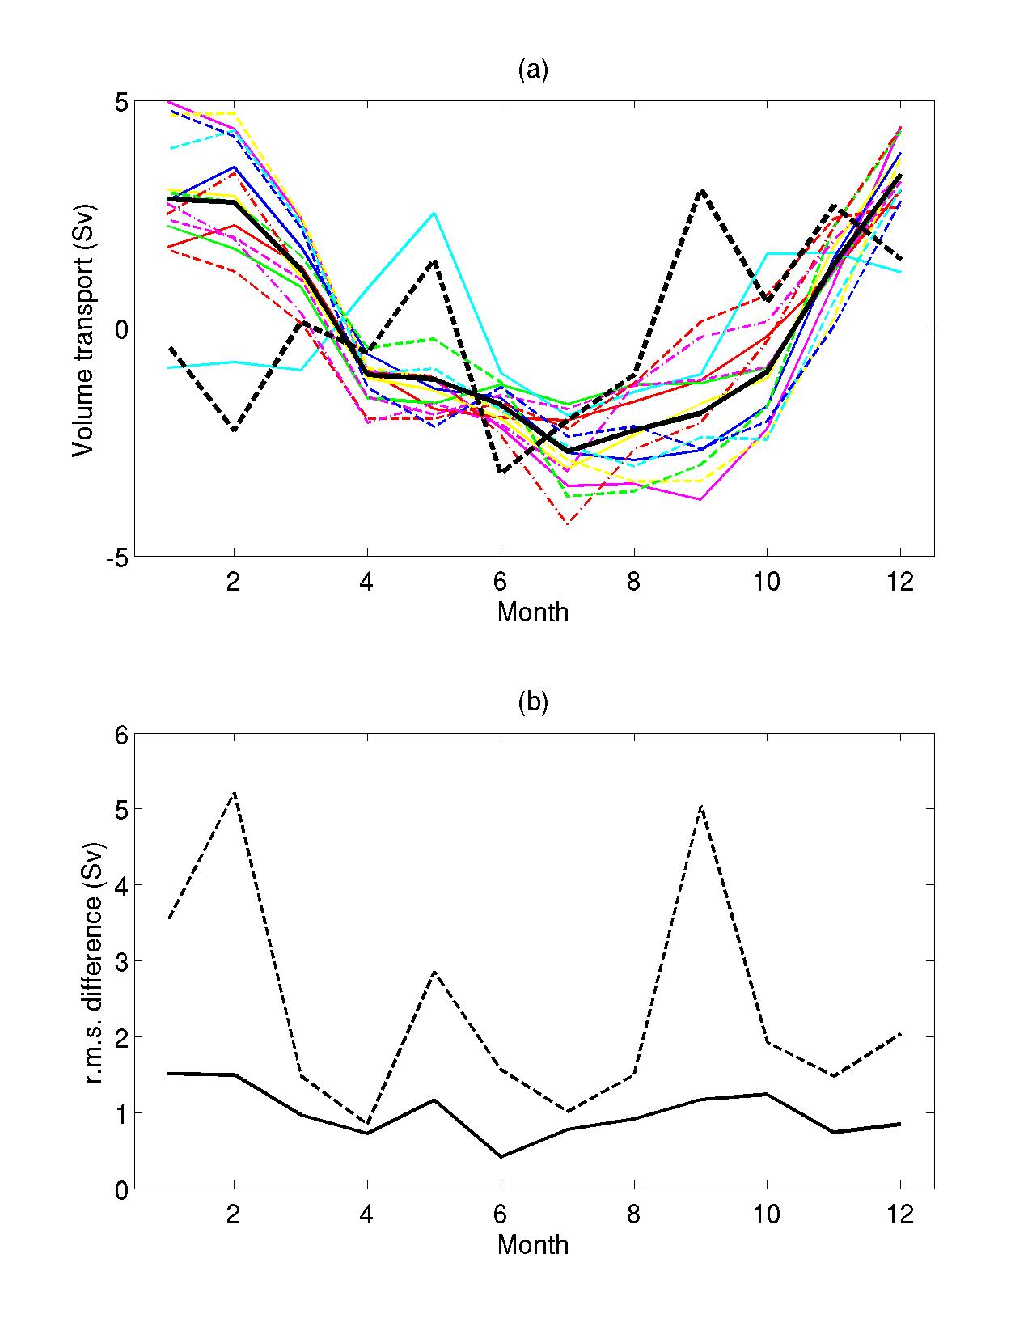
Figure 4. (a) Seasonal anomalies of estimated ITF volume transports for 1993-2001 from the 14 ODA products (color curves), their ensemble average (black solid curve), and INSTANT estimate for 2004-2006 (black dashed curve), and (b) r.m.s. difference of seasonal anomalies among the ODA estimates (solid curve) and r.m.s. difference of the ODA estimates from the INSTANT estimate (dashed curve).
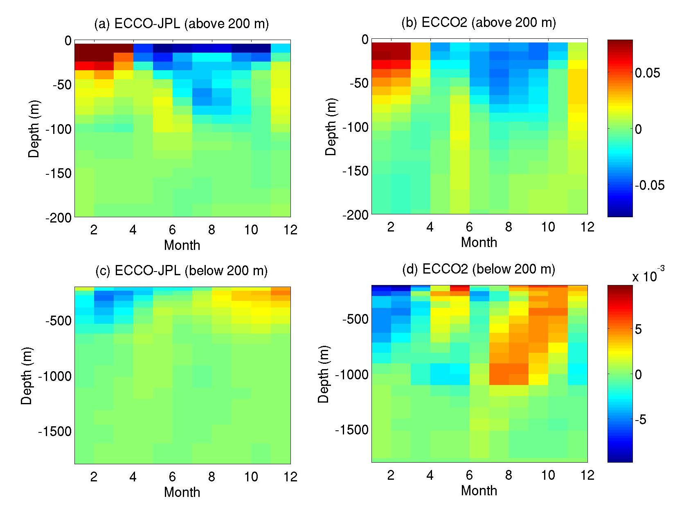
Figure 5. Seasonal anomaly of transport per unit depth from ECCO-JPL (a, c) and ECCO2 (b, d) products. The upper and lower panels show the depth range of 0-200 and 200-1800 m, respectively.
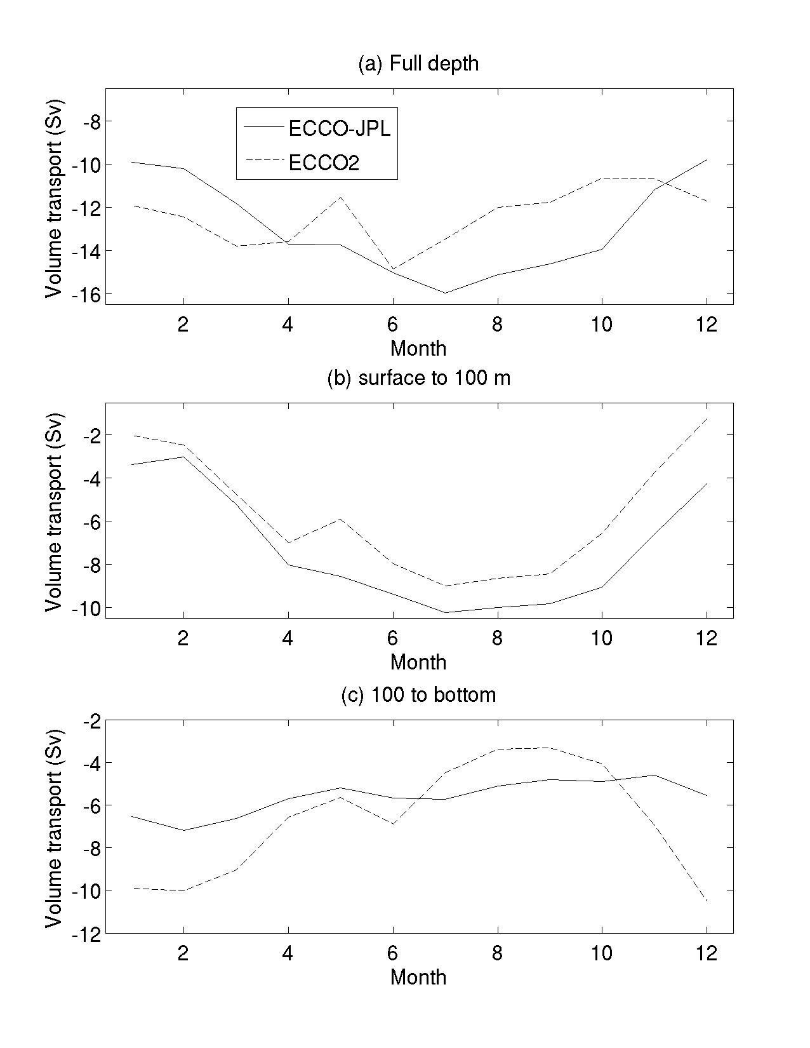
Figure 6. Volume transport integrated over full depth (a), surface to 100 m (b), and 100 m to bottom (c) from ECCO-JPL (solid) and ECCO2 (dash) products.
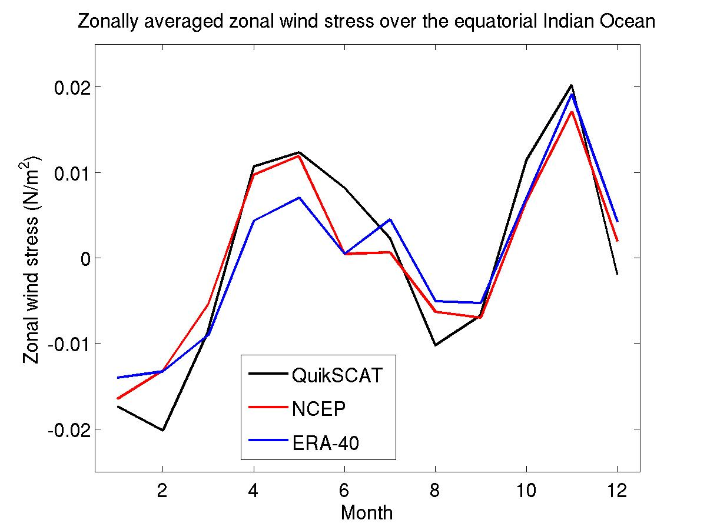
Figure 7. Comparison of seasonal anomalies of zonal wind stress averaged over the equatorial Indian Ocean from QuikSCAT measurements for the period of 2000-2008 (black), NCEP/NCAR (red), and ERA-40 (blue) reanalysis products for the period of 1993-2001.
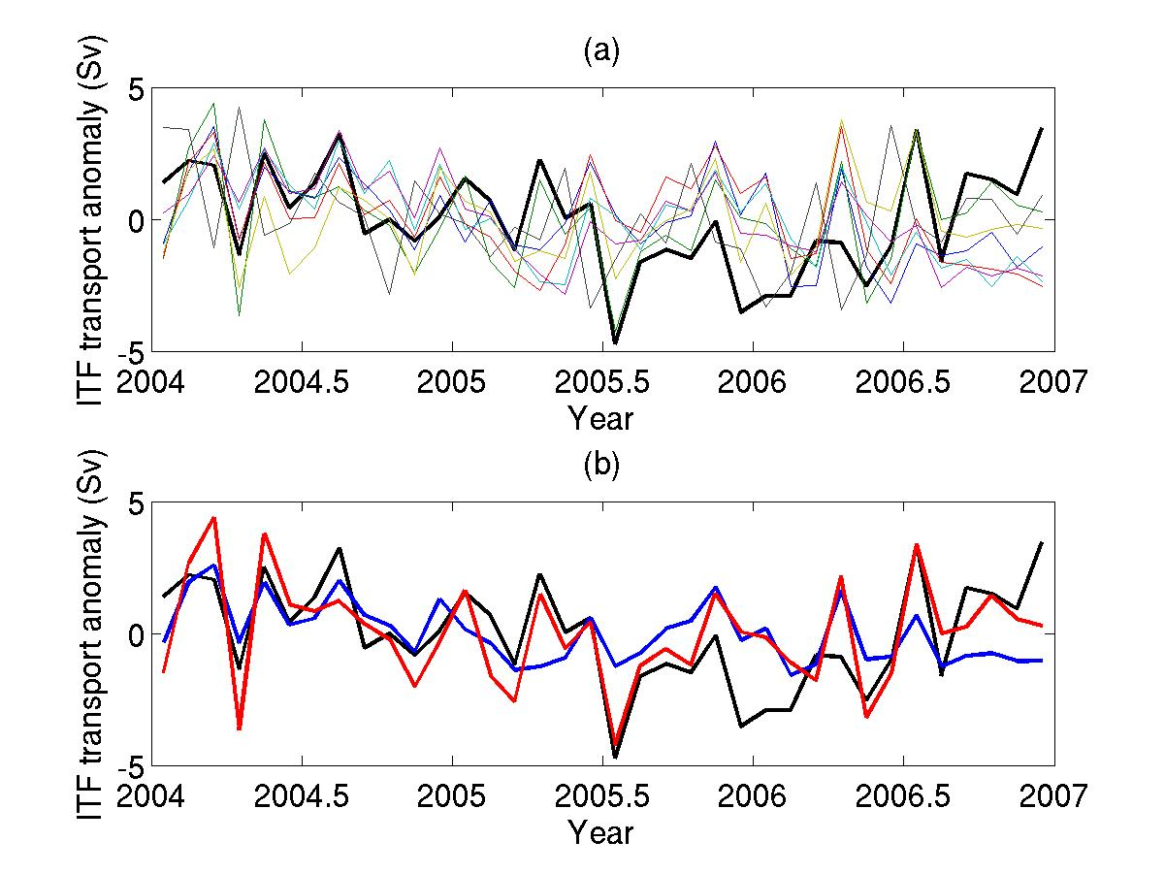
Figure 8. Comparison of non-seasonal anomalies among 7 ODA products (color curves) that cover the 2004-2006 period with INSTANT estimates (black) (a) and the ensemble mean of ODA products (blue), ECCO2 (red), and INSTANT (black) estimates (b). The non-seasonal anomalies are determined by removing the three-year averaged monthly estimates (i.e. averaged seasonal cycle) from the corresponding total estimates.
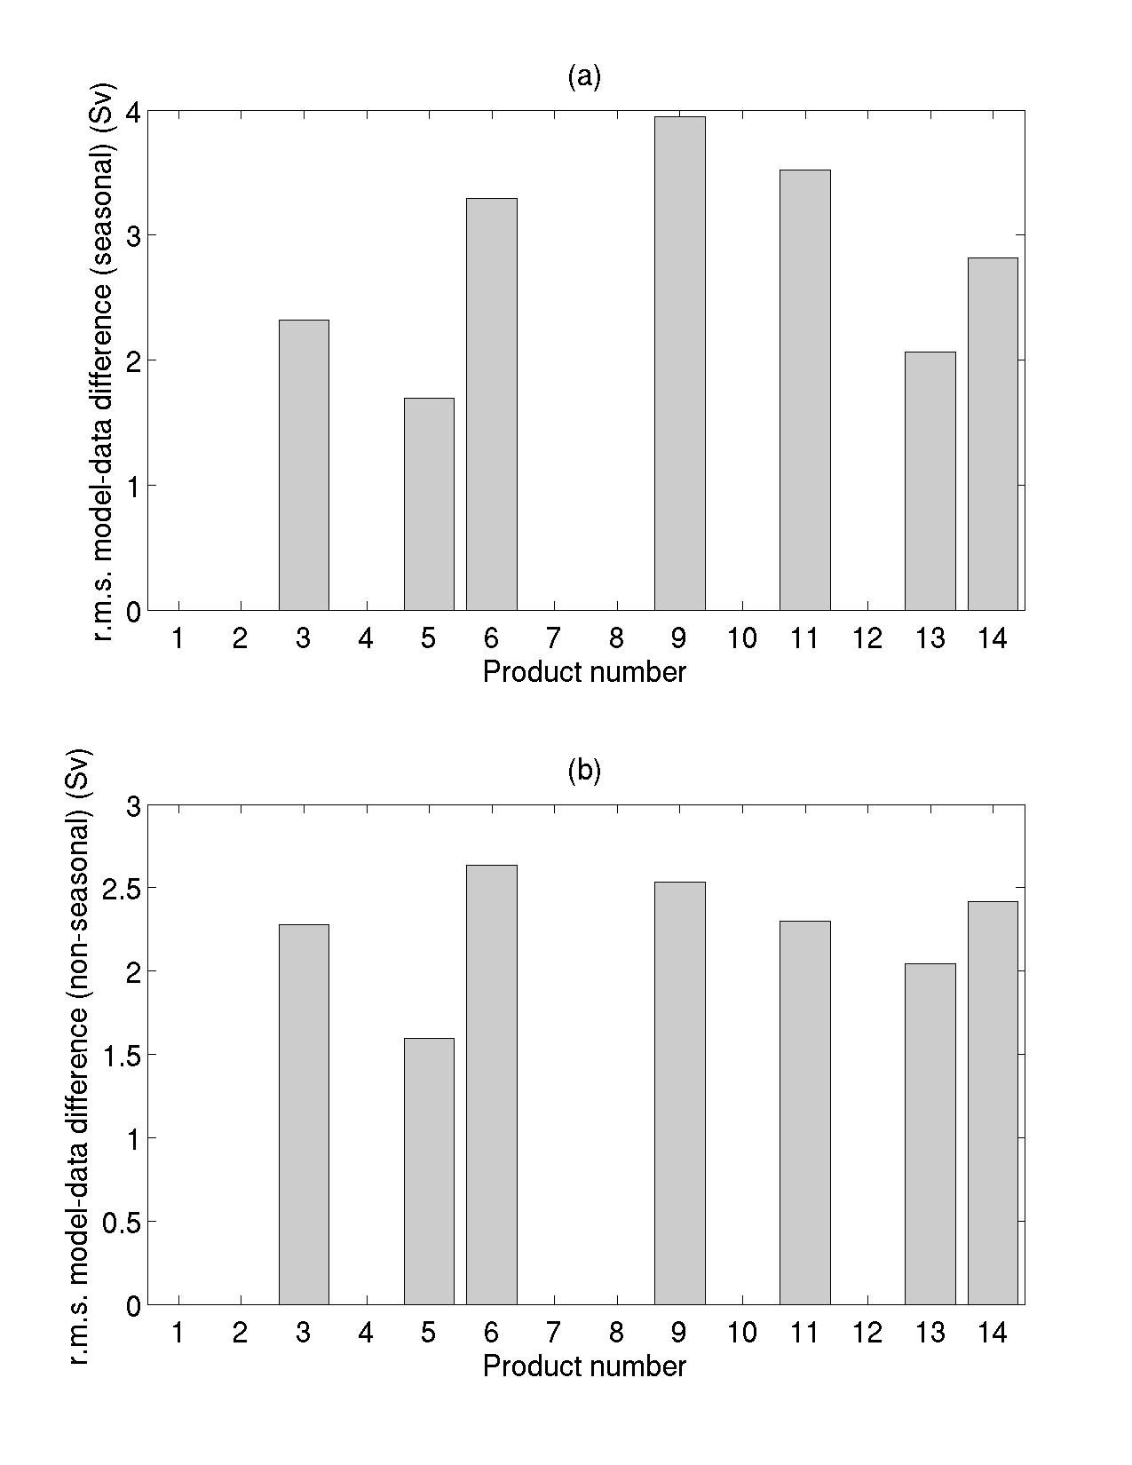
Figure 9. r.m.s. differences between individual ODA and INSTANT estimates for (a) seasonal and (b) non-seasonal anomalies. Only ODA estimates that cover the entire INSTANT periods are shown.
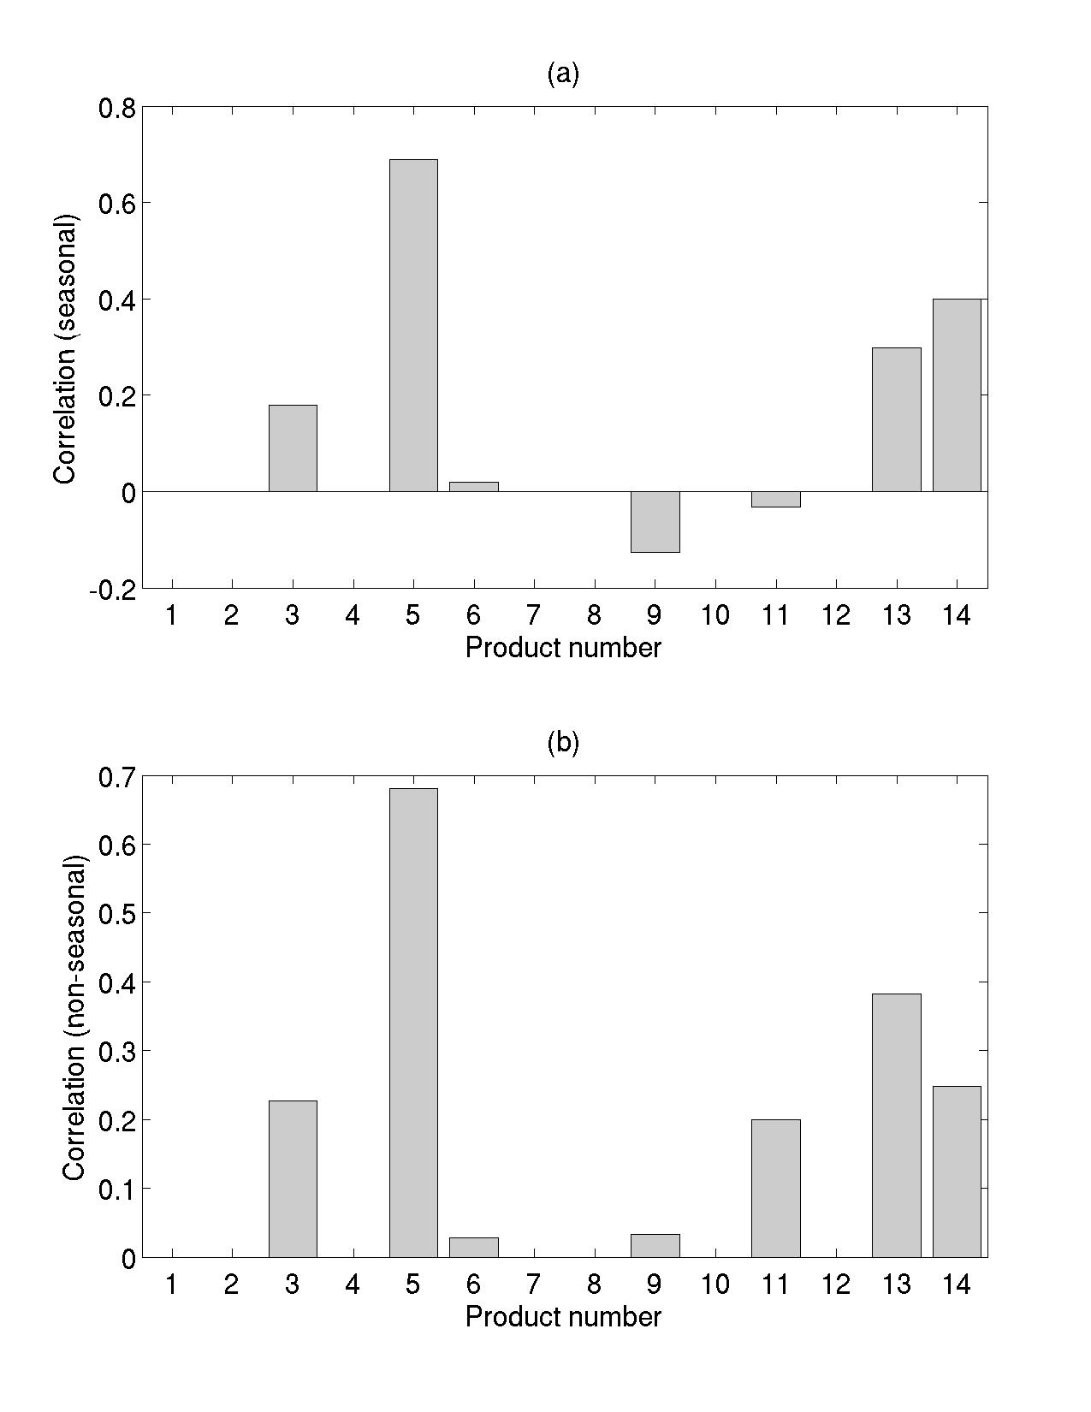
Figure 10. Correlation between individual ODA and INSTANT estimates for (a) seasonal and (b) non-seasonal anomalies. Only ODA estimates that cover the entire INSTANT periods are shown.

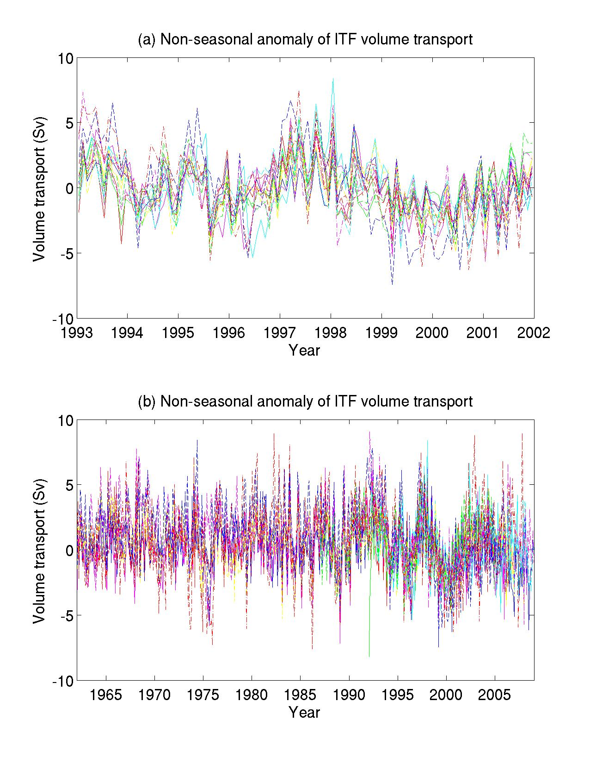
Figure 11. Non-seasonal anomalies of ITF volume transport referenced to the respective 1993- 2001 averaged seasonal cycle for the common period of 1993-2001 (a) and for a multidecade period.

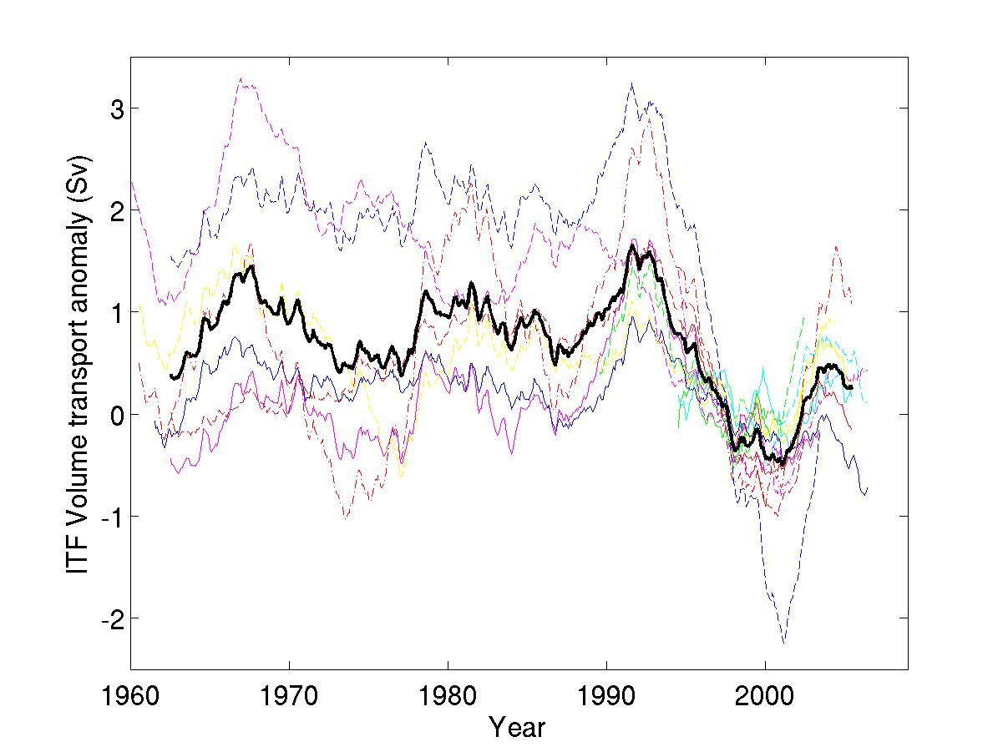
Figure 12. Temporal variations of five-year running averaged ITF transport anomalies (color curves) and their ensemble average (black curve). The anomalies are referenced to the respective 1993-2001 mean values.
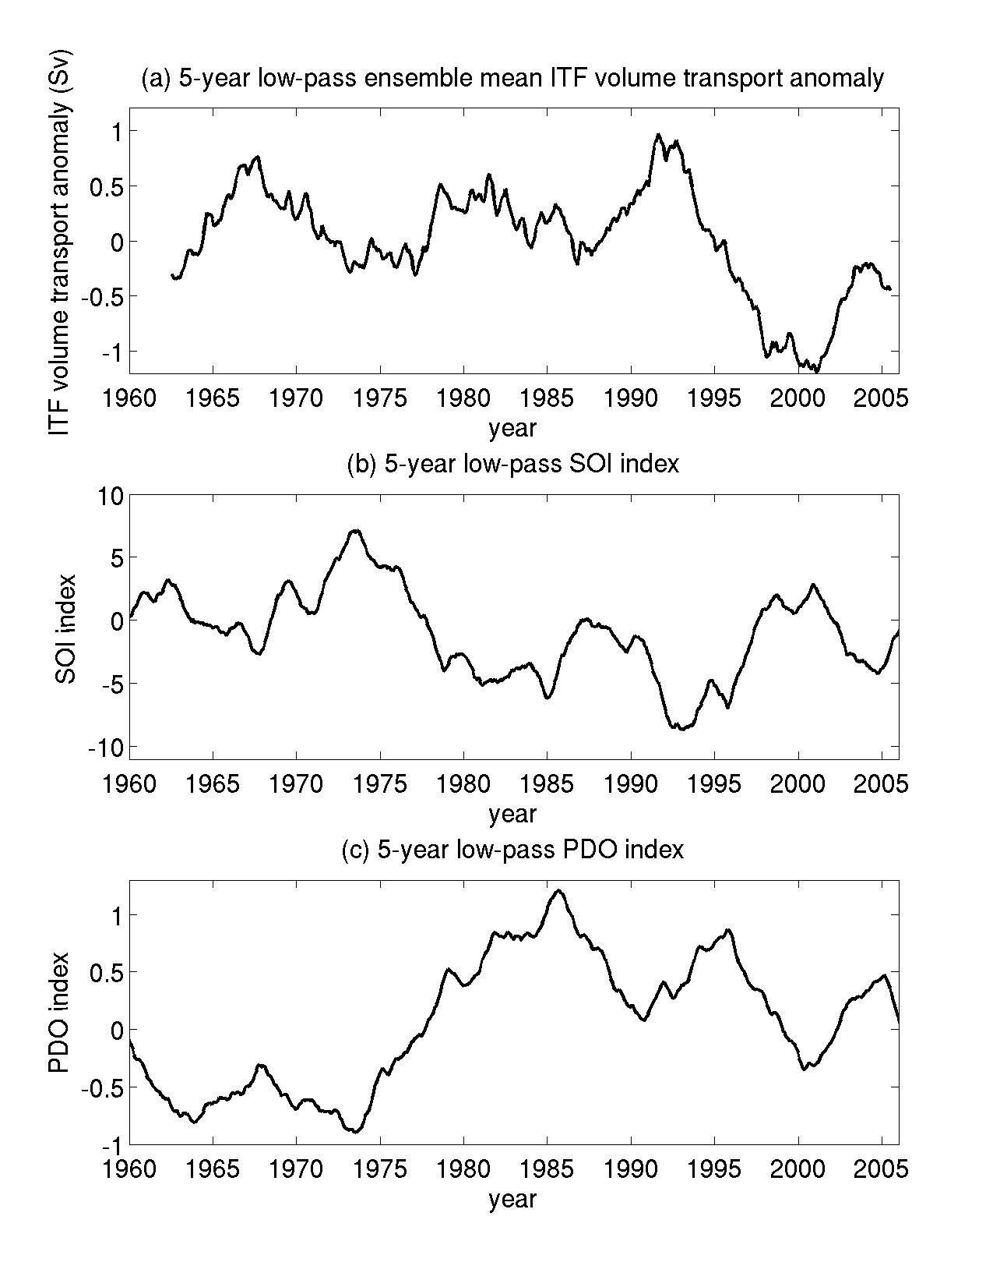
Figure 13. Five-year low-passed time series of (a) 14-product ensemble mean ITF transport anomaly, (b) Southern-Oscillation index, and (c) Pacific Decadal Oscillation index.
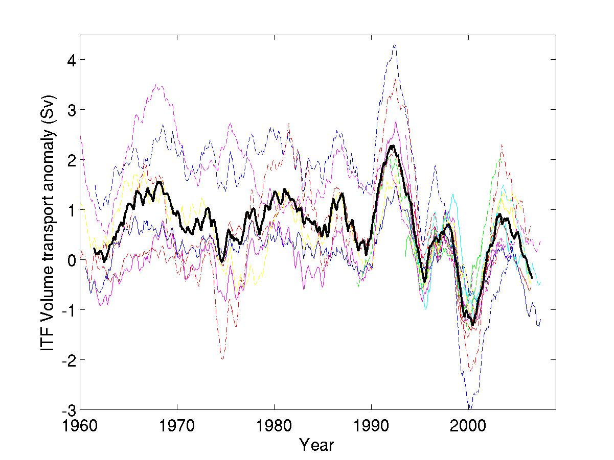
Figure 14. Temporal variations of three-year running averaged ITF transport anomaly (color curves) and their ensemble average (black curve). The anomalies are referenced to the respective 1993-2001 mean values.

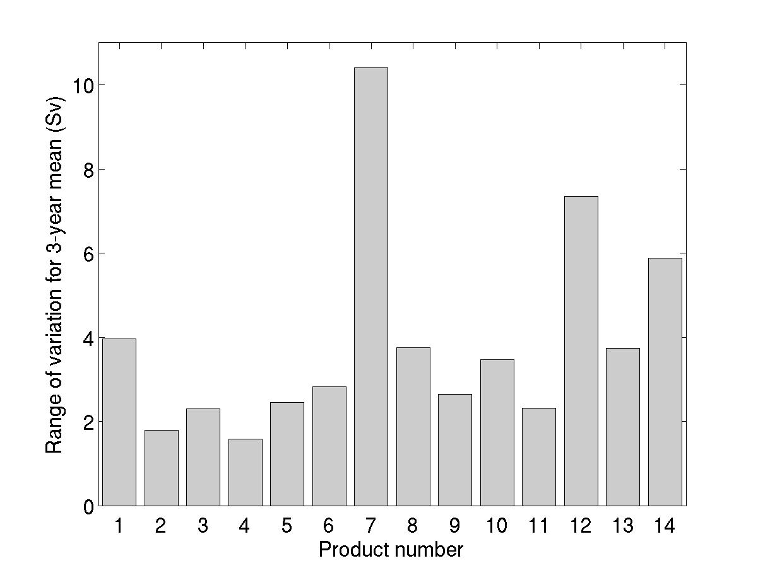
Figure 15. The range of variations (maximum-minimum) for the three-year running averages shown in Figure 12.
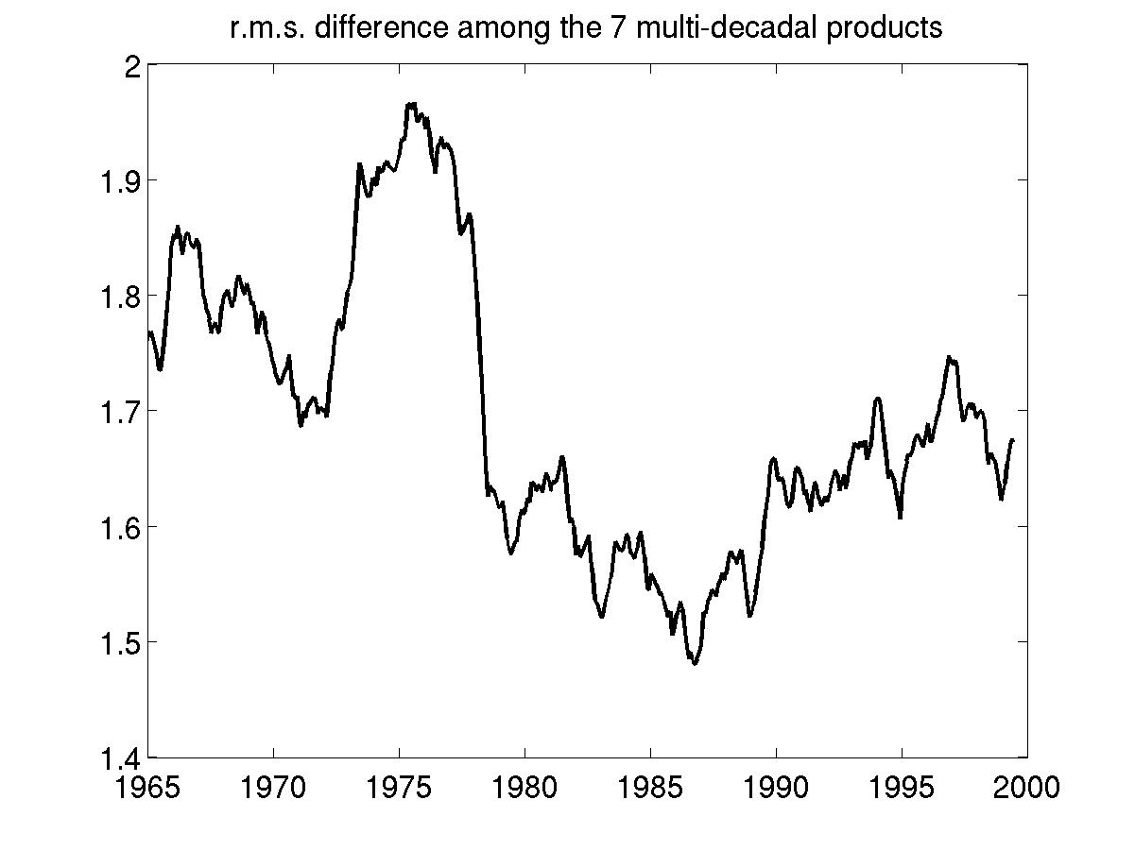
Figure 16. Root-mean-squared difference of ITF volume transport among the 7 multi-decadal products. A five-year running average was applied.

