Archaeological, structural, and compositional observations of the concrete architecture of the Basilica Ulpia and Trajan’s Forum

Elisabetta Bianchi, Roberto Meneghini
Sovraintendenza per i Beni Culturali del Comune di Roma, Ufficio Fori Imperiali, Via Quattro Novembre 94, Rome, 00187, Italy
elisabetta.bianchi@comune.roma.it, roberto.meneghini@comune.roma.it, Tel. 0039-06-6789487
Marie Jackson
Department of History, Northern Arizona University, Flagstaff, Arizona, 86011-6023, marie.jackson@nau.edu; Tel. 928- 774-2276
Philip Brune
Department of Mechanical Engineering, University of Rochester, Rochester, New York 14627, pbrune@gmail.com, Tel. 585.275.3724
Fabrizio Marra
Istituto Nazionale di Geofisica e Vulcanologia, Via di Vigna Murata 605, Rome, 00143, Italy marra@ingv.it; Tel. 0039-06-51860420

INTRODUCTION
New archaeological excavations begun in 1998 have exposed the complexity of construction design and planning of the Basilica Ulpia and Forum of Trajan, raising new research questions and providing a unique opportunity to reexamine sectors of these structures that were the object of older excavations dating to 1812 and 1924-1933. In this article, we integrate archaeological, geological, and mechanical perspectives to reconsider diverse aspects of Roman building technology and the construction of the Forum. In particular, we investigate forms and structural stability of the integrated structural elements that constitute the upper stories of the Basilica Ulpia. Furthermore, we document the compositions of brick faced, opus latericium walls and the wall core, or nucleus, of these structures, as well as those of concrete vaults and staircases, focusing on the petrographic and material characteristics of their coarse aggregates (caementa) and the fine aggregates (harenae fossiciae) of their pozzolanic mortars. With this interdisciplinary approach, we evaluate the technical expertise of Roman builders in designing the complex concrete elements in the architectures of the Basilica Ulpia and Forum of Trajan.
COMPOSITIONS OF THE CONCRETES
The aggregate compositions of concrete walls, vaults, and staircases of the Forum show a great deal of variation (figure 1; figure 2; table 1). In modern Portland cements, the proportion and compositions of aggregates define the material characteristics of the concrete. This apparently holds true for ancient Roman concretes as well. It is common knowledge, for example, that Roman builders selected certain types of caementa to enhance the material characteristics of distinct concrete architectural elements. These include: dense leucitic lava for foundations, as at the Colosseum, moderately robust brick and Tufo Lionato tuff for weight bearing walls, as at Auditorium of Maecenas, and brown, glassy scoriae for vaults, as at Forum of Caesar. Little information exists, however, as to whether Roman builders intentionally designed mixes of harenae fossiciae to enhance specific material characteristics of pozzolanic mortars. Petrographic observations of the proportions and compositions of concrete aggregates of the Basilica Ulpia and other parts of Trajan’s Forum provide a means to evaluate the material characteristics of the concretes and evaluate the expertise of the Roman builders in formulating concretes for specific structural components of the Forum.
Petrographic studies of pozzolanic mortars of the original construction of the Forum reveal that all contain reddened or dark gray granular volcanic ash from Pozzolane Rosse (table 1). This mid-Pleistocene pyroclastic flow, also known as Pozzolane di San Paolo, erupted ~457,000 years ago from Alban Hills volcano, located about 20 km southeast of Rome. Imperial age quarries for the ash may have been as close as the Caffarrella Valley, about 2 km south of the building site. The volcanic ash consists, in general, of 45-55% sand- to fine-gravel sized altered scoriae, 5-10% crystals, mainly leucite, or leucite replaced by analcime, and clinopyroxene, <5% lava rock fragments, and about 20-30% secondary alteration products, which developed through weathering of the ash by ground waters. The groundmass of the scoriae is weathered pervasively to clay mineral, mainly halloysite. These altered scoriae have natural surface coatings or cements of poorly crystalline clay mineral, opaline silica, and/or zeolite (mainly phillipsite and chabazite). An intermediate alteration facies of Pozzolane Rosse, quarried from the middle horizons of the deposit, has moderate reddish brown (10R 4/6 to 10R 3/6) altered scoriae with large leucite crystals intact but fine-grained leucite replaced by analcime, and abundant poorly crystalline clay and opal surface coatings. A least altered facies, quarried from the lower horizons of the deposit, has dark gray (N2) to dusky red (10 2/2 to 5R 3/4) altered scoriae that are resistant to crushing, with leucite mainly intact, and opal and halloysite clay mineral surface coatings. These components of the volcanic ash apparently have strong pozzolanic reactivity with hydrated lime, producing an alkali- and alumina-enriched, calcium-silicate-hydrate cementitious gel (KNAFCSH) that forms a highly durable cementitious matrix in the pozzolanic mortars. Fine sand and silt-sized, altered scoriae have themselves participated in pozzolanic reactions with hydrated lime, especially within naturally cemented ash accretions on the perimeters of larger altered scoriae (figure 2a, c) or within naturally-cemented ash aggregates (figure 2b). The intermediate alteration facies (figure 2b, c) may have greater reactivity with hydrated lime, because of a greater abundance of secondary alteration products.
Concrete Walls
The concrete walls, staircases, and vaults of the Basilica Ulpia and Forum of Trajan are composed of various types of coarse aggregate bound together by robust pozzolanic mortars and faced with fine brickwork. The very high quality brick facing of several concrete walls examined in this study show similar characteristics. These include the walls of the so-called Libraries (figure 1, sample C23), and the walls in the area at the south end of the Eastern Portico (figure 1, sample C2). The facings exhibit extremely regular workmanship: the courses are well leveled, with thin and carefully formed mortar beds; the bricks themselves are of homogeneous color and there are regular bonding courses of bipedales. The concrete cores, or nuclei, of these walls form indurated conglomerates, which have resisted decay and degradation for nearly 2000 years.
The pozzolanic mortar of the brick-faced exterior of a concrete wall at the southern termination of the Eastern Portico gives a good example of robust mortars formulated with reddened scoriae of the intermediate alteration facies of Pozzolane Rosse and dark gray scoriae of the least altered facies (figure 1, sample C2; figure 2a, b). Roman builders also added <5% sand-sized fragments of Tufo Lionato tuff, by volume of mortar (table 1). Tufo Lionato erupted as a pyroclastic flow from Alban Hills volcano, but a series of different alteration processes created a fairly well cemented, hardened tuff. Roman builders employed Tufo Lionato extensively as opus quadratum cut stone masonry during the Republican era in Rome and as caementa in concretes during the Imperial era. The addition of fine Tufo Lionato tuff fragments to the mortar was apparently an intentional choice on the part of Roman builders, as the nuclei of the walls of the Basilica Ulpia also contain a similar proportion of the tuff fragments (table 1). We measured the bulk specific gravity (G) of five wall mortars, finding values in the range of 1.78 to 1.83, with average G = 1.79. Brick (average G=1.60) and Tufo Lionato (average G=1.73) caementa contribute to the overall bulk specific gravity and unit weight of the concrete, and give it good weight bearing strength. Overall, the mortars of the wall cores appear carefully formulated and well compacted.
Concrete Vaults
The concrete vaults of the Basilica Ulpia (figure 1, samples C18, C19) and the Sala Trisegmentata (figure 1, samples C7, C9, C13) have quite different aggregate compositions from those of the walls. Builders evidently formulated the mortars to contain a predominance of the Pozzolane Rosse intermediate alteration facies. They also added a significant proportion of various, light yellow gray (5Y 9/1), sanidine-bearing pumices (table 1). Our measurements of bulk specific gravity of altered Pozzolane Rosse scoriae give G in the range of 1.6 to 1.8. The large vesicular voids and soft glass of the sanidine-bearing pumice fragments, however, create difficulties in accurately measuring their specific gravity and that of the pumice-bearing pozzolanic mortars. Silicic pumices similar to those included in the mortars have unit weight of 600 to 700 kg/m³, ranging up to about 900 kg/m³ for various modern industrial sources. Petrographic observations suggest that the pumices make up about 10-20% of the overall volume of the vault mortars. Their provenance(s) are unknown. Roman builders apparently substituted the pumice for a portion of the Pozzolane Rosse fine aggregate, maintaining total aggregate compositions of about 40% of the mortar volume (table 1). Summing the previously cited specific gravities of the constituent aggregates, converted to unit weights and multiplied by their proportions in the mortars (table 1), and using G = 2.1 for hydrated cementitious materials forming 45% to 50% of the mortars with about 5% porosity, gives unit weight estimates of about 1600 kg/m³ for three vault mortar samples (figure 1, samples C18, C7, C9). This value is about 12% than less similar computations and measured G for the wall mortars. Roman builders evidently selected the pumices to lighten the weight of the mortars. They further lightened the weight of the concrete vaults with caementa of brown, glassy scoriae and Tufo Giallo della Via Tiberina tuff. The highly porous brown, glassy scoriae most likely derive from vesiculated, lava or cinders, which L. Lancaster has identified as from the Bay of Naples. The glassy scoriae contain abundant vesicles, or open-rounded cavities produced by entrapment of gas bubbles during the solidification of the lava, giving the scoriae low unit weight, 750-850 kg/m³. Vesicular basalts have compressive strengths of about 40-50 MPa, suggesting that the glassy scoriae lend strength to the concrete despite their porous texture. By contrast, Tufo Giallo della Via Tiberina tuff erupted as a pumice-rich pyroclastic flow from Monti Sabatini volcano. Tufo Giallo della Via Tiberina tuff has low unit weight, about 1520 kg/m³, and low compressive strength, about 23 MPa. It is only weakly durable, as noted by Vitruvius (De Architectura 2.7.1-5) more than one hundred years before the Trajanic constructions. Romans quarried a moderately well cemented variety of the tuff along Via Tiberina about 10 to 15 km north of Rome.
CONCRETE VAULTED STRUCTURES OF THE BASILICA ULPIA
Various collapsed sections of vaults in opus caementicium, unearthed during the excavations in 1932, now rest on the pavement of the western sector of the Basilica. These originally belonged to the ceiling of the two minor northern aisles (figure 3). During recent studies, we precisely located the positions of all the vault fragments in the area of the Basilica Ulpia. Some of these no longer occupy their original positions (yellow in figure 3) – that is, where they first fell when the vault ceilings collapsed – because they were moved during earlier excavations. Overall, we mapped, classified, and analyzed 25 concrete nuclei identifiable as collapsed vault sections, pertaining to two different stories of the Basilica.
A double row of minor aisles, each two stories tall, surrounded the 90 m-long central nave. The width of the aisles, measured from the center of one column to the center of the other across the aisle, is 7.45 m. Hypothetical reconstructions proposed by C. Amici and J. Packer, and summarized by L. Lancaster, diverge in the number of stories of the outermost aisles and in the curvature of the vaults. In the Amici reconstruction the curvature of the vault is reduced, whereas according to Packer it is fully circular (figure 4). It should be noted, however, that only a very small percentage of the debris of the original vaulted ceilings survives, rendering the accuracy of such reconstructions somewhat difficult to evaluate.
Of all of the collapsed vault fragments, the large fragment No. 10 (figure 1, sample C18; figure 3; figure 5) with its length of 5 m, width of 3 m, and thickness of 1.25 m certainly has the most impressive dimensions. It probably comes from the longitudinal part of a minor aisle on the northwest side of the monument. Its fabric contains no traces of iron tie-bars. In 1932, fragment No. 10 was found upside down in the outer northern aisle, where it most likely formed part of the vault of the lower order, but it was then moved, with some effort, into the adjacent aisle. The simultaneous presence of fragments – specifically those of fragment Nos. 10 and 13 – pertaining to two different stories of vaults in the north outer aisle allows us to theorize about the coverings of both levels in all four minor aisles of the Basilica.
Roman builders evidently gave a good deal of attention to fabricating the concrete of the No. 10 vault fragment. They laid Tufo Giallo della Via Tiberina tuff and brown glassy scoria caementa in well compacted, alternating courses parallel to the flat upper and lower surfaces of the vault. Furthermore, they formulated a lightweight but durable mortar containing reddened scoriae of the intermediate alteration facies of Pozzolane Rosse, sand-sized, glassy, light yellow gray, sanidine bearing pumice of unknown origin, occasional sand-sized fragments Tufo Giallo della Via Tiberina pumice and Tufo Lionato tuff (figure 2c; table 1).
The concrete core of fragment No. 10 was overlain by a 20 cm thick layer of cocciopesto and a 4-5 cm thick concrete pavement preparation, which themselves were covered by the marble pavement of the upper story of the Basilica (figure 5). The surface presumed to constitute the intrados of this lower order vault was flat: in its present state it displays little trace of the curvature that has been supposed by previous scholars. We therefore infer that the lower order, rather than having a fully curved or reduced vault profile, actually formed a broad extended loft with a flat floor hidden behind a false ceiling or false vault (figure 6). In contrast, examination of fragments assigned to the upper story of the vaults reveals that these vaults likely featured at least some degree of curvature. Numerous vault fragments have been attributed to the upper order, either because they exhibit a layer of cocciopesto on their upper surface (corresponding to the pavement of the external terrace) or because they retain traces on their lower surface that suggestive of a curved surface of an intrados.
The collapsed vault fragment No. 13 (figure 1, sample C19; figure 3) preserves parts of its upper surface and its intrados. Notwithstanding its great weight (about 7 to 8 tons), it has been possible to rotate it a few degrees in order to examine the profiles of both the intradossal and extradossal surfaces. The upper surface slopes toward a small channel, 28 cm deep and lined with brick: we might therefore imagine that it forms the base of an external sloping terrace for the collection of rain water which was funneled into brick-faced drains running continuous and parallel with the vaults themselves.
The intrados preserves traces of the original curvature that, reconstructed graphically (figure 7b), reveals a reasonably well defined curve with a maximum width at the crown of 0.80 m. Fragment No. 13 may therefore be interpreted as part of the impost of the vault. The presence of a shallow square hole, which we interpret as used for the insertion of a metal bar of 3-4 cm side-length, ran horizontally (figure 7a), at the intrados near the top of the curve. This allows us to surmise the presence of a false ceiling, perhaps made of wood and/or bronze and fixed in place by a series of hanging vertical metal bars suspended from the horizontal bar. The lack of finishing work over the surviving portions of the intrados and, in contrast, the presence of frequent imprints of formwork on this and other vault fragments, suggests that the vaults of this order remained hidden from view. Moreover, it seems builders placed iron tie-bars below the vaults, cut into the architraves of the structure and spanning the aisle to secure one side to the other. Consequently, if these iron tie-bars were to have been out of sight, the false ceiling must have been immediately below this level.
Metal false vaults have been suggested within the Domus Flavia, the calidarium of the Baths of Caracalla, the portico of the Pantheon. In the Roman Baths of the Piazza della Signoria in Florence, J. Shepherd has demonstrated that the false ceiling could have been suspended from an iron framework, constructed following the principles of Vitruvius, and composed of “regulae ferrae aut arcus”, or metal bands. The framework would have been suspended from “uncini ferrei”, or iron hooks, attached to wooden beams. Furthermore, K. De Fine Licht describes the suspension system of three barrel vaults constructed of gilded bronze and hanging from the ancient trusses, discovered in the 1600s in the pronaos of the Pantheon.
In the case of the Pantheon, the false bronze vault probably rested on a wooden support, the ends of which must have rested on stone blocks that presented a roughly chiseled setback (figure 8). In the case of the Basilica Ulpia, if the lower order featured a bronze ceiling, then it could have been attached to a frame formed of metal bands suspended from hooks. These hooks would have been attached to the iron tie-bars directly beneath the vault, similar to the system whose traces we have recovered in collapsed fragment No.13, which we have restored to the second order. A surviving piece of trabeation bearing a “Vittoria Tauroctona” relief , into whose rear side is chiseled a 15 cm setback, would be an appropriate spot to support the ends of such a false ceiling (figures 6; 9).
Returning to the proposed flat profile of the lower order vault, we find two other examples where sizeable rooms are restored as vaulted with flat concrete ceilings similar to those proposed here for the Basilica Ulpia: in Rome, at the Baths of Caracalla, and in Tivoli at the Villa Adriana, in the so called Sala a Tre Esedre.
A flat spanning structure that is supported at its ends, such as the concrete vault proposed here for the first order vaults, works in a state of mechanical bending that induces compressive and tensile stress states. Roman concrete, as a cementitious composite, can be considered more vulnerable to tensile loads. Thus restorations such as those of figures 6 and 7, which inevitably produce tensile stresses, should be approached with careful analytical attention. Still, experimental investigations into the mechanical properties Roman concrete in tension have indicated that, while predictably less than its compressive strength, Roman concrete does demonstrate an appreciable tensile strength. The compact texture indicated by petrographic analyses of the vault mortars (figure 2c, d) along with the supposed strength of the constituent glassy scoriae caementa of the concrete suggests that the concrete of the first order vault would have been sufficiently strong to resist the tensile loads introduced by the flat profile proposed by the interpretative reconstruction.
In the Basilica Ulpia, because cuttings for metal tie-bars remain only in a number of blocks of the entablatures (figure 10), it appears that they served only to guarantee the stability of the architectural orders against the horizontal thrusts produced by the vaults. We presume that the tie-bars did not pass through the cores of the concrete vaults, as no traces of through-going iron have been found in the collapsed fragments. The use of tie-bars specifically to stabilize the vault springings contrasts with other instances of imperial age concrete vaulting where tie-bars were instead immersed within the fabric of the concrete vault, at a location typically identified as above the intrados. Examples of this type are included in the Horrea Agrippiana and the Palaestrae of the Baths of Caracalla. In her reconstruction of the aisle vaults of the Basilica Ulpia, C. Amici has included iron tie-bars passing through the complete concrete nuclei of both the upper and lower orders the vaults. L. Lancaster limits their presence to specific areas of the Basilica.
The restored locations of the marble blocks with cut-outs for insertion of the tie-bars further shape our view that the tie-bars were installed as connections between the entablature colonnades. In our reconstruction, the blocks with the relevant cuts include a cornice belonging to the lower storey (figure 10a) and a fragment of a lintel from the upper storey (figure 10b). For these locations in the restoration, the tie-bars serve only as connecting elements to impede horizontal movements among colonnades, as the reconstruction places the tie-bars as completely outside of the concrete fabric of the vaults. Thus, the tie-bars do not directly oppose the vault thrusts, and instead restrain against the motion of the structural elements that comprise the architectural order to which the thrusts are applied.
Additionally, in the case of the lower order, the placement of the tie-bars flush against the bottom surface of the flat vaults would result in the bars directly supporting the downward weight of the vaults, and – given their subtle cross-sections – perhaps functioning with a low margin of safety. As part of this structural configuration, Roman builders evidently reduced the unit weight of the concrete in the vaults, by deliberately including significant proportions of lightweight fine and coarse aggregate (table 1). This reduction in weight was perhaps intended to reduce the overall load on the marble elements that formed the entablature colonnades, and is considered further in the following section.
In the central colonnade that separated the two side aisles, the trabeation was not composed only of marble, but included an upper row of travertine blocks. These correspond to the level of the (marble) cornice in the colonnades lining the central nave, and were apparently hexagonal in form, as is seen in their only surviving example, shown in figures 10c and 11.
STRUCTURAL ANALYSES OF THE NEW BASILICA ULPIA RECONSTRUCTION
As discussed above, one of the more intriguing features of the new reconstruction of the Basilica Ulpia (figure 10) is the significant modification to the profiles of the vaults that cover the aisles to the main nave. In order to explore the static stability of this structural configuration, we performed structural analyses of a representative section of the lateral aisle vaults and their supporting elements, as they seem to be the most likely source of static vulnerability. The extraordinary complexity of the building as a whole precludes a more thorough investigation at this time.
We prepared a three-dimensional computational solid model derived entirely from the proposed reconstruction, and mapped in figure 11. We then employed the Finite Element method to explore the static structural behavior of a reduced model that focuses on the aisle vaults and their supports. The objective was to evaluate the viability of the proposed reconstruction by simulating its physical response to a static gravitational (self-weight) loading. Significant analysis output quantities include the mechanical stresses, particularly those calculated in the vaults of the upper and lower orders and the relative displacements of the entablature blocks, as excessive relative movement between the blocks would indicate instability in the overall system.
Preliminary results indicate a pronounced importance of the bulk material density of the concrete, which exerts a considerable influence on the structural behavior of the vaults. As in modern concretes, the material characteristics of aggregates and their relative proportions determine the bulk density of the ancient concrete formulations. These findings therefore place added importance on petrographic analyses to provide an accurate determination of the compositions of the fine aggregate of the pozzolanic mortars as well as the coarse aggregate of the concrete. Also, the cut stone masonry walls found to be of Lapis Albanus, a tuff rich in lava lithic fragments that erupted from the Lago Albano crater of Alban Hills volcano, may have been chosen for its proven durability in sustaining the large vertical generated by the extensive use of marble in the entablatures.
Furthermore, it is apparent that the connections between the various structural elements, in particular the marble entablature blocks that directly support the vaults, are significant in opposing the outwards thrusts developed by the vaults. These analyses suggest that the strength capabilities of Roman builders’ concrete formulations, as demonstrated in several experimental testing programs, rendered unnecessary the installation of a system of metal tie-bars to reinforce the concrete structural elements. While no such mechanical tests have been performed on the Basilica concrete fragments, the firm and coherent texture of the pozzolanic mortars of the vaults, the supposed strength of the brown, glassy scoriae, and the firm packing of the pumice bearing mortar into the open vesicles of these scoriae (figure 2 d) suggests that the concrete was of similar quality to those tested in the other investigations.
Increasingly detailed Finite Element analyses will give a better understanding of the structural behavior of the vaults and the static behavior of the novel configuration of the Basilica as a whole.
CONCRETE VAULTS OF THE “SALA TRISEGMENTATA”
The two collapsed fragments that formed the vaulting of the so called Sala Trisegmentata, situated at the southern limit of the Forum of Trajan (figures 12, 13), record diverse formulations of coarse and fine aggregate. For the collapsed concrete vault fragment, in the western location (figure 13a), builders formulated a fine aggregate mix of reddened, altered scoriae of the intermediate alteration facies of Pozzolane Rosse, glassy light gray pumice of unknown provenance, Tufo Giallo della Via Tiberina pumice fragments up to 2-3 cm in diameter, and fine Tufo Lionato fragments (figure 1, sample C7; figure 2c; table 1). They laid brown, glassy, vesicular scoria caementa in precise, even courses, and carefully compacted the concrete. The nuanced selection of volcanic materials and their distribution through the concrete demonstrates the exceptional care that Roman builders brought to creating a concrete of low unit weight yet apparently good mechanical strength. It shows clear variations with the concrete of the Basilica Ulpia No. 10 vault fragment, suggesting that builders took an innovative approach to designing the aggregate mixes, and did not adhere to a single formulation of lightweight vault concrete.
The collapsed concrete vault fragment about 5 m to the north of the pumiceous fragment (figures 12, 13b) has a complex composition, indicating a density gradation that decreases progressively upwards. A nearly flat, broken surface of stucco facing forms the lowermost part of the fragment (figure 13b, location A). Builders laid thin, planar, fragments of brick (figure 13b, location B) parallel to the stucco surface, in a mortar with Pozzolane Rosse fine aggregate mixed with a small proportion of sand sized Tufo Lionato tuff fragments (figure 1, sample C13). At about 45 cm from the stucco surface, builders gradually increased the proportion of rough, randomly placed chunks of Tufo Giallo della Via Tiberina tuff caementa. Indeed, the tuff caementa predominates through the central and upper zones of the vault fragment (figure 13b, location C). Furthermore, petrographic examination of the mortar at the top of the vault reveals that it contains fine aggregate of Pozzolane Rosse least and intermediate alteration facies mixed with light gray, glassy, sanidine-bearing pumice and a small proportion of sand sized Tufo Lionato tuff fragments (figure 1, sample C9; figure 2f; table 1). Roman builders evidently deliberately created the density stratification within the concrete. In the lower zone, they used wall-type mortar with no pumices and coarse aggregate of brick and a small proportion of Tufo Giallo della Via Tiberina, giving the concrete a greater unit weight. In the upper zone, they used mortar with pumices and coarse aggregate of Tufo Giallo della Via Tiberina caementa, giving the concrete lower unit weight. This structural gradation in the caementa and pozzolanic mortar appears quite similar to the compositional transition of concretes within the Great Hall of the Markets of Trajan. There, builders designed concrete pillars with heavyweight aggregate and apparently good weight-bearing strength to support concrete vaults with lightweight aggregate.
The diverse compositions of the concretes of the collapsed fragments suggest two possible hypotheses for the vaulted structure of the Sala Trisegmentata. The first involves the roofing of two separate sections of the long hall, evidently created in order to support the downwards loads. The second holds that the long vault of the hall was created in two overlapping levels of different concrete types, with the upper level being lighter (figure 13a). In this case the two fragments would be part of the same section of the vault.
It is possible that the stucco surface (figure 13b, location A) corresponds to a flat intrados forming the lower portion of a vaulted structure, with the more lightweight concrete at the top of the fragment (figure 13b, location C) and the more pumiceous concrete of the western fragment (figure 13a) forming successively higher levels of a vaulted ceiling. This is, at best, a tentative evaluation that requires further analysis. If this is the case, however, given the considerable overall thickness (about 1.5 m) of the fragments, both could possibly be restored to a lateral section of a vault.
CONCRETE STAIRCASES
In the southern area of the piazza, a single flight of steps is preserved at the end of the Eastern Portico (figure 1, sample C3; figure 14). This staircase, Scala D, probably gave access to an upper floor of the areas situated at the termination of the portico on one side, and to the terrace located above the Sala Trisegmentata on the other side. The pozzolanic mortar contains reddened and dark gray scoriae of the intermediate and least altered facies of Pozzolane Rosse and sand-sized fragments of Tufo Lionato tuff, similar to the well-selected mortar formulations. In addition, builders added small pieces of broken brick, Tufo Giallo della Via Tiberina tuff, marble, bits of older mortars containing Pozzolane Rosse, and Lapis Albanus tuff. The caementa consists of Tufo Lionato tuff, brick, Tufo Giallo della Via Tiberina tuff, and lava fragments (figure 2g, h; table 1). In contrast to the carefully selected aggregates of the concrete vaults and walls of the Basilica Ulpia and Forum of Trajan, Roman builders seem to have assembled the fine and coarse aggregate of the concrete nucleus of the Scala D staircase quite carelessly. This rather haphazard assemblage suggests that builders selected whatever fine and coarse constituents were available at the work site at that moment. Indeed, the concrete constituents represent a nearly complete sampling of stone materials employed in the building of the Forum. Furthermore, unlike most mortars of the original construction of the Forum, the Scala D mortar contains 2-3 cm diameter open voids (figure 2h); these could result from poor compaction or, alternatively, from free or excessive water combined with the lime and sand mixture of the mortar. Scala D appears to have been hidden from view in the center of the Forum, and the quite careless preparation of its concrete suggests that it was perhaps of secondary importance in terms of its structural mechanics and stabilization of the monumental construction. Builders evidently chose to give only perfunctory attention to formulating and/or compacting the concrete.
In contrast, the large Scala C staircase, recently identified on the north side of the Libraries and Trajan’s Column (figure 1, sample 25), was the monumental access to the galleries of the Basilica Ulpia. The reconstruction of this staircase was made possible during a new analysis of the architectural remains in the basement of the church of SS. Nome di Maria, where a few courses of volcanic tuff blocks and parts of a brick wall are visible. These belong to the southern wall of the staircase. Similar, symmetrical remains had already been discovered during excavations of the 1930s on the opposite side of the complex, behind the so-called Western Library. The pozzolanic mortar of the wall core is well compacted and contains a predominance of the dark gray least altered facies of Pozzolane Rosse mixed with sand sized fragments of Tufo Lionato tuff (table 1). Roman builders evidently formulated the aggregate of the concrete nucleus of Scala C quite carefully.
TECHNOLOGICAL CHOICES OF ROMAN BUILDERS
The archaeological and structural studies of the concrete vaulted architecture of the Basilica Ulpia and Forum of Trajan presented in this article combine with the petrographic study of the diverse aggregate compositions of these concretes to suggest three hypotheses regarding Roman builders’ methods for concrete construction at the end of the first century and beginning of the second century C.E.
1. Roman builders intentionally selected coarse aggregate (caementa) and sand mixtures (harenae fossiciae) to develop specific mechanical characteristics within the concretes giving a) good weight-bearing strength in walls, whose mortars contain no pumice, and b) relatively low self-weight in vaults, whose mortars contain various pumices.
2. Roman builders intentionally varied the density of concrete vault formulations, creating density stratifications through certain vaults, and using varying proportions of three pumices as caementa and harenae fossiciae, along with altered scoriae of the intermediate alteration facies of Pozzolane Rosse. The diverse provenance of these pumices: yellow, sanidine-bearing pumice of Tufo Giallo della Via Tiberina from Monti Sabatini volcano north of Rome, brown, vesicular glassy scoriae identified by L. Lancaster as from the Bay of Naples, and light gray pumices of unknown provenance, demonstrate a great deal of forethought and advance planning on the part of Roman builders. They apparently developed concrete formulations far in advance of building and made calculations of the amounts of volcanic materials needed from various quarries. They organized the precise excavation of diverse volcanic materials and kept these from mixing with one another at the quarry, during transport, and the construction site. Finally, they managed a skilled workforce who carefully formulated the diverse harenae mixtionem and caementa of various concretes.
3. Roman builders, however, took a practical approach to quality assurance. They evidently employed very careful selection and compaction of aggregate for vault formulations and weight-bearing walls. Secondary structures, such as a minor staircase, bear the traces of rapid execution, poor compaction, and somewhat careless selection of aggregate, including re-cycled mortars, based on what was currently at hand at the worksite.
WORKSITE MANAGEMENT
Previous studies have shown that during the Trajanic era, a limited number of suppliers provided the brick for the most important public buildings in Rome, including the Markets of Trajan, the Baths of Trajan, and the quays and docks of the Lungotevere Testaccio. These suppliers apparently had either family connections or other ties to the emperor. A similar situation may have existed for the supply of brick to the Forum, as well as for stone building materials excavated from quarries. During this period, public works in Rome and Ostia occurred through imperial commission. As noted by M. Steinby, it is important to consider the economic mechanisms that strongly influenced the execution of these complex monumental structures, as well as the influence of a powerful organizational structure that coordinated of all aspects of construction. The importance and grand scale of monumental construction within emperor Trajan’s building program required both the consistent supply of high quality building materials scheduled for various parts of the worksite complex, and the participation of master workmen capable of carrying out the highest standards of building quality, while working simultaneously at different construction sites. In this regard, we may imagine that the details of construction management were the responsibility of redemptores, who must have been entrusted with the specific organization of each project, under the lead of a curator operum publicorum. Two curatores operum publicorum are known during this period: C. Iulius M. F. Proculus, consul suffectus of 109 A.D. and P. Metilius Secundus Po[ntianus?]. These men held management positions during the most intense period of monumental construction in Rome, and may have indeed supervised the actual construction of the Forum of Trajan.
CONCLUSIONS
New archaeological observations of the details of construction methods employed by Roman builders coupled with an initial investigation using a three-dimensional mechanical model of an interpretative reconstruction of the Basilica Ulpia clarify the forms of the lateral aisle vaults and their supporting elements. This modeling, integrated with the geological identification of aggregate compositions and unit weights of diverse formulations of concrete walls and vaults, represents a first step in establishing the reliability of archaeological reconstructions from the collapsed fragments of the Basilica Ulpia through a mathematical model. In particular, the petrographic analyses of the fine aggregates of vault mortars reveal that altered scoriae of Pozzolane Rosse are mixed with various proportions of light-colored, sand-sized pumices of unknown provenance, confirming that builders deliberately formulated pozzolanic mortars to lighten the weight of the vault concretes. Future study of the structures of the Basilica will include further mathematical analysis of the static problems and investigation of the composition and material characteristics of the diverse concretes fragments. Our interdisciplinary approach, which integrates archaeological, structural, and petrographical observations and analyses to understand the various structures of the Forum of Trajan, provides a unique perspective with which to identify Trajanic age builders’ technical expertise and construction methods for creating bold, innovative monumental structures.

FIGURE CAPTIONS
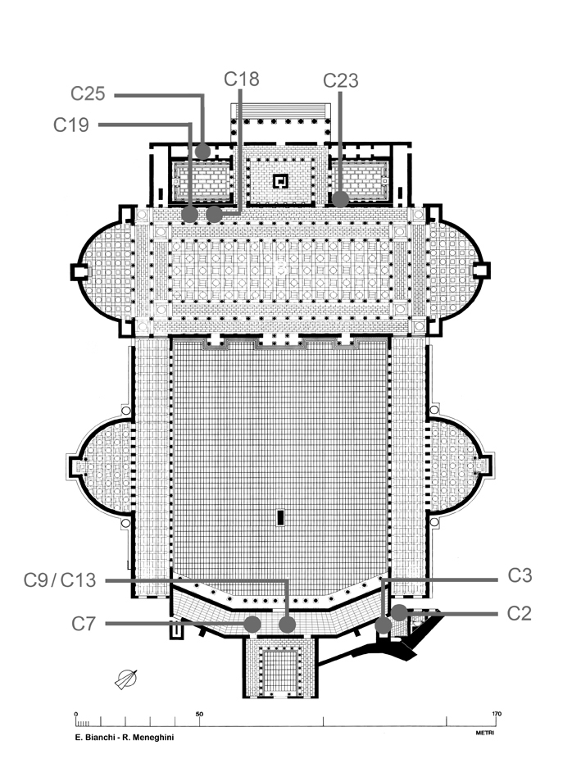Figure 1 Trajan’s Forum. Reconstructed plan view showing sample locations of pozzolanic mortars. Walls: C2, Eastern Portico; C23, Eastern Library. Vaults: C18, C19, Basilica Ulpia; C7, C9, C13, Sala Trisegmentata; Staircases: C3, Scala D; C25, Scala C. (Plan: E. Bianchi and R. Meneghini).
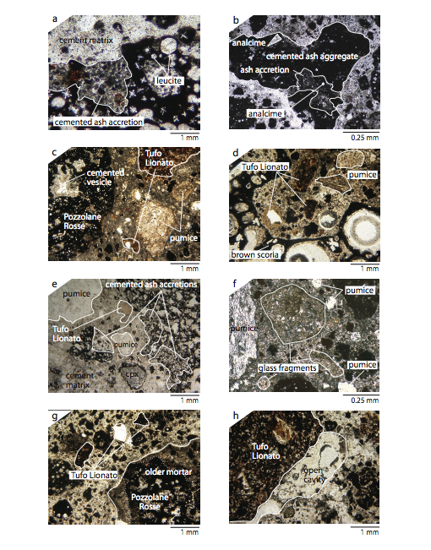
Figure 2 Photomicrographs of pozzolanic mortars. Brick facing of concrete wall, southern end of the Eastern Portico (sample 07-FOROTRAI-C2): a) least altered facies of Pozzolane Rosse, b) intermediate altered facies of Pozzolane Rosse. Basilica Ulpia: c) vault fragment no. 10 (sample 07-FOROTRAI-C18), Pozzolane Rosse, pumice, and Tufo Lionato aggregate, d) vault fragment no. 13 (sample 07-FOROTRAI-C19), Pozzolane Rosse, pumice, Tufo Lionato, and glassy brown scoria aggregate. Sala Trisegmentata: e) pumiceous vault fragment (figure 12a) (sample 07-FOROTRAI-C7), Pozzolane Rosse, light gray pumice, and Tufo Giallo della Via Tiberina pumice aggregate; f) stratified vault fragment (figure 12b) (samples 07-FOROTRAI-C9, C13), Pozzolane Rosse, pumices, volcanic glass fragments. Secondary staircase, Scala D (sample 07-FOROTRAI-C3): g) Pozzolane Rosse, Tufo Lionato, and older mortar fragment aggregate; h) cavity in mortar derived from excessive water in mortar mix or poor compaction. See figure 1 for sample locations. (color preferred)
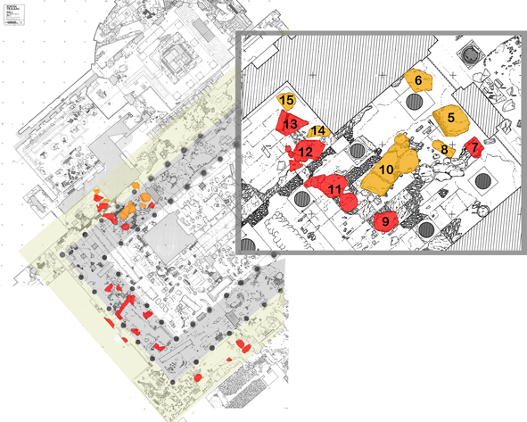
Figure 3 Basilica Ulpia. Position of the collapsed vault fragments. Red: fragments “in situ”; yellow: fragments moved during excavations in 1932. Framed: the most significant fragments for the reconstruction of the vaults of the aisles. (Plan from Packer, 1997; redrawn by E. Bianchi-R. Meneghini).
(color preferred)
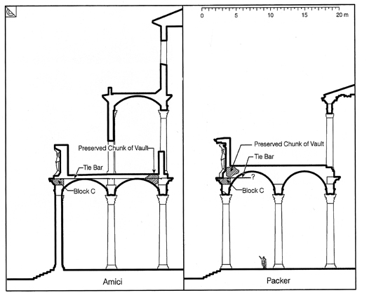
Figure 4 Basilica Ulpia. Previous hypotheses (C. Amici and J. Packer) for the ceilings of the aisles (from Lancaster, 2007).
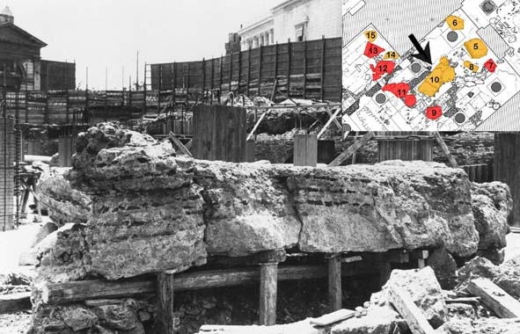
Figure 5 Basilica Ulpia. Vault fragment No.10 during excavations in 1932. (Photo Rome, Museo di Roma, Photographic Archive).
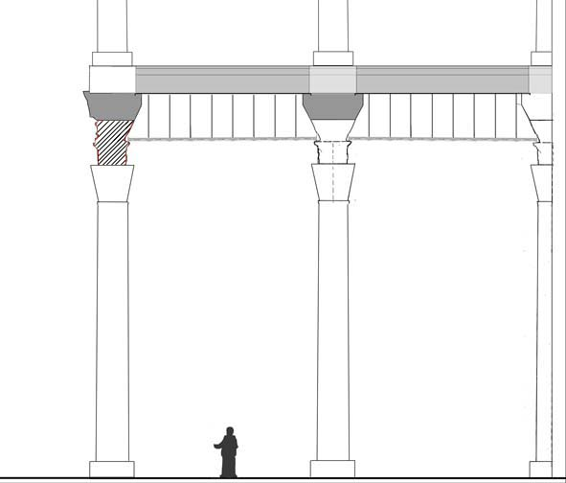
Figure 6 Basilica Ulpia. Reconstructed section of the ceiling at the ground level of the aisles. In red, marble block with the “Victoria Tauroctona” relief, on the back of which would have rested the false ceiling. (Drawing: E. Bianchi).
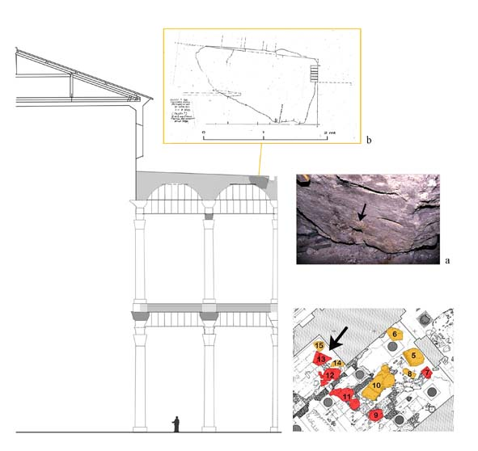
Figure 7 Basilica Ulpia. Reconstructed section of the ceiling at ground and first levels of the aisles, and collocation of vault fragment No.13 (Drawing: E. Bianchi). (color preferred)
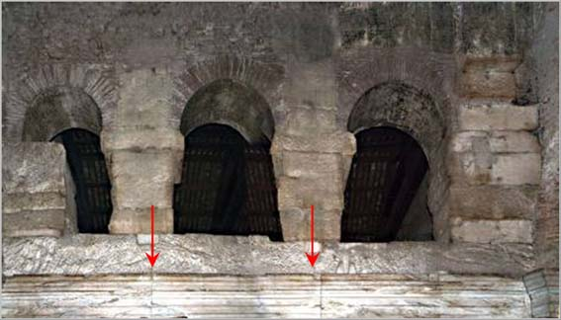
Figure 8 Pantheon. Entablature of the pronaos. The setback for the false vault is indicated (Photo Soprintendenza Archeologica di Roma)
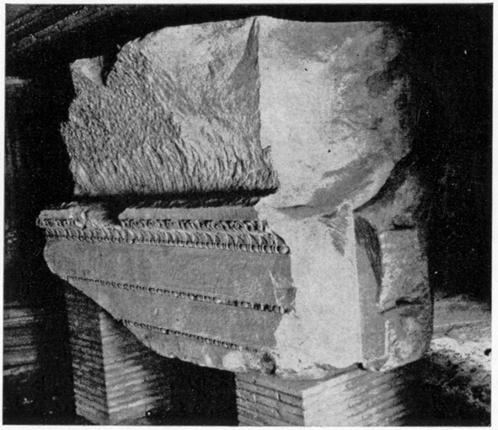
Figure 9 Basilica Ulpia. Rear side of the lintel with the “Vittoria Tauroctona” relief, showing the setback for the support of the false ceiling of the aisles (Photo Archive of Imperial Fora).
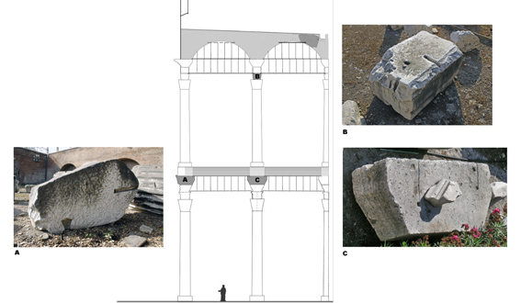
Figure 10 Basilica Ulpia. Architectural elements. A) marble cornice of the first order with recess for metal bar; B) element of marble lintel of the second order with recess for metal bar; C) travertine block originally placed between the epistyle of the first order of the aisles and the base of the second order (Drawing: E. Bianchi).
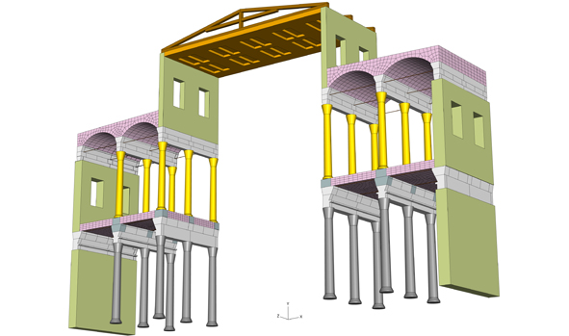
Figure 11 Structural system of the main nave and aisle vaults of the Basilica Ulpia. Constituent materials color-coded as follows: wooden truss = brown; bronze (?) false ceiling = orange and brown; Lapis Albanus (peperino) cut stone masonry walls = light green; white marble entablature blocks = white and light gray; second level Cipollino marble columns = yellow; travertine plinths beneath second level columns = light purple; first level granite columns = darker gray; and concrete vaults = pink. Vaults are shown with Finite Element meshes attached to underline their importance in the structural analyses. (color preferred)
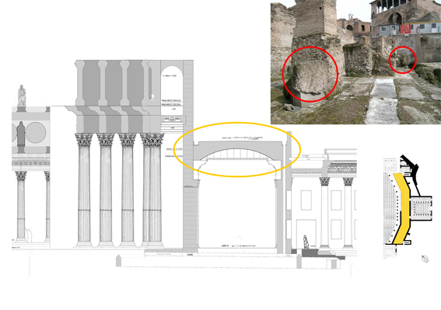
Figure 12 Trajan's Forum. Southern sector. The collapsed fragments of the vault of the Sala Trisegmentata (drawing: E. Bianchi and R. Meneghini; photograph: E. Bianchi)
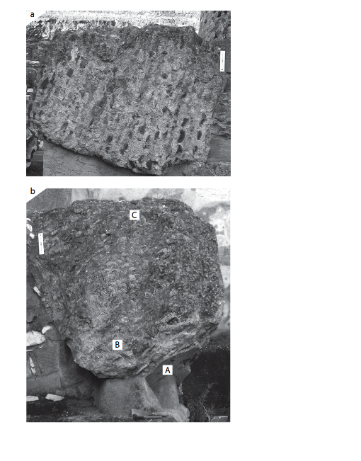Figure 13 Photographs of concrete formulations of collapsed vaults, Sala Trisegmentata. a) Western vault fragment: Pumiceous concrete has layers of brown, glassy scoria coarse aggregate and pozzolanic mortar with fine aggregate of Pozzolane Rosse intermediate alteration facies, sanidine-bearing light gray pumices, and Tufo Giallo della Via Tiberina pumice (sample 07-FOROTRAI-C7). b) Northeastern vault fragment: Concrete with a gradational density stratification has dense brick caementa (B) overlying a nearly flat stucco intrados (A), and pozzolanic mortar with fine aggregate of Pozzolane Rosse from all alteration facies (sample 07-FOROTRAI-C13). At (C), concrete has Tufo Giallo della Via Tiberina caementa and pozzolanic mortar with fine aggregate of Pozzlane Rosse intermediate alteration facies, various pumices, and glass fragments (sample 07-FOROTRAI-C9).
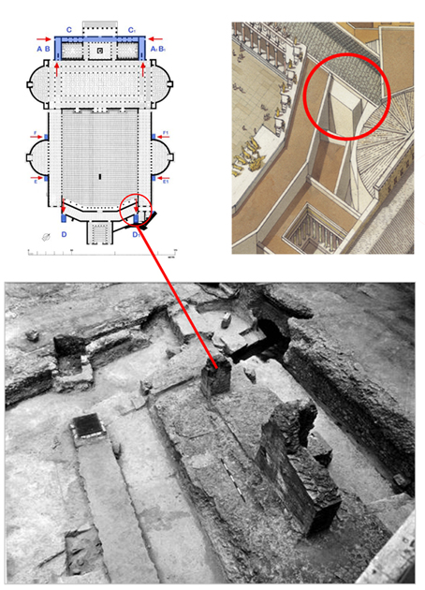
Figure 14 Trajan's Forum. Southern sector. The remains of stair “D” (Photo: Archive of the Office for the Imperial Fora; reconstruction Inklink; plan E. Bianchi and R. Meneghini).
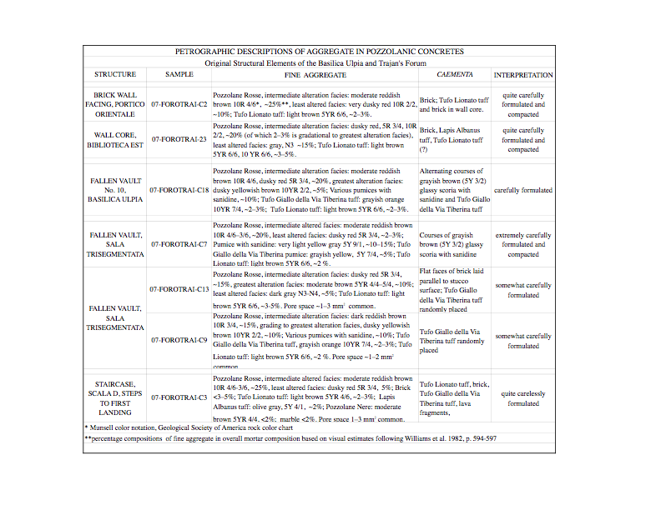Table 1 Petrographic descriptions of fine aggregate in pozzolanic mortars.
REFERENCES CITED
Al-Harthi, A. A., Al-Amri, R. M., and Shehata, W. M., 1999, The porosity and engineering properties of vesicular basalt in saudi Arabia, Engineering Geology, v. 54, p. 313-320.

Amici, C. M., 1982, Foro Traiano: Basilica Ulpia e Bilblioteche, Roma.
Amici, C. M.,1991, Il Foro di Cesare, Florence, L. S. Olschki.
Amici, C. M., 1997, L’uso del ferro nelle strutture romane. Materiali e strutture. Problemi di conservazione, 7, 2-3, 85-95.

ASTM, 2000, Absorption and bulk specific gravity of dimension stone (C 97-96), in ASTM 2000 Annual Book of ASTM Standards, Section 4, v. 04.07, 1-3, Dimension Stone, Philadelphia, American Society for Testing and Materials.

Barroero, L. et al., 1983, Via dei Fori Imperiali. La zona archeologica di Roma: urbanistica, beni artistici e politica culturale, Venezia.

Bauer H., 1978, Elementi architettonici degli Horrea Agrippiana; Un tentativo di ricostruzione degli Horrea Agrippina, Archeologia Classica 30, 106-131, 132-146.

Bianchi E., 2001, I Bolli laterizi del Foro di Traiano. Il catalogo del Bloch e i rinvenimenti delle campagne di scavo 1991-1997 e 1998-2000, BCom 102, 83-120.

Bianchi, E., 2003, I bolli laterizi dei Mercati di Traiano, BCom 104, 329-352.

Bianchi, E., 2004, Produzioni laterizie e cantieri edilizi traianei, in E.C. De Sena, H.Dessales (edd.), Archeological methods and Approaches: industry and commerce in Ancient Italy, BAR, International Series, 1262, 268-290.

Bianchi, E., 2007, I bolli laterizi del porto fluviale romano di Lungotevere Testaccio, BCom 108, 89-124.

Bianchi, E., and Meneghini, R., 2002, Il cantiere costruttivo del Foro di Traiano, Romische Mitteilungen 109, 395-417.

Bloch, H., 1947, I bolli laterizi e la storia edilizia romana, Roma.
De Fine Licht, K., 1968, The Rotunda in Rome: a study of Hadrian's Pantheon, Copenhagen.

DeLaine, J., 1985, An engineering approach to roman buiding techniques: the Bath of Caracalla in Rome, Papers in Italian archaeology 4, 195-205.

DeLaine, J., 1987, The Cella Solearis of the Bath of Caracalla in Rome: a reappraisal, PBSR, 62.

DeLaine J., 1990, Structural experimentation: the lintel, corbel and tie in western Roman architecture, World Archaeology 21.3, 417-421.

DeLaine, J. 1997. The Baths of Caracalla, Journal of Roman Archaeology Supplemental Series 25.

De Ruggiero, E., 1910, Dizionario epigrafico di antichità romane, Spoleto, V. II, II, 1326-1327.

Goodman, R., 1989, Rock Mechanics, New York, John Wiley and Sons.

Jackson, M., Marra, F., Hay, R. L., Cawood, C., and Winkler, E. M., 2005. The judicious selection and preservation of tuff and travertine building stone in ancient Rome, Archaeometry 47, 485-510.

Jackson, M. and Marra, F., 2006, Roman stone masonry: Volcanic foundations of the ancient city: American Journal of Archaeology, v. 110, 403-446.

Jackson, M., Marra, F., Deocampo, D., Vella, A., Kosso, C., Hay, R., 2007, Geological observations of excavated sand (harenae fossiciae) used as fine aggregate in Roman pozzolanic mortars: Journal of Roman Archaeology, v. 20, 25-52.

Karner, D. B., Marra, F., Renne, P. R., 2001, The history of the Monti Sabatini and Alban Hills volcanoes: groundwork for assessing volcanic-tectonic hazards for Rome: Journal of Volcanology and Geothermal Research, v. 107, 185-219.

Lancaster, L. C., 1998, Building Trajan’s Markets, AJA 102, 283-308.

Lancaster, L. C., 2000, Building Trajan’s Markets 2. The construction process, AJA 104, 755-785.

Lancaster, L. C., 2005, Concrete Vaulted Construction in Imperial Rome: Innovations in Context. Cambridge: Cambridge University Press.

Langton, C., and D. Roy, 1984, Longevity of borehole and shaft sealing materials: characterization of ancient cement based building materials: Material Research Society Symposium Proceedings, v. 26, 543-549.

La Padula, A., Roma 1809-1914, contributo alla storia dell’urbanistica, Roma 1958.

Leon, C. F., 1971, Die Bauornamentik des Trajansforums und ihre Stellung in der früh-und mittelkaiserzeitlichen Architekturdekoration Roms, Wien-Köln-Graz.

Meneghini, R., 1989, Roma – ricerca nel foro di Traiano – Basilica Ulpia: un esempio di sopravvivenza di strutture antiche in età medievale, in AMediev XVI, 541-557.

Meneghini, R., 2002, Nuovi dati sulla funzione e le fasi costruttive delle “Biblioteche” del Foro di Traiano, Mélanges de l’Ecole Francaise de Rome, v. 114, 655-692.

Middleton, J. H., 1892, The Remains of Ancient Rome II, London, A. and C. Black.

Mindess, S., Young, J. F., and Darwin, D., 2003, Concrete: Pearson Education, Inc., London.

Packer, J. E., 1997, The Forum of Trajan in Rome: a study of the monuments. Berkeley, Los Angeles, Oxford, University of California Press.

Rea, R., 2002. La cantieristica e le opere fondali degli ipogei e della cavea. Il cantiere del Colosseo, Romische Mitteilungen 109: 341-54.

Salza Prina Ricotti, E., 1988, Villa Adriana. Un singolare solaio piano in opus caementicium, Palladio 1, 15-26.

Samuelli Ferretti, A., 1997, Proposte per lo studio teorio-sperimentale delle statica dei monumenti in opus caementicium, Materiali e Strutture, v. 7, n. 2-3, p. 63-83.

Samuelli Ferretti, A., in press, The Roman “Opus Caementicium”: An experimental research, ASCE Journal of Structural Engineering.

Shepherd, J., 1989, Concamarationes in ferro nitentes, RomMitt 96, 419-431.

Steinby, E. M., 1983, L’edilizia come industria pubblica e privata, in K. De Finelicht (ed.), Città e architettura nella Roma imperiale, ARID 19, Suppl. XI, 219-221.
Steinby, E. M. 1993-1999. Lexicon Topographicum Urbis Romae. Rome: Quasar
Wesley, L. D., 2001, Determination of specific gravity and void ratio of pumice materials. Geotechnical Testing Journal, v. 24, 418-422

The excavation of the site, as it appears today, was completed in two periods: in 1812 by the Napoleonic administration of Rome and in 1932-33 by the “Governatorato”, as the city government of Rome was called during the Fascist Era. No documentation remains from the first excavation and it is possible that none may have been executed. A number of plans and photographs from the second excavation have allowed us to follow the order of work and examine the character of the finds. Directed by Corrado Ricci, the excavations of the 1930s revealed the western sector of the Basilica Ulpia. For the excavations of 1814, see La Padula, 1958; for the 20th-century excavations, see Barroero et al., 1983.
Trajan’s Forum and the Basilica Ulpia were dedicated in 112 A.D. (Fast. Ost., I. I. XIII., 1, n. 22, p. 200)
Mindess et al., 2003.
Samuelli Ferretti, 1997.
Lancaster, 2005.
Rea, 2002.
LTUR 3: 74-75.
Amici, 1991; Lancaster, 2005.
Karner et al., 2001.
DeLaine, 1995.
Jackson et al., 2007.
Langton and Roy, 1984.
Jackson et al., 2007
The bricks bear stamps that have aided the reconstruction of certain aspects of the production process relating to late 1st and early 2nd-century imperial building projects. Bloch, 1947, 49-61; Bianchi, 2001. Among the most significant brick stamps found are: CIL XV 811d (Anteros Severianus); 612-613 (Figlinae Tempesinae); 83b, 97b, 97c (Figlinae Caepionianae).
Jackson et al., 2005; Jackson and Marra, 2006.
We measured G following the guidelines of ASTM 2000 C96-97.
Samuelli Ferretti, in press; Jackson et al., 2005.
Samuelli Ferretti, 1997; Jackson et al., 2005.
Wesley, 2001
Lancaster, 2005.
Note that the proportions of 3 parts excavated sand to 1 part lime given by Vitruvius (2.5.1) do not directly correspond to the ratio of cementitious materials to aggregate particles in the ancient mortars because the cements penetrate much of the pore space in the ashes.
Multiplying G by1000 gives the approximate unit weight in kg/m³ of these materials (Goodman, 1989, p. 30-32)
Mindess et al., 2003.
Lancaster, 2005.
Lancaster, 2005.
Al-Harthi, 1999.
Jackson and Marra, 2006.
Jackson and Marra, 2006.
Meneghini 1989.
Amici 1982, p. 25.
In her 1982 book, Carla Amici stated that such vaults would have covered both of the side aisles of the ground floor, and on the first story they would have covered the inner aisles (Fig. 53 and Pl. III). In his monumental 1997 essay on the Forum of Trajan, James Packer instead hypothesized vaulted roofing for only the side aisles on the lower floor. In the recent Italian edition of his book, however, he has inserted new reconstructions, from which one may conclude that he now leans toward a solution analogous to that advanced by Carla Amici.
Amici, 1982, 17-46; Lancaster, 2005, fig. 108.
Packer, 1997; Lancaster, 2005, fig. 108.
Fragments No. 1, 5-6, 8, 13, 16. For fragment No. 5, see Amici, 1982, 30-31.
The false ceiling would have had to been very lightweight, to maintain the stability of the overlying arch.
DeLaine, 1987, 147-156.
De Fine Licht, 1968, 48-58, 67, Fig. 72.
Shepherd, 1989, fig. 3.
Vitr., V.10.3.
See n. 27
A passage of Pausanias (V, XII, 6) is often cited to support the assumption that either the roof (Packer, 1997, 442-443) or ceiling of the Basilica Ulpia was of bronze (DeLaine 1987, 153).
Leon, 1971, 68 Typ.I; Amici, 1982, 25, Fig. 43; Packer, 1997, 336, n. 109, 344, n.124, 347, n.129, 353, n. 136.
DeLaine, 1997: 157, Appendix I, 238-239; Salza Prina Ricotti, 1988. Also see Middleton II, 1892: 70-72 for unsupported concrete hypocaust floors of considerable spans.
Samuelli Ferretti, in press.
This claim is currently being evaluated by structural analyses described in the following section.
See also Amici 1982, figures 50, 51.
Bauer, 1978; Amici, 1997, 85-95.
DeLaine, 1985; DeLaine, 1987: 151-155, part. 152, n.25; DeLaine, 1990.
Amici, 1982, Fig. 53
Lancaster, 2005, fig. 109.
Amici, 1982, 32, fig. 50. The socket for the metal bar measures 27 cm (length) x 3-3.5 (width).
Amici, 1982, 42, fig. 71. The socket for the metal bar measures 4-4.5 cm (width).
Maximum dimensions of the block: 1,00 m high x 2,05 m wide x 0,70 m thick.
Jackson et al., 2005.
Jackson and Marra, 2006.
Samuelli Ferretti, 1997.
Lancaster, 1998; Lancaster, 2000.
Bianchi and Meneghini, 2002.
A detailed report on these structures, with reconstructions and interpretations, is under preparation by the authors of the present article.
Bianchi, 2001; Bianchi, 2003: Bianchi, 2004; Bianchi, 2007.
Steinby, 1983.
C. Iulius M. F. Proculus (CIL X, 6658; PIR² IV 497) e P. Metilius Secundus Pontianus (CIL X, 3718; PIR² V 549); see also De Ruggiero, 1910.
Per C. Iulius M. F. Proculus vedi CIL X, 6658; PIR² IV 497;per P. Metilius Secundus Pontianus : CIL X, 3718; PIR² V 549; see also De Ruggiero, 1910.

