PEGASO
(Polar Explorer for Geomagnetic And other Scientific Observation)
Romeo G.(1), Di Stefano G.(1), Di Felice F.(1), Caprara F(1), Iarocci A.(1), Peterzen S.(3,4), Masi S.(2),
Spoto D.(3), Ibba R.(3), Musso I.(5), Dragoy P.(6), Palangio P.(1).

(1) Istituto Nazionale di Geofisica e Vulcanologia – Sezione Roma1- Italy
(2) Università “La Sapienza” Roma – Dipartimento di Fisica - Italy
(3) Agenzia Spaziale Italiana
(4) ISTAR - USA
(5) ISTI – CNR - Italy
(6) Andoya rocket Range – Norway

Abstract

PEGASO (Polar Explorer for Geomagnetic And other Scientific Observation) program has been created to conduct small experiments in as many disciplines on-board of small stratospheric balloons.
PEGASO uses the very low expensive pathfinder balloons. Stratospheric pathfinders are small balloons commonly used to explore the atmospheric circumpolar upper winds and to predict the trajectory for big LDBs (Long Duration Balloons). Installing scientific instruments on pathfinder and using solar energy to power supply the system, we have the opportunity to explorer the Polar Regions, during the polar summer, following circular trajectory. These stratospheric small payload have flown for 14 up to 40 days, measuring the magnetic field of polar region, by means of 3-axis-fluxgate magnetometer.
PEGASO payload uses IRIDIUM satellite telemetry (TM). A ground station communicates with one or more payloads to download scientific and house-keeping data and to send commands for ballast releasing, for system resetting and for operating on the separator system at the flight end.
The PEGASO missions have been performed from the Svalbard islands with the logistic collaboration of the Andoya Rocket Range and from the Antarctic Italian base. Continuous trajectory predictions, elaborated by Institute of Information Science and Technology (ISTI-CNR), were necessary for the flight safety requirements in the north hemisphere. This light payloads (<10 Kg) are realized by the cooperation between the INGV and the Physics department “La Sapienza” University and it has operated five times in polar areas with the sponsorship of Italian Antarctic Program (PNRA), Italian Space Agency (ASI).
This paper summarizes important results about stratospheric missions.

INTRODUCTION

Long duration stratospheric balloons are vehicles used to carry many scientific experiments in space observations. They are able to lift payloads from few kilograms to one ton or more and they can carry big experiments at very high altitude giving the possibility to conduct earth or space observation’s for many days and less expensive as compared to the satellite missions.
Launching experiments on stratospheric balloon from Polar Regions during summery window offers several advantages: the typical stratospheric winds bring the balloon in a circular and predictable trajectory and the payload stays in the sunlight for months. These factors solve some questions: scientific instruments recovery, the energy supply and low temperature problems, extremely important for keeping long experiments, and the sun represents an alternative way for payload’s orientation. The localized trajectories can be object of investigation and great interest for cosmology (instruments can integrate for days the same portion of sky), for polar sciences and for earth sciences.
Stratospheric Balloons missions from polar area are an usual activity in the southern hemisphere, but quite new for the northern one: big Long Duration Balloons (LDB up to 3 weeks of operation), with a weight over two tons, have been successfully operated from McMurdo (USA, Antarctica), getting impressive results.
PEGASO (Polar Explorer for Geomagnetic and Scientific Observation) program is started to open the way for Italian LDB activity in northern polar area. The first target of the project was to investigate earth magnetic field in polar region but, in general, to provide Long Duration Balloon (LDB) know-how to the Italian scientific community.
The technical objective are to design and realize a cheap long duration small payload for polar areas, following the same flight rules for stratospheric long duration big balloons (real time localization, termination control, radar visibility) and employing commercial components adapting them for using in the stratosphere.
The scientific purpose was the study of the Earth’s magnetic field in an area not well covered by ground or satellite measurements. Scientific and logistic objectives, were to investigate the quality of the stratospheric trajectories in the Svalbard Islands site (78º 14’N), chosen by ASI and ARR for stratospheric ballooning in northern polar area. This site mirrors the northern hemisphere position of the NASA/NSBF balloon launch base in McMurdo, but it is easily reachable and offers logistic supports.

PEGASO system

PEGASO is designed following the delicate balancing between requirements, design parameters and low costs. Basically, the idea is to develop an expansible payload able to be easily interfaced with guest scientific instruments. An important technical target was to test a bi-directional communications system based on satellite telemetry (TM), using a commercial IRIDIUM mobile/modem. The Iridium satellite constellation has a good coverage of the polar area and this telemetry allows to optimise the communication time calling the payload and having a link only when it is required: to monitor the payload status and/or to send commands for running remotely operation on the payload (ballast release, end of the flight,…). A operator, with password authorization, can send commands and to change the status of the flight using a simple and portable ground station, easily implemented on a laptop (or PDA).
The IRIDIUM TM increased the payload weight (exceeding 4kg) and a remotely termination device and ballast releasing system were necessary.
An aluminium pressurized vessel (white cylinder in Fig.1,a) is used to contain normal electronics devices allowing a standard environment conditions. Tree flexible solar panels, arranged on a cylindrical shape guarantee a constant electrical energy to the system and not depends by the balloon orientation. The vessel keeps 4 ballast box fuller of small glass balls; it may prolong the flight or correct an imperfect launch. The ballast is released cutting the thin aluminium tape (Fig.1,b) using pyrotechnic actuator.
a)
b)
Fig. 1

Fig.2 shows the “sandwich” modular layout of the payload electronics systems (a) and functional block diagram (b).
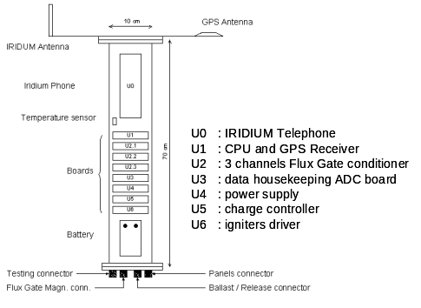 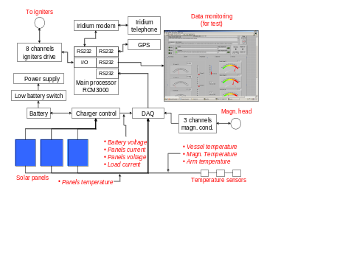b)

a)

Fig. 2

An inexpensive GPS (Trimble Lassen) is used for time marking the data and also for tracking the payload when it comes down below the parachute after the flight termination. A RCM2000 main processor, U1 unit, acquires every 30 seconds the GPS information, housekeeping and magnetometer data from the DAQ unit U3. The housekeeping data consist of solar panels temperatures, magnetometer head temperature, internal vessel and external arm temperature, solar panels currents, solar panels voltages, battery voltage and load current. The analog signals picked up on the sense coils of the magnetometer head, allocated at the bottom than the flight system (Fig.1,a), are conditioned by the units U2.x. The output signals are acquired by the DAQ unit with a 20bit AD converter. At the end of acquisition cycle, the main system U1 checks the pyrotechnic devices status (ballast releasing and separation systems) using a digital I/O port.
A second GPS mounted on Argos TM is used as a redundant localization system and for tracking the balloon, after separation with the payload, at the end of the fly; Argos TM was powered by lithium cells for the first flights and, for the other flights, by small solar panel buffered with a rechargeable battery for long duration guarantee.
The communication between the ground station (Fig.3) and the balloon it occurs in plain ASCII text. The ground station software calls the payload automatically or manually mode, downloads data, upgrades the web site and periodically notifies the balloon(s) position, and issued alarms in case of loss of height or malfunctions sending SMS automatically on the GSM mobile personal phone.
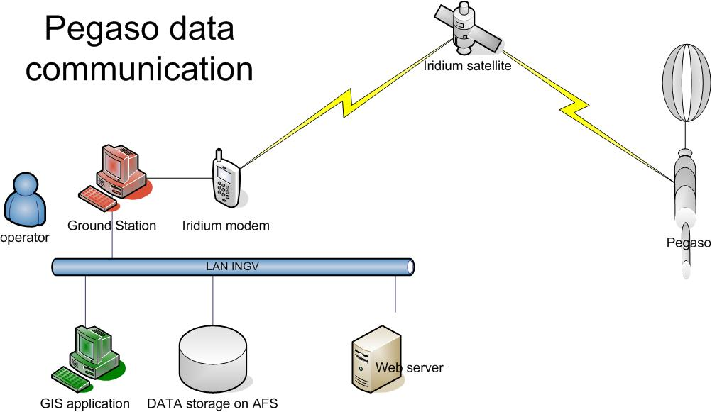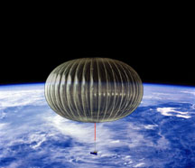

Fig. 3

PEGASO missions and Data Result

A first test of satellite TM prototype, using only GPS data, was lunched from ASI base of Trapani (Sicily) on-board ASI payload. Afterwards, five PEGASO payloads were launched since 2004 using 10000 m³ balloons: four payloads were lunched from Longyearbyen (Svalbard) and one from MZS (Antarctica Italian base) as indicated on the table 1 and the respective trajectory are displayed in Fig.4.

PEGASO | POLE | LAUNCH DATE | FALL DATE | N° of flight days | KM covered | Magn.
A | NORTH | 24 July 2004 | 31 August 2004 | 39 | 12 624 | No
B | NORTH | 29 June 2005 | 23 July 2005 | 25 | 9 966 | Yes
C | NORTH | 5 July 2005 | 18 July 2005 | 13 | 6 317 | No
D | SOUTH | 1 February 2006 | 7 March 2006 | 35 | 13 978 | Yes
E | NORTH | 14 June 2006 | 2 July 2006 | 18 | 10 193 | Yes
Table 1
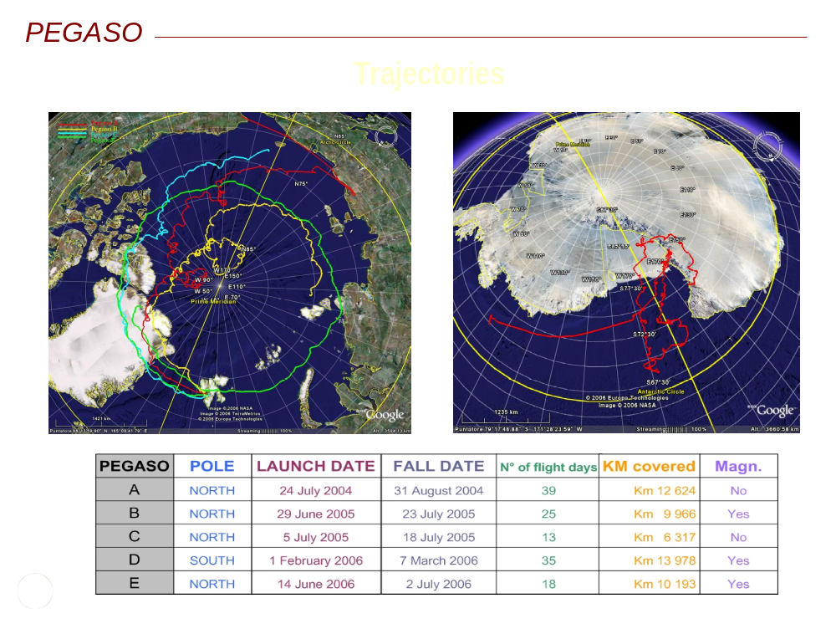
Fig. 4

During the 2004 summer season a first small LDB equipped of the first PEGASO payload was launched to check the on-board electronic devices. The mission time was about 40 days, but the balloon trajectory result (red track) was not round at the pole for at later lunch date. Only data housekeeping and data position were downloaded and the flight was an excellent test of the first small IRIDIUM on-board.
PEGASO B-C flights were better than campaign before and the balloons followed convergent trajectory. They carried an updated telemetry and PEGASO B was equipped with a 3 axis fluxgate magnetometer. During the campaign, trajectory prediction software was tested as new approach of the ground base tracking system. The software computed the predictions trajectories of the balloons, before and during flights, as well as statistical evaluations of the seasonal flight windows at the beginning of the ASI LDB.
PEGASO D was launched from MZS base (Terra Nova, Antarctica). Some logistic and technical problems delayed the launch which occurred too late for a circular trajectory.
A perfect circumpolar trajectory was performed during the last campaign in Svalbard by PEGASO E. The stratospheric window show a good behaviour and the fly was terminated over north-west Greenland, in a place suitable for recovery. The payload hosted RDR/BXR a joint Norwegian-Italian experiment to study high energy particle precipitation.

During PEGASO campaigns many information were collected. Fig.5 shows a typical effect of the ballast releasing (about 2 kg) during the flight 2006, saving the flight duration with an estimated increasing of over
10 days.

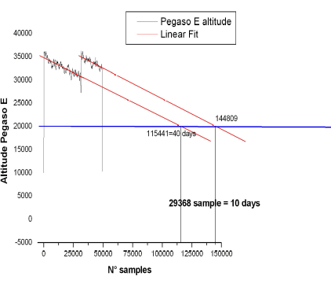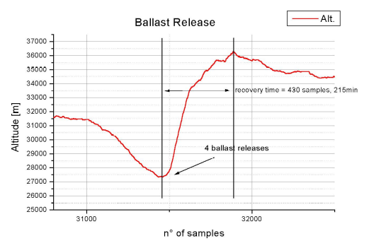

Fig. 5
Figure 13 shows a data window from the solar array. The balloon rotation causes the random oscillation.

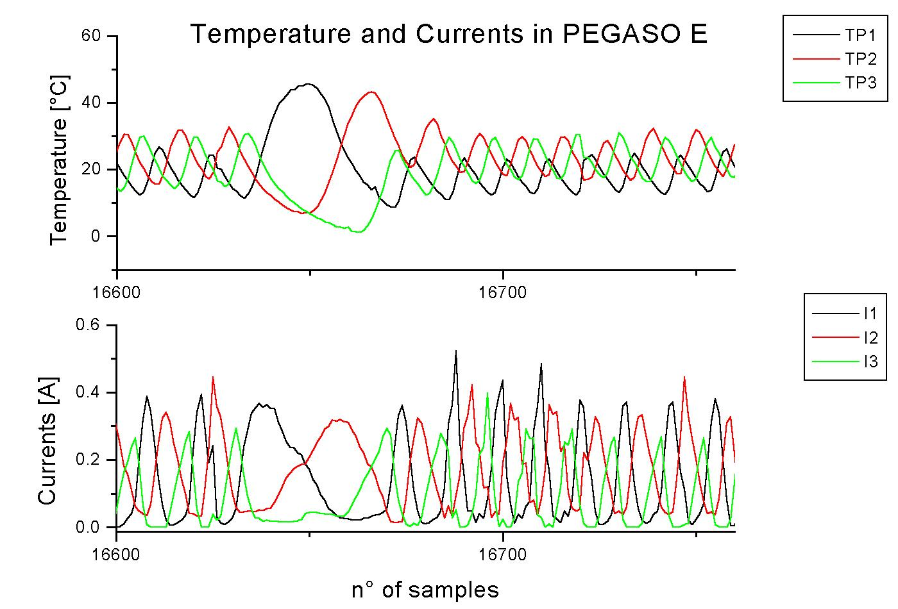
Fig. 6

Fig. 14 shows a typical data record of the vessel internal temperature (PEGASO E). The daily sun elevation originates the periodical fluctuation; on the right, the picture shows the behaviour of the internal temperature during the ascending phase.
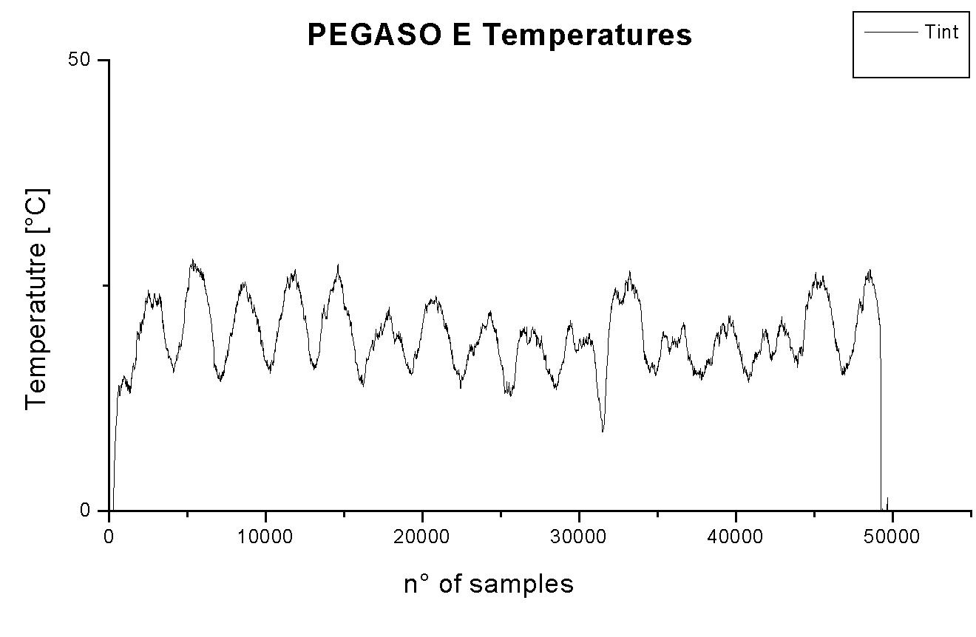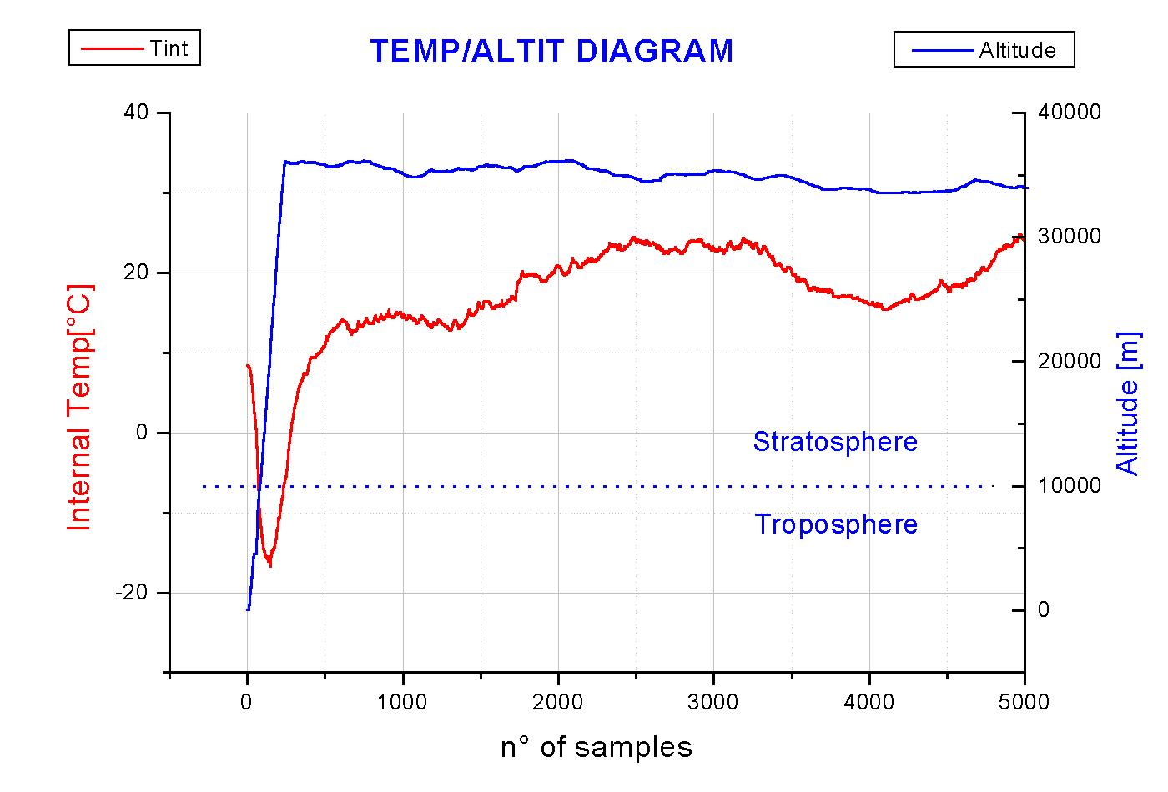
Fig. 7

The pressurized aluminium vessel keeps the temperature in a reasonable range. Half surface is exposed to the sunlight; the other half is exposed to the cold space. This effect stabilizes the temperature inside the vessel.
The vertical Z component and horizontal component of the magnetic field data (Fig.8), recorded during PEGASO B mission, show the daily periodic oscillations (visible on the vertical component) caused by the day-night variations of balloon altitude. Looking the yellow trajectory (Fig.4), the H component intensity changes with the distance from the magnetic pole. The balloon rotation modulates the Y and X components of the horizontal (Fig.8.c).
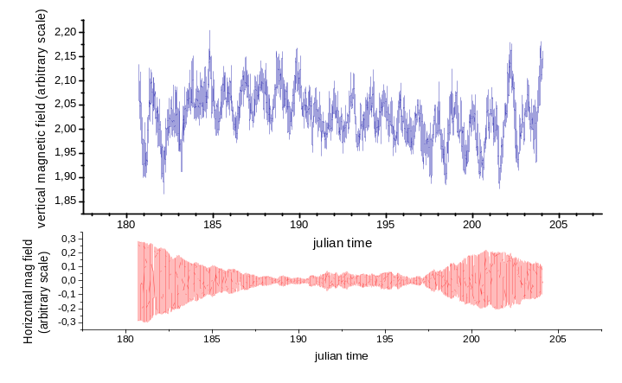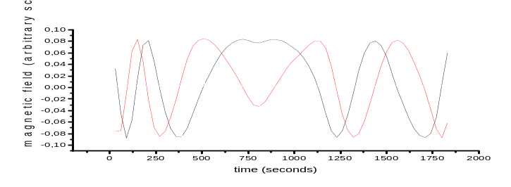
Fig. 8

CONCLUSIONS
Stratospheric Balloons provide access to polar space at a reasonable cost. This is extremely interesting for earth sciences, atmosphere science and cosmology. PEGASO provides a good test for experimentation in this direction. The success of Pegaso missions demonstrates the possibility to build a small cost-effective long duration payload for operating in scientific and technical disciplines. The 2004 and 2006 missions have been defined also to investigate the stratospheric winds structure and they tested the possibility for future heavy LDB flights.
The LDB program is an established activity in the southern hemisphere. The interest in this technology is rapidly growing and ASI, in a cooperative effort with ARR, is developing a program of balloon launches from the Svalbard site of Longyearbyen. This complementary one in the Northern Polar regions will add significant flight opportunities to scientific groups worldwide. The Italian scientific community foresees this kind of missions from 2007-2009 campaigns.
PEGASO missions are the first step in this direction and this article wants expresses the success of this simple system from the point of view of scientific and technical results. Some improvements are planned for the next payload like: increase the buffer size to several days, improve the expandability using an internal communication bus in order to have an easy interfacing, design a mini ACS for measuring the solar orientation and use a magnetic gradiometer.

REFERENCES

PETERZEN S. et al. (2003): “Development of a Long Duration Balloon program in the Polar Regions – Svalbard, Norway”, 16th ESA Symposium on Rockets and Balloons, St. Gallen, Switzerland, 2-5 June 2003.
PETERZEN S. et al. (2005): “Ultra light to heavy long duration balloon development from Svalbard, Norway”, 17th ESA Symposium on Rockets and Balloons, Sandefjord, Norway, 30 May-2 June 2005.
MUSSO, I. et al. (2004): “A Balloon Trajectory Prediction System”, Advances in Space Research, Vol. 33, 2004, pp. 1722 –1726
MUSSO I. et al. (2003): “Software and methodologies for stratospheric balloons’ flights prediction”, 3th AIAA Aviation Technology Forum, Denver, 17-19 November 2003.
CARDILLO A. et al. (2003): “Trailblazer and PEGASO: exploring Polar Regions using small stratospheric balloons”, Meeting Nazionale sulle tecnologie del PNRA, 14-15 mar. 2003
ROMEO G.: “Drive Pyrotechnic Igniters from a Microprocessor Port, Electronic Design”, 20.08.08 n. 57, pp 67-68
OLIMPO S., et al., “Olimpo: A multi-wavwlenght survey of Galaxy Clusters and the Cosmic sub-mm/mm Background”, 17th ESA Symposium on Rockets and Balloons, Sandefjord, Norway, 30 May-2 June 2005.
CORTIGLIONI S. et al., “Bar-SPOrt: an experiment to measure the linearly polarized sky emission from both Cosmic Microwave Background and Foregrounds”, 16th ESA Symposium on Rockets and Balloons, St. Gallen, Switzerland, 2-5 June 2003.
DE BERNARDIS P., et al., “A flat Universe from high-resolution maps of the Cosmic Microwave Background Radiation”, Nature, Vol. 404, 2000.

Table Caption

Table 1: Five Pegaso missions resuming table.

Figure Caption

Fig. 1: PEGASO flight chain. Left side (picture a): magnetometer head, arm, passive radar reflector, solar panels, payload with four ballast tubes. A detail of the ballast cover and solar panels mechanics interface.

Fig. 5: Trajectories of PEGASO from Longyearbyen (left) and in Antarctica (right). On the left the track colours are relative to different payloads. Red: PegasoA; yellow: PegasoB; cyan: PegasoC; green: PegasoE.

Fig. 6: Left: Pegaso 2005 ready to fly. Right: Filling the pyro explosive in the ballast tubes.

Fig. 7: Vessel layout (picture a): a pressurized cylinder contains all the electronic parts of PEGASO allowing them to work in laboratory conditions. Schematic functioning of the PEGASO electronic system (picture b).

Fig. 3: Communication sketch and ground station block diagram.

Fig. 12: Effect of ballast releasing on the balloon height during the 2004 flight.

Fig. 6: A housekeeping data fragment from PEGASO E. The solar panels temperatures and currents waveform are variable with the balloon rotation.

Fig. 14: Typical temperature panorama inside PEGASO vessel.

Fig. 15: Rough data of the vertical and horizontal magnetic field recorded by Pegaso B. a) all data record. b) A portion of horizontals components (Y, X) show one inversion of the gondola rotation.

